Trinity Lutheran Church

**The Lutheran Church-Missouri Synod**

**Trinity Lutheran Church**

**Trinity Lutheran Church**

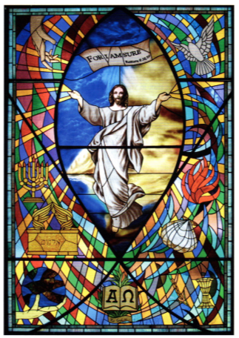

**12391 Mercy Blvd. · Savannah, GA 31419 · (912) 925-4839**

**www.trinitylutheransavannah.com**

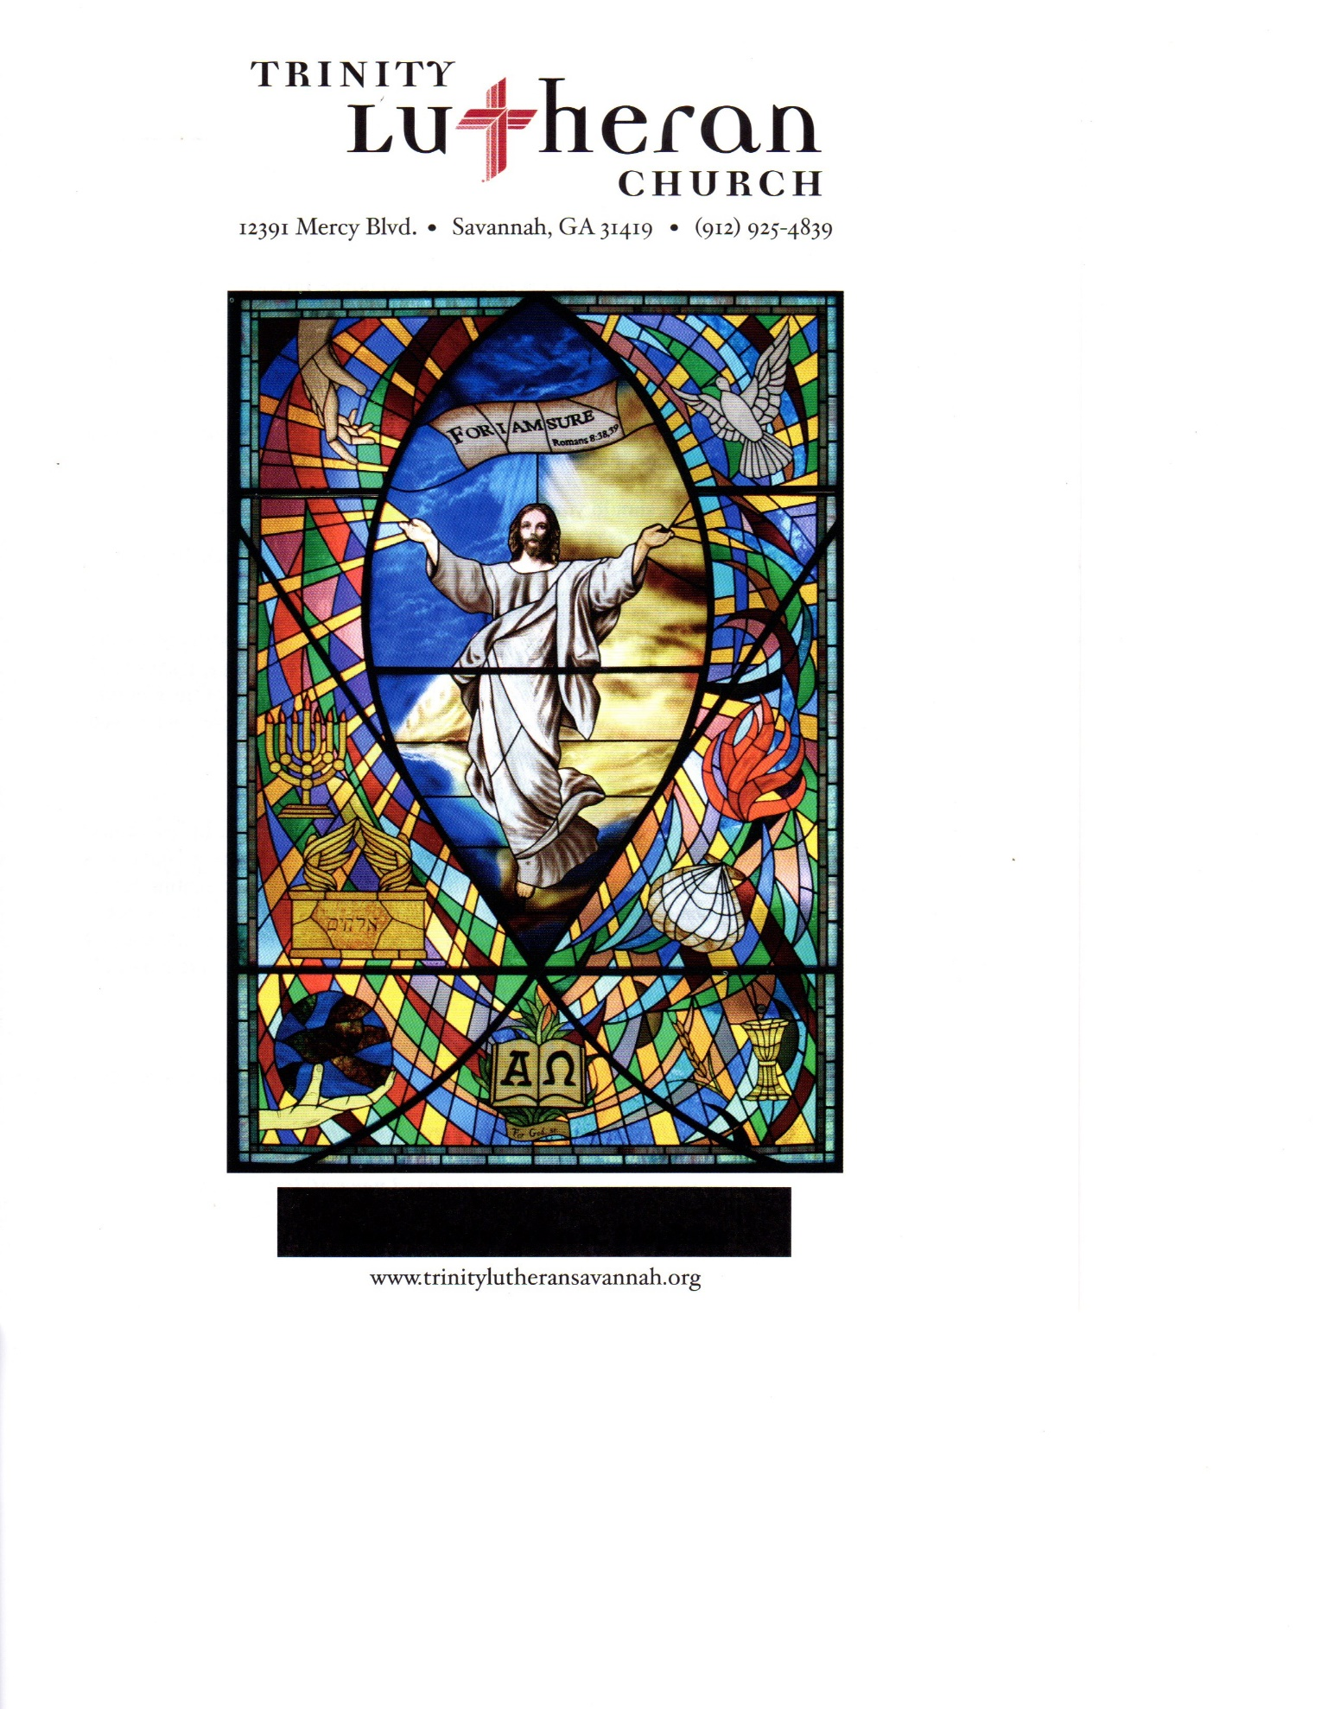

8:30 & 11:00 a.m. Divine Service

**Trinity Lutheran Church**

**The Third Sunday after Pentecost**

**June 9, 2024 8:30 Non-Communion and 11:00 a.m. Communion Service**

**WELCOME TO TRINITY!**

Thank you for worshipingwith us today. We want to know who you are, so please provide your contact information in the Friendship Book as it is passed during the Offertory. If you are visiting, honor us by signing the Guest Register in the Narthex.

There are times in our worship service where we stand or kneel. Feel free to participate in either as you are able or feel comfortable to remain seated.

Gluten-free wafers are available upon request during communion services. Please speak to the pastor before service if you wish to receive the host in this form.

Please ask an usher should you require a hearing assistance device.

(†) ~ Those who wish may make the sign of the Cross in remembrance of their Baptism.

**RECEPTION OF HOLY COMMUNION**

If you are not a member of Trinity Lutheran Church, we ask that you speak with the pastor prior to the service before receiving the Lord’s Supper.

**REQUESTS FOR PRAYER**

If you have a prayer request, please fill out a Blue Card from the pew rack and place it in the offering plate. Prayer requests may also be emailed to [trinityoffice@bellsouth.net](mailto:trinityoffice@bellsouth.net) or to pastorjeffwebb@yahoo.com.

**FOR PARENTS WITH YOUNG CHILDREN**

We are delighted that you have brought your child to worship! We invite you to use the Cry Room as a courtesy to others if your little one gets a little rambunctious. Our Cry Room, complete with seating and children's activities, is located at the back of the Sanctuary. The service can be heard through the sound system. We hope your children feel glad they were here and that they are a part of the Trinity family!

***Our Vision:***

***Growing in God’s Word to Share Christ’s Love***

***Our Mission:***

***Led by God, equipped as disciples through Word and Sacrament,***

***we are empowered by the Holy Spirit to reach out with the Gospel of Jesus Christ to all.***



**AS WE GATHER TODAY**

In the face of a world seeming to be falling apart, and maybe even your personal “world,” God’s Word has great and convincing comfort and hope for you this day. That hope, however, begins with knowing the real cause of our troubles. It is our sin and alienation from God that is at the root of all anger, frustration, bitterness, and death. We easily “lose heart” when all seems hopeless for us. The center and substance of hope in God is Jesus Christ whose resurrection from all that is darkness and death to us is the means and strength of faith to endure and stand firm through all that troubles us. For “if the Spirit of Him who raised Jesus from the dead dwells in you, He who raised Christ Jesus from the dead will also give life to your mortal bodies through His Spirit who dwells in you” (Romans 8:11). Far from being merely a blind hope for future deliverance, believing in the resurrection of the dead and the life of the world to come far outweighs everything and anything that can happen to us now. Living in this hope, we do not lose heart.

**Divine Service**

***Setting Four***

**ORGAN**

**WELCOME**

**CHIMING OF THE HOUR**

**Confession and Absolution**

*Please Stand*

**PROCESSIONAL HYMN 868 "Awake, My Soul, and with the Sun"**

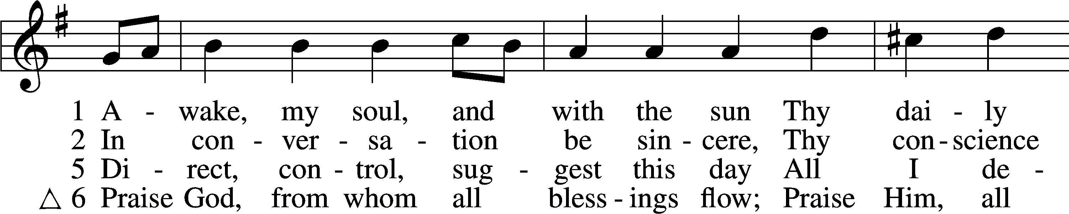

Text and tune: Public domain

**INVOCATION**

P In the name of the Father and of the (†) Son and of the Holy Spirit.

C **Amen.** *Matthew 28:19b*

P Our help is in the name of the Lord,

C **who made heaven and earth.** *Psalm 124:8*

P Since we are gathered to hear God’s Word, call upon Him in prayer and praise, and receive the body and blood of our Lord Jesus Christ in the fellowship of this altar, let us first consider our unworthiness and confess before God and one another that we have sinned in thought, word, and deed, and that we cannot free ourselves from our sinful condition. Together as His people let us take refuge in the infinite mercy of God, our heavenly Father, seeking His grace for the sake of Christ, and saying: God, be merciful to me, a sinner. *[Luke 18:13]*

C **Almighty God, have mercy upon us, forgive us our sins, and lead us to everlasting life. Amen.**

P Almighty God in His mercy has given His Son to die for you and for His sake forgives you all your sins. As a called and ordained servant of Christ, and by His authority, I therefore forgive you all your sins in the name of the Father and of the (†) Son and of the Holy Spirit.

C **Amen.** *[John 20:19-23]*

**Service of the Word**

**PSALM *Psalm 130***

P 1Out of the depths  
C **I cry to you, O Lord!**

P 2O Lord, hear my voice!  
C **Let your ears be attentive to the voice of my pleas for mercy!**

P 3If you, O Lord, should mark iniquities,  
C **O Lord, who could stand?**

P 4But with you there is forgiveness,  
C **that you may be feared.**

P 5I wait for the Lord, my soul waits,  
C **and in his word I hope;**

P 6my soul waits for the Lord more than watchmen for the morning,  
C **more than watchmen for the morning.**

P 7O Israel, hope in the Lord! For with the Lord there is steadfast love,  
 C **and with him is plentiful redemption.**

P 8And he will redeem Israel  
C **from all his iniquities.**

**All Glory be to the Father and to the Son and to the Holy Spirit;**

**as it was in the beginning, is now, and will be forever. Amen.**

**KYRIE ~ *Lord, Have Mercy*** *Mark 10:47*

**GLORIA IN EXCELSIS ~ *Glory to God in the Highest*** *Luke 2:14; John 1:29*

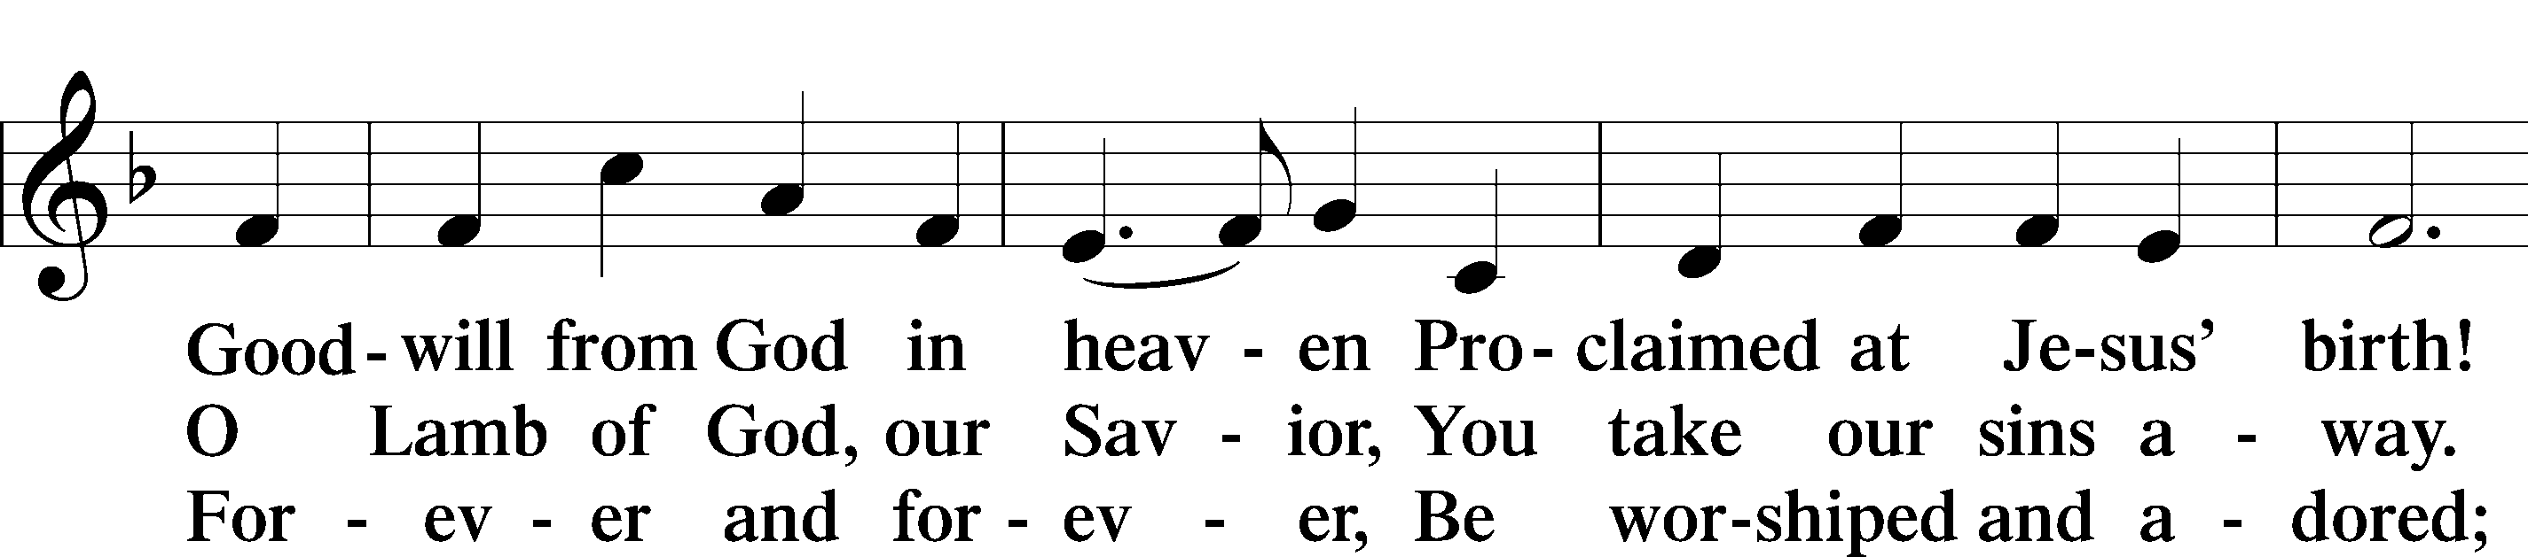

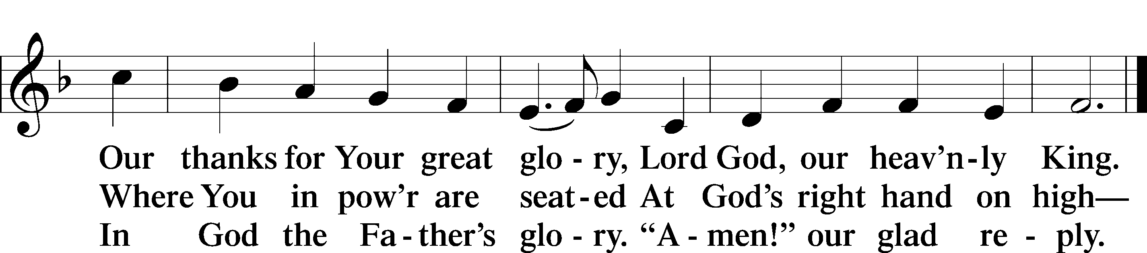

**SALUTATION and COLLECT OF THE DAY**

P The Lord be with you. *2 Timothy 4:22*

C **And also with you.**

P Let us pray.

Almighty and eternal God, Your Son Jesus triumphed over the prince of demons and freed us from bondage to sin. Help us to stand firm against every assault of Satan, and enable us always to do Your will; through Jesus Christ, our Lord, who lives and reigns with You and the Holy Spirit, one God, now and forever.

C **Amen.**

*Be Seated*

**OLD TESTAMENT LESSON *Genesis 3:8–15***

8They heard the sound of the Lord God walking in the garden in the cool of the day, and the man and his wife hid themselves from the presence of the Lord God among the trees of the garden. 9But the Lord God called to the man and said to him, “Where are you?” 10And he said, “I heard the sound of you in the garden, and I was afraid, because I was naked, and I hid myself.” 11He said, “Who told you that you were naked? Have you eaten of the tree of which I commanded you not to eat?” 12The man said, “The woman whom you gave to be with me, she gave me fruit of the tree, and I ate.” 13Then the Lord God said to the woman, “What is this that you have done?” The woman said, “The serpent deceived me, and I ate.”

14The Lord God said to the serpent,

“Because you have done this,  
 cursed are you above all livestock  
 and above all beasts of the field;  
on your belly you shall go,  
 and dust you shall eat  
 all the days of your life.  
15I will put enmity between you and the woman,  
 and between your offspring and her offspring;  
he shall bruise your head,  
 and you shall bruise his heel.”

A This is the Word of the Lord.

C **Thanks be to God.**

**EPISTLE LESSON*****2 Corinthians 4:13—5:1***

13Since we have the same spirit of faith according to what has been written, “I believed, and so I spoke,” we also believe, and so we also speak, 14knowing that he who raised the Lord Jesus will raise us also with Jesus and bring us with you into his presence. 15For it is all for your sake, so that as grace extends to more and more people it may increase thanksgiving, to the glory of God.

16So we do not lose heart. Though our outer nature is wasting away, our inner nature is being renewed day by day. 17For this slight momentary affliction is preparing for us an eternal weight of glory beyond all comparison, 18as we look not to the things that are seen but to the things that are unseen. For the things that are seen are transient, but the things that are unseen are eternal.

1For we know that if the tent, which is our earthly home, is destroyed, we have a building from God, a house not made with hands, eternal in the heavens.

A This is the Word of the Lord.

C **Thanks be to God.**

*Please Stand*

**ALLELUIA and VERSE** *John 20:31*

**HOLY GOSPEL *Mark 3:20–35***

P The Holy Gospel according to St. Mark, the third chapter.

**C Glory to You, O Lord.**

20Then [Jesus] went home, and the crowd gathered again, so that they could not even eat. 21And when his family heard it, they went out to seize him, for they were saying, “He is out of his mind.”

22And the scribes who came down from Jerusalem were saying, “He is possessed by Beelzebul,” and “by the prince of demons he casts out the demons.” 23And he called them to him and said to them in parables, “How can Satan cast out Satan? 24If a kingdom is divided against itself, that kingdom cannot stand. 25And if a house is divided against itself, that house will not be able to stand. 26And if Satan has risen up against himself and is divided, he cannot stand, but is coming to an end. 27But no one can enter a strong man’s house and plunder his goods, unless he first binds the strong man. Then indeed he may plunder his house.

28“Truly, I say to you, all sins will be forgiven the children of man, and whatever blasphemies they utter, 29but whoever blasphemes against the Holy Spirit never has forgiveness, but is guilty of an eternal sin”— 30for they had said, “He has an unclean spirit.”

31And his mother and his brothers came, and standing outside they sent to him and called him. 32And a crowd was sitting around him, and they said to him, “Your mother and your brothers are outside, seeking you.” 33And he answered them, “Who are my mother and my brothers?” 34And looking about at those who sat around him, he said, “Here are my mother and my brothers! 35Whoever does the will of God, he is my brother and sister and mother.”

P This is the Gospel of the Lord.

**C Praise to You, O Christ.**

**NICENE CREED**

**I believe in one God, the Father Almighty, maker of heaven and earth and of all things visible and invisible.**

**And in one Lord Jesus Christ, the only-begotten Son of God, begotten of His Father before all worlds, God of God, Light of Light, very God of very God, begotten, not made, being of one substance with the Father, by whom all things were made; who for us men and for our salvation came down from heaven and was incarnate by the Holy Spirit of the virgin Mary and was made man; and was crucified also for us under Pontius Pilate. He suffered and was buried. And the third day He rose again according to the Scriptures and ascended into heaven and sits at the right hand of the Father. And He will come again with glory to judge both the living and the dead, whose kingdom will have no end.**

**And I believe in the Holy Spirit, the Lord and Giver of life, who proceeds from the Father and the Son, who with the Father and the Son together is worshiped and glorified, who spoke by the prophets. And I believe in one holy Christian and apostolic Church, I acknowledge one Baptism for the remission of sins, and I look for the resurrection of the dead and the life of the world to come. Amen.**

*Be Seated*

**CHILDREN'S MESSAGE *8:30 Service***

**HYMN OF THE DAY 669 "Come, We That Love the Lord"**

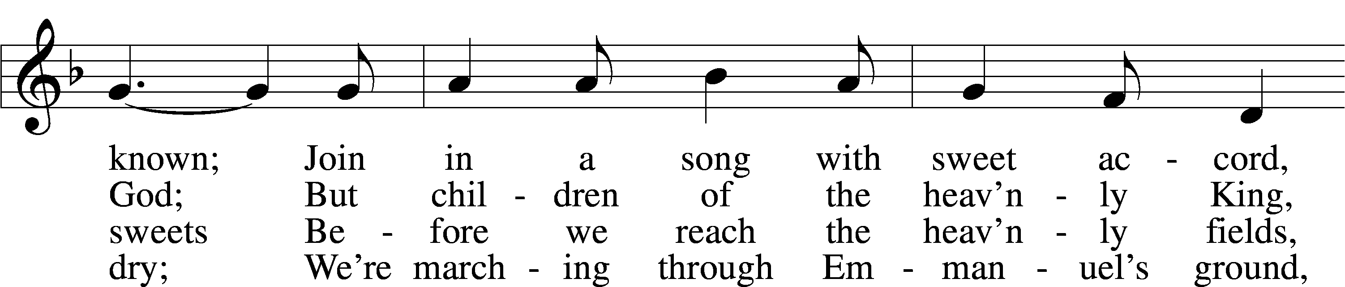

Text and tune: Public domain

**SERMON "Walking in the Light" *1 John 1:5-10***

This is the message we have heard from him and proclaim to you, that God is light, and in him is no darkness at all. If we say we have fellowship with him while we walk in darkness, we lie and do not practice the truth. But if we walk in the light, as he is in the light, we have fellowship with one another, and the blood of Jesus his Son cleanses us from all sin. If we say we have no sin, we deceive ourselves, and the truth is not in us. If we confess our sins, he is faithful and just to forgive us our sins and to cleanse us from all unrighteousness. If we say we have not sinned, we make him a liar, and his word is not in us.

**OFFERING** *(Please fill out and pass the red Friendship Book at this time; and fill out the blue card in the pew rack for prayers.)*

*Please Stand*

**OFFERTORY 781 vv. 1, 2 “We Give Thee but Thine Own”**

Text and tune: Public domain

*Kneel or Be Seated*

**PRAYER OF THE CHURCH** *[1 Timothy 2:1-4]*

**Non-Communion Service (8:30)**

**LORD'S PRAYER** *Matthew 6:9-13*

**Our Father who art in heaven, hallowed be Thy name, Thy kingdom come, Thy will be done on earth as it is in heaven. Give us this day our daily bread; and forgive us our trespasses as we forgive those who trespass against us; and lead us not into temptation, but deliver us from evil. For Thine is the kingdom and the power and the glory forever and ever. Amen**.

*Please Stand*

**BENEDICAMUS and BENEDICTION**

P Let us bless the Lord. *[Psalm 103:1]*

C **Thanks be to God.**

P The Lord bless you and keep you. The Lord make His face shine on you and be gracious to you. The Lord look upon you with favor and (†) give you peace. *Numbers 6:24-26*

C **Amen.**

**CLOSING HYMN 851**  **"Lord of Glory, You Have Bought Us"**

Text and tune: Public domain

*Be Seated*

**Service of the Sacrament (11:00)**

*The Sacrament, or Lord's Supper, is a special gift from God that brings us into personal communion with Jesus Christ. "In, with and under" the bread and wine we receive His body and blood for forgiveness and renewal. If you are a repentant sinner, come to the table expecting to receive God's wonderful gifts for you!*

*Communicants will take their own wine cups as they are passed. Those requiring non-alcoholic grape juice will take the cups with white grape juice from the middle of the tray.*

*Be Seated*

**OUR EXAMINATION**

P In preparation for Holy Communion, St. Paul tells us in 1 Corinthians 11:27-29, “Whoever, therefore, eats the bread or drinks the cup of the Lord in an unworthy manner will be guilty concerning the body and blood of the Lord. 28Let a person examine himself, then, and so eat of the bread and drink of the cup. 29For anyone who eats and drinks without discerning the body eats and drinks judgment on himself.” So that we may properly examine ourselves prior to receiving the Lord’s Supper, I ask you to reflect on these questions:

* Do you repent of all your sins of thought, word, and deed?
* Do you believe that Jesus Christ is your only Savior from all sin, Satan, and death?
* Do you believe that the Risen Christ is really present in the Sacrament and that in, with, and under the bread and wine you receive His true Body and Blood?

If you answer in faith "Yes!" to these questions, and are properly instructed, you are invited to come forward and partake of the Lord's Supper during Distribution. If you are unable to answer yes to any of these questions, you are invited to come forward, cross your arms as I approach you and receive a blessing. By your coming forward, "You proclaim the Lord's death until He comes."

*Please Stand*

**PREFACE**

P The Lord be with you. *2 Timothy 4:22*

**C And also with you.**

P Lift up your hearts. *[Colossians 3:1]*

**C We lift them to the Lord.**

P Let us give thanks to the Lord, our God. *[Psalm 136]*

**C It is right to give Him thanks and praise.**

P It is truly good, right, and salutary that we should at all times and in all places give thanks to You, O Lord, holy Father, almighty and everlasting God, for the countless blessings You so freely bestow on us and all creation. Above all, we give thanks for Your boundless love shown to us when You sent Your only-begotten Son, Jesus Christ, into our flesh and laid on Him our sin, giving Him into death that we might not die eternally. Because He is now risen from the dead and lives and reigns to all eternity, all who believe in Him will overcome sin and death and will rise again to new life. Therefore with angels and archangels and with all the company of heaven we laud and magnify Your glorious name, evermore praising You and singing:

**SANCTUS ~ *Holy, Holy, Holy*** *Isaiah 6:3; Matthew 21:9*

**PRAYER OF THANKSGIVING**

P Blessed are You, O Lord our God, king of all creation, for You have had mercy on us and given Your only-begotten Son that whoever believes in Him should not perish but have eternal life.

In Your righteous judgment You condemned the sin of Adam and Eve, who ate the forbidden fruit, and You justly barred them and all their children from the tree of life. Yet, in Your great mercy, You promised salvation by a second Adam, Your Son, Jesus Christ, our Lord, and made His cross a life-

giving tree for all who trust in Him.

We give You thanks for the redemption You have prepared for us through Jesus Christ. Grant us Your Holy Spirit that we may faithfully eat and drink of the fruits of His cross and receive the blessings of forgiveness, life, and salvation that come to us in His body and blood.

Hear us as we pray in His name and as He has taught us:

**LORD'S PRAYER** *Matthew 6:9-13*

**Our Father who art in heaven, hallowed be Thy name, Thy kingdom come, Thy will be done on earth as it is in heaven. Give us this day our daily bread; and forgive us our trespasses as we forgive those who trespass against us; and lead us not into temptation, but deliver us from evil. For Thine is the kingdom and the power and the glory forever and ever. Amen**.

**THE WORDS OF OUR LORD** *Matthew 26:26-28; Mark 14:22-24;*

*Luke 22:19-20; 1 Corinthians 11:23-25*

P Our Lord Jesus Christ, on the night when He was betrayed, took bread, and when He had given thanks, He broke it and gave it to the disciples and said: “Take, eat; this is My body, which is given for you. This do in remembrance of Me.” In the same way also He took the cup after supper, and when He had given thanks, He gave it to them, saying: "Drink of it, all of you; this is my blood of the new covenant, which is poured out for you for the remission of sins. This do as often as you drink it, in remembrance of Me."

**PAX DOMINI ~ *The Peace of the Lord*** *John 20:19*

PThe peace of the Lord be with you always.

C **And also with you.**

**AGNUS DEI ~ *Lamb of God*** *John 1:29*

*Be Seated*

**DISTRIBUTION HYMN**

**HYMN 673 "Jerusalem, My Happy Home"**

5 Apostles, martyrs, prophets, there  
    Around my Savior stand;  
And soon my friends in Christ below  
    Will join the glorious band.

6 O Christ, do Thou my soul prepare  
    For that bright home of love  
That I may see Thee and adore  
    With all Thy saints above.

Text and tune: Public domain

*Please Stand*

**NUNC DIMITTIS ~ *Song of Simeon*** *Luke 2:29-32*

**POST-COMMUNION COLLECT**

P Let us pray.

O God the Father, the fountain and source of all goodness, who in loving- kindness sent Your only-begotten Son into the flesh, we thank You that for His sake You have given us pardon and peace in this Sacrament, and we ask You not to forsake Your children but always to rule our hearts and minds by Your Holy Spirit that we may be enabled constantly to serve You; through Jesus Christ, Your Son, our Lord, who lives and reigns with You and the

Holy Spirit, one God, now and forever.

C **Amen.**

**BENEDICAMUS and BENEDICTION**

P Let us bless the Lord. *[Psalm 103:1]*

C **Thanks be to God.**

P The Lord bless you and keep you. The Lord make His face shine on you and be gracious to you. The Lord look upon you with favor and (†) give you peace. *Numbers 6:24-26*

C **Amen.**

**CLOSING HYMN 851**  **"Lord of Glory, You Have Bought Us"**

Text and tune: Public domain

*Be Seated*

**ANNOUNCEMENTS and RECOGNITION OF OUR GUESTS**

**ORGAN**

**TO THE GLORY OF GOD**

The Altar flowers are given to the glory of God

by Kip and Delane Wiltse.

***Do not be anxious about anything, but in everything by prayer and supplication***

***with thanksgiving let your requests be made known to God.***

***Philippians 4:6***

**COFFEE & CONVERSATION**

Join us in the Social Hall after the 8:30 service for coffee and breakfast goodies

provided by the Youth.

**BIBLE STUDY OPPORTUNITIES**

**ADULT SUNDAY BIBLE STUDY**

Pastor Webb leads a Bible study in the Social Hall after the 8:30 service.

**CHURCH YEAR CONNECTIONS**

**(Ages 3 through High School)**

Join us for Sunday School classes for ages three through young adult. Teachers: Megan Haverland (3 years-1st Grade), Judy Bringman (2nd-5th Grade), Bob Hanovich (Middle School), and Karl Schumacher (High School).

**PARENTS & TWOS CLASS**

In this class for parents and two-year-olds, Karen Hanovich helps parents encourage their little ones as they learn about Jesus together.

**YOUNG ADULT SINGLES CLASS**

For ages 18-26, this class led by Kevin Riedl is studying “Lessons from the Underground Church.”

**21ST CENTURY PARENTING CLASS**

Parents of school-aged kids gain insight into the issues facing Gen Z and learn how to engage them in meaningful conversations. Eric and Megan Thompson lead this class in the Education Building.

**YOUNG AT HEART CLASS**

Mature members study how we can demonstrate love and compassion to people in need. Bob Reynolds and Mark Waltz lead this class on the ground floor of the Education Building.

**WEDNESDAY MORNING BIBLE STUDY**

Join us at 10:00 a.m. on Wednesday mornings in the Education Building to study the Word.

**LADIES’ BIBLE STUDY**

The Ladies’ Bible Study that meets on Mondays at 10:00am in the Education Building is now taking a break for the summer.

**HAPPENING AT TRINITY**

**THANK YOU**

Thank you to Barbara Lunick for playing the organ for us.

**OFFERINGS**

Please remain faithful in bringing your offerings to the Lord by mail or online if you are unable to attend worship in person.

**TODAY IS "CAN DO SUNDAY"**

Please place your food items in the grocery cart in the Social Hall to help provide a meal for those in need who visit our Food Pantry. As always, thank you for your participation.

**VBS 2024**

**June 10-14 at 5:15-8:00**

Join us June 10-14 from 5:13 - 8:00. Kids will learn ways they can put their trust in God when they are afraid, challenged, or called to do God's work and share the Good News of God's love through Jesus Christ. Dinner will be served.  Open to age 3- Middle School

**OVER 50 GROUP LUNCH**

**Wednesday, June 19 at 12:00**

The Over 50 Group will meet for lunch at 12:00 on Wednesday, June 19 at Ole Times Country Buffet (209 Stephenson Ave). See Marilyn McKee for more information.

**LARGE PRINT PORTALS OF PRAYER**

Each quarter, we receive one large print edition of Portals of Prayer. If you need the large print copy, please help yourself or let Traci (trinityoffice@bellsouth.net) know if we don’t have enough. If no one takes it, we can discontinue that order. There is also a medium size available if you need us to order that size. Thank you!

**BULLETIN ANNOUNCEMENTS**

**Due Wednesday, June 12**

Please submit any bulletin announcements for June 23 and June 30 to the office by Wednesday evening, June 12 as those bulletins will print early before Traci goes on vacation.

**ONLINE GIVING**

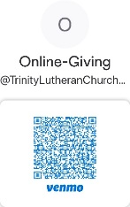Our ONLINE GIVING options have changed! We now have a TLC Venmo account for easy giving of your tithes and offerings. Contribute directly from your checking or savings account, check card, or credit card. Use the QR Code for easy access.

**CONNECT WITH US**

Connect with TLC and keep up with what’s going on.

\***Website** - [www.trinitylutheransavannah.com](http://www.trinitylutheransavannah.com)  
\***Facebook** - Friends of Trinity Lutheran Church; Trinity Lutheran Church – Community Info & Events (shareable page); Trinity Lutheran Church of Savannah Media; TLC Hearts of Compassion Helping Hands Ministry; Lizzie Comfort Dog  
\***Instagram** - #lcck9lizzie (Lizzie Comfort Dog)

\***YouTube** – Trinity Lutheran Savannah

**MINISTRY NEEDS**

**VBS VOLUNTEERS NEEDED**

VBS is great for fellowship and outreach. There are many opportunities to help with VBS from volunteering your time to donating food for dinner. Details to be announced. Please look for signup sheets in the Narthex or contact Jennifer Wolfe 912-507-4990 or Megan Haverland 248-930-6146.

**SPONSOR A VBS MEAL**

Please consider sponsoring a VBS meal as a group or a family.

**Monday:** **Hot Dogs w/ ants on a log**

• Hot dogs • Hot dog buns • Ketchup • Mustard • Relish • Chips (Big bags or individuals)

• Celery • Peanut Butter • Raisins *Dessert

**Tuesday: Walking Tacos**

• Ground Beef • Taco Seasoning • Lettuce • Tomatoes • Salsa • Cheese • Fritos/Doritos

• Goldfish *Dessert

**Wednesday:** **Sloppy Joes w/ Oven Baked Smores**

• Ground beef • Ketchup • Mustard • Brown Sugar • Hamburger Buns • Graham crackers

• Large Marshmallows • Hershey Bars

**Thursday:** **Pizza (Provided or Made?) If Made…**

• Frozen Pizzas? • Pizza dough • Pizza Sauce • Shredded Mozzarella • Pepperoni *Dessert

**Friday:** **Grilled Cheese**

• Bread • Sliced American cheese • Grapes pretzels *Closing Ceremony Treats

**CAMPING SUPPLIES FOR VBS**

VBS needs camping supplies for decorating. Items can be placed by the Sunday School secretary desk. Please label items clearly with your name.

     Tents

     Sleeping bags

     Lanterns

     Anything else camping related

If you have any questions, please see Jennifer Wolfe or Megan Haverland.

**TODAY'S WORSHIP SERVICES**

Traditional 8:30 a.m. and 11:00 a.m.

**IN RESPONSE TO THE GOSPEL LAST SUNDAY**

8:30 a.m. – 56 11:00 a.m. – 41 Facebook – 120 YouTube – 10

Giving $5,490.40

Concordia Seminary 75.00

Food Pantry 35.00

Helen Williams 160.00

Memorial – Perks 175.00

Pastor's Discretionary Fund 25.00

Roof Repair 225.00

Vacation Bible School 120.00

Youth 27.00

**SERVING IN THE LORD'S HOUSE TODAY**

**8:30 a.m. 11:00 a.m.**

Mike Bennet, Reader

Sharon Johnson & Linda Tomko, Greeters Kip & Delane Wiltse, Greeters

Gary & Patricia Bradshaw, Ushers Bob Sautter, Usher

**SERVING NEXT SUNDAY**

**8:30 a.m. 11:00 a.m.**

Rosemary Gerdes, Reader

Betty Morrell, Greeter Cindy Baldwin & Cathy Dotson, Greeters

Cathy Crotwell & JB Strange, Ushers John Anander, Usher

**THIS WEEK AT A GLANCE**

TODAY Traditional Worship Services 8:30 & 11:00 a.m.

Sunday School 9:45 a.m.

Evangelism Meeting (Cry Room) 9:45-10:45 a.m.

Can Do Sunday

VBS Set-Up (Whole Campus)

MONDAY 6/10 VBS (Whole Campus) 5:15-8:00 p.m.

TUESDAY 6/11 VBS (Whole Campus) 5:15-8:00 p.m.

WEDNESDAY 6/12 Bible Study (Education Building) 10:00 a.m.

VBS (Whole Campus) 5:15-8:00 p.m.

THURSDAY 6/13 Clothes Closet 10:00 a.m.-1:00 p.m.

Crafters (Education Building) 10:00 a.m.-2:00 p.m.

VBS (Whole Campus) 5:15-8:00 p.m.

FRIDAY 6/14 VBS (Whole Campus) 5:15-8:00 p.m.

SATURDAY 6/15 SOS Workshop (Social Hall) 9:00 a.m.-1:00 p.m.

Young Adult Singles Zoom 7:30 p.m.

**REMEMBER IN PRAYER**

*(Please help us keep the prayer list updated)*

HEALTH

Pastor Hopkins

CANCER

Jim Eckes; Harold LaMarr; Samuel Martin (19)

PEACE

Israel, Ukraine, & all who suffer from war and violence

OUR WITNESS

Let us proclaim Jesus Christ is risen to all!

**TRINITY LUTHERAN CHURCH**

12391 Mercy Blvd

Savannah, GA 31419

phone 912-925-4839 [trinityoffice@bellsouth.net](mailto:trinityoffice@bellsouth.net)

fax 912-925-4056 www.trinitylutheransavannah.com

Contact Pastor: 717-333-6263; pastorjeffwebb@yahoo.com

**STAFF**

Jeff Webb, Pastor

Traci Schumacher, Administrative Assistant

Helen Williams, Church Custodian

**BOARD OF ELDERS**

Mark Waltz, Head Elder (C – E)

Mike Fajen (K – Mc)

Todd Freesemann (F – J)

Sonny Massey (A – B)

Bob Reynolds (Me – Sa)

Tom Wayman (Sc – Z)

**CHURCH COUNCIL**

Kip Wiltse, President

Eric Thompson, Vice President

Cathy Crotwell, Secretary

Karl Schumacher, Treasurer

Megan Haverland, Board of Education

Mark Waltz, Board of Elders

Chris Garretson, Board of Evangelism

Charles Rogers, Board of Property Management

Jennifer Wolfe, Board of Social Ministry

Lonna McEwen, Board of Stewardship

Cindy Reynolds, Financial Secretary

Bob Hanovich, Board of Youth

**ORGANIZATIONAL LEADERS**

Cindy Baldwin, Comfort Dog Top Dog

Jackie Deemer, Director of TLC Singers & LWML President

Megan Thompson, Sunday School Superintendent

Rosemary Gerdes, Quilters

Karen Hanovich, TLC Marketing

Lonna McEwen, Altar Guild

Rose Pitt, Prayer Team