Trinity Lutheran Church

**The Lutheran Church-Missouri Synod**

**Trinity Lutheran Church**

**Trinity Lutheran Church**

**12391 Mercy Blvd. · Savannah, GA 31419 · (912) 925-4839**

**www.trinitylutheransavannah.com**

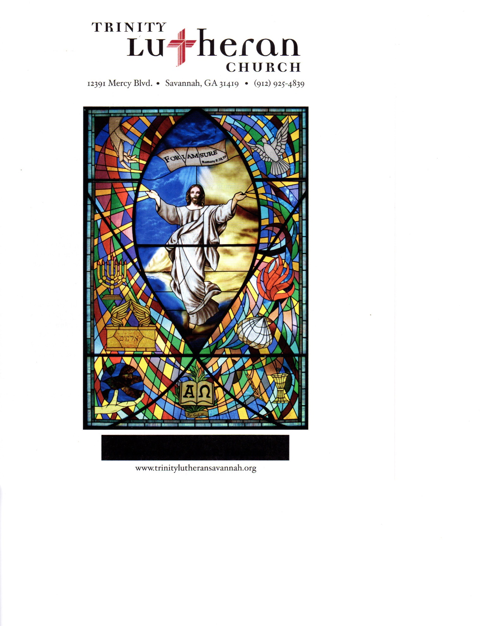

8:30 & 11:00 a.m. Divine Service

**Trinity Lutheran Church**

**The Eleventh Sunday after Pentecost**

**August 4, 2024, 8:30 Communion and 11:00 a.m. Non-Communion Service**

**WELCOME TO TRINITY!**

Thank you for worshipingwith us today. We want to know who you are, so please provide your contact information in the Friendship Book as it is passed during the Offertory. If you are visiting, honor us by signing the Guest Register in the Narthex.

There are times in our worship service where we stand or kneel. Feel free to participate in either as you are able or feel comfortable to remain seated.

Gluten-free wafers are available upon request during communion services. Please speak to the pastor before service if you wish to receive the host in this form.

Please ask an usher should you require a hearing assistance device.

(†) ~ Those who wish may make the sign of the Cross in remembrance of their Baptism.

**RECEPTION OF HOLY COMMUNION**

If you are not a member of Trinity Lutheran Church, we ask that you speak with the pastor prior to the service before receiving the Lord’s Supper.

**REQUESTS FOR PRAYER**

If you have a prayer request, please fill out a Blue Card from the pew rack and place it in the offering plate. Prayer requests may also be emailed to [trinityoffice@bellsouth.net](mailto:trinityoffice@bellsouth.net) or to pastorjeffwebb@yahoo.com.

**FOR PARENTS WITH YOUNG CHILDREN**

We are delighted that you have brought your child to worship! We invite you to use the Cry Room as a courtesy to others if your little one gets a little rambunctious. Our Cry Room, complete with seating and children's activities, is located at the back of the Sanctuary. The service can be heard through the sound system. We hope your children feel glad they were here and that they are a part of the Trinity family!

***Our Vision:***

***Growing in God’s Word to Share Christ’s Love***

***Our Mission:***

***Led by God, equipped as disciples through Word and Sacrament,***

***we are empowered by the Holy Spirit to reach out with the Gospel of Jesus Christ to all.***



**AS WE GATHER TODAY**

When it comes to biblical foods, bread is prominent throughout the pages of Scripture. The first mention of bread is found in Genesis, the first book of the Bible, where it is an indicator of fellowship. When Abram (later called Abraham) returns from a successful military campaign, local tribal rulers in his home region who were known as kings came out to meet him in the Kings Valley. Among these rulers was Melchizedek, the king of Salem, who brought out bread and wine as part of the welcome for Abram (Genesis 14:18). Although a common dietary component in biblical times, bread that was given and shared had great symbolic value. Since the earliest form of the Lord’s Supper included a ceremonial breaking of the bread, Christian worship in New Testament times came to be known by that name. Luke records in Acts that the first Christians “devoted themselves to the apostles’ teaching and fellowship, to the breaking of bread and the prayers” (2:42). As we gather for worship with the breaking of the bread, we also remember those ties of fellowship shared by Melchizedek and Abram, by the first Christians, and by the faithful of every generation!

**Divine Service**

***Setting Four***

**ORGAN**

**WELCOME**

**CHIMING OF THE HOUR**

**Confession and Absolution**

*Please Stand*

**PROCESSIONAL HYMN 633 vv. 1-4 "At the Lamb’s High Feast We Sing"**

Text and tune: Public domain

**INVOCATION**

P In the name of the Father and of the (†) Son and of the Holy Spirit.

C **Amen.** *Matthew 28:19b*

P Our help is in the name of the Lord,

C **who made heaven and earth.** *Psalm 124:8*

P Since we are gathered to hear God’s Word, call upon Him in prayer and praise, and receive the body and blood of our Lord Jesus Christ in the fellowship of this altar, let us first consider our unworthiness and confess before God and one another that we have sinned in thought, word, and deed, and that we cannot free ourselves from our sinful condition. Together as His people let us take refuge in the infinite mercy of God, our heavenly Father, seeking His grace for the sake of Christ, and saying: God, be merciful to me, a sinner. *[Luke 18:13]*

C **Almighty God, have mercy upon us, forgive us our sins, and lead us to everlasting life. Amen.**

P Almighty God in His mercy has given His Son to die for you and for His sake forgives you all your sins. As a called and ordained servant of Christ, and by His authority, I therefore forgive you all your sins in the name of the Father and of the (†) Son and of the Holy Spirit.

C **Amen.** *[John 20:19-23]*

**Service of the Word**

**PSALM *Psalm 145:10–21***

P 10All your works shall give thanks to you, O Lord,  
C **and all your saints shall bless you!**

P 11They shall speak of the glory of your kingdom  
C **and tell of your power,**

P 12to make known to the children of man your mighty deeds,  
C **and the glorious splendor of your kingdom.**

P 13Your kingdom is an everlasting kingdom,  
C **and your dominion endures throughout all generations.**

P The Lord is faithful in all his words  
C **and kind in all his works.**

P 14The Lord upholds all who are falling  
C **and raises up all who are bowed down.**

P 15The eyes of all look to you,  
C **and you give them their food in due season.**

P 16You open your hand;  
C **you satisfy the desire of every living thing.**

P 17The Lord is righteous in all his ways  
C **and kind in all his works.**

P 18The Lord is near to all who call on him,  
C **to all who call on him in truth.**

P 19He fulfills the desire of those who fear him;  
C **he also hears their cry and saves them.**

P 20The Lord preserves all who love him,  
C **but all the wicked he will destroy.**

P 21My mouth will speak the praise of the Lord,  
C **and let all flesh bless his holy name forever and ever.**

**All Glory be to the Father and to the Son and to the Holy Spirit;**

**as it was in the beginning, is now, and will be forever. Amen.**

**KYRIE ~ *Lord, Have Mercy*** *Mark 10:47*

**HYMN OF PRAISE 822 "Alleluia! Let Praises Ring"**

Text and tune: Public domain

**SALUTATION and COLLECT OF THE DAY**

P The Lord be with you. *2 Timothy 4:22*

C **And also with you.**

P Let us pray.

Merciful Father, You gave Your Son Jesus as the heavenly bread of life. Grant us faith to feast on Him in Your Word and Sacraments that we may be nourished unto life everlasting; through the same Jesus Christ, our Lord, who lives and reigns with You and the Holy Spirit, one God, now and forever.

C **Amen.**

*Be Seated*

**OLD TESTAMENT LESSON *Exodus 16:2–15***

2The whole congregation of the people of Israel grumbled against Moses and Aaron in the wilderness, 3and the people of Israel said to them, “Would that we had died by the hand of the Lord in the land of Egypt, when we sat by the meat pots and ate bread to the full, for you have brought us out into this wilderness to kill this whole assembly with hunger.”

4Then the Lord said to Moses, “Behold, I am about to rain bread from heaven for you, and the people shall go out and gather a day’s portion every day, that I may test them, whether they will walk in my law or not. 5On the sixth day, when they prepare what they bring in, it will be twice as much as they gather daily.” 6So Moses and Aaron said to all the people of Israel, “At evening you shall know that it was the Lord who brought you out of the land of Egypt, 7and in the morning you shall see the glory of the Lord, because he has heard your grumbling against the Lord. For what are we, that you grumble against us?” 8And Moses said, “When the Lord gives you in the evening meat to eat and in the morning bread to the full, because the Lord has heard your grumbling that you grumble against him—what are we? Your grumbling is not against us but against the Lord.”

9Then Moses said to Aaron, “Say to the whole congregation of the people of Israel, ‘Come near before the Lord, for he has heard your grumbling.’” 10And as soon as Aaron spoke to the whole congregation of the people of Israel, they looked toward the wilderness, and behold, the glory of the Lord appeared in the cloud. 11And the Lord said to Moses, 12“I have heard the grumbling of the people of Israel. Say to them, ‘At twilight you shall eat meat, and in the morning you shall be filled with bread. Then you shall know that I am the Lord your God.’”

13In the evening quail came up and covered the camp, and in the morning dew lay around the camp. 14And when the dew had gone up, there was on the face of the wilderness a fine, flake-like thing, fine as frost on the ground. 15When the people of Israel saw it, they said to one another, “What is it?” For they did not know what it was. And Moses said to them, “It is the bread that the Lord has given you to eat.”

A This is the Word of the Lord.

C **Thanks be to God.**

**EPISTLE LESSON*****Ephesians 4:1–16***

1I therefore, a prisoner for the Lord, urge you to walk in a manner worthy of the calling to which you have been called, 2with all humility and gentleness, with patience, bearing with one another in love, 3eager to maintain the unity of the Spirit in the bond of peace. 4There is one body and one Spirit—just as you were called to the one hope that belongs to your call— 5one Lord, one faith, one baptism, 6one God and Father of all, who is over all and through all and in all. 7But grace was given to each one of us according to the measure of Christ’s gift. 8Therefore it says,

“When he ascended on high he led a host of captives,  
 and he gave gifts to men.”

9(In saying, “He ascended,” what does it mean but that he had also descended into the lower parts of the earth? 10He who descended is the one who also ascended far above all the heavens, that he might fill all things.) 11And he gave the apostles, the prophets, the evangelists, the pastors and teachers, 12to equip the saints for the work of ministry, for building up the body of Christ, 13until we all attain to the unity of the faith and of the knowledge of the Son of God, to mature manhood, to the measure of the stature of the fullness of Christ, 14so that we may no longer be children, tossed to and fro by the waves and carried about by every wind of doctrine, by human cunning, by craftiness in deceitful schemes. 15Rather, speaking the truth in love, we are to grow up in every way into him who is the head, into Christ, 16from whom the whole body, joined and held together by every joint with which it is equipped, when each part is working properly, makes the body grow so that it builds itself up in love.

A This is the Word of the Lord.

C **Thanks be to God.**

*Please Stand*

**ALLELUIA and VERSE** *John 20:31*

**HOLY GOSPEL *John 6:22–35***

P The Holy Gospel according to St. John, the sixth chapter.

**C Glory to You, O Lord.**

22On the next day the crowd that remained on the other side of the sea saw that there had been only one boat there, and that Jesus had not entered the boat with his disciples, but that his disciples had gone away alone. 23Other boats from Tiberias came near the place where they had eaten the bread after the Lord had given thanks. 24So when the crowd saw that Jesus was not there, nor his disciples, they themselves got into the boats and went to Capernaum, seeking Jesus.

25When they found him on the other side of the sea, they said to him, “Rabbi, when did you come here?” 26Jesus answered them, “Truly, truly, I say to you, you are seeking me, not because you saw signs, but because you ate your fill of the loaves. 27Do not labor for the food that perishes, but for the food that endures to eternal life, which the Son of Man will give to you. For on him God the Father has set his seal.” 28Then they said to him, “What must we do, to be doing the works of God?” 29Jesus answered them, “This is the work of God, that you believe in him whom he has sent.” 30So they said to him, “Then what sign do you do, that we may see and believe you? What work do you perform? 31Our fathers ate the manna in the wilderness; as it is written, ‘He gave them bread from heaven to eat.’” 32Jesus then said to them, “Truly, truly, I say to you, it was not Moses who gave you the bread from heaven, but my Father gives you the true bread from heaven. 33For the bread of God is he who comes down from heaven and gives life to the world.” 34They said to him, “Sir, give us this bread always.”

35Jesus said to them, “I am the bread of life; whoever comes to me shall not hunger, and whoever believes in me shall never thirst.”

P This is the Gospel of the Lord.

**C Praise to You, O Christ.**

**APOSTLES' CREED**

**I believe in God, the Father Almighty, maker of heaven and earth.**

**And in Jesus Christ, His only Son, our Lord, who was conceived by the Holy Spirit, born of the virgin Mary, suffered under Pontius Pilate, was crucified, died and was buried. He descended into hell. The third day He rose again from the dead. He ascended into Heaven and sits at the right hand of God the Father Almighty. From thence He will come to judge the living and the dead.**

**I believe in the Holy Spirit, the holy Christian Church, the communion of saints, the forgiveness of sins, the resurrection of the body, and the life everlasting. Amen.**

*Be Seated*

**CHILDREN'S MESSAGE *11:00 Service***

**HYMN OF THE DAY 578 vv. 1, 3, 4, 6 "Thy Strong Word"**

Text: © 1969 Concordia Publishing House. Used by permission: LSB Hymn License no. 110000966  
Tune: Public domain

**SERMON "Discerning Truth and Error" *1 John 4:1-6***

Beloved, do not believe every spirit, but test the spirits to see whether they are from God, for many false prophets have gone out into the world. By this you know the Spirit of God: every spirit that confesses that Jesus Christ has come in the flesh is from God, and every spirit that does not confess Jesus is not from God. This is the spirit of the antichrist, which you heard was coming and now is in the world already. Little children, you are from God and have overcome them, for he who is in you is greater than he who is in the world. They are from the world; therefore, they speak from the world, and the world listens to them. We are from God. Whoever knows God listens to us; whoever is not from God does not listen to us. By this we know the Spirit of truth and the spirit of error.

**OFFERING** *(Please fill out and pass the red Friendship Book at this time; and fill out the blue card in the pew rack for prayers.)*

*Please Stand*

**OFFERTORY 781 vv. 1, 2 “We Give Thee but Thine Own”**

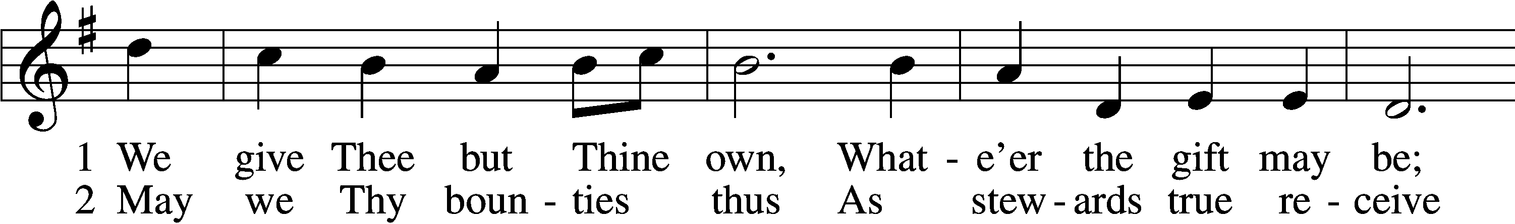

Text and tune: Public domain

*Kneel or Be Seated*

**PRAYER OF THE CHURCH** *[1 Timothy 2:1-4]*

**Non-Communion Service (11:00)**

**LORD'S PRAYER** *Matthew 6:9-13*

**Our Father who art in heaven, hallowed be Thy name, Thy kingdom come, Thy will be done on earth as it is in heaven. Give us this day our daily bread; and forgive us our trespasses as we forgive those who trespass against us; and lead us not into temptation, but deliver us from evil. For Thine is the kingdom and the power and the glory forever and ever. Amen**.

*Please Stand*

**BENEDICAMUS and BENEDICTION**

P Let us bless the Lord. *[Psalm 103:1]*

C **Thanks be to God.**

P The Lord bless you and keep you. The Lord make His face shine on you and be gracious to you. The Lord look upon you with favor and (†) give you peace. *Numbers 6:24-26*

C **Amen.**

**CLOSING HYMN 633 vv. 5-8** **"At the Lamb’s High Feast We Sing"**

Text and tune: Public domain

*Be Seated*

**Service of the Sacrament (8:30)**

*The Sacrament, or Lord's Supper, is a special gift from God that brings us into personal communion with Jesus Christ. "In, with and under" the bread and wine we receive His body and blood for forgiveness and renewal. If you are a repentant sinner, come to the table expecting to receive God's wonderful gifts for you!*

*Communicants will take their own wine cups as they are passed. Those requiring non-alcoholic grape juice will take the cups with white grape juice from the middle of the tray.*

*Be Seated*

**OUR EXAMINATION**

P In preparation for Holy Communion, St. Paul tells us in 1 Corinthians 11:27-29, “Whoever, therefore, eats the bread or drinks the cup of the Lord in an unworthy manner will be guilty concerning the body and blood of the Lord. 28Let a person examine himself, then, and so eat of the bread and drink of the cup. 29For anyone who eats and drinks without discerning the body eats and drinks judgment on himself.” So that we may properly examine ourselves prior to receiving the Lord’s Supper, I ask you to reflect on these questions:

* Do you repent of all your sins of thought, word, and deed?
* Do you believe that Jesus Christ is your only Savior from all sin, Satan, and death?
* Do you believe that the Risen Christ is really present in the Sacrament and that in, with, and under the bread and wine you receive His true Body and Blood?

If you answer in faith "Yes!" to these questions, and are properly instructed, you are invited to come forward and partake of the Lord's Supper during Distribution. If you are unable to answer yes to any of these questions, you are invited to come forward, cross your arms as I approach you and receive a blessing. By your coming forward, "You proclaim the Lord's death until He comes."

*Please Stand*

**PREFACE**

P The Lord be with you. *2 Timothy 4:22*

**C And also with you.**

P Lift up your hearts. *[Colossians 3:1]*

**C We lift them to the Lord.**

P Let us give thanks to the Lord, our God. *[Psalm 136]*

**C It is right to give Him thanks and praise.**

P It is truly good, right, and salutary that we should at all times and in all places give thanks to You, O Lord, holy Father, almighty and everlasting God, for the countless blessings You so freely bestow on us and all creation. Above all, we give thanks for Your boundless love shown to us when You sent Your only-begotten Son, Jesus Christ, into our flesh and laid on Him our sin, giving Him into death that we might not die eternally. Because He is now risen from the dead and lives and reigns to all eternity, all who believe in Him will overcome sin and death and will rise again to new life. Therefore with angels and archangels and with all the company of heaven we laud and magnify Your glorious name, evermore praising You and singing:

**SANCTUS ~ *Holy, Holy, Holy*** *Isaiah 6:3; Matthew 21:9*

**PRAYER OF THANKSGIVING**

P Blessed are You, O Lord our God, king of all creation, for You have had mercy on us and given Your only-begotten Son that whoever believes in Him should not perish but have eternal life.

In Your righteous judgment You condemned the sin of Adam and Eve, who ate the forbidden fruit, and You justly barred them and all their children from the tree of life. Yet, in Your great mercy, You promised salvation by a second Adam, Your Son, Jesus Christ, our Lord, and made His cross a life-

giving tree for all who trust in Him.

We give You thanks for the redemption You have prepared for us through Jesus Christ. Grant us Your Holy Spirit that we may faithfully eat and drink of the fruits of His cross and receive the blessings of forgiveness, life, and salvation that come to us in His body and blood.

Hear us as we pray in His name and as He has taught us:

**LORD'S PRAYER** *Matthew 6:9-13*

**Our Father who art in heaven, hallowed be Thy name, Thy kingdom come, Thy will be done on earth as it is in heaven. Give us this day our daily bread; and forgive us our trespasses as we forgive those who trespass against us; and lead us not into temptation, but deliver us from evil. For Thine is the kingdom and the power and the glory forever and ever. Amen**.

**THE WORDS OF OUR LORD** *Matthew 26:26-28; Mark 14:22-24;*

*Luke 22:19-20; 1 Corinthians 11:23-25*

P Our Lord Jesus Christ, on the night when He was betrayed, took bread, and when He had given thanks, He broke it and gave it to the disciples and said: “Take, eat; this is My body, which is given for you. This do in remembrance of Me.” In the same way also He took the cup after supper, and when He had given thanks, He gave it to them, saying: "Drink of it, all of you; this is my blood of the new covenant, which is poured out for you for the remission of sins. This do as often as you drink it, in remembrance of Me."

**PAX DOMINI ~ *The Peace of the Lord*** *John 20:19*

PThe peace of the Lord be with you always.

C **And also with you.**

**AGNUS DEI ~ *Lamb of God*** *John 1:29*

*Be Seated*

**DISTRIBUTION HYMN**

**HYMN 642 "O Living Bread from Heaven"**

Text and tune: Public domain

*Please Stand*

**NUNC DIMITTIS ~ *Song of Simeon*** *Luke 2:29-32*

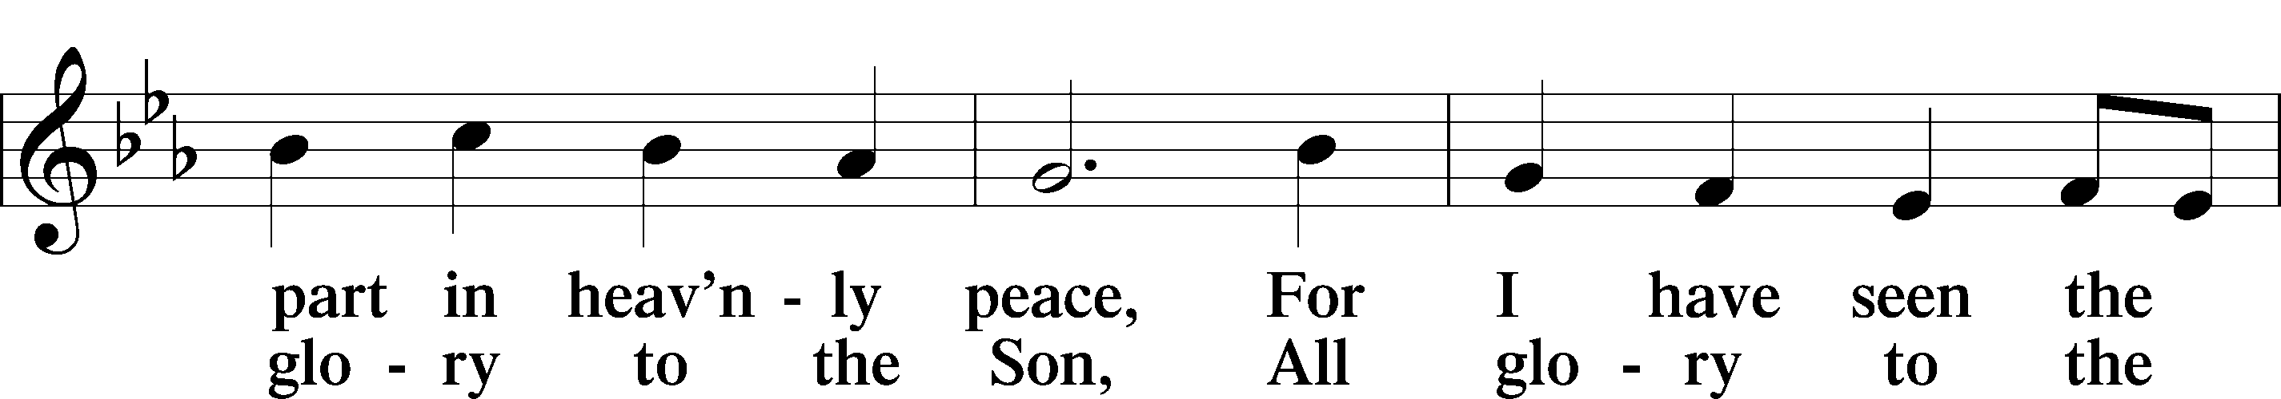

**POST-COMMUNION COLLECT**

P Let us pray.

We give thanks to You, almighty God, that You have refreshed us through this salutary gift, and we implore You that of Your mercy You would strengthen us through the same in faith toward You and in fervent love toward one another; through Jesus Christ, Your Son, our Lord, who lives and reigns with You and the Holy Spirit, one God, now and forever.

C **Amen.**

**BENEDICAMUS and BENEDICTION**

P Let us bless the Lord. *[Psalm 103:1]*

C **Thanks be to God.**

P The Lord bless you and keep you. The Lord make His face shine on you and be gracious to you. The Lord look upon you with favor and (†) give you peace. *Numbers 6:24-26*

C **Amen.**

**CLOSING HYMN 633 vv. 5-8** **"At the Lamb’s High Feast We Sing"**

Text and tune: Public domain

*Be Seated*

**ANNOUNCEMENTS and RECOGNITION OF OUR GUESTS**

**ORGAN**

**TO THE GLORY OF GOD**

The Altar flowers are given to the glory of God

by Doug & Shirley Masini in celebration of their anniversary.

***Oh give thanks to the Lord, for he is good, for his steadfast love endures forever!***

***Psalm 107:1***

**COFFEE & CONVERSATION**

Join us in the Social Hall after the 8:30 service for coffee and breakfast goodies.

**BIBLE STUDY OPPORTUNITIES**

**ADULT SUNDAY BIBLE STUDY**

Pastor Webb leads a Bible study in the Social Hall after the 8:30 service.

**CHURCH YEAR CONNECTIONS**

**(Ages 3 through High School)**

Join us for Sunday School classes for ages three through young adult. Teachers: Megan Haverland (3 years-1st Grade), Judy Bringman (2nd-5th Grade), Bob Hanovich (Middle School), and Karl Schumacher (High School).

**PARENTS & TWOS CLASS**

In this class for parents and two-year-olds, Karen Hanovich helps parents encourage their little ones as they learn about Jesus together.

**YOUNG ADULT SINGLES CLASS**

For ages 18-26, this class led by Kevin Riedl is studying “Lessons from the Underground Church.”

**21ST CENTURY PARENTING CLASS**

Parents of school-aged kids gain insight into the issues facing Gen Z and learn how to engage them in meaningful conversations. Eric and Megan Thompson lead this class in the Education Building.

**YOUNG AT HEART CLASS**

Mature members study how we can demonstrate love and compassion to people in need. Bob Reynolds and Mark Waltz lead this class on the ground floor of the Education Building.

**WEDNESDAY MORNING BIBLE STUDY**

Join us at 10:00 a.m. on Wednesday mornings in the Education Building to study the Word.

**WOMEN’S BIBLE STUDY**

The Women’s Bible Study will return on Monday, September 9 with a study on Parables. It meets on Mondays at 10:00am in the Education Building.

**HAPPENING AT TRINITY**

**THANK YOU**

Thank you to Barbara Lunick for playing the organ for us.

**OFFERINGS**

Please remain faithful in bringing your offerings to the Lord by mail or online if you are unable to attend worship in person.

**LUTHERAN WOMEN'S MISSIONARY LEAGUE MITES**

LWML miteswill be collected today. Please empty your small mite boxes into the congregational mite box or just drop in change from your pocket. District and international mission projects need your prayers and mites. Thanks for your support!

**Mite Dedication:** Dear Lord, we are blessed to be called Your children. Thank you for supplying our every need. Thank you for sending Your Son to be our Savior. Help us to share Your truth and Your love with our friends and neighbors. Help us to be a blessing to others. May our mite offerings be used to bring Christ to the nations and to help those in need, especially those in need of Your saving grace. To You be the glory! In Jesus’ name we pray. Amen.

**"CAN DO SUNDAY"**

Next Sunday is "Can-Do Sunday" when you can donate basic food items to help provide meals for those in need who visit our Food Pantry. We especially need **pop tab cans** for the homeless. Hopefully we can all remember to buy a "Second Can for the Second Sunday" of the month. Thanks from the Board of Social Ministry.

**EVERY ONE HIS WITNESS, LUTHERAN EVANGELISM**

**Saturday, August 17 at 9:00-12:00**

Join us for a Witness Workshop on Saturday, 17 August 2024, from 9 am until noon, followed by lunch at Trinity Lutheran Church in the Education Building. We will be working on Sessions 4-6. The videos for all sessions are available for viewing on the Friends of Trinity Facebook page under Media, Albums, Every One His Witness. Workbooks will be provided to witness workshop participants. Bob Hanovich is the point of contact for more information.

**CHURCH WORKDAY**

**Saturday, August 17 at 9:00-12:00**

Please join us for church Workday on Saturday, 17 August 2024, from 9 am until noon, followed by lunch. We will be gardening, replacing ceiling tiles, and taking care of other facility maintenance requirements. Ed Rogers is the point of contact for additional information.

**FUN – FRIENDS – FELLOWSHIP**

**Saturday, August 24 at 10:00-1:00**

Fun with Buttons, lots of laughter as we fellowship together. Select your message and create a memory. $10 includes supplies and a light lunch. Registration sheet and messages to select from in the Narthex. See craft gals, Betty Morrell or Lonna McEwen for more info.

**TLC HOMECOMING**

**Saturday, September 7 at 1:00-5:00**

We are having a Church Homecoming on Saturday, September 7. Let’s get together for fellowship, fun, and food. The festivities will start at 1 pm with lunch, hamburgers, beef hot dogs, and bratwurst and many side dishes and refreshments. There will be activities throughout the church campus. There will be games for adults and children, and many of the children’s games will have prizes. Bingo, Bubbles, Cup Cake Walk, Cornhole, Bouncers, and Rubber Ducks! The Georgia-Tennessee Tech game will be available for viewing. We will have a TLC Memory Board covered with photos from previous TLC events. Rides to and from church will be available. Your personal invitation to fellowship, fun, and food will be arriving soon. Bob Hanovich is the point of contact for additional information. Let’s GO!

**CARE TEAM SUPPORT**

We have missed seeing some of our beloved members in our Worship Services. It was then pointed out to us that we have neglected to reach out to our members who have not been with us for Worship. Therefore, we have formed a Shepherding CARE Team, and we want to reach out to our missing Brothers and Sisters in Christ. To accomplish this task, we ask you to prayerfully consider helping in one of the Support Teams listed at the end of this article. Help us reach our fellow congregates to share our love and concern for them and welcome their return to us so we can experience fellowship and the gifts the Lord has given to each of us. Points of contact for additional information are shown next to the CARE Team Support Role.

CARE Team Support Roles

Card Writer/ Sender – Linda Tomko

Gift Basket Maker – Lonna McEwen

Prayer Support – Linda Tomko and Rosemary Gerdes

Welcomer – Bob Hanovich

**CONNECT WITH US**

Connect with TLC and keep up with what’s going on.

\***Website** - [www.trinitylutheransavannah.com](http://www.trinitylutheransavannah.com)  
\***Facebook** - Friends of Trinity Lutheran Church; Trinity Lutheran Church – Community Info & Events (shareable page); Trinity Lutheran Church of Savannah Media; TLC Hearts of Compassion Helping Hands Ministry; Lizzie Comfort Dog  
\***Instagram** - #lcck9lizzie (Lizzie Comfort Dog)

\***YouTube** – Trinity Lutheran Savannah

**TODAY'S WORSHIP SERVICES**

Traditional 8:30 a.m. and 11:00 a.m.

**IN RESPONSE TO THE GOSPEL LAST SUNDAY**

8:30 a.m. – 75 11:00 a.m. – 63 Facebook – 103 YouTube – 2

Giving $3,519.76

Backpack Ministry 20.00

Food Pantry 35.00

Pastor's Discretionary Fund 25.00

Roof Repair 10,000.00

Seminary Student Willoughby 75.00

The Living Vine 75.00

**SERVING IN THE LORD'S HOUSE TODAY**

**8:30 a.m. 11:00 a.m.**

Rosemary Gerdes, Reader

Bob & Cindy Reynolds, Greeters Rosemary Gerdes & Barbara Prieto, Greeters

Larry Futch & Karl Schumacher, Ushers John Anander, Usher

**SERVING NEXT SUNDAY**

**8:30 a.m. 11:00 a.m.**

Linda Tomko, Reader

Sharon Johnson & Linda Tomko, Greeters Shirley Lewis, Greeter

Gary & Patricia Bradshaw, Ushers Mark & Ann Waltz, Ushers

**THIS WEEK AT A GLANCE**

TODAY Traditional Worship Services 8:30 & 11:00 a.m.

Sunday School 9:45 a.m.

MS Youth Group 11:00 a.m.-1:00 p.m.

Mite Sunday

MONDAY 8/5 Board of Elders 6:30 p.m.

TUESDAY 8/6 Clothes Closet 4:00-6:00 p.m.

WEDNESDAY 8/7 Bible Study (Education Building) 10:00 a.m.

THURSDAY 8/8 Clothes Closet 10:00 a.m.-1:00 p.m.

Crafters (Education Building) 10:00 a.m.-2:00 p.m.

NAMI (Social Hall) 6:00-7:00 p.m.

Church Council (Education Building) 6:30 p.m.

FRIDAY 8/9 Meals for Homeless (Education Building Kitchen) 4:00 p.m.

SATURDAY 8/10 Witness Workshop (Education Building) 9:00 a.m.-12:00 p.m.

Neighborhood Prayer Walk 10:00 a.m.

Young Adult Singles Zoom 7:30 p.m.

**REMEMBER IN PRAYER**

*(Please help us keep the prayer list updated)*

HEALTH

Pastor Hopkins

CANCER

Jim Eckes; Wendy Holland; Harold LaMarr; Samuel Martin (19)

SPECIAL REQUEST

Family of 10-month-old Lainey Grace

PEACE

Israel, Ukraine, & all who suffer from war and violence

OUR WITNESS

Let us proclaim Jesus Christ is risen to all!

**TRINITY LUTHERAN CHURCH**

12391 Mercy Blvd

Savannah, GA 31419

phone 912-925-4839 [trinityoffice@bellsouth.net](mailto:trinityoffice@bellsouth.net)

fax 912-925-4056 www.trinitylutheransavannah.com

Contact Pastor: 717-333-6263; pastorjeffwebb@yahoo.com

**STAFF**

Jeff Webb, Pastor

Traci Schumacher, Administrative Assistant

Helen Williams, Church Custodian

**BOARD OF ELDERS**

Mark Waltz, Head Elder (C – E)

Mike Fajen (K – Mc)

Todd Freesemann (F – J)

Sonny Massey (A – B)

Bob Reynolds (Me – Sa)

Tom Wayman (Sc – Z)

**CHURCH COUNCIL**

Kip Wiltse, President

Eric Thompson, Vice President

Cathy Crotwell, Secretary

Karl Schumacher, Treasurer

Megan Haverland, Board of Education

Mark Waltz, Board of Elders

Chris Garretson, Board of Evangelism

Charles Rogers, Board of Property Management

Jennifer Wolfe, Board of Social Ministry

Lonna McEwen, Board of Stewardship

Cindy Reynolds, Financial Secretary

Bob Hanovich, Board of Youth

**ORGANIZATIONAL LEADERS**

Cindy Baldwin, Comfort Dog Top Dog

Jackie Deemer, Director of TLC Singers & LWML President

Megan Thompson, Sunday School Superintendent

Rosemary Gerdes, Quilters

Karen Hanovich, TLC Marketing

Lonna McEwen, Altar Guild

Rose Pitt, Prayer Team