Trinity Lutheran Church

**The Lutheran Church-Missouri Synod**

**Trinity Lutheran Church**

**Trinity Lutheran Church**

**12391 Mercy Blvd. · Savannah, GA 31419 · (912) 925-4839**

**www.trinitylutheransavannah.com**

8:30 & 11:00 a.m. Divine Service

**Trinity Lutheran Church**

**The Sixteenth Sunday after Pentecost**

**September 8, 2024 8:30 Non-Communion and 11:00 a.m. Communion Service**

**WELCOME TO TRINITY!**

Thank you for worshipingwith us today. We want to know who you are, so please provide your contact information in the Friendship Book as it is passed during the Offertory. If you are visiting, honor us by signing the Guest Register in the Narthex.

There are times in our worship service where we stand or kneel. Feel free to participate in either as you are able or feel comfortable to remain seated.

Gluten-free wafers are available upon request during communion services. Please speak to the pastor before service if you wish to receive the host in this form.

Please ask an usher should you require a hearing assistance device.

(†) ~ Those who wish may make the sign of the Cross in remembrance of their Baptism.

**RECEPTION OF HOLY COMMUNION**

If you are not a member of Trinity Lutheran Church, we ask that you speak with the pastor prior to the service before receiving the Lord’s Supper.

**REQUESTS FOR PRAYER**

If you have a prayer request, please fill out a Blue Card from the pew rack and place it in the offering plate. Prayer requests may also be emailed to [trinityoffice@bellsouth.net](mailto:trinityoffice@bellsouth.net) or to pastorjeffwebb@yahoo.com.

**FOR PARENTS WITH YOUNG CHILDREN**

We are delighted that you have brought your child to worship! We invite you to use the Cry Room as a courtesy to others if your little one gets a little rambunctious. Our Cry Room, complete with seating and children's activities, is located at the back of the Sanctuary. The service can be heard through the sound system. We hope your children feel glad they were here and that they are a part of the Trinity family!

***Our Vision:***

***Growing in God’s Word to Share Christ’s Love***

***Our Mission:***

***Led by God, equipped as disciples through Word and Sacrament,***

***we are empowered by the Holy Spirit to reach out with the Gospel of Jesus Christ to all.***



**AS WE GATHER TODAY**

Since the fall and expulsion from Eden, the ramifications of sin have been quite evident. People do not have to be worse sinners than anyone else to become blind, deaf, lame, or mute. They need not sin more than other people to find themselves unfairly treated in court. How can those problems be reversed? It takes God’s power. The Gospel tells of how Jesus cast out demons and healed the deaf. He seeks to make such great reversals today! Through the letter to James, we, God’s faith-filled people, are encouraged to treat our neighbors as ourselves and do more than give them lip service. But the inability of the disciples to exorcize a demon is a startling reminder that all things are possible only for God, to whom we must entrust all our problems.

**Divine Service**

***Setting Four***

**ORGAN**

**WELCOME**

**CHIMING OF THE HOUR**

**Confession and Absolution**

*Please Stand*

**PROCESSIONAL HYMN 797 vv. 1, 3, 5 "Praise the Almighty"**

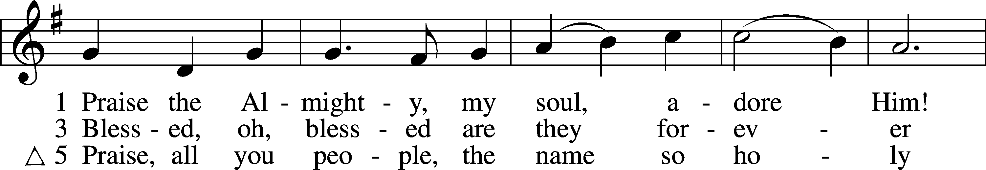

Text and tune: Public domain

**INVOCATION**

P In the name of the Father and of the (†) Son and of the Holy Spirit.

C **Amen.** *Matthew 28:19b*

P Our help is in the name of the Lord,

C **who made heaven and earth.** *Psalm 124:8*

P Since we are gathered to hear God’s Word, call upon Him in prayer and praise, and receive the body and blood of our Lord Jesus Christ in the fellowship of this altar, let us first consider our unworthiness and confess before God and one another that we have sinned in thought, word, and deed, and that we cannot free ourselves from our sinful condition. Together as His people let us take refuge in the infinite mercy of God, our heavenly Father, seeking His grace for the sake of Christ, and saying: God, be merciful to me, a sinner. *[Luke 18:13]*

C **Almighty God, have mercy upon us, forgive us our sins, and lead us to everlasting life. Amen.**

P Almighty God in His mercy has given His Son to die for you and for His sake forgives you all your sins. As a called and ordained servant of Christ, and by His authority, I therefore forgive you all your sins in the name of the Father and of the (†) Son and of the Holy Spirit.

C **Amen.** *[John 20:19-23]*

**Service of the Word**

**KYRIE ~ *Lord, Have Mercy*** *Mark 10:47*

**GLORIA IN EXCELSIS ~ *Glory to God in the Highest*** *Luke 2:14; John 1:29*

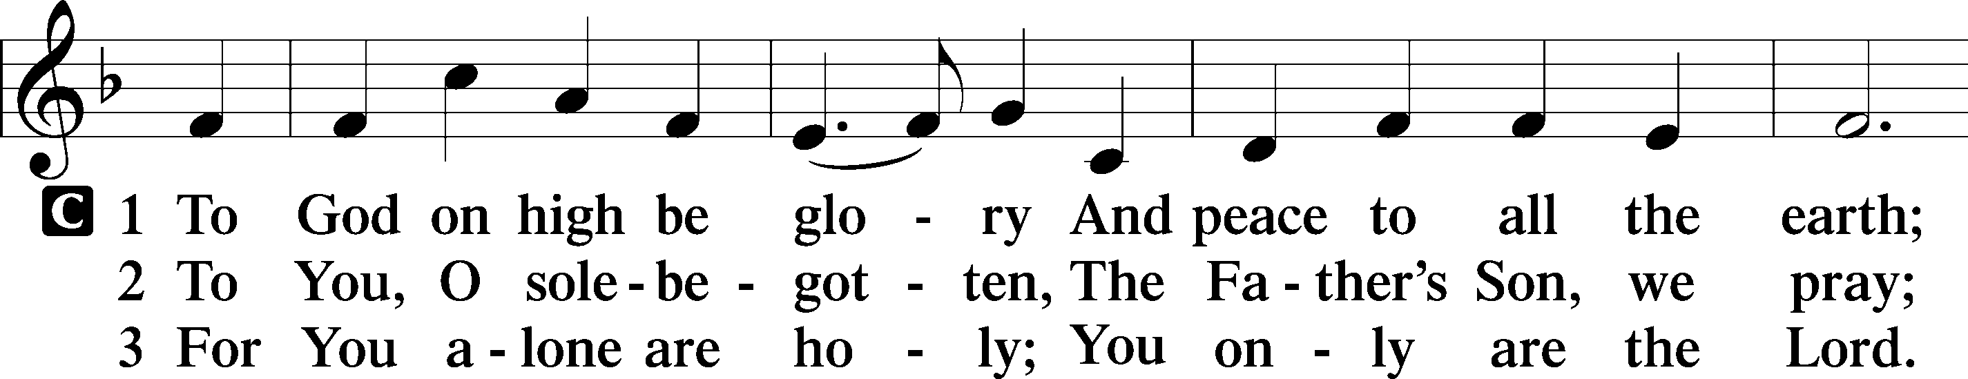

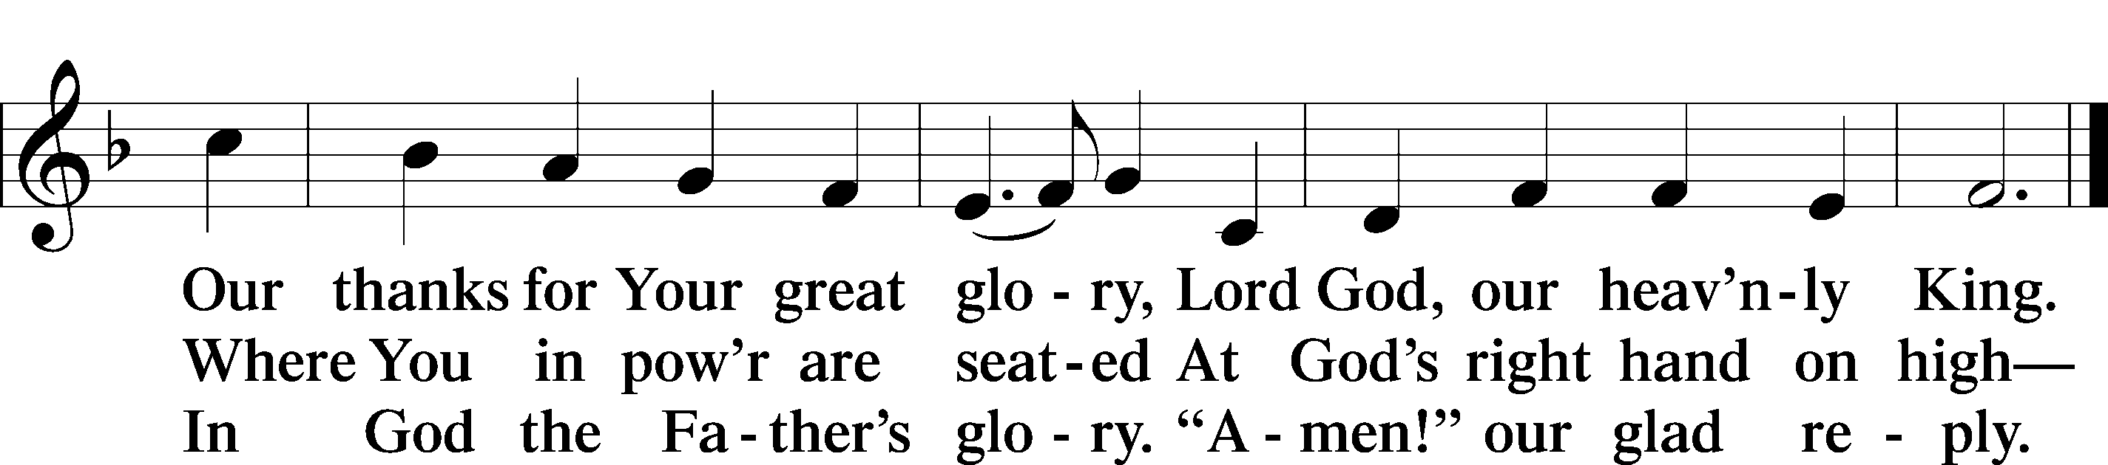

**SALUTATION and COLLECT OF THE DAY**

P The Lord be with you. *2 Timothy 4:22*

C **And also with you.**

P Let us pray.

O Lord, let Your merciful ears be open to the prayers of Your humble servants and grant that what they ask may be in accord with Your gracious will; through Jesus Christ, Your Son, our Lord, who lives and reigns with You and the Holy Spirit, one God, now and forever.

C **Amen.**

*Be Seated*

**OLD TESTAMENT LESSON *Isaiah 35:4–7a***

4Say to those who have an anxious heart,  
 “Be strong; fear not!  
Behold, your God  
 will come with vengeance,  
with the recompense of God.  
 He will come and save you.”  
5Then the eyes of the blind shall be opened,  
 and the ears of the deaf unstopped;  
6then shall the lame man leap like a deer,  
 and the tongue of the mute sing for joy.  
For waters break forth in the wilderness,  
 and streams in the desert;  
7the burning sand shall become a pool,  
 and the thirsty ground springs of water.

A This is the Word of the Lord.

C **Thanks be to God.**

**CHOIR ANTHEM**

***After the choir sings the first verse, you are invited to join in singing the Chorus.***

**EPISTLE LESSON*****James 2:1–10, 14–18***

1My brothers, show no partiality as you hold the faith in our Lord Jesus Christ, the Lord of glory. 2For if a man wearing a gold ring and fine clothing comes into your assembly, and a poor man in shabby clothing also comes in, 3and if you pay attention to the one who wears the fine clothing and say, “You sit here in a good place,” while you say to the poor man, “You stand over there,” or, “Sit down at my feet,” 4have you not then made distinctions among yourselves and become judges with evil thoughts? 5Listen, my beloved brothers, has not God chosen those who are poor in the world to be rich in faith and heirs of the kingdom, which he has promised to those who love him? 6But you have dishonored the poor man. Are not the rich the ones who oppress you, and the ones who drag you into court? 7Are they not the ones who blaspheme the honorable name by which you were called?

8If you really fulfill the royal law according to the Scripture, “You shall love your neighbor as yourself,” you are doing well. 9But if you show partiality, you are committing sin and are convicted by the law as transgressors. 10For whoever keeps the whole law but fails in one point has become accountable for all of it. . . .

14What good is it, my brothers, if someone says he has faith but does not have works? Can that faith save him? 15If a brother or sister is poorly clothed and lacking in daily food, 16and one of you says to them, “Go in peace, be warmed and filled,” without giving them the things needed for the body, what good is that? 17So also faith by itself, if it does not have works, is dead.

18But someone will say, “You have faith and I have works.” Show me your faith apart from your works, and I will show you my faith by my works.

A This is the Word of the Lord.

C **Thanks be to God.**

*Please Stand*

**ALLELUIA and VERSE** *John 20:31*

**HOLY GOSPEL *Mark 7:24–37***

P The Holy Gospel according to St. Mark, the seventh chapter.

**C Glory to You, O Lord.**

24From there [Jesus] arose and went away to the region of Tyre and Sidon. And he entered a house and did not want anyone to know, yet he could not be hidden. 25But immediately a woman whose little daughter was possessed by an unclean spirit heard of him and came and fell down at his feet. 26Now the woman was a Gentile, a Syrophoenician by birth. And she begged him to cast the demon out of her daughter. 27And he said to her, “Let the children be fed first, for it is not right to take the children’s bread and throw it to the dogs.” 28But she answered him, “Yes, Lord; yet even the dogs under the table eat the children’s crumbs.” 29And he said to her, “For this statement you may go your way; the demon has left your daughter.” 30And she went home and found the child lying in bed and the demon gone.

31Then he returned from the region of Tyre and went through Sidon to the Sea of Galilee, in the region of the Decapolis. 32And they brought to him a man who was deaf and had a speech impediment, and they begged him to lay his hand on him. 33And taking him aside from the crowd privately, he put his fingers into his ears, and after spitting touched his tongue. 34And looking up to heaven, he sighed and said to him, “Ephphatha,” that is, “Be opened.” 35And his ears were opened, his tongue was released, and he spoke plainly. 36And Jesus charged them to tell no one. But the more he charged them, the more zealously they proclaimed it. 37And they were astonished beyond measure, saying, “He has done all things well. He even makes the deaf hear and the mute speak.”

P This is the Gospel of the Lord.

**C Praise to You, O Christ.**

**NICENE CREED**

**I believe in one God, the Father Almighty, maker of heaven and earth and of all things visible and invisible.**

**And in one Lord Jesus Christ, the only-begotten Son of God, begotten of His Father before all worlds, God of God, Light of Light, very God of very God, begotten, not made, being of one substance with the Father, by whom all things were made; who for us men and for our salvation came down from heaven and was incarnate by the Holy Spirit of the virgin Mary and was made man; and was crucified also for us under Pontius Pilate. He suffered and was buried. And the third day He rose again according to the Scriptures and ascended into heaven and sits at the right hand of the Father. And He will come again with glory to judge both the living and the dead, whose kingdom will have no end.**

**And I believe in the Holy Spirit, the Lord and Giver of life, who proceeds from the Father and the Son, who with the Father and the Son together is worshiped and glorified, who spoke by the prophets. And I believe in one holy Christian and apostolic Church, I acknowledge one Baptism for the remission of sins, and I look for the resurrection of the dead and the life of the world to come. Amen.**

*Be Seated*

**CHILDREN'S MESSAGE “Heavenly Homecoming” *8:30 Service***

**Song:** Heaven is a beautiful place; Heaven is a beautiful place; Filled with Glory and Grace; I’m going to see my Savior’s face; ‘cause Heaven is a beautiful place!

**HYMN OF THE DAY 749 "There Is a Balm in Gilead"**

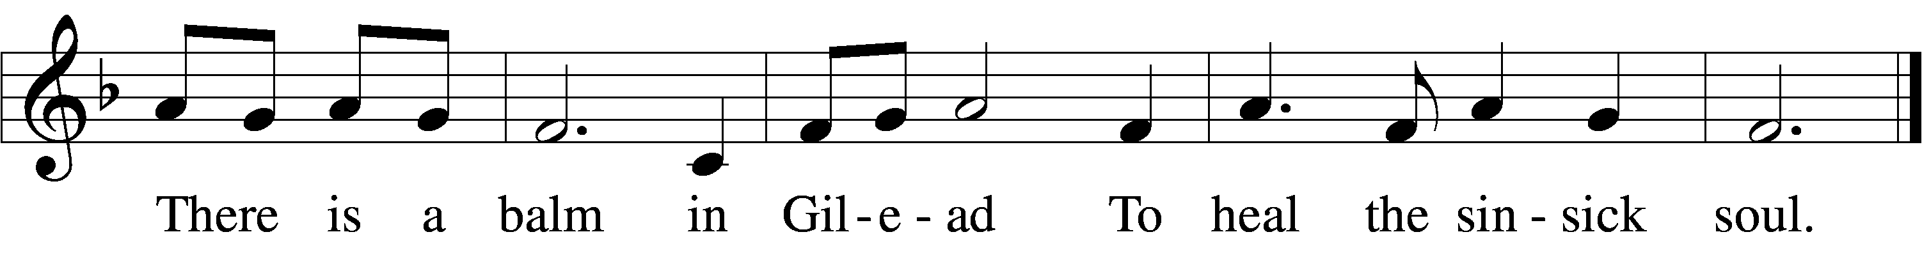

Text and tune: Public domain

**SERMON "Keeping Yourselves from Idols" *1 John 5:19-21***

We know that we are from God, and the whole world lies in the power of the evil one.

And we know that the Son of God has come and has given us understanding, so that we may know him who is true; and we are in him who is true, in his Son Jesus Christ. He is the true God and eternal life. Little children, keep yourselves from idols.

**OFFERING** *(Please fill out and pass the red Friendship Book at this time; and fill out the blue card in the pew rack for prayers.)*

*Please Stand*

**OFFERTORY 781 vv. 1, 2 “We Give Thee but Thine Own”**

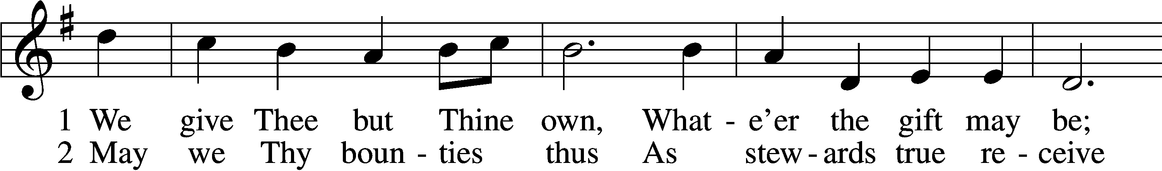

Text and tune: Public domain

*Kneel or Be Seated*

**PRAYER OF THE CHURCH** *[1 Timothy 2:1-4]*

**Non-Communion Service (8:30)**

**LORD'S PRAYER** *Matthew 6:9-13*

**Our Father who art in heaven, hallowed be Thy name, Thy kingdom come, Thy will be done on earth as it is in heaven. Give us this day our daily bread; and forgive us our trespasses as we forgive those who trespass against us; and lead us not into temptation, but deliver us from evil. For Thine is the kingdom and the power and the glory forever and ever. Amen**.

*Please Stand*

**BENEDICAMUS and BENEDICTION**

P Let us bless the Lord. *[Psalm 103:1]*

C **Thanks be to God.**

P The Lord bless you and keep you. The Lord make His face shine on you and be gracious to you. The Lord look upon you with favor and (†) give you peace. *Numbers 6:24-26*

C **Amen.**

**CLOSING HYMN 528 vv. 1-3, 5, 7** **"Oh, for a Thousand Tongues to Sing"**

Text and tune: Public domain

*Be Seated*

**Service of the Sacrament (11:00)**

*The Sacrament, or Lord's Supper, is a special gift from God that brings us into personal communion with Jesus Christ. "In, with and under" the bread and wine we receive His body and blood for forgiveness and renewal. If you are a repentant sinner, come to the table expecting to receive God's wonderful gifts for you!*

*Communicants will take their own wine cups as they are passed. Those requiring non-alcoholic grape juice will take the cups with white grape juice from the middle of the tray.*

*Be Seated*

**OUR EXAMINATION**

P In preparation for Holy Communion, St. Paul tells us in 1 Corinthians 11:27-29, “Whoever, therefore, eats the bread or drinks the cup of the Lord in an unworthy manner will be guilty concerning the body and blood of the Lord. 28Let a person examine himself, then, and so eat of the bread and drink of the cup. 29For anyone who eats and drinks without discerning the body eats and drinks judgment on himself.” So that we may properly examine ourselves prior to receiving the Lord’s Supper, I ask you to reflect on these questions:

* Do you repent of all your sins of thought, word, and deed?
* Do you believe that Jesus Christ is your only Savior from all sin, Satan, and death?
* Do you believe that the Risen Christ is really present in the Sacrament and that in, with, and under the bread and wine you receive His true Body and Blood?

If you answer in faith "Yes!" to these questions, and are properly instructed, you are invited to come forward and partake of the Lord's Supper during Distribution. If you are unable to answer yes to any of these questions, you are invited to come forward, cross your arms as I approach you and receive a blessing. By your coming forward, "You proclaim the Lord's death until He comes."

*Please Stand*

**PREFACE**

P The Lord be with you. *2 Timothy 4:22*

**C And also with you.**

P Lift up your hearts. *[Colossians 3:1]*

**C We lift them to the Lord.**

P Let us give thanks to the Lord, our God. *[Psalm 136]*

**C It is right to give Him thanks and praise.**

P It is truly good, right, and salutary that we should at all times and in all places give thanks to You, O Lord, holy Father, almighty and everlasting God, for the countless blessings You so freely bestow on us and all creation. Above all, we give thanks for Your boundless love shown to us when You sent Your only-begotten Son, Jesus Christ, into our flesh and laid on Him our sin, giving Him into death that we might not die eternally. Because He is now risen from the dead and lives and reigns to all eternity, all who believe in Him will overcome sin and death and will rise again to new life. Therefore with angels and archangels and with all the company of heaven we laud and magnify Your glorious name, evermore praising You and singing:

**SANCTUS ~ *Holy, Holy, Holy*** *Isaiah 6:3; Matthew 21:9*

**PRAYER OF THANKSGIVING**

P Blessed are You, O Lord our God, king of all creation, for You have had mercy on us and given Your only-begotten Son that whoever believes in Him should not perish but have eternal life.

In Your righteous judgment You condemned the sin of Adam and Eve, who ate the forbidden fruit, and You justly barred them and all their children from the tree of life. Yet, in Your great mercy, You promised salvation by a second Adam, Your Son, Jesus Christ, our Lord, and made His cross a life-

giving tree for all who trust in Him.

We give You thanks for the redemption You have prepared for us through Jesus Christ. Grant us Your Holy Spirit that we may faithfully eat and drink of the fruits of His cross and receive the blessings of forgiveness, life, and salvation that come to us in His body and blood.

Hear us as we pray in His name and as He has taught us:

**LORD'S PRAYER** *Matthew 6:9-13*

**Our Father who art in heaven, hallowed be Thy name, Thy kingdom come, Thy will be done on earth as it is in heaven. Give us this day our daily bread; and forgive us our trespasses as we forgive those who trespass against us; and lead us not into temptation, but deliver us from evil. For Thine is the kingdom and the power and the glory forever and ever. Amen**.

**THE WORDS OF OUR LORD** *Matthew 26:26-28; Mark 14:22-24;*

*Luke 22:19-20; 1 Corinthians 11:23-25*

P Our Lord Jesus Christ, on the night when He was betrayed, took bread, and when He had given thanks, He broke it and gave it to the disciples and said: “Take, eat; this is My body, which is given for you. This do in remembrance of Me.” In the same way also He took the cup after supper, and when He had given thanks, He gave it to them, saying: "Drink of it, all of you; this is my blood of the new covenant, which is poured out for you for the remission of sins. This do as often as you drink it, in remembrance of Me."

**PAX DOMINI ~ *The Peace of the Lord*** *John 20:19*

PThe peace of the Lord be with you always.

C **And also with you.**

**AGNUS DEI ~ *Lamb of God*** *John 1:29*

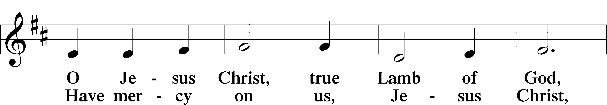

*Be Seated*

**DISTRIBUTION HYMN**

**HYMN 524 "How Sweet the Name of Jesus Sounds"**

5 How weak the effort of my heart,  
    How cold my warmest thought!  
But when I see Thee as Thou art,  
    I’ll praise Thee as I ought.

6 Till then I would Thy love proclaim  
    With ev’ry fleeting breath;  
And may the music of Thy name  
    Refresh my soul in death!

Text and tune: Public domain

*Please Stand*

**NUNC DIMITTIS ~ *Song of Simeon*** *Luke 2:29-32*

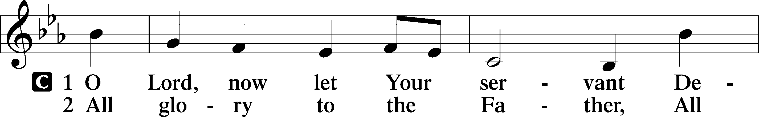

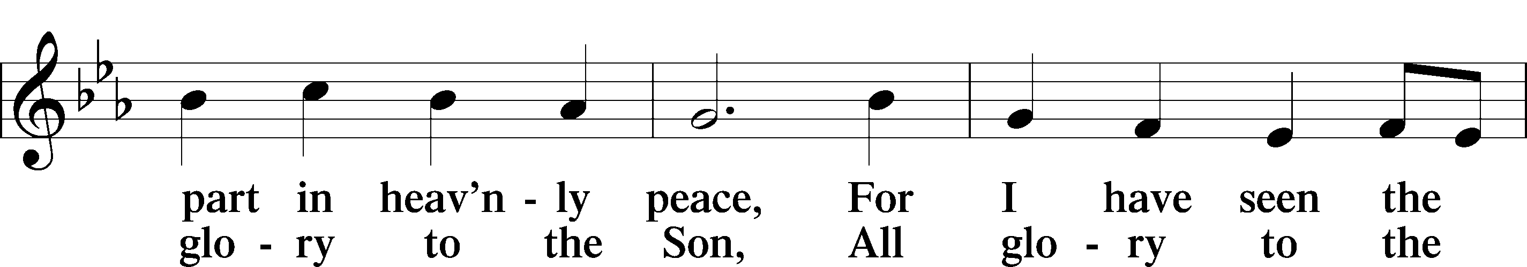

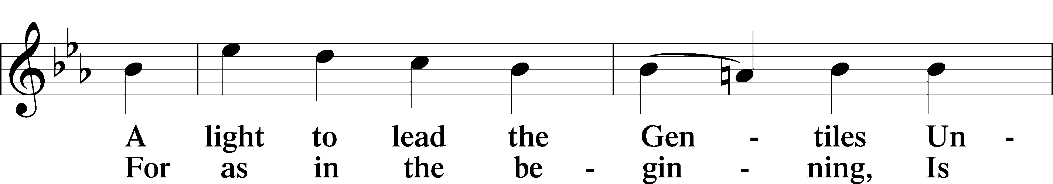

**POST-COMMUNION COLLECT**

P Let us pray.

Gracious God, our heavenly Father, You have given us a foretaste of the feast to come in the Holy Supper of Your Son's body and blood. Keep us firm in the true faith throughout our days of pilgrimage that, on the day of His coming, we may, together with all Your saints, celebrate the marriage feast of the Lamb in His kingdom which has no end; through Jesus Christ, Your Son, our Lord, who lives and reigns with You and the Holy Spirit, one God, now and forever.

C **Amen.**

**BENEDICAMUS and BENEDICTION**

P Let us bless the Lord. *[Psalm 103:1]*

C **Thanks be to God.**

P The Lord bless you and keep you. The Lord make His face shine on you and be gracious to you. The Lord look upon you with favor and (†) give you peace. *Numbers 6:24-26*

C **Amen.**

**CLOSING HYMN 528 vv. 1-3, 5, 7** **"Oh, for a Thousand Tongues to Sing"**

Text and tune: Public domain

*Be Seated*

**ANNOUNCEMENTS and RECOGNITION OF OUR GUESTS**

**ORGAN**

**TO THE GLORY OF GOD**

The Altar flowers are given to the glory of God

by Kip and Delane Wiltse in celebration of Kip’s birthday.

***For God gave us a spirit not of fear, but of power and love and self-control.***

***2 Timothy 1:7***

**COFFEE & CONVERSATION**

Join us in the Social Hall after the 8:30 service for coffee and breakfast goodies

provided by the Youth.

**BIBLE STUDY OPPORTUNITIES**

**ADULT SUNDAY BIBLE STUDY**

Pastor Webb leads a Bible study titled “Are You a Disciple or a Christian?” in the Social Hall after the 8:30 service.

**CHURCH YEAR CONNECTIONS**

**(Ages 3 through High School)**

Join us for Sunday School classes for ages three through young adult. Teachers: Megan Haverland (3 years-1st Grade), Judy Bringman (2nd-5th Grade), Bob Hanovich (Middle School), and Karl Schumacher (High School).

**PARENTS & TWOS CLASS**

In this class for parents and two-year-olds, Karen Hanovich helps parents encourage their little ones as they learn about Jesus together.

**YOUNG ADULT SINGLES CLASS**

For ages 18-26, this class led by Kevin Riedl is studying “Lessons from the Underground Church.”

**21ST CENTURY PARENTING CLASS**

Parents of school-aged kids gain insight into the issues facing Gen Z and learn how to engage them in meaningful conversations. Eric and Megan Thompson lead this class in the Education Building.

**YOUNG AT HEART CLASS**

Mature members study how we can demonstrate love and compassion to people in need. Bob Reynolds and Mark Waltz lead this class on the ground floor of the Education Building.

**WEDNESDAY MORNING BIBLE STUDY**

Join us at 10:00 a.m. on Wednesday mornings in the Education Building to study the Word.

**WOMEN’S BIBLE STUDY**

The Women’s Bible Study returns tomorrow, Monday, September 9 with a study on Parables. It meets on Mondays at 10:00am in the Education Building. A Zoom link is also available. See Linda Tomko for more details.

**HAPPENING AT TRINITY**

**THANK YOU**

Thank you to Barbara Lunick for playing the organ for us.

**OFFERINGS**

Please remain faithful in bringing your offerings to the Lord by mail or online if you are unable to attend worship in person.

**TODAY IS "CAN DO SUNDAY"**

Please place your food items in the grocery cart in the Social Hall to help provide a meal for those in need who visit our Food Pantry. As always, thank you for your participation.

**WOMEN’S BIBLE STUDY RESUMES**

**Tomorrow at 10:00**

Women’s Bible Study resumes tomorrow, September 9, at 10:00 in the Education Building. Most of us like a good story, and Jesus was a master of telling stories called Parables. Come join us as we go through some of His Parables and their meanings. We also have Zoom for our study. Please contact Linda Tomko for more info on that.

**REGISTER TO VOTE**

**Deadline is October 7 in Chatham County**

In preparation for the November 5 election, be sure to register or verify your voter registration by the deadline. Check with your county Board of Elections for all deadlines and registration instructions, as well as Absentee and Early Voting information. Pray and vote and pray!

**LUTHERANS FOR LIFE REGIONAL CONFERENCE**

**Saturday, November 9 in Winter Garden, FL**

Lutherans For Life invites you to join fellow life-minded Lutherans celebrating life and equipping ourselves on life issues during the LFL Regional Conference Southeast at *Zion Evangelical Lutheran Church in Winter Garden, Florida, on Saturday, November 9, 2024*. This one-day in-person conference features four national life-affirming, Gospel-motivated speakers, as well as fellowship, lunch, and a service opportunity. Limited childcare is available. Come and learn how the Lord calls us to follow Him and be “Life in the Darkness.” Details and registration at <https://lutheransforlife.org/conferences/>

**LATE SERVICE READERS**

We are looking for more volunteers! You only have to read about every two to three months if we get enough help. Traci will put you on the list and rotate through. Please text or call Rosemary Gerdes at 912.644.0313. Thank you!

**CHECK THE CALENDAR**

Curious what’s going on? Planning an event? Check the Trinity calendar on our website anytime ([www.trinitylutheransavannah.com](http://www.trinitylutheransavannah.com)/connect/calendar.cfm). If you need to schedule an event, please contact Traci in the office ([trinityoffice@bellsouth.net](mailto:trinityoffice@bellsouth.net), 912-925-4839). Thanks!

**CONNECT WITH US**

Connect with TLC and keep up with what’s going on.

\***Website** - [www.trinitylutheransavannah.com](http://www.trinitylutheransavannah.com)  
\***Facebook** - Friends of Trinity Lutheran Church; Trinity Lutheran Church – Community Info & Events (shareable page); Trinity Lutheran Church of Savannah Media; TLC Hearts of Compassion Helping Hands Ministry; Lizzie Comfort Dog  
\***Instagram** - #lcck9lizzie (Lizzie Comfort Dog)

\***YouTube** – Trinity Lutheran Savannah

**DEADLINE for BULLETIN ANNOUNCEMENTS**

**Every Wednesday by 9:00am**

Email bulletin announcements to [trinityoffice@bellsouth.net](mailto:trinityoffice@bellsouth.net) prior to 9:00am on Wednesdays.

**TODAY'S WORSHIP SERVICES**

Traditional 8:30 a.m. and 11:00 a.m.

**IN RESPONSE TO THE GOSPEL LAST SUNDAY**

8:30 a.m. – 68 11:00 a.m. – 44 Facebook – 149 YouTube – 3

Giving $5,556.35

Building Repair – Roof 100.00

Comfort Dog 25.00

Food Pantry 35.00

NAMI 5.00

Old Savannah City Mission 10.00

Pastor's Discretionary Fund 100.00

Seminary Student Willoughby 75.00

Youth Ministry 71.00

**SERVING IN THE LORD'S HOUSE TODAY**

**8:30 a.m. 11:00 a.m.**

Mike Bennet, Reader

Sharon Johnson & Linda Tomko, Greeters Cindy Baldwin & Cathy Dotson, Greeters

Gary & Patricia Bradshaw, Ushers Mark & Ann Waltz, Ushers

**SERVING NEXT SUNDAY**

**8:30 a.m. 11:00 a.m.**

Mary Helen Anander, Reader

Betty Morrell, Greeter Vicky Lunick & Barbara Prieto, Greeters

Cathy Crotwell & JB Strange, Ushers Rosemary Gerdes & Gretchen Holmes, Ushers

**THIS WEEK AT A GLANCE**

TODAY Traditional Worship Services 8:30 & 11:00 a.m.

Sunday School 9:45 a.m.

Evangelism Meeting (Cry Room) 9:45-10:45 a.m.

Can Do Sunday

MONDAY 9/9 Women’s Bible Study (Education Building) 10:00 a.m.

Cub Scouts (Social Hall) 6:00-8:00 p.m.

Board of Elders 6:30 p.m.

TUESDAY 9/10 TLC Quilters (Education Building) 10:00 a.m.-1:00 p.m.

Clothes Closet 4:00-6:00 p.m.

Cub Scouts (Social Hall) 6:00-8:00 p.m.

WEDNESDAY 9/11 Bible Study (Education Building) 10:00 a.m.

THURSDAY 9/12 Clothes Closet 10:00 a.m.-1:00 p.m.

NAMI (Social Hall) 6:00-7:00 p.m.

Church Council (Education Building) 6:30 p.m.

FRIDAY 9/13 Meals for Homeless (Education Building Kitchen) 4:00 p.m.

LWML Convention (Orlando)

SATURDAY 9/14 Neighborhood Prayer Walk 10:00 a.m.

Ervin Baby Shower (Social Hall) 11:00 a.m.-3:00 p.m.

Young Adult Singles Zoom 7:30 p.m.

LWML Convention (Orlando)

**REMEMBER IN PRAYER**

*(Please help us keep the prayer list updated)*

CANCER

Jim Eckes; Wendy Holland; Harold LaMarr; Samuel Martin (19)

SPECIAL REQUEST

Family & friends of Pat Mascio

PEACE

Israel, Ukraine, & all who suffer from war and violence

OUR WITNESS

Let us proclaim Jesus Christ is risen to all!

OUR CONCERNS

Raise up those, Lord, who would serve Your Church.

**TRINITY LUTHERAN CHURCH**

12391 Mercy Blvd

Savannah, GA 31419

phone 912-925-4839 [trinityoffice@bellsouth.net](mailto:trinityoffice@bellsouth.net)

fax 912-925-4056 www.trinitylutheransavannah.com

Contact Pastor: 717-333-6263; pastorjeffwebb@yahoo.com

**STAFF**

Jeff Webb, Pastor

Traci Schumacher, Administrative Assistant

Helen Williams, Church Custodian

**BOARD OF ELDERS**

Mark Waltz, Head Elder (C – E)

Mike Fajen (K – Mc)

Todd Freesemann (F – J)

Sonny Massey (A – B)

Bob Reynolds (Me – Sa)

Tom Wayman (Sc – Z)

**CHURCH COUNCIL**

Kip Wiltse, President

Eric Thompson, Vice President

Cathy Crotwell, Secretary

Karl Schumacher, Treasurer

Megan Haverland, Board of Education

Mark Waltz, Board of Elders

Chris Garretson, Board of Evangelism

Charles Rogers, Board of Property Management

Jennifer Wolfe, Board of Social Ministry

Lonna McEwen, Board of Stewardship

Cindy Reynolds, Financial Secretary

Bob Hanovich, Board of Youth

**ORGANIZATIONAL LEADERS**

Cindy Baldwin, Comfort Dog Top Dog

Jackie Deemer, Director of TLC Singers & LWML President

Megan Thompson, Sunday School Superintendent

Rosemary Gerdes, Quilters

Karen Hanovich, TLC Marketing

Lonna McEwen, Altar Guild

Rose Pitt, Prayer Team