Trinity Lutheran Church

**The Lutheran Church-Missouri Synod**

**Trinity Lutheran Church**

**Trinity Lutheran Church**

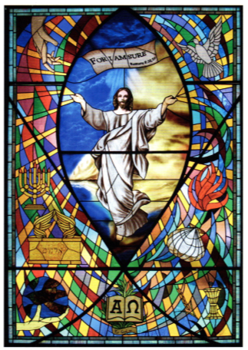

**12391 Mercy Blvd. · Savannah, GA 31419 · (912) 925-4839**

**www.trinitylutheransavannah.com**

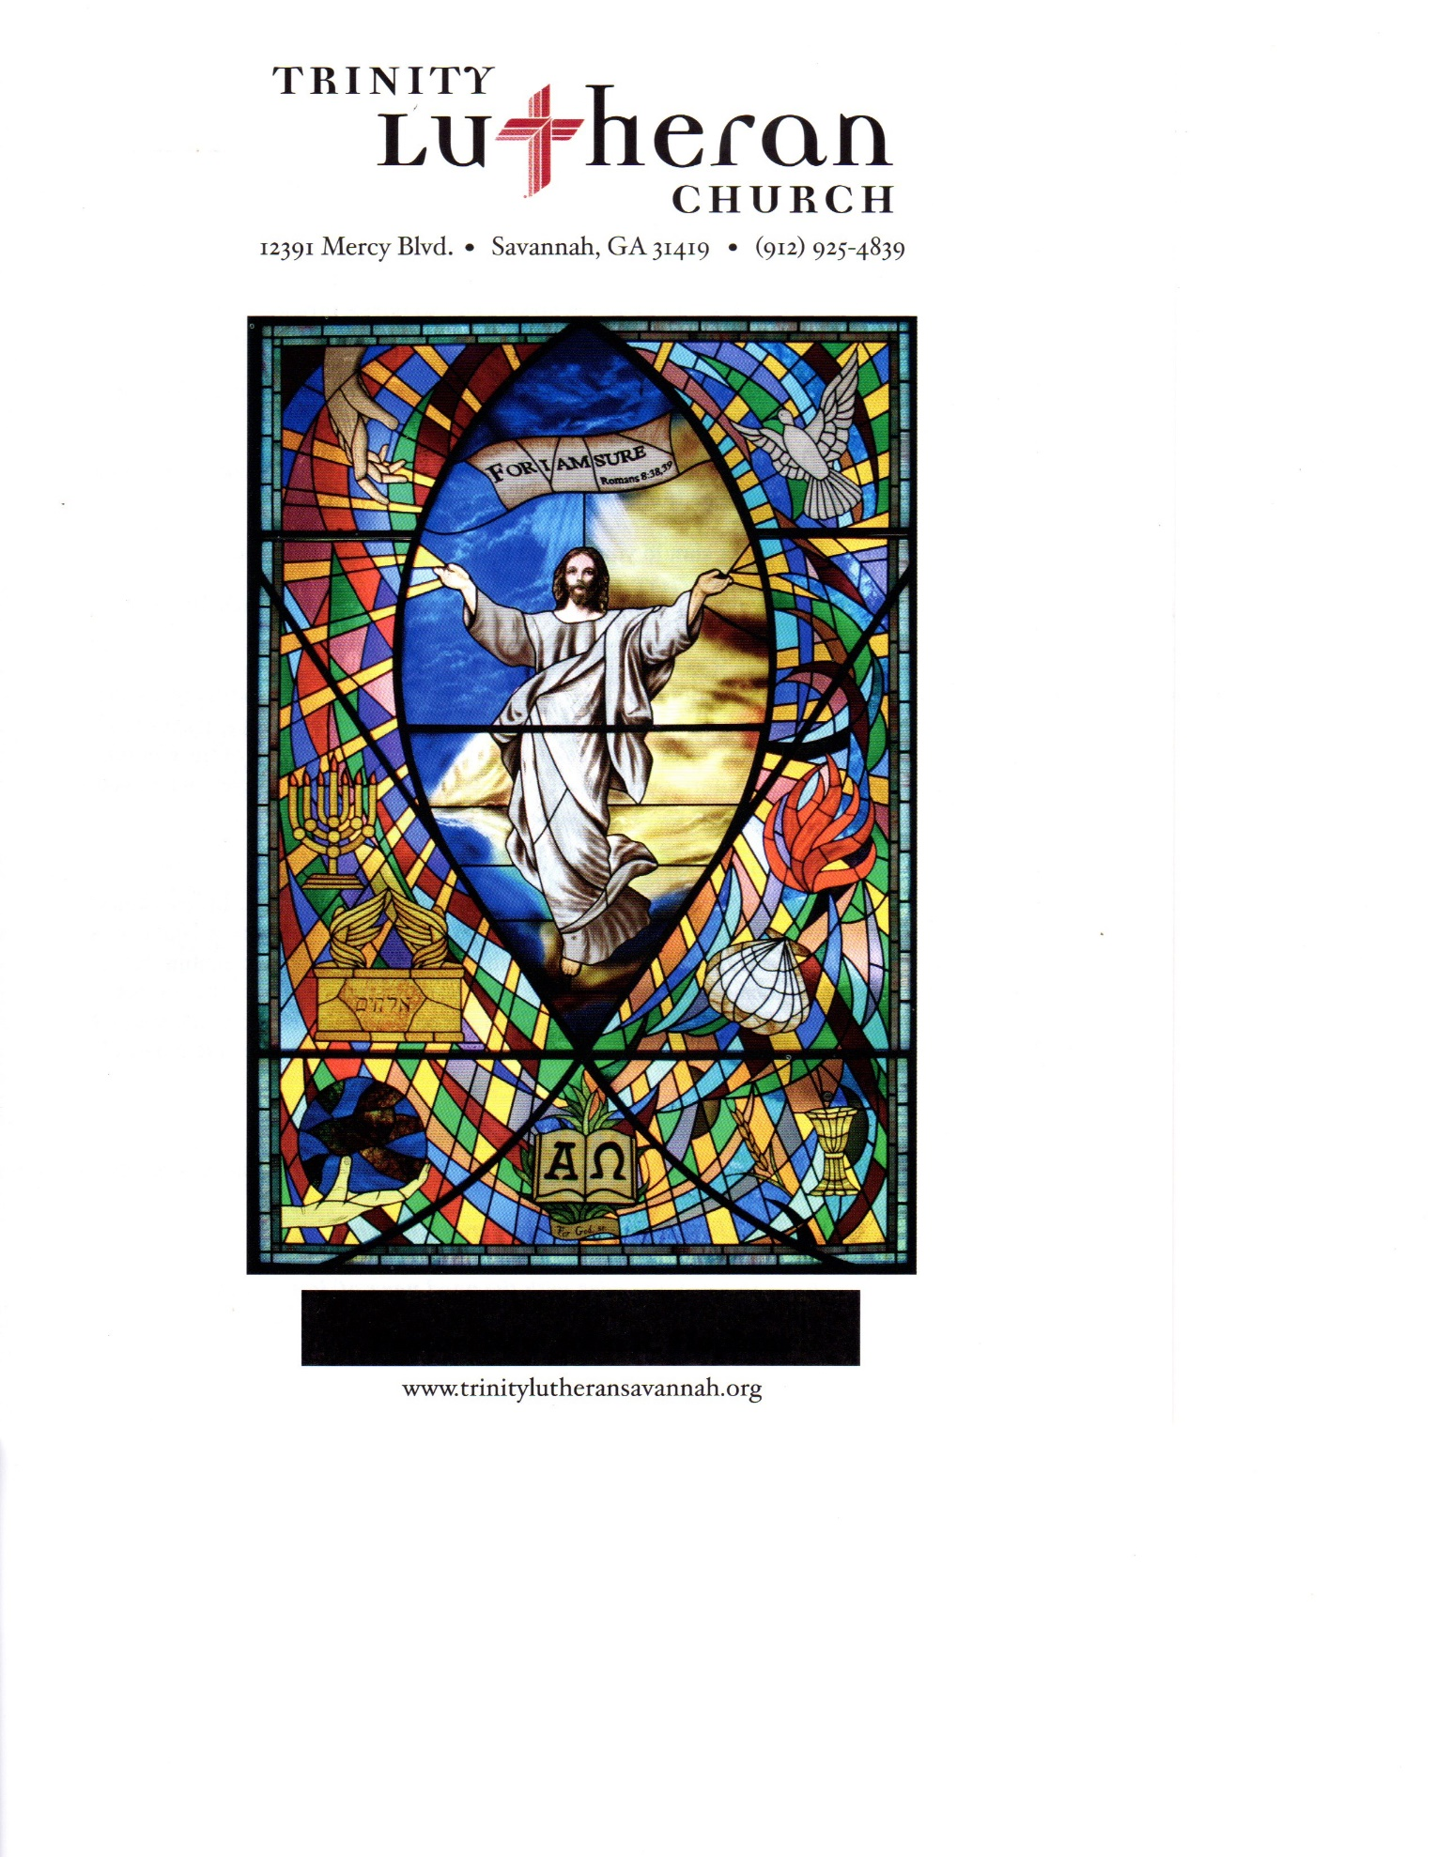

8:30 & 11:00 a.m. Divine Service

**Trinity Lutheran Church**

**The Eighteenth Sunday after Pentecost**

**September 22, 2024, 8:30 Non-Communion & 11:00 a.m. Communion Service**

**WELCOME TO TRINITY!**

Thank you for worshipingwith us today. We want to know who you are, so please provide your contact information in the Friendship Book as it is passed during the Offertory. If you are visiting, honor us by signing the Guest Register in the Narthex.

There are times in our worship service where we stand or kneel. Feel free to participate in either as you are able or feel comfortable to remain seated.

Gluten-free wafers are available upon request during communion services. Please speak to the pastor before service if you wish to receive the host in this form.

Please ask an usher should you require a hearing assistance device.

(†) ~ Those who wish may make the sign of the Cross in remembrance of their Baptism.

**RECEPTION OF HOLY COMMUNION**

If you are not a member of Trinity Lutheran Church, we ask that you speak with the pastor prior to the service before receiving the Lord’s Supper.

**REQUESTS FOR PRAYER**

If you have a prayer request, please fill out a Blue Card from the pew rack and place it in the offering plate. Prayer requests may also be emailed to [trinityoffice@bellsouth.net](mailto:trinityoffice@bellsouth.net) or to pastorjeffwebb@yahoo.com.

**FOR PARENTS WITH YOUNG CHILDREN**

We are delighted that you have brought your child to worship! We invite you to use the Cry Room as a courtesy to others if your little one gets a little rambunctious. Our Cry Room, complete with seating and children's activities, is located at the back of the Sanctuary. The service can be heard through the sound system. We hope your children feel glad they were here and that they are a part of the Trinity family!

***Our Vision:***

***Growing in God’s Word to Share Christ’s Love***

***Our Mission:***

***Led by God, equipped as disciples through Word and Sacrament,***

***we are empowered by the Holy Spirit to reach out with the Gospel of Jesus Christ to all.***



**AS WE GATHER TODAY**

Jeremiah didn’t have it easy, confronting enemies of himself and of God. Even his friends have betrayed him! So the prophet relies on God’s faithful promises, just as David had to do as he wrote today’s Psalm, which announces, “God is my helper; the Lord is the upholder of my life.” We need not quarrel and become angry with the world around us, James writes in the Epistle. God responds better to those who have “the meekness of wisdom.” Our Lord was faithful in His earthly ministry despite betrayal from one of the His followers. In today’s Gospel He teaches the Twelve about true greatness even when they cannot understand His coming execution and resurrection. It is His faithfulness for us that buoys us up in the face of the conflicts around us. And that’s what we celebrate today.

**Divine Service**

***Setting One***

**ORGAN**

**WELCOME**

**CHIMING OF THE HOUR**

*Please Stand*

**PROCESSIONAL HYMN 851 "Lord of Glory, You Have Bought Us"**

Text and tune: Public domain

**INVOCATION**

*(The sign of the cross may be made by all in remembrance of their Baptism.)*

P In the name of the Father and of the (†) Son and of the Holy Spirit.

C **Amen.** *Matthew 28:19b*

P If we say we have no sin, we deceive ourselves and the truth is not in us.

C **But if we confess our sins, God, who is faithful and just, will forgive our sins and cleanse us from all unrighteousness.** *1 John 1:8-9*

*Kneel or Be Seated*

**CONFESSION AND ABSOLUTION**

P Let us then confess our sins to God our Father.

*(Silence for reflection on God's Word and for self-examination.)*

P Most merciful God,

C **we confess that we are by nature sinful and unclean. We have sinned against You in thought, word, and deed, by what we have done and by what we have left undone. We have not loved You with our whole heart; we have not loved our neighbors as ourselves. We justly deserve Your present and eternal punishment. For the sake of Your Son, Jesus Christ, have mercy on us. Forgive us, renew us, and lead us, so that we may delight in Your will and walk in Your ways to the glory of Your holy name. Amen.**

P Almighty God in His mercy has given His Son to die for you and for His sake forgives you all your sins. As a called and ordained servant of Christ, and by His authority, I therefore forgive you all your sins in the name of the Father and of the (†) Son and of the Holy Spirit. *[John 20:19-23]*

C **Amen.**

**Service of the Word**

*Please Stand*

**PSALM *Psalm 54***

P 1O God, save me, by your name,  
C **and vindicate me by your might.**

P 2O God, hear my prayer;  
C **give ear to the words of my mouth.**

P 3For strangers have risen against me; ruthless men seek my life;  
C  **they do not set God before themselves.**

P 4Behold, God is my helper;  
C **the Lord is the upholder of my life.**

P 5He will return the evil to my enemies;  
C **in your faithfulness put an end to them.**

P 6With a freewill offering I will sacrifice to you;  
C **I will give thanks to your name, O Lord, for it is good.**

P 7For he has delivered me from every trouble,  
C **and my eye has looked in triumph on my enemies.**

**All Glory be to the Father and to the Son and to the Holy Spirit;**

**as it was in the beginning, is now, and will be forever. Amen.**

**KYRIE ~ *Lord, Have Mercy*** *Mark 10:47*

P In peace let us pray to the Lord.



P For the peace from above and for our salvation, let us pray to the Lord**.**



P For the peace of the whole world, for the well-being of the Church of God,

and for the unity of all, let us pray to the Lord.



P For this holy house and for all who offer here their worship and praise, let us pray to the Lord.



P Help, save, comfort, and defend us, gracious Lord.



**HYMN OF PRAISE "This Is the Feast"** *Revelation 5:12-13; 19:5-9*

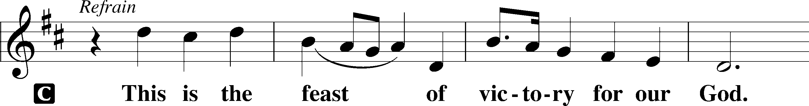

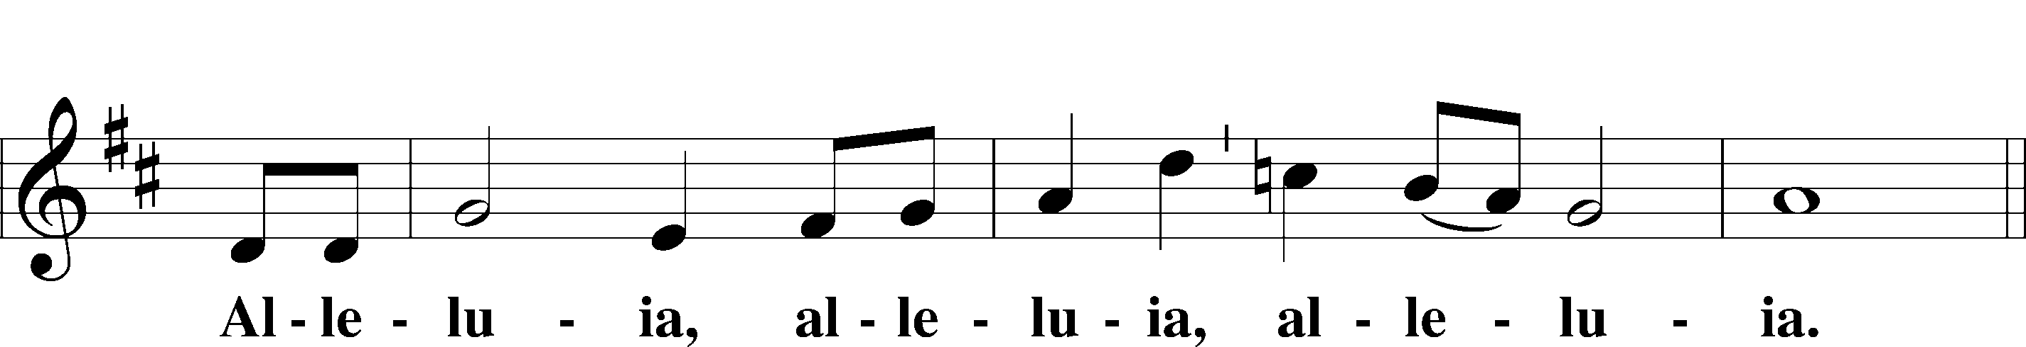

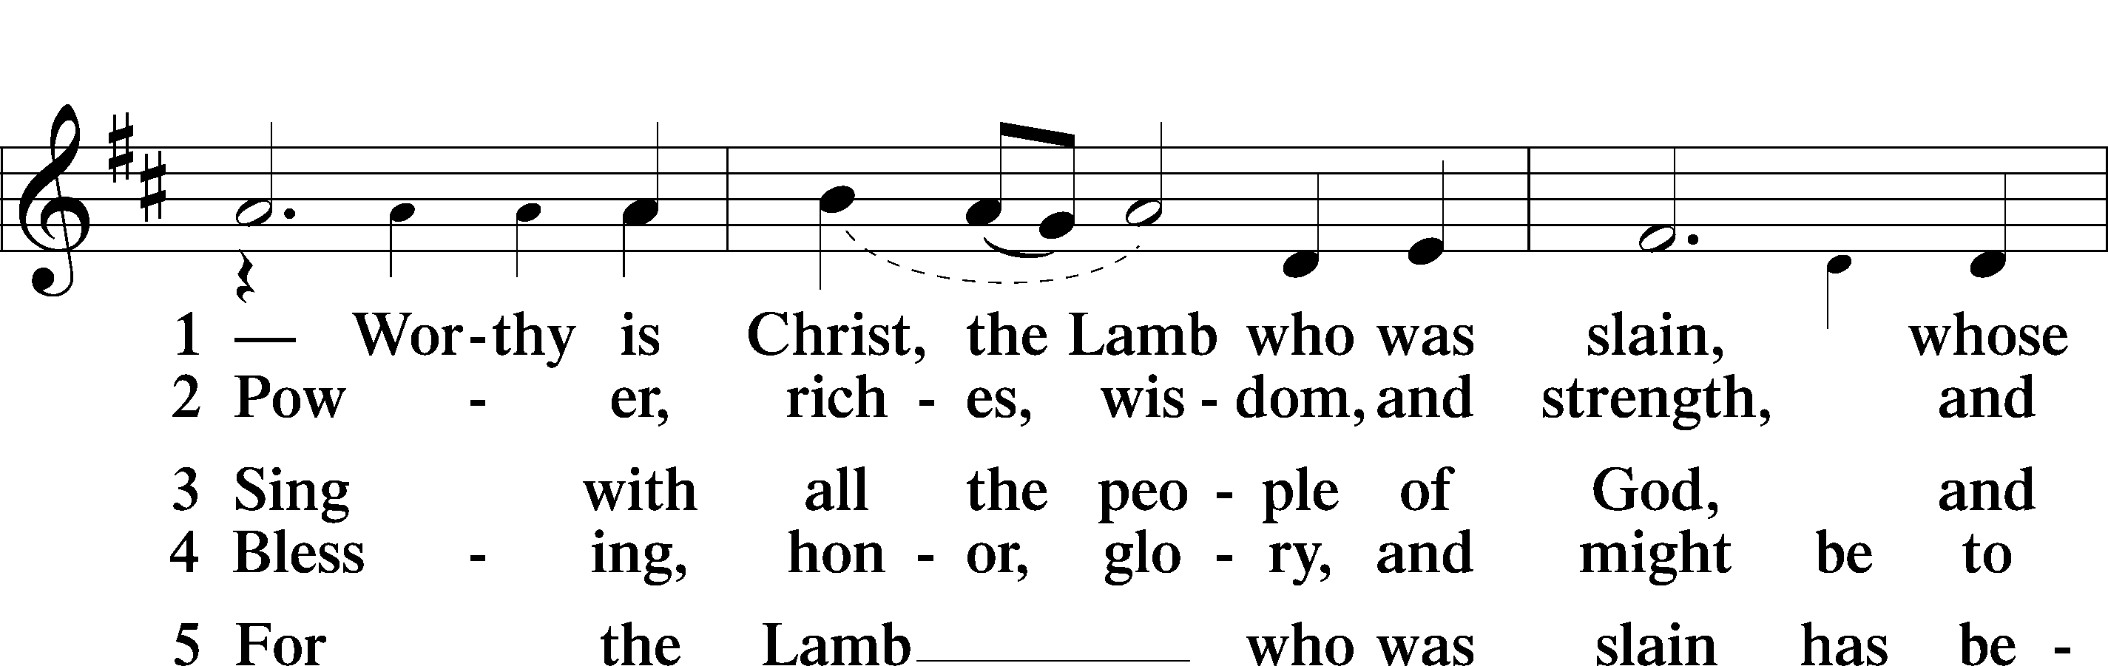

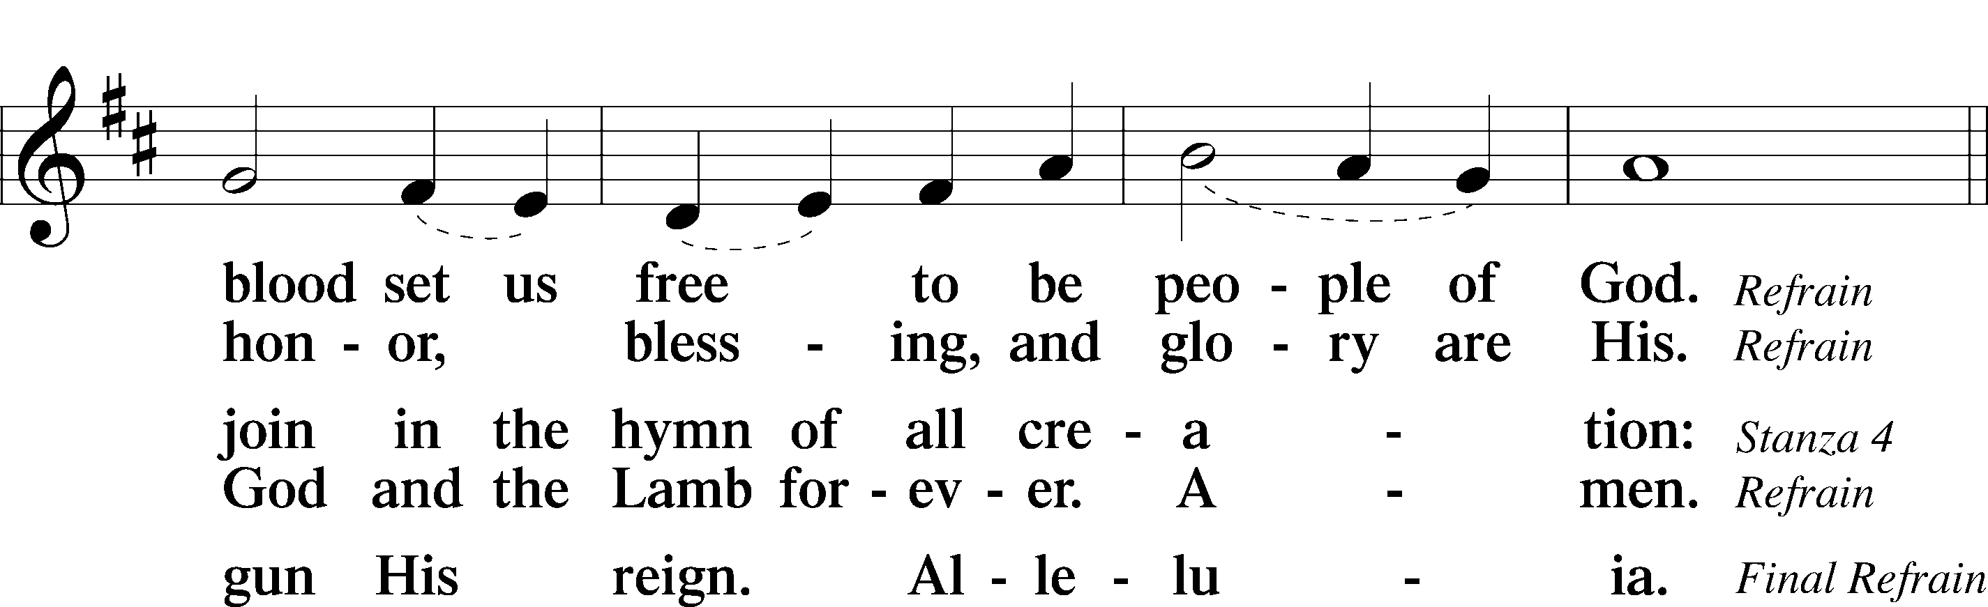

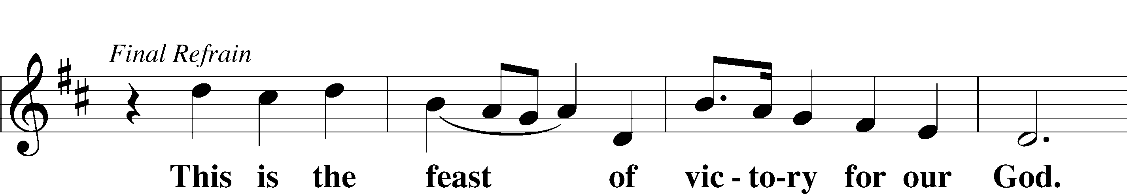

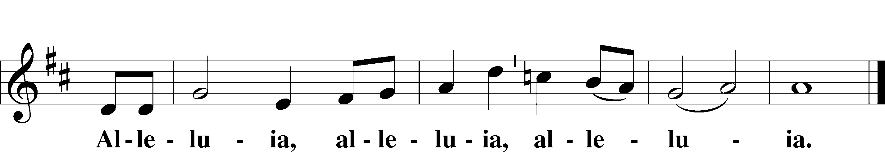

**SALUTATION and COLLECT OF THE DAY**

P The Lord be with you. *2 Timothy 4:22*

**C** **And also with you.**

P Let us pray.

O God, whose strength is made perfect in weakness, grant us humility and childlike faith that we may please You in both will and deed; through Jesus Christ, Your Son, our Lord, who lives and reigns with You and the Holy Spirit, one God, now and forever.

**C Amen.**

*Be Seated*

**OLD TESTAMENT LESSON *Jeremiah 11:18–20***

18The Lord made it known to me and I knew;  
 then you showed me their deeds.  
19But I was like a gentle lamb  
 led to the slaughter.  
I did not know it was against me  
 they devised schemes, saying,  
“Let us destroy the tree with its fruit,  
 let us cut him off from the land of the living,  
 that his name be remembered no more.”  
20But, O Lord of hosts, who judges righteously,  
 who tests the heart and the mind,  
let me see your vengeance upon them,  
 for to you have I committed my cause.

A This is the Word of the Lord.

**C** **Thanks be to God.**

**EPISTLE LESSON*****James 3:13—4:10***

13Who is wise and understanding among you? By his good conduct let him show his works in the meekness of wisdom. 14But if you have bitter jealousy and selfish ambition in your hearts, do not boast and be false to the truth. 15This is not the wisdom that comes down from above, but is earthly, unspiritual, demonic. 16For where jealousy and selfish ambition exist, there will be disorder and every vile practice. 17But the wisdom from above is first pure, then peaceable, gentle, open to reason, full of mercy and good fruits, impartial and sincere. 18And a harvest of righteousness is sown in peace by those who make peace.

1What causes quarrels and what causes fights among you? Is it not this, that your passions are at war within you? 2You desire and do not have, so you murder. You covet and cannot obtain, so you fight and quarrel. You do not have, because you do not ask. 3You ask and do not receive, because you ask wrongly, to spend it on your passions. 4You adulterous people! Do you not know that friendship with the world is enmity with God? Therefore whoever wishes to be a friend of the world makes himself an enemy of God. 5Or do you suppose it is to no purpose that the Scripture says, “He yearns jealously over the spirit that he has made to dwell in us”? 6But he gives more grace. Therefore it says, “God opposes the proud, but gives grace to the humble.” 7Submit yourselves therefore to God. Resist the devil, and he will flee from you. 8Draw near to God, and he will draw near to you. Cleanse your hands, you sinners, and purify your hearts, you double-minded. 9Be wretched and mourn and weep. Let your laughter be turned to mourning and your joy to gloom. 10Humble yourselves before the Lord, and he will exalt you.

A This is the Word of the Lord.

**C** **Thanks be to God.**

*Please Stand*

**ALLELUIA and VERSE** *John 6:68*

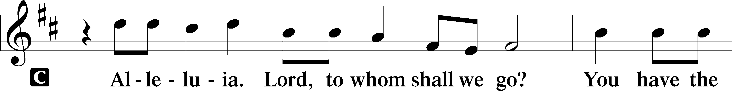

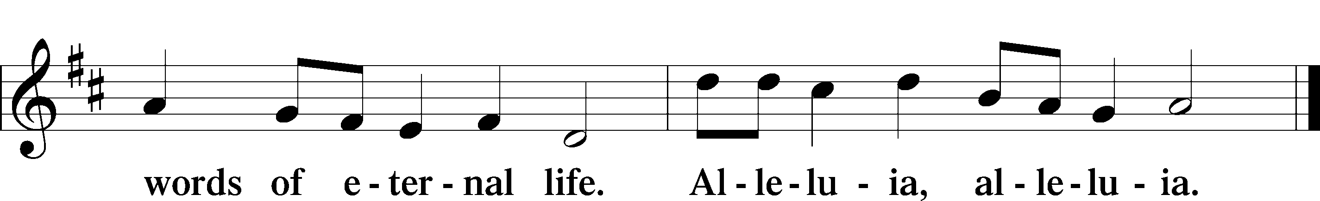

**HOLY GOSPEL *Mark 9:30–37***

P The Holy Gospel according to St. Mark, the ninth chapter.

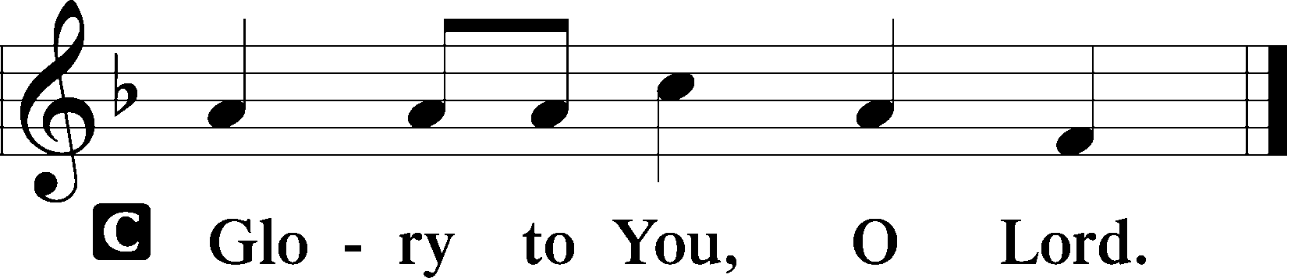

30[The disciples] went on from there and passed through Galilee. And [Jesus] did not want anyone to know, 31for he was teaching his disciples, saying to them, “The Son of Man is going to be delivered into the hands of men, and they will kill him. And when he is killed, after three days he will rise.” 32But they did not understand the saying, and were afraid to ask him.

33And they came to Capernaum. And when he was in the house he asked them, “What were you discussing on the way?” 34But they kept silent, for on the way they had argued with one another about who was the greatest. 35And he sat down and called the twelve. And he said to them, “If anyone would be first, he must be last of all and servant of all.” 36And he took a child and put him in the midst of them, and taking him in his arms, he said to them, 37“Whoever receives one such child in my name receives me, and whoever receives me, receives not me but him who sent me.”

P This is the Gospel of the Lord.

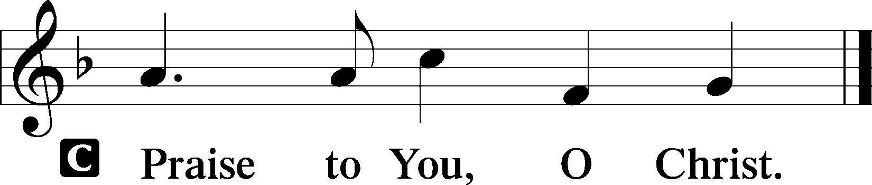

**NICENE CREED**

**I believe in one God, the Father Almighty, maker of heaven and earth and of all things visible and invisible.**

**And in one Lord Jesus Christ, the only-begotten Son of God, begotten of His Father before all worlds, God of God, Light of Light, very God of very God, begotten, not made, being of one substance with the Father, by whom all things were made; who for us men and for our salvation came down from heaven and was incarnate by the Holy Spirit of the virgin Mary and was made man; and was crucified also for us under Pontius Pilate. He suffered and was buried. And the third day He rose again according to the Scriptures and ascended into heaven and sits at the right hand of the Father. And He will come again with glory to judge both the living and the dead, whose kingdom will have no end.**

**And I believe in the Holy Spirit, the Lord and Giver of life, who proceeds from the Father and the Son, who with the Father and the Son together is worshiped and glorified, who spoke by the prophets. And I believe in one holy Christian and apostolic Church, I acknowledge one Baptism for the remission of sins, and I look for the resurrection of the dead and the life of the world to come. Amen.**

*Be Seated*

**CHILDREN'S MESSAGE *8:30 Service***

**HYMN OF THE DAY 842 "Son of God, Eternal Savior"**

Text and tune: Public domain

**SERMON**

**OFFERING** *(Please fill out and pass the red Friendship Book at this time; and fill out the blue card in the pew rack for prayers.)*

*Please Stand*

**OFFERTORY** *Psalm 116:12-13, 17-19*

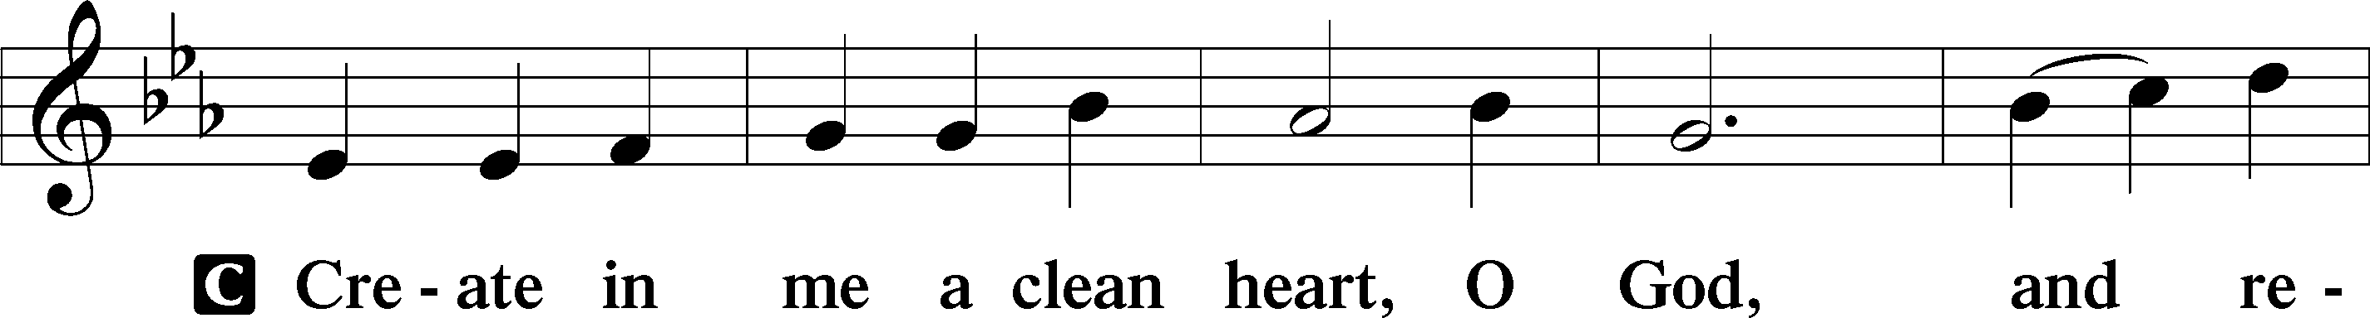

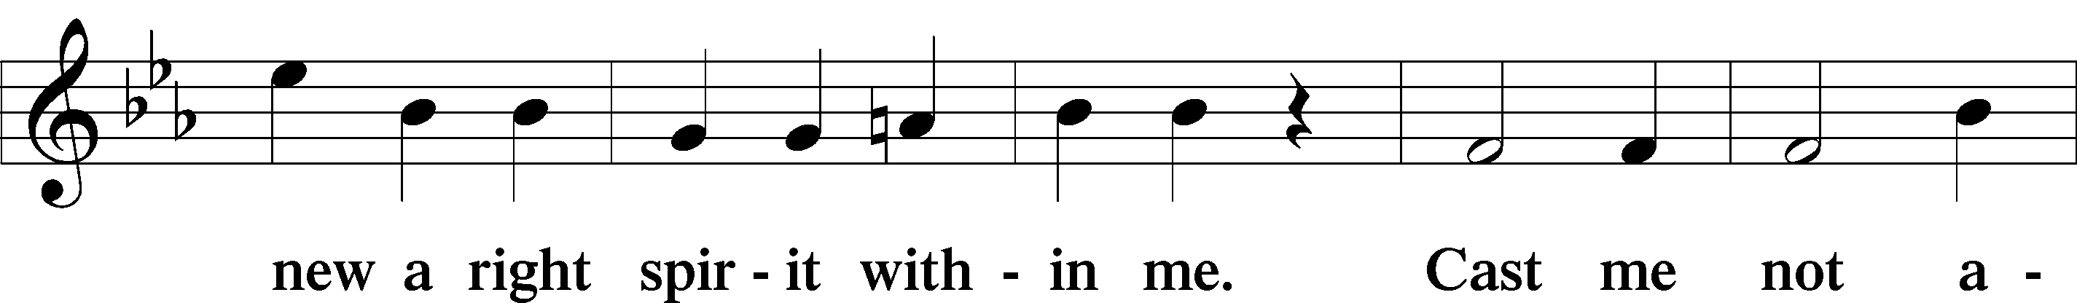

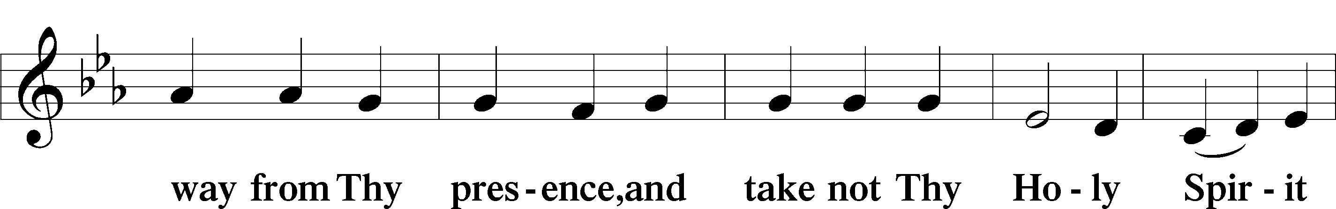

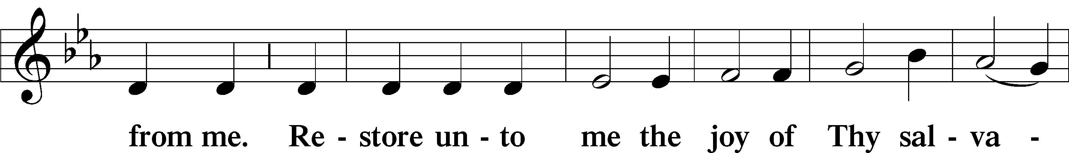

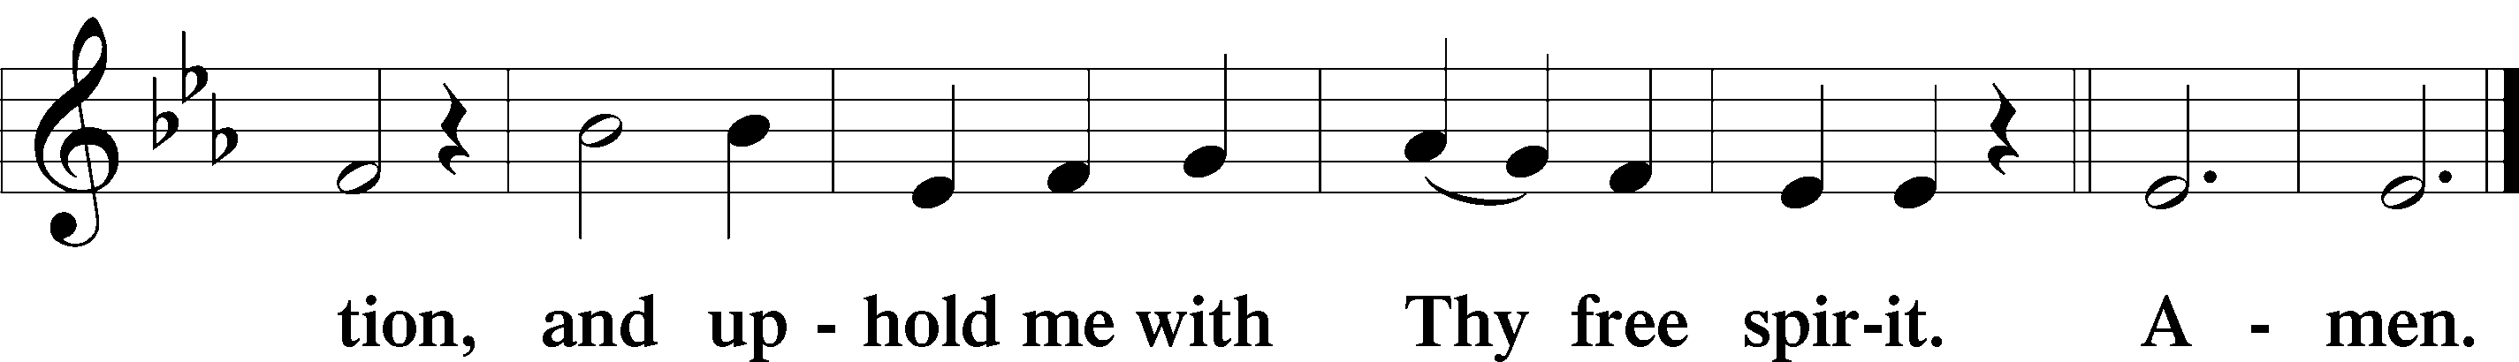

*Kneel or Be Seated*

**PRAYER OF THE CHURCH** *[1 Timothy 2:1-4]*

**Non-Communion Service (8:30)**

**LORD'S PRAYER** *Matthew 6:9-13*

**Our Father who art in heaven, hallowed be Thy name, Thy kingdom come, Thy will be done on earth as it is in heaven. Give us this day our daily bread; and forgive us our trespasses as we forgive those who trespass against us; and lead us not into temptation, but deliver us from evil. For Thine is the kingdom and the power and the glory forever and ever. Amen.**

*Please Stand*

**CLOSING PRAYER**

P O God, from whom come all holy desires, all good counsels, and all just works, give to us, Your servants, that peace which the world cannot give, that our hearts may be set to obey Your commandments and also that we, being defended from the fear of our enemies, may live in peace and quietness; through Jesus Christ, Your Son, our Lord, who lives and reigns with You and the Holy Spirit, one God, now and forever.

**C Amen.**

**BENEDICTION** *Numbers 6:24-26*

P The Lord bless you and keep you. The Lord make His face shine on you and be gracious to you. The Lord look upon you with favor and (†) give you peace.

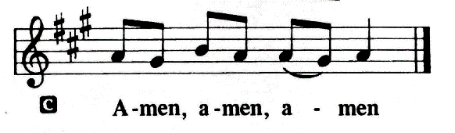

**CLOSING HYMN 661** **"The Son of God Goes Forth to War"**

Text and tune: Public domain

*Be Seated*

**Service of the Sacrament (11:00)**

*The Sacrament, or Lord's Supper, is a special gift from God that brings us into personal communion with Jesus Christ. "In, with and under" the bread and wine we receive His body and blood for forgiveness and renewal. If you are a repentant sinner, come to the table expecting to receive God's wonderful gifts for you!*

*Communicants will take their own wine cups as they are passed. Those requiring non-alcoholic grape juice will take the cups with white grape juice from the middle of the tray.*

*Be Seated*

**OUR EXAMINATION**

P In preparation for Holy Communion, St. Paul tells us in 1 Corinthians 11:27-29, “Whoever, therefore, eats the bread or drinks the cup of the Lord in an unworthy manner will be guilty concerning the body and blood of the Lord. 28Let a person examine himself, then, and so eat of the bread and drink of the cup. 29For anyone who eats and drinks without discerning the body eats and drinks judgment on himself.” So that we may properly examine ourselves prior to receiving the Lord’s Supper, I ask you to reflect on these questions:

* Do you repent of all your sins of thought, word, and deed?
* Do you believe that Jesus Christ is your only Savior from all sin, Satan, and death?
* Do you believe that the Risen Christ is really present in the Sacrament and that in, with, and under the bread and wine you receive His true Body and Blood?

If you answer in faith "Yes!" to these questions, and are properly instructed, you are invited to come forward and partake of the Lord's Supper during Distribution. If you are unable to answer yes to any of these questions, you are invited to come forward, cross your arms as I approach you and receive a blessing. By your coming forward, "You proclaim the Lord's death until He comes."

*Please Stand*

**PREFACE**

P The Lord be with you. *2 Timothy 4:22*



P Lift up your hearts. *[Colossians 3:1]*



P Let us give thanks to the Lord, our God. *[Psalm 136]*

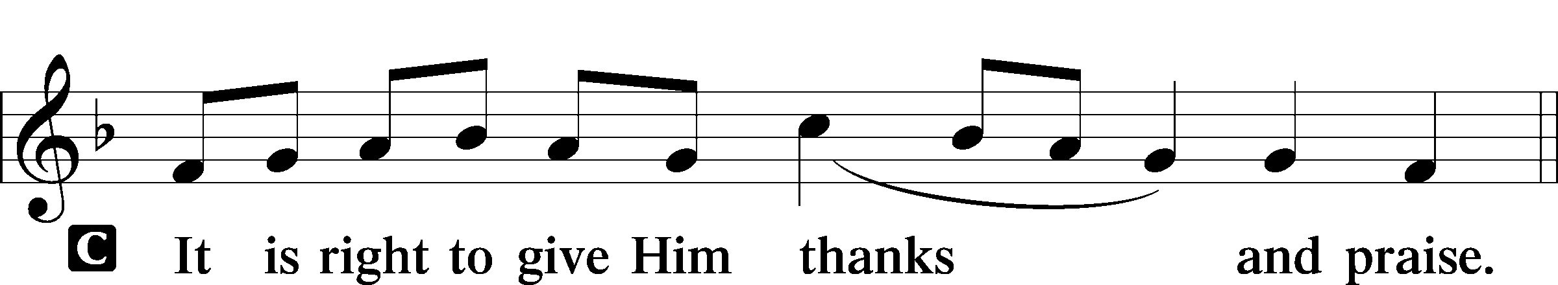

P It is truly good, right, and salutary that we should at all times and in all places give thanks to You, holy Lord, almighty Father, everlasting God, through Jesus Christ, our Lord, who on this day overcame death and the grave and by His glorious resurrection opened to us the way of everlasting life. Therefore with angels and archangels and with all the company of heaven we laud and magnify Your glorious name, evermore praising you and singing:

**SANCTUS ~ *Holy, Holy, Holy*** *Isaiah 6:3; Matthew 21:9*

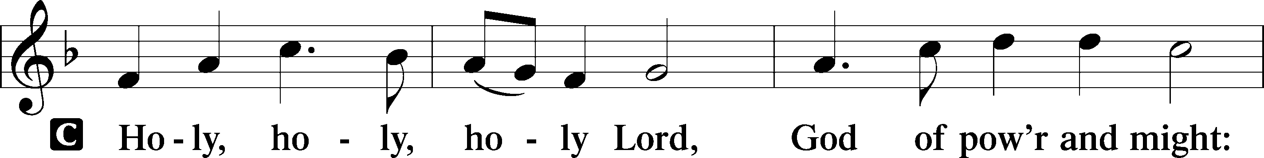

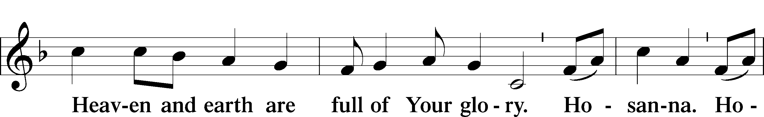

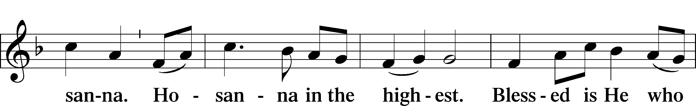

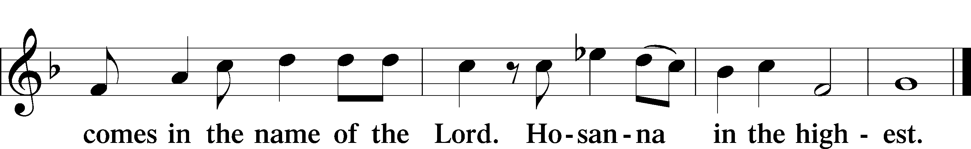

**PRAYER OF THANKSGIVING**

P Blessed are You, Lord of heaven and earth, for You have had mercy on those whom You created and sent Your only begotten Son into our flesh to bear our sin and be our Savior. With repentant joy we receive the salvation accomplished for us by the all-availing sacrifice of His body and His blood on the cross.

Gathered in the name and the remembrance of Jesus, we beg You, O Lord, to forgive, renew, and strengthen us with Your Word and Spirit. Grant us faithfully to eat His body and drink His blood as He bids us do in His own testament. Gather us together, we pray, from the ends of the earth to celebrate with all the faithful the marriage feast of the Lamb in His kingdom, which has no end. Graciously receive our prayers; deliver and preserve us. To You alone, O Father, be all glory, honor, and worship, with the Son and the Holy Spirit, one God, now and forever.

**C Amen.**

**LORD'S PRAYER** *Matthew 6:9-13*

**Our Father who art in heaven, hallowed be Thy name, Thy kingdom come, Thy will be done on earth as it is in heaven. Give us this day our daily bread; and forgive us our trespasses as we forgive those who trespass against us; and lead us not into temptation, but deliver us from evil. For Thine is the kingdom and the power and the glory forever and ever. Amen**.

**THE WORDS OF OUR LORD** *Matthew 26:26-28; Mark 14:22-24;*

*Luke 22:19-20; 1 Corinthians 11:23-25*

P Our Lord Jesus Christ, on the night when He was betrayed, took bread, and when He had given thanks, He broke it and gave it to the disciples and said: “Take, eat; this is My body, which is given for you. This do in remembrance of Me.” In the same way also He took the cup after supper, and when He had given thanks, He gave it to them, saying: "Drink of it, all of you; this is my blood of the new covenant, which is poured out for you for the remission of sins. This do as often as you drink it, in remembrance of Me."

**PAX DOMINI ~ *The Peace of the Lord*** *John 20:19*

PThe peace of the Lord be with you always.

C **And also with you.**

**AGNUS DEI ~ *Lamb of God*** *John 1:29*

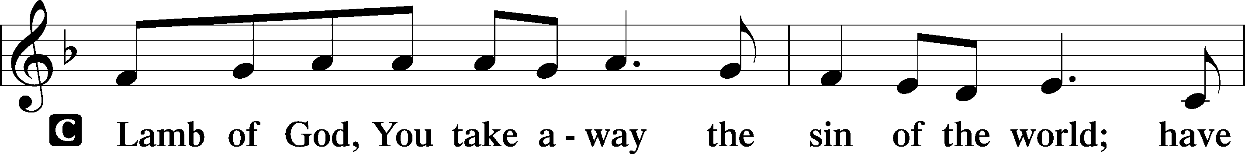

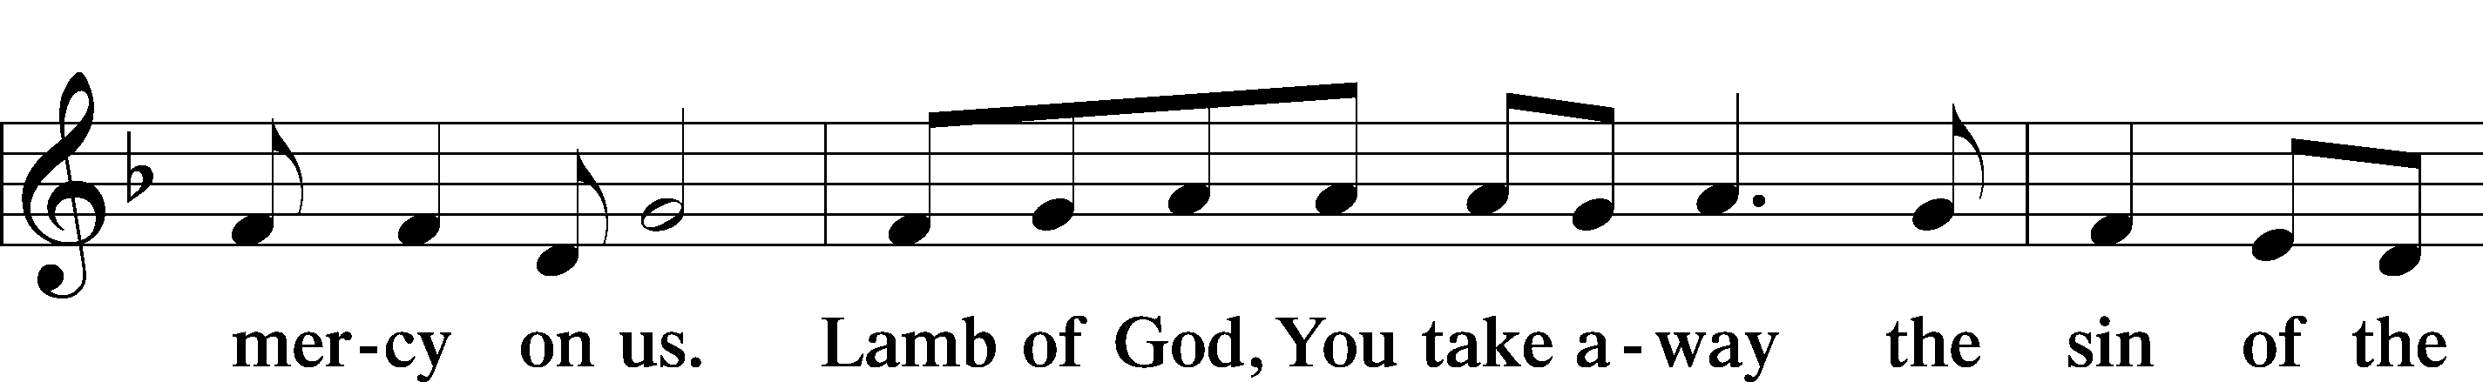

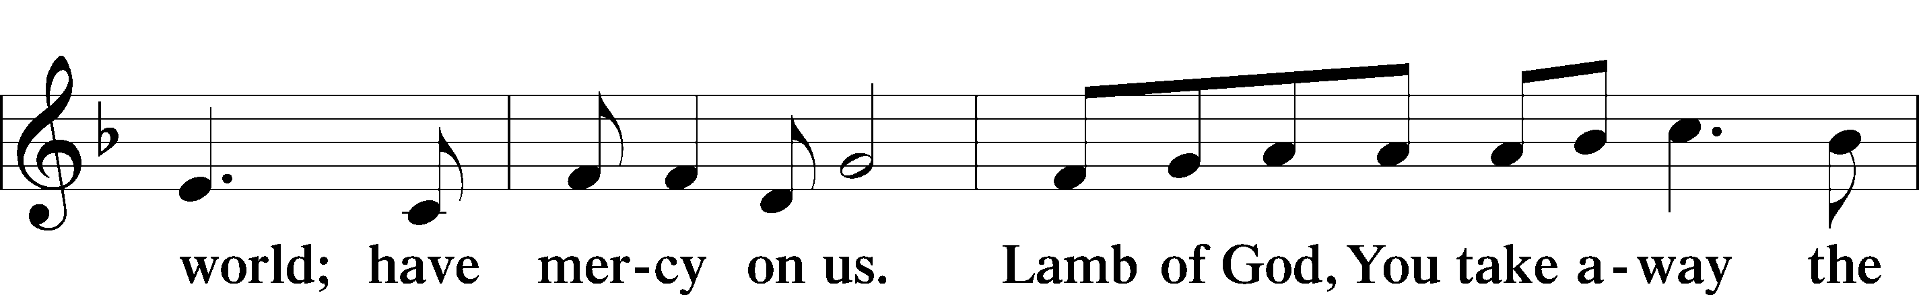

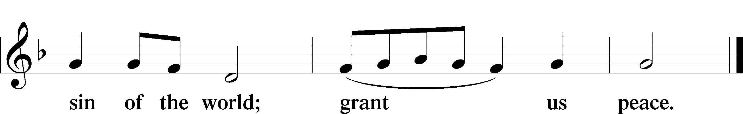

*Be Seated*

**DISTRIBUTION HYMN**

**HYMN 725 "Children of the Heavenly Father"**

Text: Public domain  
Tune: Public domain

*Please Stand*

**POST-COMMUNION CANTICLE "Thank the Lord"**

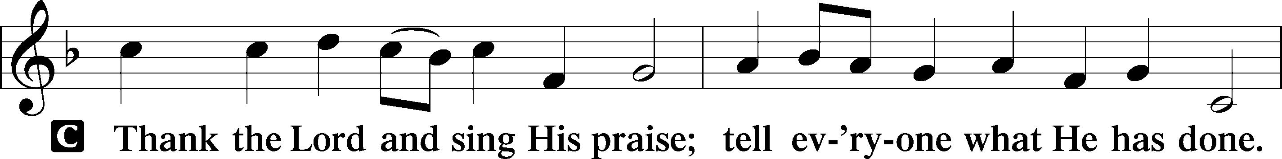

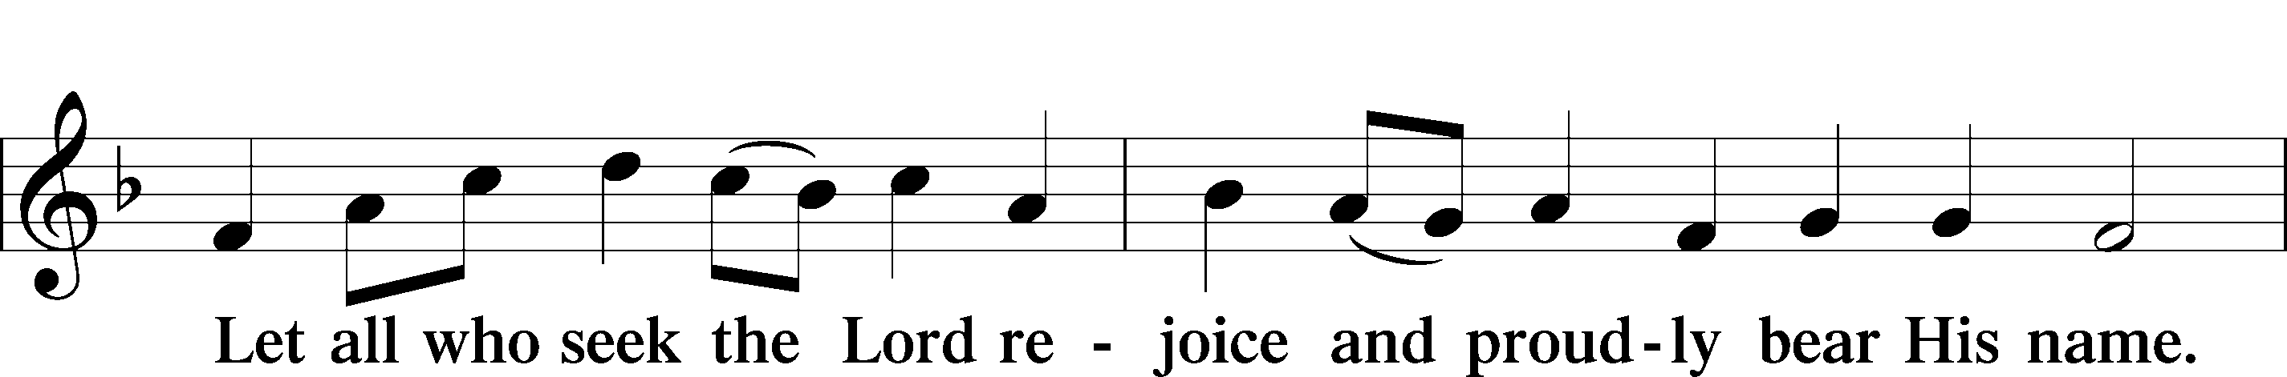

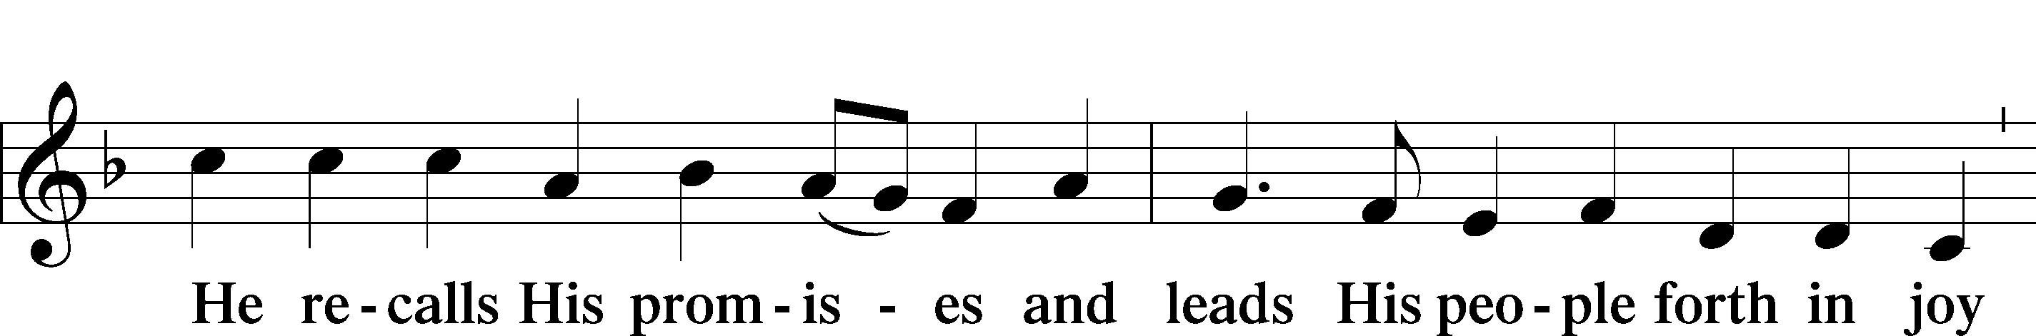

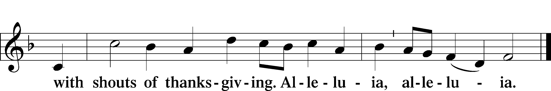

**POST-COMMUNION COLLECT**

P Let us pray.

O God the Father, the fountain and source of all goodness, who in loving- kindness sent Your only-begotten Son into the flesh, we thank You that for His sake You have given us pardon and peace in this Sacrament, and we ask You not to forsake Your children but always to rule our hearts and minds by Your Holy Spirit that we may be enabled constantly to serve You; through Jesus Christ, Your Son, our Lord, who lives and reigns with You and the

Holy Spirit, one God, now and forever.

C **Amen.**

**BENEDICTION** *Numbers 6:24-26*

P The Lord bless you and keep you. The Lord make His face shine on you and be gracious to you. The Lord look upon you with favor and (†) give you peace.



**CLOSING HYMN 661** **"The Son of God Goes Forth to War"**

Text and tune: Public domain

*Be Seated*

**ANNOUNCEMENTS and RECOGNITION OF OUR GUESTS**

**ORGAN**

**TO THE GLORY OF GOD**

The Altar flowers are given to the glory of God

by Pastor Jeff and Cathleen Webb in celebration of Will's 25th birthday.

***He has told you, O man, what is good; and what does the Lord require of you but***

***to do justice, and to love kindness, and to walk humbly with your God?***

***Micah 6:8***

**COFFEE & CONVERSATION**

Join us in the Social Hall after the 8:30 service for coffee and breakfast goodies

provided by the Lutheran Women’s Missionary League.

**BIBLE STUDY OPPORTUNITIES**

**ADULT SUNDAY BIBLE STUDY**

Pastor Webb leads a Bible study titled “Are You a Disciple or a Christian?” in the Social Hall after the 8:30 service.

**CHURCH YEAR CONNECTIONS**

**(Ages 3 through High School)**

Join us for Sunday School classes for ages three through young adult. Teachers: Megan Haverland (3 years-1st Grade), Judy Bringman (2nd-5th Grade), Bob Hanovich (Middle School), and Karl Schumacher (High School).

**PARENTS & TWOS CLASS**

In this class for parents and two-year-olds, Karen Hanovich helps parents encourage their little ones as they learn about Jesus together.

**YOUNG ADULT SINGLES CLASS**

For ages 18-26, this class led by Kevin Riedl is studying “Lessons from the Underground Church.”

**21ST CENTURY PARENTING CLASS**

Parents of school-aged kids gain insight into the issues facing Gen Z and learn how to engage them in meaningful conversations. Eric and Megan Thompson lead this class in the Education Building.

**YOUNG AT HEART CLASS**

Mature members study how we can demonstrate love and compassion to people in need. Bob Reynolds and Mark Waltz lead this class on the ground floor of the Education Building.

**WEDNESDAY MORNING BIBLE STUDY**

Join us at 10:00 a.m. on Wednesday mornings in the Education Building to study the Word.

**WOMEN’S BIBLE STUDY**

The Women’s Bible Study meets on Mondays at 10:00am in the Education Building, and is studying the Parables. A Zoom link is also available. See Linda Tomko for more details.

**HAPPENING AT TRINITY**

**THANK YOU**

Thank you to Barbara Lunick for playing the organ for us.

**OFFERINGS**

Please remain faithful in bringing your offerings to the Lord by mail or online if you are unable to attend worship in person.

**NO WEDNESDAY BIBLE STUDY THIS WEEK**

**CONFIRMATION CLASS**

**Sunday, September 29 at 12:30**

The Confirmation Class will begin on Sunday, September 29 at 12:30. Class will meet each week at the same time.

**YOUNG ADULT SINGLES GROUP**

**Sunday, September 29 at 11:00-1:00**

The Young Adult Singles Group will meet next Sunday, 29 September, from 11 am until 1 pm in the Education Building. We will plan events for October, November, and December.

**REGISTER TO VOTE**

**Deadline is October 7 in Chatham County**

In preparation for the November 5 election, be sure to register or verify your voter registration by the deadline. Check with your county Board of Elections for all deadlines and registration instructions, as well as Absentee and Early Voting information. Pray and vote and pray!

**LWML FALL RALLY**

**Saturday, October 12 at 9:30-2:00**

**Our Redeemer Lutheran Church, 402 Aumond Rd., Augusta, GA 30909**

Our guest speaker will be Chaplain Joshua Schneider from Fort Eisenhower, Augusta. We will learn more about his ministry to soldiers stationed there and about ways we can support this important endeavor. We will serve breakfast snacks, and lunch will be followed by a communion service. Please join us for a day of fellowship, study, and worship. For GIFTS FROM THE HEART, we ask for monetary donations to Concordia Theological Seminary Fort Wayne Military Project. This project, directed by Deac. Carolyn Brinkley, supports chaplains of The Lutheran Church—Missouri Synod (LCMS) with encouragement and theological resources for their important ministry of bringing the mercy of Christ to the Armed Forces. Please make any checks payable to CTSFW Military Project. **Registration begins at 9:30 a.m. COST: $15.00.** Our Redeemer Lutheran Church is in Augusta, Georgia, at the intersection of Aumond Road and Boy Scout Road. Phone: 706-733-6076. Sign up in the Narthex.

**CHRIST’S “LIFE SHINES IN DARKNESS”**

**Saturday, November 9 in Winter Garden, FL**

Lutherans For Life wants you to experience Jesus’ life and share that life with others! Join fellow Lutherans at the LFL Regional Conference Southeast at *Zion Evangelical Lutheran Church in Winter Garden, Florida, on Saturday, November 9, 2024*. Join us for this one-day in-person conference including national for-life speakers, lunch, and fellowship. Limited childcare is available. <https://lutheransforlife.org/conferences/> will give you all the details!

**YOUTH MINISTRY FUNDRAISER**

The Youth Ministry will be selling t-shirts to raise funds for the LCMS Youth Gathering. The t-shirts have a small cross encircled by the phrase, “I am a beloved child of the heavenly King” on the front left and a Bible verse on the back of the t-shirt. The t-shirts will be sold for $20 each and $6.10 will be added to the Youth Ministry Designated Funds for each t-shirt sold. The t-shirts will be available for viewing in the Social Hall after Divine Service. Please contact Bob Hanovich for additional information.

**EVERY ONE HIS WITNESS**

The *Every One His Witness*video series and self-study guide are available on the Friends of Trinity Facebook page. The video series is posted under Media, then Albums, then *Every One His Witness*. The self-study guide is posted under Files, then E1HW – Self Study Guide – 2021-05-26.

**What is *Every One His Witness?*** *Every One His Witness* is a Lutheran evangelism program that teaches you to witness to your friends, coworkers, and any other nonchurched people you may know. Using the LASSIE approach to witnessing (listen, ask, seek, share, invite, and encourage), you will learn how to naturally share the Good News of Jesus Christ through relational, contextual witnessing.

**What does this mean?** It means listening to those who are unsure about Christianity. It means asking questions that aren’t accusatory. It means sharing the Good News about Jesus. **Notice how there’s no bashing, no judgment, and no forced imposition of beliefs.** Instead, there’s understanding, communication, and honesty between friends. And *Every One His Witness* teaches you how.

Bob Hanovich is the POC for additional information on *Every One His Witness*. LET’S GO!

**CHECK THE CALENDAR**

Curious what’s going on? Planning an event? Check the Trinity calendar on our website anytime ([www.trinitylutheransavannah.com](http://www.trinitylutheransavannah.com)/connect/calendar.cfm). If you need to schedule an event, please contact Traci in the office ([trinityoffice@bellsouth.net](mailto:trinityoffice@bellsouth.net), 912-925-4839). Thanks!

**CONNECT WITH US**

Connect with TLC and keep up with what’s going on.

\***Website** - [www.trinitylutheransavannah.com](http://www.trinitylutheransavannah.com)  
\***Facebook** - Friends of Trinity Lutheran Church; Trinity Lutheran Church – Community Info & Events (shareable page); Trinity Lutheran Church of Savannah Media; TLC Hearts of Compassion Helping Hands Ministry; Lizzie Comfort Dog  
\***Instagram** - #lcck9lizzie (Lizzie Comfort Dog)

\***YouTube** – Trinity Lutheran Savannah

**TODAY'S WORSHIP SERVICES**

Traditional 8:30 a.m. and 11:00 a.m.

**IN RESPONSE TO THE GOSPEL LAST SUNDAY**

8:30 a.m. – 72 11:00 a.m. – 53 Facebook – 148 YouTube – 5

Giving $3,251.58

Building Repair Fund 198.00

Comfort Dog 25.00

Food Pantry 35.00

Pastor's Discretionary Fund 75.00

Sharla Fritz Retreat 70.00

Youth 41.00

**SERVING IN THE LORD'S HOUSE TODAY**

**8:30 a.m. 11:00 a.m.**

Karl Schumacher, Reader

Jackie Deemer, Greeter Shirley Lewis, Greeter

Chris Cesaroni & Barbara Duch, Ushers Bob Sautter, Usher

**SERVING NEXT SUNDAY**

**8:30 a.m. 11:00 a.m.**

Pat Sautter, Reader

JB Strange, Greeter Marilyn McKee & Wayne White, Greeters

Doug & Shirley Masini, Ushers John Anander, Usher

**THIS WEEK AT A GLANCE**

TODAY Traditional Worship Services 8:30 & 11:00 a.m.

Sunday School 9:45 a.m.

LWML Breakfast

MONDAY 9/23 Women’s Bible Study (Education Building) 10:00 a.m.

Cub Scouts (Social Hall) 6:00-8:00 p.m.

TUESDAY 9/24 Windsor Forest Garden Club (Social Hall) 8:30 a.m.-12:30 p.m.

Clothes Closet 4:00-6:00 p.m.

Cub Scouts (Social Hall) 6:00-8:00 p.m.

WEDNESDAY 9/25

THURSDAY 9/26 Clothes Closet 10:00 a.m.-1:00 p.m.

Crafters (Education Building) 10:00 a.m.-2:00 p.m.

NAMI (Education Building) 6:00-7:00 p.m.

FRIDAY 9/27 Meals for Homeless (Education Building Kitchen) 4:00 p.m.

SATURDAY 9/28 PTA Fall Conference (Education Building) 8:00 a.m.-1:00 p.m.

Eckes Memorial 11:00 a.m.

**REMEMBER IN PRAYER**

*(Please help us keep the prayer list updated)*

CANCER

Wendy Holland; Harold LaMarr; Samuel Martin (19)

PEACE

Israel, Ukraine, & all who suffer from war and violence

SPECIAL REQUEST

Family & friends of Jim Eckes

OUR WITNESS

Let us proclaim Jesus Christ is risen to all!

OUR CONCERNS

Raise up those, Lord, who would serve Your Church.

**TRINITY LUTHERAN CHURCH**

12391 Mercy Blvd

Savannah, GA 31419

phone 912-925-4839 [trinityoffice@bellsouth.net](mailto:trinityoffice@bellsouth.net)

fax 912-925-4056 www.trinitylutheransavannah.com

Contact Pastor: 717-333-6263; pastorjeffwebb@yahoo.com

**STAFF**

Jeff Webb, Pastor

Traci Schumacher, Administrative Assistant

Helen Williams, Church Custodian

**BOARD OF ELDERS**

Mark Waltz, Head Elder (C – E)

Mike Fajen (K – Mc)

Todd Freesemann (F – J)

Sonny Massey (A – B)

Bob Reynolds (Me – Sa)

Tom Wayman (Sc – Z)

**CHURCH COUNCIL**

Kip Wiltse, President

Eric Thompson, Vice President

Cathy Crotwell, Secretary

Karl Schumacher, Treasurer

Megan Haverland, Board of Education

Mark Waltz, Board of Elders

Chris Garretson, Board of Evangelism

Charles Rogers, Board of Property Management

Jennifer Wolfe, Board of Social Ministry

Lonna McEwen, Board of Stewardship

Cindy Reynolds, Financial Secretary

Bob Hanovich, Board of Youth

**ORGANIZATIONAL LEADERS**

Cindy Baldwin, Comfort Dog Top Dog

Jackie Deemer, Director of TLC Singers & LWML President

Megan Thompson, Sunday School Superintendent

Rosemary Gerdes, Quilters

Karen Hanovich, TLC Marketing

Lonna McEwen, Altar Guild

Rose Pitt, Prayer Team