Trinity Lutheran Church

**The Lutheran Church-Missouri Synod**

**Trinity Lutheran Church**

**Trinity Lutheran Church**

**12391 Mercy Blvd. · Savannah, GA 31419 · (912) 925-4839**

**www.trinitylutheransavannah.com**

8:30 & 11:00 a.m. Divine Service

**Trinity Lutheran Church**

**The Twenty-first Sunday after Pentecost**

**October 13, 2024, 8:30 Non-Communion and 11:00 a.m. Communion Service**

**WELCOME TO TRINITY!**

Thank you for worshipingwith us today. We want to know who you are, so please provide your contact information in the Friendship Book as it is passed during the Offertory. If you are visiting, honor us by signing the Guest Register in the Narthex.

There are times in our worship service where we stand or kneel. Feel free to participate in either as you are able or feel comfortable to remain seated.

Gluten-free wafers are available upon request during communion services. Please speak to the pastor before service if you wish to receive the host in this form.

Please ask an usher should you require a hearing assistance device.

(†) ~ Those who wish may make the sign of the Cross in remembrance of their Baptism.

**RECEPTION OF HOLY COMMUNION**

If you are not a member of Trinity Lutheran Church, we ask that you speak with the pastor prior to the service before receiving the Lord’s Supper.

**REQUESTS FOR PRAYER**

If you have a prayer request, please fill out a Blue Card from the pew rack and place it in the offering plate. Prayer requests may also be emailed to [trinityoffice@bellsouth.net](mailto:trinityoffice@bellsouth.net) or to pastorjeffwebb@yahoo.com.

**FOR PARENTS WITH YOUNG CHILDREN**

We are delighted that you have brought your child to worship! We invite you to use the Cry Room as a courtesy to others if your little one gets a little rambunctious. Our Cry Room, complete with seating and children's activities, is located at the back of the Sanctuary. The service can be heard through the sound system. We hope your children feel glad they were here and that they are a part of the Trinity family!

***Our Vision:***

***Growing in God’s Word to Share Christ’s Love***

***Our Mission:***

***Led by God, equipped as disciples through Word and Sacrament,***

***we are empowered by the Holy Spirit to reach out with the Gospel of Jesus Christ to all.***



**AS WE GATHER TODAY**

The call to faithfulness is itself both a warning against losing faith in God’s promises and the encouragement to have confidence in the Lord. Scripture regularly reminds us that God is not out to trap us or confound us but uses the things of this mortal life to increase our faith in Him. Nowhere is that more felt than in the tension between the things of this life that appear so real and urgent and the things of the kingdom of God which are truly real and urgent. The promise is that if we have Christ, we have all things needful. The encouragement is to live out this promise with a lively and confident faith.

**Divine Service**

***Setting Four***

**ORGAN**

**WELCOME**

**CHIMING OF THE HOUR**

**Confession and Absolution**

*Please Stand*

**PROCESSIONAL HYMN 850 "God of Grace and God of Glory"**

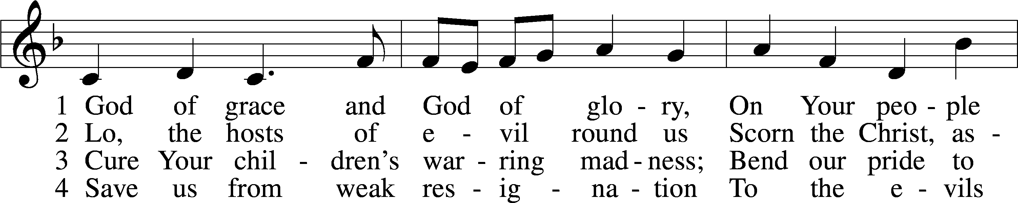

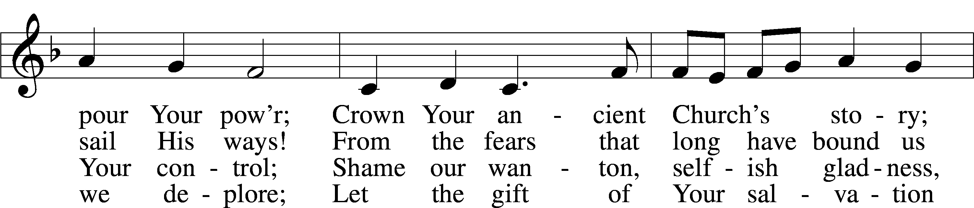

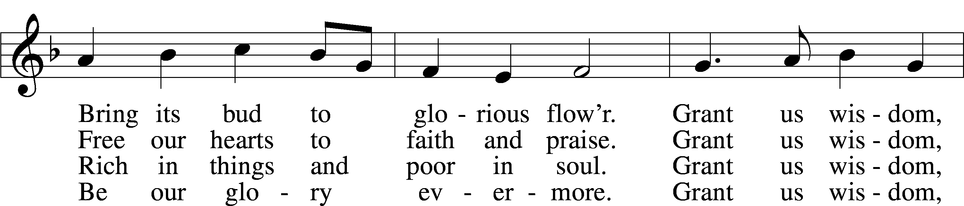

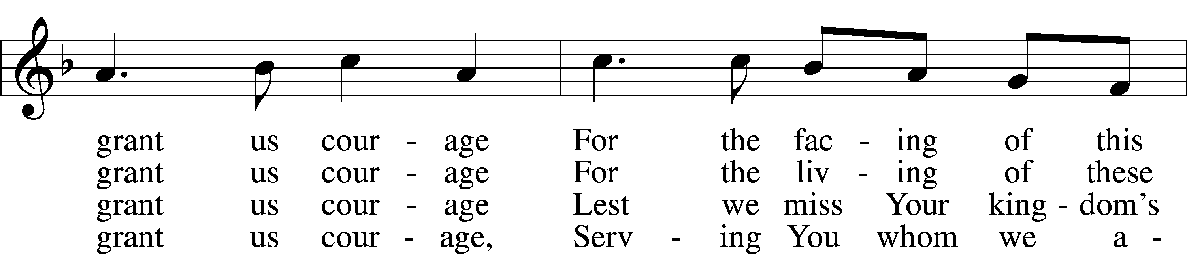

Text and tune: Public domain

**INVOCATION**

P In the name of the Father and of the (†) Son and of the Holy Spirit.

C **Amen.** *Matthew 28:19b*

P Our help is in the name of the Lord,

C **who made heaven and earth.** *Psalm 124:8*

P Since we are gathered to hear God’s Word, call upon Him in prayer and praise, and receive the body and blood of our Lord Jesus Christ in the fellowship of this altar, let us first consider our unworthiness and confess before God and one another that we have sinned in thought, word, and deed, and that we cannot free ourselves from our sinful condition. Together as His people let us take refuge in the infinite mercy of God, our heavenly Father, seeking His grace for the sake of Christ, and saying: God, be merciful to me, a sinner. *[Luke 18:13]*

C **Almighty God, have mercy upon us, forgive us our sins, and lead us to everlasting life. Amen.**

P Almighty God in His mercy has given His Son to die for you and for His sake forgives you all your sins. As a called and ordained servant of Christ, and by His authority, I therefore forgive you all your sins in the name of the Father and of the (†) Son and of the Holy Spirit.

C **Amen.** *[John 20:19-23]*

**Service of the Word**

**PSALM *Psalm 90:12–17***

P 12So teach us to number our days  
C **that we may get a heart of wisdom.**

P 13Return, O Lord! How long?  
C **Have pity on your servants!**

P 14Satisfy us in the morning with your steadfast love,  
C **that we may rejoice and be glad all our days.**

P 15Make us glad for as many days as you have afflicted us,  
C **and for as many years as we have seen evil.**

P 16Let your work be shown to your servants,  
C **and your glorious power to their children.**

P 17Let the favor of the Lord our God be upon us,  
 and establish the work of our hands upon us;  
C **yes, establish the work of our hands!**

**All Glory be to the Father and to the Son and to the Holy Spirit;**

**as it was in the beginning, is now, and will be forever. Amen.**

**KYRIE ~ *Lord, Have Mercy*** *Mark 10:47*

**GLORIA IN EXCELSIS ~ *Glory to God in the Highest*** *Luke 2:14; John 1:29*

**SALUTATION and COLLECT OF THE DAY**

P The Lord be with you. *2 Timothy 4:22*

C **And also with you.**

P Let us pray.

Lord Jesus Christ, whose grace always precedes and follows us, help us to forsake all trust in earthly gain and to find in You our heavenly treasure; for You live and reign with the Father and the Holy Spirit, one God, now and forever.

C **Amen.**

*Be Seated*

**OLD TESTAMENT LESSON *Amos 5:6–7, 10–15***

6Seek the Lord and live,  
 lest he break out like fire in the house of Joseph,  
 and it devour, with none to quench it for Bethel,  
7O you who turn justice to wormwood  
 and cast down righteousness to the earth! . . .

10They hate him who reproves in the gate,  
 and they abhor him who speaks the truth.  
11Therefore because you trample on the poor  
 and you exact taxes of grain from him,  
you have built houses of hewn stone,  
 but you shall not dwell in them;  
you have planted pleasant vineyards,  
 but you shall not drink their wine.  
12For I know how many are your transgressions  
 and how great are your sins—  
you who afflict the righteous, who take a bribe,  
 and turn aside the needy in the gate.  
13Therefore he who is prudent will keep silent in such a time,  
 for it is an evil time.  
14Seek good, and not evil,  
 that you may live;  
and so the Lord, the God of hosts, will be with you,  
 as you have said.  
15Hate evil, and love good,  
 and establish justice in the gate;  
it may be that the Lord, the God of hosts,  
 will be gracious to the remnant of Joseph.

A This is the Word of the Lord.

C **Thanks be to God.**

**EPISTLE LESSON*****Hebrews 3:12–19***

12Take care, brothers, lest there be in any of you an evil, unbelieving heart, leading you to fall away from the living God. 13But exhort one another every day, as long as it is called “today,” that none of you may be hardened by the deceitfulness of sin. 14For we share in Christ, if indeed we hold our original confidence firm to the end. 15As it is said,

“Today, if you hear his voice,  
do not harden your hearts as in the rebellion.”

16For who were those who heard and yet rebelled? Was it not all those who left Egypt led by Moses? 17And with whom was he provoked for forty years? Was it not with those who sinned, whose bodies fell in the wilderness? 18And to whom did he swear that they would not enter his rest, but to those who were disobedient? 19So we see that they were unable to enter because of unbelief.

A This is the Word of the Lord.

C **Thanks be to God.**

*Please Stand*

**ALLELUIA and VERSE** *John 20:31*

**HOLY GOSPEL *Mark 10:17–22***

P The Holy Gospel according to St. Mark, the tenth chapter.

**C Glory to You, O Lord.**

17As [Jesus] was setting out on his journey, a man ran up and knelt before him and asked him, “Good Teacher, what must I do to inherit eternal life?” 18And Jesus said to him, “Why do you call me good? No one is good except God alone. 19You know the commandments: ‘Do not murder, Do not commit adultery, Do not steal, Do not bear false witness, Do not defraud, Honor your father and mother.’” 20And he said to him, “Teacher, all these I have kept from my youth.” 21And Jesus, looking at him, loved him, and said to him, “You lack one thing: go, sell all that you have and give to the poor, and you will have treasure in heaven; and come, follow me.” 22Disheartened by the saying, he went away sorrowful, for he had great possessions.

P This is the Gospel of the Lord.

**C Praise to You, O Christ.**

**NICENE CREED**

**I believe in one God, the Father Almighty, maker of heaven and earth and of all things visible and invisible.**

**And in one Lord Jesus Christ, the only-begotten Son of God, begotten of His Father before all worlds, God of God, Light of Light, very God of very God, begotten, not made, being of one substance with the Father, by whom all things were made; who for us men and for our salvation came down from heaven and was incarnate by the Holy Spirit of the virgin Mary and was made man; and was crucified also for us under Pontius Pilate. He suffered and was buried. And the third day He rose again according to the Scriptures and ascended into heaven and sits at the right hand of the Father. And He will come again with glory to judge both the living and the dead, whose kingdom will have no end.**

**And I believe in the Holy Spirit, the Lord and Giver of life, who proceeds from the Father and the Son, who with the Father and the Son together is worshiped and glorified, who spoke by the prophets. And I believe in one holy Christian and apostolic Church, I acknowledge one Baptism for the remission of sins, and I look for the resurrection of the dead and the life of the world to come. Amen.**

*Be Seated*

**CHILDREN'S MESSAGE *8:30 Service***

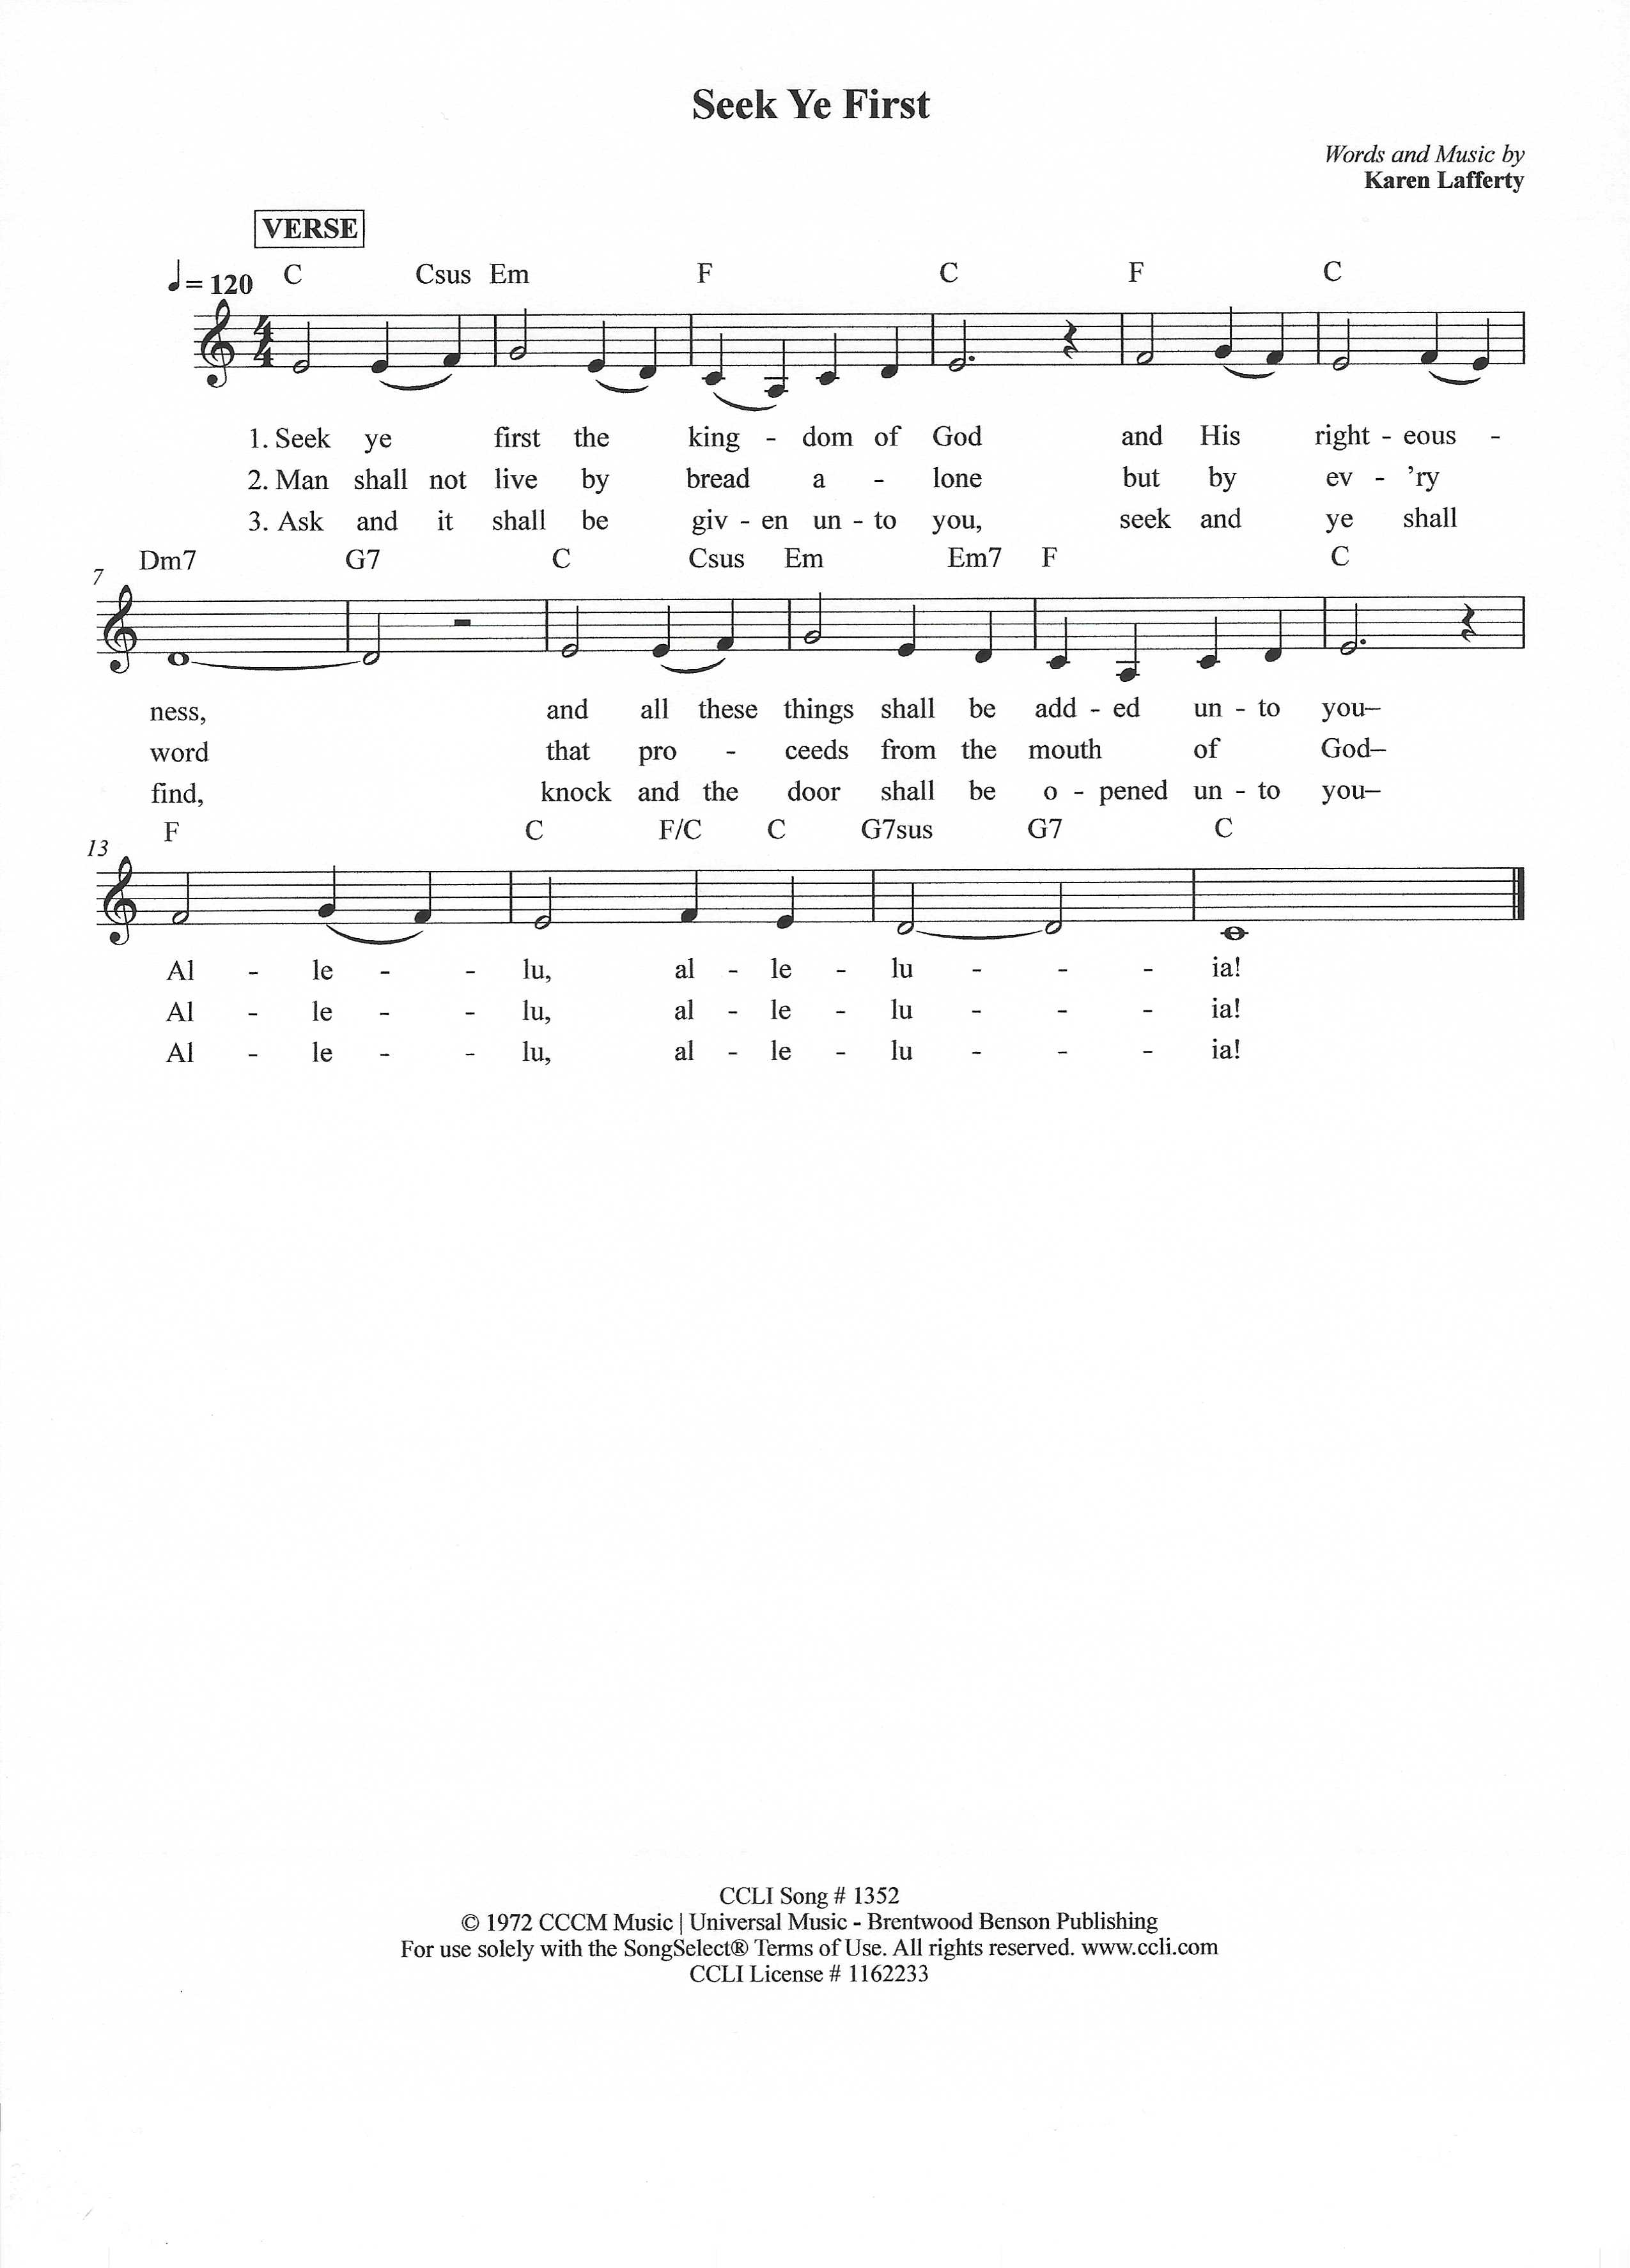

**SERMON "Hearing the Voice of God" *Hebrews 3:12-15***

**OFFERING** *(Please fill out and pass the red Friendship Book at this time; and fill out the blue card in the pew rack for prayers.)*

*Please Stand*

**OFFERTORY 781 vv. 1, 2 “We Give Thee but Thine Own”**

Text and tune: Public domain

*Kneel or Be Seated*

**PRAYER OF THE CHURCH** *[1 Timothy 2:1-4]*

**Non-Communion Service (8:30)**

**LORD'S PRAYER** *Matthew 6:9-13*

**Our Father who art in heaven, hallowed be Thy name, Thy kingdom come, Thy will be done on earth as it is in heaven. Give us this day our daily bread; and forgive us our trespasses as we forgive those who trespass against us; and lead us not into temptation, but deliver us from evil. For Thine is the kingdom and the power and the glory forever and ever. Amen**.

*Please Stand*

**BENEDICAMUS and BENEDICTION**

P Let us bless the Lord. *[Psalm 103:1]*

C **Thanks be to God.**

P The Lord bless you and keep you. The Lord make His face shine on you and be gracious to you. The Lord look upon you with favor and (†) give you peace. *Numbers 6:24-26*

C **Amen.**

**CLOSING HYMN 555 vv. 1, 6, 9-10** **"Salvation unto Us Has Come"**

Text and tune: Public domain

*Be Seated*

**Service of the Sacrament (11:00)**

*The Sacrament, or Lord's Supper, is a special gift from God that brings us into personal communion with Jesus Christ. "In, with and under" the bread and wine we receive His body and blood for forgiveness and renewal. If you are a repentant sinner, come to the table expecting to receive God's wonderful gifts for you!*

*Communicants will take their own wine cups as they are passed. Those requiring non-alcoholic grape juice will take the cups with white grape juice from the middle of the tray.*

*Be Seated*

**OUR EXAMINATION**

P In preparation for Holy Communion, St. Paul tells us in 1 Corinthians 11:27-29, “Whoever, therefore, eats the bread or drinks the cup of the Lord in an unworthy manner will be guilty concerning the body and blood of the Lord. 28Let a person examine himself, then, and so eat of the bread and drink of the cup. 29For anyone who eats and drinks without discerning the body eats and drinks judgment on himself.” So that we may properly examine ourselves prior to receiving the Lord’s Supper, I ask you to reflect on these questions:

* Do you repent of all your sins of thought, word, and deed?
* Do you believe that Jesus Christ is your only Savior from all sin, Satan, and death?
* Do you believe that the Risen Christ is really present in the Sacrament and that in, with, and under the bread and wine you receive His true Body and Blood?

If you answer in faith "Yes!" to these questions, and are properly instructed, you are invited to come forward and partake of the Lord's Supper during Distribution. If you are unable to answer yes to any of these questions, you are invited to come forward, cross your arms as I approach you and receive a blessing. By your coming forward, "You proclaim the Lord's death until He comes."

*Please Stand*

**PREFACE**

P The Lord be with you. *2 Timothy 4:22*

**C And also with you.**

P Lift up your hearts. *[Colossians 3:1]*

**C We lift them to the Lord.**

P Let us give thanks to the Lord, our God. *[Psalm 136]*

**C It is right to give Him thanks and praise.**

P It is truly good, right, and salutary that we should at all times and in all places give thanks to You, O Lord, holy Father, almighty and everlasting God, for the countless blessings You so freely bestow on us and all creation. Above all, we give thanks for Your boundless love shown to us when You sent Your only-begotten Son, Jesus Christ, into our flesh and laid on Him our sin, giving Him into death that we might not die eternally. Because He is now risen from the dead and lives and reigns to all eternity, all who believe in Him will overcome sin and death and will rise again to new life. Therefore with angels and archangels and with all the company of heaven we laud and magnify Your glorious name, evermore praising You and singing:

**SANCTUS ~ *Holy, Holy, Holy*** *Isaiah 6:3; Matthew 21:9*

**PRAYER OF THANKSGIVING**

P Blessed are You, O Lord our God, king of all creation, for You have had mercy on us and given Your only-begotten Son that whoever believes in Him should not perish but have eternal life.

In Your righteous judgment You condemned the sin of Adam and Eve, who ate the forbidden fruit, and You justly barred them and all their children from the tree of life. Yet, in Your great mercy, You promised salvation by a second Adam, Your Son, Jesus Christ, our Lord, and made His cross a life-

giving tree for all who trust in Him.

We give You thanks for the redemption You have prepared for us through Jesus Christ. Grant us Your Holy Spirit that we may faithfully eat and drink of the fruits of His cross and receive the blessings of forgiveness, life, and salvation that come to us in His body and blood.

Hear us as we pray in His name and as He has taught us:

**LORD'S PRAYER** *Matthew 6:9-13*

**Our Father who art in heaven, hallowed be Thy name, Thy kingdom come, Thy will be done on earth as it is in heaven. Give us this day our daily bread; and forgive us our trespasses as we forgive those who trespass against us; and lead us not into temptation, but deliver us from evil. For Thine is the kingdom and the power and the glory forever and ever. Amen**.

**THE WORDS OF OUR LORD** *Matthew 26:26-28; Mark 14:22-24;*

*Luke 22:19-20; 1 Corinthians 11:23-25*

P Our Lord Jesus Christ, on the night when He was betrayed, took bread, and when He had given thanks, He broke it and gave it to the disciples and said: “Take, eat; this is My body, which is given for you. This do in remembrance of Me.” In the same way also He took the cup after supper, and when He had given thanks, He gave it to them, saying: "Drink of it, all of you; this is my blood of the new covenant, which is poured out for you for the remission of sins. This do as often as you drink it, in remembrance of Me."

**PAX DOMINI ~ *The Peace of the Lord*** *John 20:19*

PThe peace of the Lord be with you always.

C **And also with you.**

**AGNUS DEI ~ *Lamb of God*** *John 1:29*

*Be Seated*

**DISTRIBUTION HYMN**

**HYMN 743 vv. 1-2, 4, 6 "Jesus, Priceless Treasure"**

Text and tune: Public domain

*Please Stand*

**NUNC DIMITTIS ~ *Song of Simeon*** *Luke 2:29-32*

**POST-COMMUNION COLLECT**

P Let us pray.

O God the Father, the fountain and source of all goodness, who in loving- kindness sent Your only-begotten Son into the flesh, we thank You that for His sake You have given us pardon and peace in this Sacrament, and we ask You not to forsake Your children but always to rule our hearts and minds by Your Holy Spirit that we may be enabled constantly to serve You; through Jesus Christ, Your Son, our Lord, who lives and reigns with You and the

Holy Spirit, one God, now and forever.

C **Amen.**

**BENEDICAMUS and BENEDICTION**

P Let us bless the Lord. *[Psalm 103:1]*

C **Thanks be to God.**

P The Lord bless you and keep you. The Lord make His face shine on you and be gracious to you. The Lord look upon you with favor and (†) give you peace. *Numbers 6:24-26*

C **Amen.**

**CLOSING HYMN 555 vv. 1, 6, 9-10** **"Salvation unto Us Has Come"**

Text and tune: Public domain

*Be Seated*

**ANNOUNCEMENTS and RECOGNITION OF OUR GUESTS**

**ORGAN**

**TO THE GLORY OF GOD**

The Altar flowers are given to the glory of God

by Kip and Delane Wiltse in celebration of Willow Paula’s birthday.

***Do not be overcome by evil, but overcome evil with good.***

***Romans 12:21***

**COFFEE & CONVERSATION**

Join us in the Social Hall after the 8:30 service for coffee and breakfast goodies

provided by the Youth.

**BIBLE STUDY OPPORTUNITIES**

**ADULT SUNDAY BIBLE STUDY**

Pastor Webb leads a Bible study titled “Are You a Disciple or a Christian?” in the Social Hall after the 8:30 service.

**CHURCH YEAR CONNECTIONS**

**(Ages 3 through High School)**

Join us for Sunday School classes for ages three through young adult. Teachers: Megan Haverland (3 years-1st Grade), Judy Bringman (2nd-5th Grade), Bob Hanovich (Middle School), and Karl Schumacher (High School).

**PARENTS & TWOS CLASS**

In this class for parents and two-year-olds, Karen Hanovich helps parents encourage their little ones as they learn about Jesus together.

**YOUNG ADULT SINGLES CLASS**

For ages 18-26, this class led by Kevin Riedl is studying “Lessons from the Underground Church.”

**21ST CENTURY PARENTING CLASS**

Parents of school-aged kids gain insight into the issues facing Gen Z and learn how to engage them in meaningful conversations. Eric and Megan Thompson lead this class in the Education Building.

**YOUNG AT HEART CLASS**

Mature members study how we can demonstrate love and compassion to people in need. Bob Reynolds and Mark Waltz lead this class on the ground floor of the Education Building.

**WEDNESDAY MORNING BIBLE STUDY**

Join us at 10:00 a.m. on Wednesday mornings in the Education Building to study the Word.

**WOMEN’S BIBLE STUDY**

The Women’s Bible Study meets on Mondays at 10:00am in the Education Building, and is studying the Parables. A Zoom link is also available. See Linda Tomko for more details.

**HAPPENING AT TRINITY**

**THANK YOU**

Thank you to Barbara Lunick for playing the organ for us.

**OFFERINGS**

Please remain faithful in bringing your offerings to the Lord by mail or online if you are unable to attend worship in person.

**TODAY IS "CAN DO SUNDAY"**

Please place your food items in the grocery cart in the Social Hall to help provide a meal for those in need who visit our Food Pantry. As always, thank you for your participation.

**GET READY TO VOTE**

**Chatham County Early Voting Starts October 15; Election Day, Tuesday, November 5**

Be ready for the November 5 election: check with your county Board of Elections for information about Absentee, Early In-Person, and Election Day In-Person Voting. Then pray and vote and pray!

**OVER 50 GROUP LUNCH**

**Wednesday, October 16 at 12:00**

The Over 50 Group will meet for lunch on Wednesday the 16th at 12:00 at El Potro on Abercorn near Big Lots. Sign up in the Narthex or see Marilyn McKee for more information.

**MEN’S BREAKFAST**

**Saturday, October 26 at 9:30**

Men of Trinity, you are invited to breakfast as guests of the Ladies of LWML. We want to show our appreciation for your service to church. Please **sign up in the Narthex by Sunday, October 20**. Any questions: Jackie Deemer 912-661-3921

**SINGLE SERVICE for REFORMATION SUNDAY**

**Sunday, October 27 at 10:00 (Sunday School at 9:00)**

Join us for Reformation Sunday on October 27 as we celebrate with a Single Worship Service at 10:00 and a Potluck Meal afterwards. Enjoy games for children and adults. Sunday School will be at 9:00.

**ALL SAINTS’ DAY LIST**

**Add names by October 27**

There is a list in the Narthex where you can add the names of any dearly departed you want included in the bulletin for All Saints' Sunday, November 3. Or you can contact Traci Schumacher ([trinityoffice@bellsouth.net](mailto:trinityoffice@bellsouth.net); 925-4839) with names to add.

**LUTHERANS FOR LIFE REGIONAL CONFERENCE**

**Saturday, November 9 in Winter Garden, FL**

Join fellow Lutherans in following Christ Jesus as His “Life Shines in Darkness.” Learn and grow together at *Zion Evangelical Lutheran Church in Winter Garden, Florida, on Saturday, November 9,* for this one-day in-person event. Register and find details at <https://lutheransforlife.org/conferences/>

**CHECK THE CALENDAR**

Curious what’s going on? Planning an event? Check the Trinity calendar on our website anytime ([www.trinitylutheransavannah.com](http://www.trinitylutheransavannah.com)/connect/calendar.cfm). If you need to schedule an event, please contact Traci in the office ([trinityoffice@bellsouth.net](mailto:trinityoffice@bellsouth.net), 912-925-4839). Thanks!

**CONNECT WITH US**

Connect with TLC and keep up with what’s going on.

\***Website** - [www.trinitylutheransavannah.com](http://www.trinitylutheransavannah.com)  
\***Facebook** - Friends of Trinity Lutheran Church; Trinity Lutheran Church of Savannah Media; Lizzie Comfort Dog  
\***Instagram** - #lcck9lizzie (Lizzie Comfort Dog)

\***YouTube** – Trinity Lutheran Savannah

**DEADLINE for BULLETIN ANNOUNCEMENTS**

**Every Wednesday by 9:00am**

Email bulletin announcements to [trinityoffice@bellsouth.net](mailto:trinityoffice@bellsouth.net) prior to 9:00am on Wednesdays.

**MINISTRY NEEDS**

**BLANKETS & JACKETS**

Hearts of Compassion is collecting new and gently used blankets and jackets to prepare for the cold months. Please place items in the basket in the Narthex. If you have any questions, please see Jennifer Wolfe.

**TODAY'S WORSHIP SERVICES**

Traditional 8:30 a.m. and 11:00 a.m.

**IN RESPONSE TO THE GOSPEL LAST SUNDAY**

8:30 a.m. – 80 11:00 a.m. – 46 Facebook – 155 YouTube – 0

Giving $8,050.96

Comfort Dog 30.00

Concordia Seminary 75.00

Food Pantry 30.00

Lutheran Disaster Relief - Helene 50.00

Lutheran Women’s Missionary League Mites 283.44

Memorial – Eckes 25.00

Pastor's Discretionary Fund 200.00

Property Management -Roof 200.00

Windsor Forest Garden Club Donation 200.00

Youth Ministry 101.00

**SERVING IN THE LORD'S HOUSE TODAY**

**8:30 a.m. 11:00 a.m.**

Doug Masini, Reader

Sharon Johnson & Linda Tomko, Greeters Kip & Delane Wiltse, Greeters

Gary & Patricia Bradshaw, Ushers Gretchen Holmes, Usher

**SERVING NEXT SUNDAY**

**8:30 a.m. 11:00 a.m.**

Mary Helen Anander, Reader

Betty Morrell, Greeter Cindy Baldwin & Cathy Dotson, Greeters

Cathy Crotwell & JB Strange, Ushers Bob Sautter, Usher

**THIS WEEK AT A GLANCE**

TODAY Traditional Worship Services 8:30 & 11:00 a.m.

Sunday School 9:45 a.m.

Evangelism Meeting (Cry Room) 9:45-10:45 a.m.

Confirmation Class 12:30 p.m.

Youth Breakfast

Can Do Sunday

MONDAY 10/14 Women’s Bible Study (Education Building) 10:00 a.m.

Cub Scouts (Social Hall) 6:00-8:00 p.m.

TUESDAY 10/15 Clothes Closet 4:00-6:00 p.m.

Cub Scouts (Social Hall) 6:00-8:00 p.m.

WEDNESDAY 10/16 Bible Study (Education Building) 10:00 a.m.

Over 50 Group Lunch 12:00 p.m.

THURSDAY 10/17 Clothes Closet 10:00 a.m.-1:00 p.m.

Crafters (Education Building) 10:00 a.m.-2:00 p.m.

NAMI (Education Building) 6:00-7:00 p.m.

Cub Scouts (Social Hall) 6:00-8:00 p.m.

FRIDAY 10/18 Meals for Homeless (Education Building Kitchen) 4:00 p.m.

SATURDAY 10/19 Workday 9:00 a.m.-12:00 p.m.

**REMEMBER IN PRAYER**

*(Please help us keep the prayer list updated)*

CANCER

Wendy Holland; Harold LaMarr; Samuel Martin (19)

PEACE

Israel, Ukraine, & all who suffer from war and violence

OUR WITNESS

Let us proclaim Jesus Christ is risen to all!

OUR CONCERNS

Raise up those, Lord, who would serve Your Church.

**TRINITY LUTHERAN CHURCH**

12391 Mercy Blvd

Savannah, GA 31419

phone 912-925-4839 [trinityoffice@bellsouth.net](mailto:trinityoffice@bellsouth.net)

fax 912-925-4056 www.trinitylutheransavannah.com

Contact Pastor: 717-333-6263; pastorjeffwebb@yahoo.com

**STAFF**

Jeff Webb, Pastor

Traci Schumacher, Administrative Assistant

Helen Williams, Church Custodian

**BOARD OF ELDERS**

Mark Waltz, Head Elder (C – E)

Mike Fajen (K – Mc)

Todd Freesemann (F – J)

Jacob Johnson (Various)

Sonny Massey (A – B)

Bob Reynolds (Me – Sa)

Tom Wayman (Sc – Z)

**CHURCH COUNCIL**

Kip Wiltse, President

Eric Thompson, Vice President

Cathy Crotwell, Secretary

Karl Schumacher, Treasurer

Megan Haverland, Board of Education

Mark Waltz, Board of Elders

Chris Garretson, Board of Evangelism

Charles Rogers, Board of Property Management

Jennifer Wolfe, Board of Social Ministry

Lonna McEwen, Board of Stewardship

Cindy Reynolds, Financial Secretary

Bob Hanovich, Board of Youth

**ORGANIZATIONAL LEADERS**

Cindy Baldwin, Comfort Dog Top Dog

Jackie Deemer, Director of TLC Singers & LWML President

Megan Thompson, Sunday School Superintendent

Rosemary Gerdes, Quilters

Karen Hanovich, TLC Marketing

Lonna McEwen, Altar Guild

Rose Pitt, Prayer Team