Trinity Lutheran Church

**The Lutheran Church-Missouri Synod**

**Trinity Lutheran Church**

**Trinity Lutheran Church**

**12391 Mercy Blvd. · Savannah, GA 31419 · (912) 925-4839**

**www.trinitylutheransavannah.com**

10:00 a.m. Divine Service of Holy Communion

**Trinity Lutheran Church**

**Reformation Sunday**

**October 27, 2024, 10:00 a.m. Communion Service**

**WELCOME TO TRINITY!**

Thank you for worshipingwith us today. We want to know who you are, so please provide your contact information in the Friendship Book as it is passed during the Offertory. If you are visiting, honor us by signing the Guest Register in the Narthex.

There are times in our worship service where we stand or kneel. Feel free to participate in either as you are able or feel comfortable to remain seated.

Gluten-free wafers are available upon request during communion services. Please speak to the pastor before service if you wish to receive the host in this form.

Please ask an usher should you require a hearing assistance device.

(†) ~ Those who wish may make the sign of the Cross in remembrance of their Baptism.

**RECEPTION OF HOLY COMMUNION**

If you are not a member of Trinity Lutheran Church, we ask that you speak with the pastor prior to the service before receiving the Lord’s Supper.

**REQUESTS FOR PRAYER**

If you have a prayer request, please fill out a Blue Card from the pew rack and place it in the offering plate. Prayer requests may also be emailed to [trinityoffice@bellsouth.net](mailto:trinityoffice@bellsouth.net) or to pastorjeffwebb@yahoo.com.

**FOR PARENTS WITH YOUNG CHILDREN**

We are delighted that you have brought your child to worship! We invite you to use the Cry Room as a courtesy to others if your little one gets a little rambunctious. Our Cry Room, complete with seating and children's activities, is located at the back of the Sanctuary. The service can be heard through the sound system. We hope your children feel glad they were here and that they are a part of the Trinity family!

***Our Vision:***

***Growing in God’s Word to Share Christ’s Love***

***Our Mission:***

***Led by God, equipped as disciples through Word and Sacrament,***

***we are empowered by the Holy Spirit to reach out with the Gospel of Jesus Christ to all.***



**AS WE GATHER TODAY**

In Psalm 12, King David cries out, “Save, O Lord, for the godly one is gone; for the faithful have vanished from among the children of man” (v. 1). The Lord God’s anointed king lives in a troubling world! Many centuries later, Martin Luther paraphrased the words of David, writing in a hymn text in 1523: “O Lord, look down from heav’n, behold and let Thy pity waken; . . . dark times have us o’ertaken” (*TLH* 260:1). Looking at our world today, we can relate to both King David and Martin Luther. Yet both men expressed hope in their written words. In his psalm, David writes, “The words of the Lord are pure words, . . . You, O Lord, will keep them” (vv. 6a, 7a). And Luther confidently writes, “So through God’s Word shall men endure each trial and temptation” (*TLH* 260:5). Reformation Day echoes the call to faithfulness heard by God’s people through the ages. May we listen well!

**Divine Service**

***Setting One***

**ORGAN**

**WELCOME**

**CHIMING OF THE HOUR**

*Please Stand*

**PROCESSIONAL HYMN 657 "A Mighty Fortress Is Our God"**

Text: © 1978 Lutheran Book of Worship. Used by permission: LSB Hymn License no. 110000966  
Tune: Public domain

**INVOCATION**

*(The sign of the cross may be made by all in remembrance of their Baptism.)*

P In the name of the Father and of the (†) Son and of the Holy Spirit.

C **Amen.** *Matthew 28:19b*

P If we say we have no sin, we deceive ourselves and the truth is not in us.

C **But if we confess our sins, God, who is faithful and just, will forgive our sins and cleanse us from all unrighteousness.** *1 John 1:8-9*

*Kneel or Be Seated*

**CONFESSION AND ABSOLUTION**

P Let us then confess our sins to God our Father.

*(Silence for reflection on God's Word and for self-examination.)*

P Most merciful God,

C **we confess that we are by nature sinful and unclean. We have sinned against You in thought, word, and deed, by what we have done and by what we have left undone. We have not loved You with our whole heart; we have not loved our neighbors as ourselves. We justly deserve Your present and eternal punishment. For the sake of Your Son, Jesus Christ, have mercy on us. Forgive us, renew us, and lead us, so that we may delight in Your will and walk in Your ways to the glory of Your holy name. Amen.**

P Almighty God in His mercy has given His Son to die for you and for His sake forgives you all your sins. As a called and ordained servant of Christ, and by His authority, I therefore forgive you all your sins in the name of the Father and of the (†) Son and of the Holy Spirit. *[John 20:19-23]*

C **Amen.**

**Service of the Word**

*Please Stand*

**PSALM *Psalm 46***

P 1God is our refuge and strength,  
C  **a very present help in trouble.**

P 2Therefore we will not fear though the earth gives way,  
C  **though the mountains be moved into the heart of the sea,**

P 3though its waters roar and foam,  
C **though the mountains tremble at its swelling.**

P 4There is a river whose streams make glad the city of God,  
C **the holy habitation of the Most High.**

P 5God is in the midst of her; she shall not be moved;  
C **God will help her when morning dawns.**

P 6The nations rage, the kingdoms totter;  
C **he utters his voice, the earth melts.**

P 7The Lord of hosts is with us;  
C **the God of Jacob is our fortress.**

P 8Come, behold the works of the Lord,  
C **how he has brought desolations on the earth.**

P 9He makes wars cease to the end of the earth;  
C **he breaks the bow and shatters the spear;  
 he burns the chariots with fire.**

P 10“Be still, and know that I am God.  
C **I will be exalted among the nations,  
 I will be exalted in the earth!”**

P 11The Lord of hosts is with us;  
C **the God of Jacob is our fortress.**

**All Glory be to the Father and to the Son and to the Holy Spirit;**

**as it was in the beginning, is now, and will be forever. Amen.**

**KYRIE ~ *Lord, Have Mercy*** *Mark 10:47*

P In peace let us pray to the Lord.

P For the peace from above and for our salvation, let us pray to the Lord**.**

P For the peace of the whole world, for the well-being of the Church of God,

and for the unity of all, let us pray to the Lord.

P For this holy house and for all who offer here their worship and praise, let us pray to the Lord.

P Help, save, comfort, and defend us, gracious Lord.

**HYMN OF PRAISE "This Is the Feast"** *Revelation 5:12-13; 19:5-9*

**SALUTATION and COLLECT OF THE DAY**

P The Lord be with you. *2 Timothy 4:22*

**C** **And also with you.**

P Let us pray.

Almighty and gracious Lord, pour out Your Holy Spirit on Your faithful people. Keep us steadfast in Your grace and truth, protect and deliver us in times of temptation, defend us against all enemies, and grant to Your Church Your saving peace; through Jesus Christ, Your Son, our Lord, who lives and reigns with You and the Holy Spirit, one God, now and forever.

**C Amen.**

*Be Seated*

**FIRST READING *Revelation 14:6–7***

6Then I saw another angel flying directly overhead, with an eternal gospel to proclaim to those who dwell on earth, to every nation and tribe and language and people. 7And he said with a loud voice, “Fear God and give him glory, because the hour of his judgment has come, and worship him who made heaven and earth, the sea and the springs of water.”

A This is the Word of the Lord.

**C** **Thanks be to God.**

**CHILDREN’S ANTHEM “Thy Word Is a Lamp”** *(with handbells)*

*Children sing Refrain; Congregation sings verses.*

Text and tune: © 1984 Meadowgreen Music Company, admin. EMI. Used by permission: LSB Hymn License no. 110000966

**EPISTLE READING*****Romans 3:19–28***

19Now we know that whatever the law says it speaks to those who are under the law, so that every mouth may be stopped, and the whole world may be held accountable to God. 20For by works of the law no human being will be justified in his sight, since through the law comes knowledge of sin.

21But now the righteousness of God has been manifested apart from the law, although the Law and the Prophets bear witness to it— 22the righteousness of God through faith in Jesus Christ for all who believe. For there is no distinction: 23for all have sinned and fall short of the glory of God, 24and are justified by his grace as a gift, through the redemption that is in Christ Jesus, 25whom God put forward as a propitiation by his blood, to be received by faith. This was to show God’s righteousness, because in his divine forbearance he had passed over former sins. 26It was to show his righteousness at the present time, so that he might be just and the justifier of the one who has faith in Jesus.

27Then what becomes of our boasting? It is excluded. By what kind of law? By a law of works? No, but by the law of faith. 28For we hold that one is justified by faith apart from works of the law.

A This is the Word of the Lord.

**C** **Thanks be to God.**

*Please Stand*

**ALLELUIA and VERSE** *John 6:68*

**HOLY GOSPEL *John 8:31–36***

P The Holy Gospel according to St. John, the eighth chapter.

31So Jesus said to the Jews who had believed in him, “If you abide in my word, you are truly my disciples, 32and you will know the truth, and the truth will set you free.” 33They answered him, “We are offspring of Abraham and have never been enslaved to anyone. How is it that you say, ‘You will become free’?”

34Jesus answered them, “Truly, truly, I say to you, everyone who commits sin is a slave to sin. 35The slave does not remain in the house forever; the son remains forever. 36So if the Son sets you free, you will be free indeed.”

P This is the Gospel of the Lord.

**NICENE CREED**

**I believe in one God, the Father Almighty, maker of heaven and earth and of all things visible and invisible.**

**And in one Lord Jesus Christ, the only-begotten Son of God, begotten of His Father before all worlds, God of God, Light of Light, very God of very God, begotten, not made, being of one substance with the Father, by whom all things were made; who for us men and for our salvation came down from heaven and was incarnate by the Holy Spirit of the virgin Mary and was made man; and was crucified also for us under Pontius Pilate. He suffered and was buried. And the third day He rose again according to the Scriptures and ascended into heaven and sits at the right hand of the Father. And He will come again with glory to judge both the living and the dead, whose kingdom will have no end.**

**And I believe in the Holy Spirit, the Lord and Giver of life, who proceeds from the Father and the Son, who with the Father and the Son together is worshiped and glorified, who spoke by the prophets. And I believe in one holy Christian and apostolic Church, I acknowledge one Baptism for the remission of sins, and I look for the resurrection of the dead and the life of the world to come. Amen.**

*Be Seated*

**HYMN OF THE DAY 578 "Thy Strong Word"**

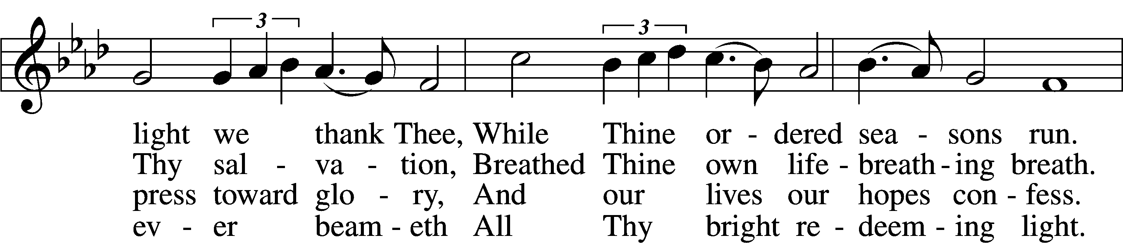

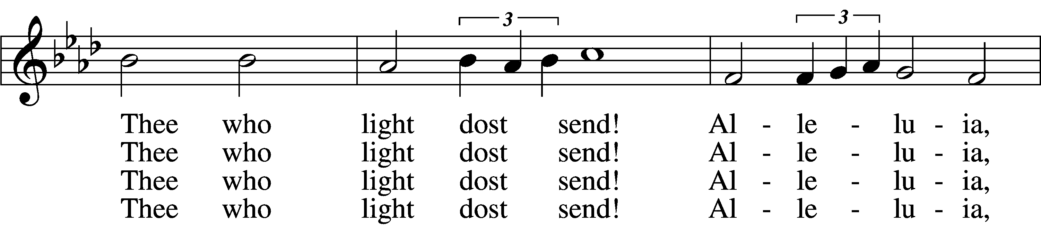

5 Give us lips to sing Thy glory,  
    Tongues Thy mercy to proclaim,  
Throats that shout the hope that fills us,  
    Mouths to speak Thy holy name.  
Alleluia, alleluia!  
    May the light which Thou dost send  
Fill our songs with alleluias,  
    Alleluias without end!

D 6 God the Father, light-creator,  
    To Thee laud and honor be.  
To Thee, Light of Light begotten,  
    Praise be sung eternally.  
Holy Spirit, light-revealer,  
    Glory, glory be to Thee.  
Mortals, angels, now and ever  
    Praise the holy Trinity!

Text: © 1969 Concordia Publishing House. Used by permission: LSB Hymn License no. 110000966  
Tune: Public domain

**SERMON**

**OFFERING** *(Please fill out and pass the red Friendship Book at this time; and fill out the blue card in the pew rack for prayers.)*

*Please Stand*

**OFFERTORY** *Psalm 116:12-13, 17-19*

*Kneel or Be Seated*

**PRAYER OF THE CHURCH** *[1 Timothy 2:1-4]*

*Be Seated*

**Service of the Sacrament**

*The Sacrament, or Lord's Supper, is a special gift from God that brings us into personal communion with Jesus Christ. "In, with and under" the bread and wine we receive His body and blood for forgiveness and renewal. If you are a repentant sinner, come to the table expecting to receive God's wonderful gifts for you!*

*Communicants will take their own wine cups as they are passed. Those requiring non-alcoholic grape juice will take the cups with white grape juice from the middle of the tray.*

*Remain Seated*

**OUR EXAMINATION**

P In preparation for Holy Communion, St. Paul tells us in 1 Corinthians 11:27-29, “Whoever, therefore, eats the bread or drinks the cup of the Lord in an unworthy manner will be guilty concerning the body and blood of the Lord. 28Let a person examine himself, then, and so eat of the bread and drink of the cup. 29For anyone who eats and drinks without discerning the body eats and drinks judgment on himself.” So that we may properly examine ourselves prior to receiving the Lord’s Supper, I ask you to reflect on these questions:

* Do you repent of all your sins of thought, word, and deed?
* Do you believe that Jesus Christ is your only Savior from all sin, Satan, and death?
* Do you believe that the Risen Christ is really present in the Sacrament and that in, with, and under the bread and wine you receive His true Body and Blood?

If you answer in faith "Yes!" to these questions, and are properly instructed, you are invited to come forward and partake of the Lord's Supper during Distribution. If you are unable to answer yes to any of these questions, you are invited to come forward, cross your arms as I approach you and receive a blessing. By your coming forward, "You proclaim the Lord's death until He comes."

*Please Stand*

**PREFACE**

P The Lord be with you. *2 Timothy 4:22*

P Lift up your hearts. *[Colossians 3:1]*

P Let us give thanks to the Lord, our God. *[Psalm 136]*

P It is truly good, right, and salutary that we should at all times and in all places give thanks to You, holy Lord, almighty Father, everlasting God, through Jesus Christ, our Lord, who on this day overcame death and the grave and by His glorious resurrection opened to us the way of everlasting life. Therefore with angels and archangels and with all the company of heaven we laud and magnify Your glorious name, evermore praising you and singing:

**SANCTUS ~ *Holy, Holy, Holy*** *Isaiah 6:3; Matthew 21:9*

**PRAYER OF THANKSGIVING**

P Blessed are You, Lord of heaven and earth, for You have had mercy on those whom You created and sent Your only begotten Son into our flesh to bear our sin and be our Savior. With repentant joy we receive the salvation accomplished for us by the all-availing sacrifice of His body and His blood on the cross.

Gathered in the name and the remembrance of Jesus, we beg You, O Lord, to forgive, renew, and strengthen us with Your Word and Spirit. Grant us faithfully to eat His body and drink His blood as He bids us do in His own testament. Gather us together, we pray, from the ends of the earth to celebrate with all the faithful the marriage feast of the Lamb in His kingdom, which has no end. Graciously receive our prayers; deliver and preserve us. To You alone, O Father, be all glory, honor, and worship, with the Son and the Holy Spirit, one God, now and forever.

**C Amen.**

**LORD'S PRAYER** *Matthew 6:9-13*

**Our Father who art in heaven, hallowed be Thy name, Thy kingdom come, Thy will be done on earth as it is in heaven. Give us this day our daily bread; and forgive us our trespasses as we forgive those who trespass against us; and lead us not into temptation, but deliver us from evil. For Thine is the kingdom and the power and the glory forever and ever. Amen**.

**THE WORDS OF OUR LORD** *Matthew 26:26-28; Mark 14:22-24;*

*Luke 22:19-20; 1 Corinthians 11:23-25*

P Our Lord Jesus Christ, on the night when He was betrayed, took bread, and when He had given thanks, He broke it and gave it to the disciples and said: “Take, eat; this is My body, which is given for you. This do in remembrance of Me.” In the same way also He took the cup after supper, and when He had given thanks, He gave it to them, saying: "Drink of it, all of you; this is my blood of the new covenant, which is poured out for you for the remission of sins. This do as often as you drink it, in remembrance of Me."

**PAX DOMINI ~ *The Peace of the Lord*** *John 20:19*

PThe peace of the Lord be with you always.

C **And also with you.**

**AGNUS DEI ~ *Lamb of God*** *John 1:29*

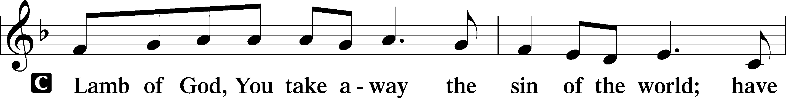

*Be Seated*

**DISTRIBUTION HYMNS**

**HYMN 566 "By Grace I’m Saved"**

5 By grace to timid hearts that tremble,  
    In tribulation’s furnace tried,  
By grace, in spite of fear and trouble,  
    The Father’s heart is open wide.  
Where could I help and strength secure  
If grace were not my anchor sure?

6 By grace! On this I’ll rest when dying;  
    In Jesus’ promise I rejoice;  
For though I know my heart’s condition,  
    I also know my Savior’s voice.  
My heart is glad, all grief has flown  
Since I am saved by grace alone.

Text and tune: Public domain

**HYMN 744 "Amazing Grace"**

Text (sts. 1s–4s): © 1991 Editorial Concordia. Used by permission: LSB Hymn License no. 110000966  
Text (sts. 1–5) and tune: Public domain

*Please Stand*

**POST-COMMUNION CANTICLE "Thank the Lord"**

**POST-COMMUNION COLLECT**

P Let us pray.

We give thanks to You, almighty God, that You have refreshed us through this salutary gift, and we implore You that of Your mercy You would strengthen us through the same in faith toward You and in fervent love toward one another; through Jesus Christ, Your Son, our Lord, who lives and reigns with You and the Holy Spirit, one God, now and forever.

C **Amen.**

**BENEDICTION** *Numbers 6:24-26*

P The Lord bless you and keep you. The Lord make His face shine on you and be gracious to you. The Lord look upon you with favor and (†) give you peace.

**CLOSING HYMN 644** **"The Church’s One Foundation"**

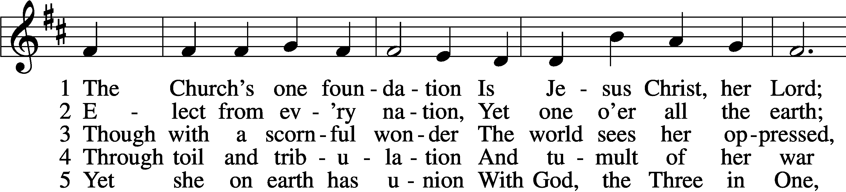

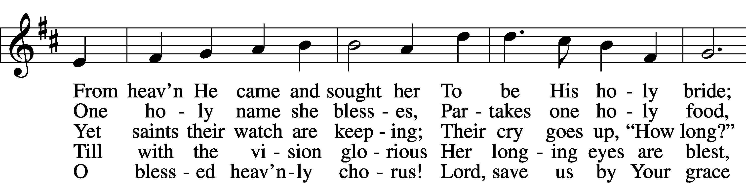

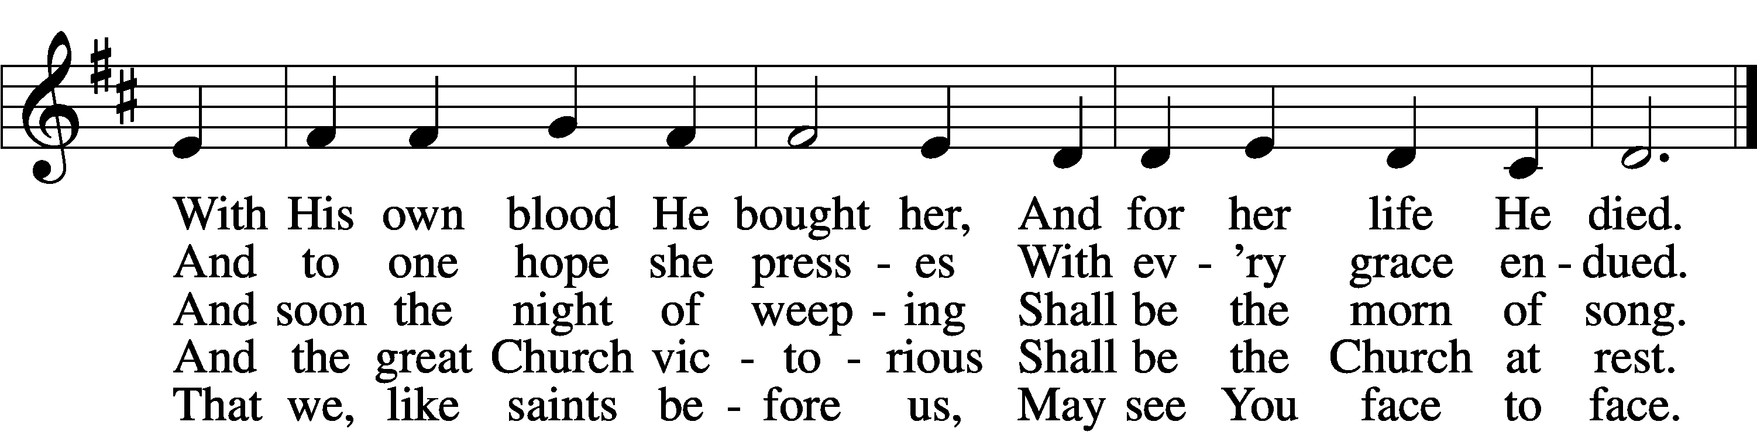

Text and tune: Public domain

*Be Seated*

**ANNOUNCEMENTS and RECOGNITION OF OUR GUESTS**

**ORGAN**

**TO THE GLORY OF GOD**

The Altar flowers are given to the glory of God

by Tom & Bethany Wayman in celebration of Madalyn's 20th birthday.

***For by grace you have been saved through faith. And this is not your own doing;***

***it is the gift of God, not a result of works, so that no one may boast.***

***Ephesians 2:8-9***

**POTLUCK LUNCH**

Join us in the Social Hall after the service for a delicious Potluck lunch and games.

**BIBLE STUDY OPPORTUNITIES**

**SUNDAY SCHOOL CLASSES ARE AT 9:00 TODAY**

**ADULT SUNDAY BIBLE STUDY**

Pastor Webb leads a Bible study titled “Are You a Disciple or a Christian?” in the Social Hall after the 8:30 service.

**CHURCH YEAR CONNECTIONS**

**(Ages 3 through High School)**

Join us for Sunday School classes for ages three through young adult. Teachers: Megan Haverland (3 years-1st Grade), Judy Bringman (2nd-5th Grade), Bob Hanovich (Middle School), and Karl Schumacher (High School).

**PARENTS & TWOS CLASS**

In this class for parents and two-year-olds, Karen Hanovich helps parents encourage their little ones as they learn about Jesus together.

**YOUNG ADULT SINGLES CLASS**

For ages 18-26, this class led by Kevin Riedl is studying “Lessons from the Underground Church.”

**21ST CENTURY PARENTING CLASS**

Parents of school-aged kids gain insight into the issues facing Gen Z and learn how to engage them in meaningful conversations. Eric and Megan Thompson lead this class in the Education Building.

**YOUNG AT HEART CLASS**

Mature members study how we can demonstrate love and compassion to people in need. Bob Reynolds and Mark Waltz lead this class on the ground floor of the Education Building.

**WEDNESDAY MORNING BIBLE STUDY**

Join us at 10:00 a.m. on Wednesday mornings in the Education Building to study the Word.

**WOMEN’S BIBLE STUDY**

The Women’s Bible Study meets on Mondays at 10:00am in the Education Building, and is studying the Parables. A Zoom link is also available. See Linda Tomko for more details.

**HAPPENING AT TRINITY**

**THANK YOU**

Thank you to Barbara Lunick for playing the organ for us.

**OFFERINGS**

Please remain faithful in bringing your offerings to the Lord by mail or online if you are unable to attend worship in person.

**LUTHERAN WOMEN'S MISSIONARY LEAGUE MITES**

LWML MITES will be collected next Sunday.

**REMEMBER TO VOTE**

**Early Voting Happening Now; Election Day, Tuesday, November 5**

Vote in the November 5 election. Check with your county Board of Elections for information about Absentee, Early In-Person, and Election Day In-Person Voting. Pray and vote and pray!

**SINGLE SERVICE for REFORMATION SUNDAY**

**Today at 10:00 (Sunday School at 9:00)**

Join us TODAY for Reformation Sunday as we celebrate with a Single Worship Service at 10:00 and a Potluck Meal afterwards. Enjoy games for children and adults. Sunday School will be at 9:00.

**ALL SAINTS’ DAY LIST**

**Add names by Today**

Use the list in the Narthex to add the names of any dearly departed you want included in the bulletin for All Saints' Sunday, November 3. Or you can contact Traci Schumacher ([trinityoffice@bellsouth.net](mailto:trinityoffice@bellsouth.net); 925-4839) with names to add.

**NOVEMBERFEST PLANTS**

**November 7-9**

Friends, please bring your plants, pretty containers, and/or yard art to Education Building, Thursday, November 7 or Friday, November 8 at 11:00am, or Saturday, November 9 at 9:00am. If you have any questions, call Shirley Lewis @ 912-925-1523 or email: [jandslewis@comcast.net](mailto:jandslewis@comcat.net). Thanks and have a blessed day. 🌼🌸🌻 Shirley

**NOVEMBERFEST**

**Saturday, November 9 at 10:00-2:00**

Come out for our annual Novemberfest on Saturday, November 9 at 10:00-2:00. There will be crafts, baked goods, and plants for sale; a lunch fundraiser for our youth; a raffle drawing; and visits with Lizzie Comfort Dog. Join us!

**LUTHERANS FOR LIFE REGIONAL CONFERENCE**

**Saturday, November 9 in Winter Garden, FL**

Join fellow Lutherans in following Christ Jesus as His “Life Shines in Darkness.” Learn and grow together at *Zion Evangelical Lutheran Church in Winter Garden, Florida, on Saturday, November 9,* for this one-day in-person event. Register and find details at <https://lutheransforlife.org/conferences/>

**DINNER & A MOVIE NIGHT**

**Friday, November 15 at 6:00**

Please join us for Dinner and a Movie Night hosted by the Youth on Friday, November 15, starting with dinner at 6 pm, in the Social Hall. The dinner will be spaghetti and meatballs, salad, dessert, and refreshments. The movie, “God’s Not Dead,” will start at 6:30 pm. Popcorn and other refreshments will be available during the movie. The cost is $10 and includes dinner, a movie, and all refreshments. A sign-up sheet is in the Narthex. Please contact Bob Hanovich for additional information. LET’S GO!

**SINGLE SERVICE & VOTERS MEETING**

**Sunday, November 17 at 10:00 (Sunday School at 9:00, Voters Meeting after Worship)**

On Sunday, November 17, we will have Sunday School at 9:00, a Single Worship Service at 10:00, and our fall Voters Meeting after worship. The meeting will include presentations by our various Boards and voting on the budget for the new year. Please plan to be there!

**THANK YOU**

Thank you to everyone for your prayers, cards, calls, flowers, and snacks while I've been out with surgery and recuperation. We appreciate the offers for rides to the doctors and meetings at church. You all were a blessing to us. God Bless our loving church. Rosemary and family.

**T-SHIRTS**

The Youth are selling t-shirts to raise funds for the LCMS Youth Gathering. The t-shirts have a small cross encircled by the phrase, “I am a beloved child of the heavenly King” on the front left and a Bible verse on the back of the t-shirt. The t-shirts will be sold for $20 each and $6.10 will be added to the Youth Ministry Designated Funds for each t-shirt sold. T-shirts are available for viewing and purchase in the Social Hall after Divine Service. Please contact Bob Hanovich for additional information. LET’S GO!

**HURRICANES HELENE & MILTON RELIEF**

If you would like to help the people affected by the recent hurricanes, you can donate to the LCMS Disaster Response efforts. Online: lcms.org/givenow/disaster; Text LCMSDISASTERS to 41444; Call 888-930-4438; Mail check payable to LCMS with memo “Disaster Response – Strategic Use (TR9206)” to LCMS, PO Box 66861, St Louis, MO 63166-6861. See the flyers on the table in the Narthex for more details.

**NOVEMBER WEDDING ANNIVERSARIES**

Todd & Penny Freesemann 11/1, Sherry & Joel Kreger 11/2, Bill & Sharon Johnson 11/18

**CHECK THE CALENDAR**

Curious what’s going on? Planning an event? Check the Trinity calendar on our website anytime ([www.trinitylutheransavannah.com](http://www.trinitylutheransavannah.com)/connect/calendar.cfm). If you need to schedule an event, please contact Traci in the office ([trinityoffice@bellsouth.net](mailto:trinityoffice@bellsouth.net), 912-925-4839). Thanks!

**CONNECT WITH US**

Connect with TLC and keep up with what’s going on.

\***Website** - [www.trinitylutheransavannah.com](http://www.trinitylutheransavannah.com)  
\***Facebook** - Friends of Trinity Lutheran Church; Trinity Lutheran Church of Savannah Media; Lizzie Comfort Dog  
\***Instagram** - #lcck9lizzie (Lizzie Comfort Dog)

\***YouTube** – Trinity Lutheran Savannah

**DEADLINE for BULLETIN ANNOUNCEMENTS**

**Every Wednesday by 9:00am**

Email bulletin announcements to [trinityoffice@bellsouth.net](mailto:trinityoffice@bellsouth.net) prior to 9:00am on Wednesdays.

**MINISTRY NEEDS**

**BLANKETS & JACKETS**

Hearts of Compassion is collecting new and gently used blankets and jackets to prepare for the cold months. Please place items in the basket in the Narthex. If you have any questions, please see Jennifer Wolfe.

**TODAY'S WORSHIP SERVICE**

Traditional 10:00 a.m.

**IN RESPONSE TO THE GOSPEL LAST SUNDAY**

8:30 a.m. – 59 11:00 a.m. – 47 Facebook – 151 YouTube – 8

Giving $4,454.42

Building Repair Fund 218.00

Comfort Dog 50.00

Food Pantry 70.00

LCMS Disaster Response 300.00

Pastor's Discretionary Fund 100.00

**SERVING IN THE LORD'S HOUSE TODAY**

**10:00 a.m.**

Jackie Deemer, Reader

Jackie Deemer, Greeter Barbara Prieto, Greeters

Chris Cesaroni & Barbara Duch, Ushers John Anander, Usher

**SERVING NEXT SUNDAY**

**8:30 a.m. 11:00 a.m.**

Pat Sautter, Reader

Bob & Cindy Reynolds, Greeters Shirley Lewis, Greeter

Larry Futch & Karl Schumacher, Ushers Mark & Ann Waltz, Ushers

**THIS WEEK AT A GLANCE**

TODAY Single Traditional Worship Service 10:00 a.m.

Sunday School 9:00 a.m.

Potluck Lunch after Worship

Confirmation Class 12:30 p.m.

Young Adult Singles Meeting

Reformation Sunday

MONDAY 10/28 Women’s Bible Study (Education Building) 10:00 a.m.

Cub Scouts (Social Hall) 6:00-8:00 p.m.

TUESDAY 10/29 Clothes Closet 4:00-6:00 p.m.

Cub Scouts (Social Hall) 6:00-8:00 p.m.

WEDNESDAY 10/30 Bible Study (Education Building) 10:00 a.m.

THURSDAY 10/31 Clothes Closet 10:00 a.m.-1:00 p.m.

Crafters (Education Building) 10:00 a.m.-2:00 p.m.

NAMI (Education Building) 6:00-7:00 p.m.

FRIDAY 11/1 Meals for Homeless (Education Building Kitchen) 4:00 p.m.

SATURDAY 11/2 Set Clocks Back 1 Hour before going to bed

**REMEMBER IN PRAYER**

*(Please help us keep the prayer list updated)*

CANCER

Wendy Holland; Harold LaMarr; Samuel Martin (19)

PEACE

Israel, Ukraine, & all who suffer from war and violence

OUR WITNESS

Let us proclaim Jesus Christ is risen to all!

OUR CONCERNS

Raise up those, Lord, who would serve Your Church.

**TRINITY LUTHERAN CHURCH**

12391 Mercy Blvd

Savannah, GA 31419

phone 912-925-4839 [trinityoffice@bellsouth.net](mailto:trinityoffice@bellsouth.net)

fax 912-925-4056 www.trinitylutheransavannah.com

Contact Pastor: 717-333-6263; pastorjeffwebb@yahoo.com

**STAFF**

Jeff Webb, Pastor

Traci Schumacher, Administrative Assistant

Helen Williams, Church Custodian

**BOARD OF ELDERS**

Mark Waltz, Head Elder (C – E)

Mike Fajen (K – Mc)

Todd Freesemann (F – J)

Jacob Johnson (Various)

Sonny Massey (A – B)

Bob Reynolds (Me – Sa)

Tom Wayman (Sc – Z)

**CHURCH COUNCIL**

Kip Wiltse, President

Eric Thompson, Vice President

Cathy Crotwell, Secretary

Karl Schumacher, Treasurer

Megan Haverland, Board of Education

Mark Waltz, Board of Elders

Chris Garretson, Board of Evangelism

Charles Rogers, Board of Property Management

Jennifer Wolfe, Board of Social Ministry

Lonna McEwen, Board of Stewardship

Cindy Reynolds, Financial Secretary

Bob Hanovich, Board of Youth

**ORGANIZATIONAL LEADERS**

Cindy Baldwin, Comfort Dog Top Dog

Jackie Deemer, Director of TLC Singers & LWML President

Megan Thompson, Sunday School Superintendent

Rosemary Gerdes, Quilters

Karen Hanovich, TLC Marketing

Lonna McEwen, Altar Guild

Rose Pitt, Prayer Team