Trinity Lutheran Church

**The Lutheran Church-Missouri Synod**

**Trinity Lutheran Church**

**Trinity Lutheran Church**

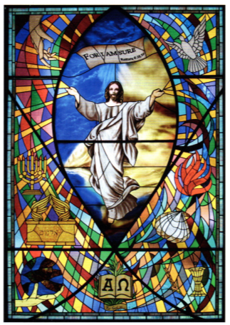

**12391 Mercy Blvd. · Savannah, GA 31419 · (912) 925-4839**

**www.trinitylutheransavannah.com**

8:30 & 11:00 a.m. Divine Service

**Trinity Lutheran Church**

**The Twenty-Fifth Sunday after Pentecost**

**Consecration Sunday**

**November 10, 2024, 8:30 Non-Communion and 11:00 a.m. Communion Service**

**WELCOME TO TRINITY!**

Thank you for worshipingwith us today. We want to know who you are, so please provide your contact information in the Friendship Book as it is passed during the Offertory. If you are visiting, honor us by signing the Guest Register in the Narthex.

There are times in our worship service where we stand or kneel. Feel free to participate in either as you are able or feel comfortable to remain seated.

Gluten-free wafers are available upon request during communion services. Please speak to the pastor before service if you wish to receive the host in this form.

Please ask an usher should you require a hearing assistance device.

(†) ~ Those who wish may make the sign of the Cross in remembrance of their Baptism.

**RECEPTION OF HOLY COMMUNION**

If you are not a member of Trinity Lutheran Church, we ask that you speak with the pastor prior to the service before receiving the Lord’s Supper.

**REQUESTS FOR PRAYER**

If you have a prayer request, please fill out a Blue Card from the pew rack and place it in the offering plate. Prayer requests may also be emailed to [trinityoffice@bellsouth.net](mailto:trinityoffice@bellsouth.net) or to pastorjeffwebb@yahoo.com.

**FOR PARENTS WITH YOUNG CHILDREN**

We are delighted that you have brought your child to worship! We invite you to use the Cry Room as a courtesy to others if your little one gets a little rambunctious. Our Cry Room, complete with seating and children's activities, is located at the back of the Sanctuary. The service can be heard through the sound system. We hope your children feel glad they were here and that they are a part of the Trinity family!

***Our Vision:***

***Growing in God’s Word to Share Christ’s Love***

***Our Mission:***

***Led by God, equipped as disciples through Word and Sacrament,***

***we are empowered by the Holy Spirit to reach out with the Gospel of Jesus Christ to all.***



**AS WE GATHER TODAY**

As the liturgical year is coming to its end, God our Father gives us great encouragement that our salvation and deliverance from sin and sorrow is complete because of the forgiveness won for us by the blood of Jesus, the one and only sacrifice for your sin and the source of daily cleansing, faith, hope, confidence, and love. This faith is certain and full of hope even if your current circumstances would have you think otherwise. As God provided for the widow of Zarephath (1 Kings 17), so was the widow’s offering (Mark 12) an expression of confident faith in God’s promised salvation. No clearer picture can be given of the certainty of hope in Christ our Savior than in the letter to the Hebrews as it tells of Christ’s once-for-all sacrifice that not only forgives but takes away all sin and supplies us with newness of life by His life-giving body and blood all our days!

**Divine Service**

***Setting Four***

**ORGAN**

**WELCOME**

**CHIMING OF THE HOUR**

**Confession and Absolution**

*Please Stand*

**PROCESSIONAL HYMN 728 "How Firm a Foundation"**

Text and tune: Public domain

**INVOCATION**

P In the name of the Father and of the (†) Son and of the Holy Spirit.

C **Amen.** *Matthew 28:19b*

P Our help is in the name of the Lord,

C **who made heaven and earth.** *Psalm 124:8*

P Since we are gathered to hear God’s Word, call upon Him in prayer and praise, and receive the body and blood of our Lord Jesus Christ in the fellowship of this altar, let us first consider our unworthiness and confess before God and one another that we have sinned in thought, word, and deed, and that we cannot free ourselves from our sinful condition. Together as His people let us take refuge in the infinite mercy of God, our heavenly Father, seeking His grace for the sake of Christ, and saying: God, be merciful to me, a sinner. *[Luke 18:13]*

C **Almighty God, have mercy upon us, forgive us our sins, and lead us to everlasting life. Amen.**

P Almighty God in His mercy has given His Son to die for you and for His sake forgives you all your sins. As a called and ordained servant of Christ, and by His authority, I therefore forgive you all your sins in the name of the Father and of the (†) Son and of the Holy Spirit.

C **Amen.** *[John 20:19-23]*

**Service of Holy Baptism**

**(11:00 Service)**

Receiving Christ's "washing of regeneration" today is ***Charlotte Evelyn Koch***, born on September 17, 2021. The Service of Holy Baptism is found on page 268 in the hymnal.

**BAPTISMAL HYMN 590 vv. 1-2 "Baptized into Your Name Most Holy"**

Text and tune: Public domain

**Service of the Word**

**PSALM *Psalm 146***

P 1Praise the Lord!  
C **Praise the Lord, O my soul!**

P 2I will praise the Lord as long as I live;  
C **I will sing praises to my God while I have my being.**

P 3Put not your trust in princes,  
C  **in a son of man, in whom there is no salvation.**

P 4When his breath departs he returns to the earth;  
C **on that very day his plans perish.**

P 5Blessèd is he whose help is the God of Jacob,  
C  **whose hope is in the Lord his God,**

P 6who made heaven and earth, the sea, and all that is in them,  
C  **who keeps faith forever;**

P 7who executes justice for the oppressed,  
C **who gives food to the hungry.**

P The Lord sets the prisoners free; 8the Lord opens the eyes of the blind.  
C **The Lord lifts up those who are bowed down;  
 the Lord loves the righteous.**

P 9The Lord watches over the sojourners;   
 he upholds the widow and the fatherless,  
C  **but the way of the wicked he brings to ruin.**

P 10The Lord will reign forever,  
 C **your God, O Zion, to all generations. Praise the Lord!**

**All Glory be to the Father and to the Son and to the Holy Spirit;**

**as it was in the beginning, is now, and will be forever. Amen.**

**KYRIE ~ *Lord, Have Mercy*** *Mark 10:47*

**GLORIA IN EXCELSIS ~ *Glory to God in the Highest*** *Luke 2:14; John 1:29*

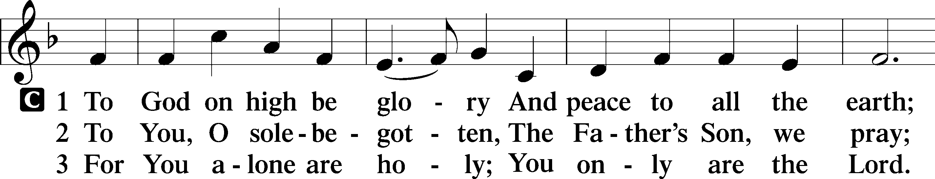

**SALUTATION and COLLECT OF THE DAY**

P The Lord be with you. *2 Timothy 4:22*

C **And also with you.**

P Let us pray.

Almighty and ever-living God, You have given exceedingly great and precious promises to those who trust in You. Grant us so firmly to believe in Your Son Jesus that our faith may never be found wanting; through the same Jesus Christ, our Lord, who lives and reigns with You and the Holy Spirit, one God, now and forever.

C **Amen.**

*Be Seated*

**OLD TESTAMENT LESSON *1 Kings 17:8–16***

8Then the word of the Lord came to [Elijah], 9“Arise, go to Zarephath, which belongs to Sidon, and dwell there. Behold, I have commanded a widow there to feed you.” 10So he arose and went to Zarephath. And when he came to the gate of the city, behold, a widow was there gathering sticks. And he called to her and said, “Bring me a little water in a vessel, that I may drink.” 11And as she was going to bring it, he called to her and said, “Bring me a morsel of bread in your hand.” 12And she said, “As the Lord your God lives, I have nothing baked, only a handful of flour in a jar and a little oil in a jug. And now I am gathering a couple of sticks that I may go in and prepare it for myself and my son, that we may eat it and die.” 13And Elijah said to her, “Do not fear; go and do as you have said. But first make me a little cake of it and bring it to me, and afterward make something for yourself and your son. 14For thus says the Lord the God of Israel, ‘The jar of flour shall not be spent, and the jug of oil shall not be empty, until the day that the Lord sends rain upon the earth.’” 15And she went and did as Elijah said. And she and he and her household ate for many days. 16The jar of flour was not spent, neither did the jug of oil become empty, according to the word of the Lord that he spoke by Elijah.

A This is the Word of the Lord.

C **Thanks be to God.**

**EPISTLE LESSON*****Hebrews 9:24–28***

24For Christ has entered, not into holy places made with hands, which are copies of the true things, but into heaven itself, now to appear in the presence of God on our behalf. 25Nor was it to offer himself repeatedly, as the high priest enters the holy places every year with blood not his own, 26for then he would have had to suffer repeatedly since the foundation of the world. But as it is, he has appeared once for all at the end of the ages to put away sin by the sacrifice of himself. 27And just as it is appointed for man to die once, and after that comes judgment, 28so Christ, having been offered once to bear the sins of many, will appear a second time, not to deal with sin but to save those who are eagerly waiting for him.

A This is the Word of the Lord.

C **Thanks be to God.**

*Please Stand*

**ALLELUIA and VERSE** *John 20:31*

**HOLY GOSPEL *Mark 12:38–44***

P The Holy Gospel according to St. Mark, the twelfth chapter.

**C Glory to You, O Lord.**

38In his teaching [Jesus] said, “Beware of the scribes, who like to walk around in long robes and like greetings in the marketplaces 39and have the best seats in the synagogues and the places of honor at feasts, 40who devour widows’ houses and for a pretense make long prayers. They will receive the greater condemnation.”

41And he sat down opposite the treasury and watched the people putting money into the offering box. Many rich people put in large sums. 42And a poor widow came and put in two small copper coins, which make a penny. 43And he called his disciples to him and said to them, “Truly, I say to you, this poor widow has put in more than all those who are contributing to the offering box. 44For they all contributed out of their abundance, but she out of her poverty has put in everything she had, all she had to live on.”

P This is the Gospel of the Lord.

**C Praise to You, O Christ.**

**NICENE CREED**

**I believe in one God, the Father Almighty, maker of heaven and earth and of all things visible and invisible.**

**And in one Lord Jesus Christ, the only-begotten Son of God, begotten of His Father before all worlds, God of God, Light of Light, very God of very God, begotten, not made, being of one substance with the Father, by whom all things were made; who for us men and for our salvation came down from heaven and was incarnate by the Holy Spirit of the virgin Mary and was made man; and was crucified also for us under Pontius Pilate. He suffered and was buried. And the third day He rose again according to the Scriptures and ascended into heaven and sits at the right hand of the Father. And He will come again with glory to judge both the living and the dead, whose kingdom will have no end.**

**And I believe in the Holy Spirit, the Lord and Giver of life, who proceeds from the Father and the Son, who with the Father and the Son together is worshiped and glorified, who spoke by the prophets. And I believe in one holy Christian and apostolic Church, I acknowledge one Baptism for the remission of sins, and I look for the resurrection of the dead and the life of the world to come. Amen.**

*Be Seated*

**CHILDREN'S MESSAGE *8:30 Service***

**HYMN OF THE DAY 782 "Gracious God, You Send Great Blessings"**

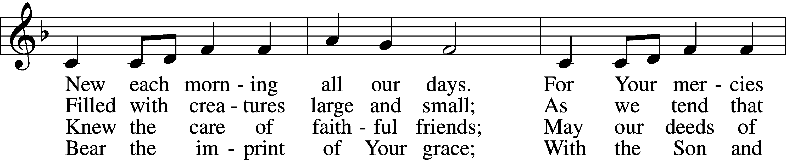

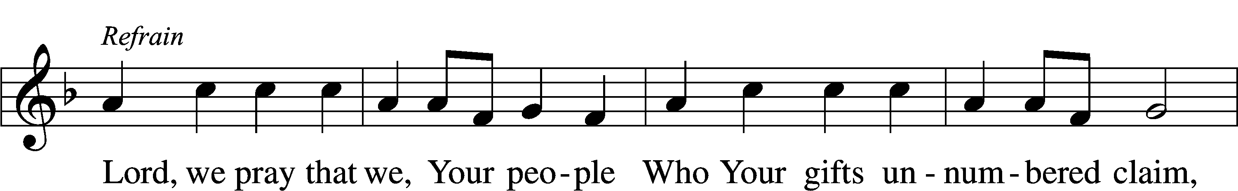

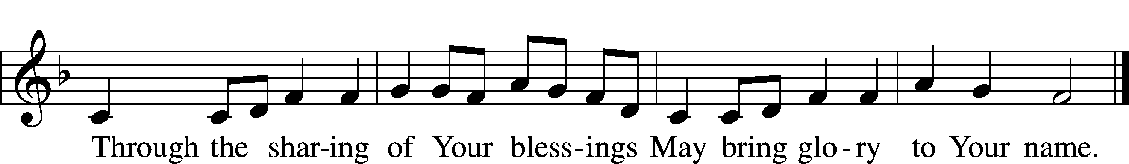

Text: © 2004 Gregory J. Wismar. Used by permission: LSB Hymn License no. 110000966  
Tune: Public domain

**SERMON "Christ’s All-Sufficient Sacrifice" *Hebrews 9:24–28***

**OFFERING** *(Please fill out and pass the red Friendship Book at this time; and fill out the blue card in the pew rack for prayers.)*

*Please Stand*

**OFFERTORY 781 vv. 1, 2 “We Give Thee but Thine Own”**

Text and tune: Public domain

*Kneel or Be Seated*

**PRAYER OF THE CHURCH** *[1 Timothy 2:1-4]*

**PRAYER FOR CONSECRATION SUNDAY**

P In Paul's Second letter to the Corinthians, he says "Each one must do as he has made up his mind, not reluctantly or under compulsion, for God loves a cheerful giver. And God is able to provide you with every blessing in abundance, so that you may always have enough of everything and may provide in abundance for every good work." 2 Corinthians 9:7-8

P Let us pray,

**All Lord God, we lift up our voices to thank You today! We thank You for transforming our lives, declaring us holy through Jesus Christ, our Lord. We thank You for the gifts of faith and life, of hope and peace that Jesus brings to us. Now, we come before You today to consecrate for Your service that which You have given to us for mission and ministry. In Jesus' name we pray. Amen.**

**COMPLETION OF ESTIMATE OF GIVING CARDS**

**Non-Communion Service (8:30)**

**LORD'S PRAYER** *Matthew 6:9-13*

**Our Father who art in heaven, hallowed be Thy name, Thy kingdom come, Thy will be done on earth as it is in heaven. Give us this day our daily bread; and forgive us our trespasses as we forgive those who trespass against us; and lead us not into temptation, but deliver us from evil. For Thine is the kingdom and the power and the glory forever and ever. Amen**.

*Please Stand*

**BENEDICAMUS and BENEDICTION**

P Let us bless the Lord. *[Psalm 103:1]*

C **Thanks be to God.**

P The Lord bless you and keep you. The Lord make His face shine on you and be gracious to you. The Lord look upon you with favor and (†) give you peace. *Numbers 6:24-26*

C **Amen.**

**CLOSING HYMN 917** **"Savior, Again to Thy Dear Name We Raise"**

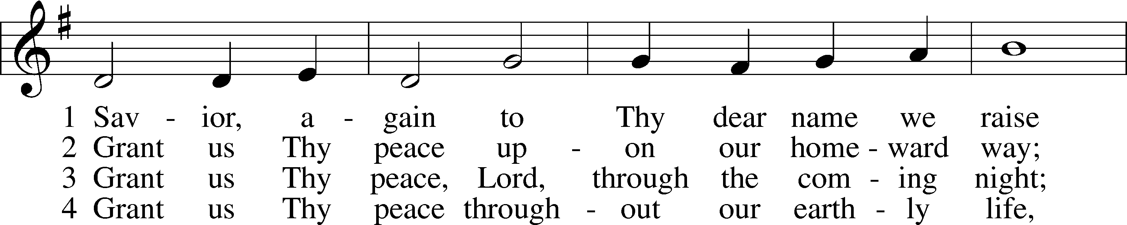

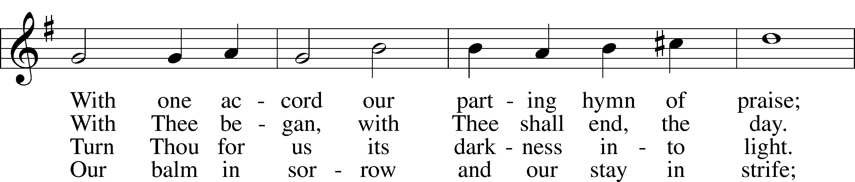

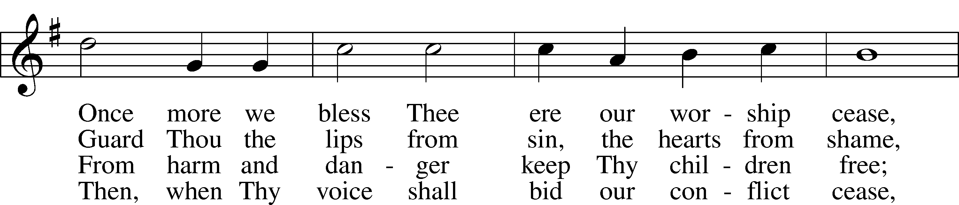

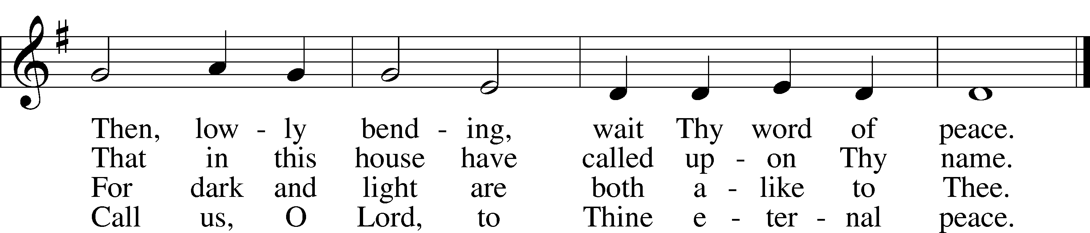

Text and tune: Public domain

*Be Seated*

**Service of the Sacrament (11:00)**

*The Sacrament, or Lord's Supper, is a special gift from God that brings us into personal communion with Jesus Christ. "In, with and under" the bread and wine we receive His body and blood for forgiveness and renewal. If you are a repentant sinner, come to the table expecting to receive God's wonderful gifts for you!*

*Communicants will take their own wine cups as they are passed. Those requiring non-alcoholic grape juice will take the cups with white grape juice from the middle of the tray.*

*Be Seated*

**OUR EXAMINATION**

P In preparation for Holy Communion, St. Paul tells us in 1 Corinthians 11:27-29, “Whoever, therefore, eats the bread or drinks the cup of the Lord in an unworthy manner will be guilty concerning the body and blood of the Lord. 28Let a person examine himself, then, and so eat of the bread and drink of the cup. 29For anyone who eats and drinks without discerning the body eats and drinks judgment on himself.” So that we may properly examine ourselves prior to receiving the Lord’s Supper, I ask you to reflect on these questions:

* Do you repent of all your sins of thought, word, and deed?
* Do you believe that Jesus Christ is your only Savior from all sin, Satan, and death?
* Do you believe that the Risen Christ is really present in the Sacrament and that in, with, and under the bread and wine you receive His true Body and Blood?

If you answer in faith "Yes!" to these questions, and are properly instructed, you are invited to come forward and partake of the Lord's Supper during Distribution. If you are unable to answer yes to any of these questions, you are invited to come forward, cross your arms as I approach you and receive a blessing. By your coming forward, "You proclaim the Lord's death until He comes."

*Please Stand*

**PREFACE**

P The Lord be with you. *2 Timothy 4:22*

**C And also with you.**

P Lift up your hearts. *[Colossians 3:1]*

**C We lift them to the Lord.**

P Let us give thanks to the Lord, our God. *[Psalm 136]*

**C It is right to give Him thanks and praise.**

P It is truly good, right, and salutary that we should at all times and in all places give thanks to You, O Lord, holy Father, almighty and everlasting God, for the countless blessings You so freely bestow on us and all creation. Above all, we give thanks for Your boundless love shown to us when You sent Your only-begotten Son, Jesus Christ, into our flesh and laid on Him our sin, giving Him into death that we might not die eternally. Because He is now risen from the dead and lives and reigns to all eternity, all who believe in Him will overcome sin and death and will rise again to new life. Therefore with angels and archangels and with all the company of heaven we laud and magnify Your glorious name, evermore praising You and singing:

**SANCTUS ~ *Holy, Holy, Holy*** *Isaiah 6:3; Matthew 21:9*

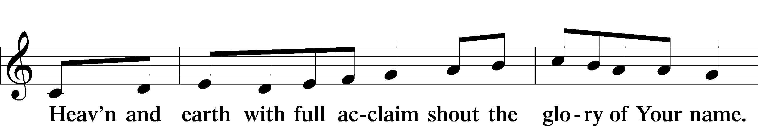

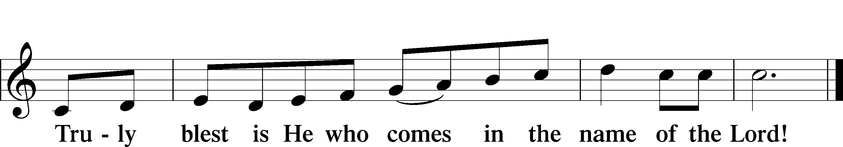

**PRAYER OF THANKSGIVING**

P Blessed are You, O Lord our God, king of all creation, for You have had mercy on us and given Your only-begotten Son that whoever believes in Him should not perish but have eternal life.

In Your righteous judgment You condemned the sin of Adam and Eve, who ate the forbidden fruit, and You justly barred them and all their children from the tree of life. Yet, in Your great mercy, You promised salvation by a second Adam, Your Son, Jesus Christ, our Lord, and made His cross a life-

giving tree for all who trust in Him.

We give You thanks for the redemption You have prepared for us through Jesus Christ. Grant us Your Holy Spirit that we may faithfully eat and drink of the fruits of His cross and receive the blessings of forgiveness, life, and salvation that come to us in His body and blood.

Hear us as we pray in His name and as He has taught us:

**LORD'S PRAYER** *Matthew 6:9-13*

**Our Father who art in heaven, hallowed be Thy name, Thy kingdom come, Thy will be done on earth as it is in heaven. Give us this day our daily bread; and forgive us our trespasses as we forgive those who trespass against us; and lead us not into temptation, but deliver us from evil. For Thine is the kingdom and the power and the glory forever and ever. Amen**.

**THE WORDS OF OUR LORD** *Matthew 26:26-28; Mark 14:22-24;*

*Luke 22:19-20; 1 Corinthians 11:23-25*

P Our Lord Jesus Christ, on the night when He was betrayed, took bread, and when He had given thanks, He broke it and gave it to the disciples and said: “Take, eat; this is My body, which is given for you. This do in remembrance of Me.” In the same way also He took the cup after supper, and when He had given thanks, He gave it to them, saying: "Drink of it, all of you; this is my blood of the new covenant, which is poured out for you for the remission of sins. This do as often as you drink it, in remembrance of Me."

**PAX DOMINI ~ *The Peace of the Lord*** *John 20:19*

PThe peace of the Lord be with you always.

C **And also with you.**

**AGNUS DEI ~ *Lamb of God*** *John 1:29*

*Be Seated*

**DISTRIBUTION HYMN**

**HYMN 783 "Take My Life and Let It Be"**

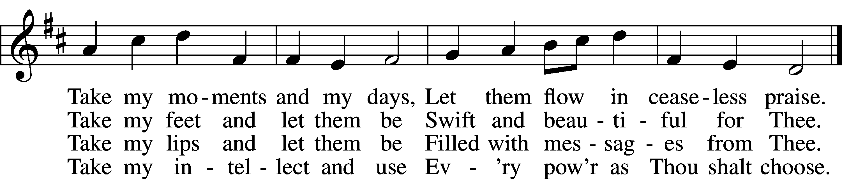

5 Take my will and make it Thine,  
It shall be no longer mine;  
Take my heart, it is Thine own,  
It shall be Thy royal throne.

6 Take my love, my Lord, I pour  
At Thy feet its treasure store;  
Take myself, and I will be  
Ever, only, all for Thee.

Text and tune: Public domain

*Please Stand*

**NUNC DIMITTIS ~ *Song of Simeon*** *Luke 2:29-32*

**POST-COMMUNION COLLECT**

P Let us pray.

Gracious God, our heavenly Father, You have given us a foretaste of the feast to come in the Holy Supper of Your Son's body and blood. Keep us firm in the true faith throughout our days of pilgrimage that, on the day of His coming, we may, together with all Your saints, celebrate the marriage feast of the Lamb in His kingdom which has no end; through Jesus Christ, Your Son, our Lord, who lives and reigns with You and the Holy Spirit, one God, now and forever.

C **Amen.**

**BENEDICAMUS and BENEDICTION**

P Let us bless the Lord. *[Psalm 103:1]*

C **Thanks be to God.**

P The Lord bless you and keep you. The Lord make His face shine on you and be gracious to you. The Lord look upon you with favor and (†) give you peace. *Numbers 6:24-26*

C **Amen.**

**CLOSING HYMN 917** **"Savior, Again to Thy Dear Name We Raise"**

Text and tune: Public domain

*Be Seated*

**ANNOUNCEMENTS and RECOGNITION OF OUR GUESTS**

**ORGAN**

**TO THE GLORY OF GOD**

The Altar flowers are given to the glory of God

by Pastor Webb in celebration of Cathleen’s birthday.

***Give thanks in all circumstances; for this is the will of God in Christ Jesus for you.***

***1 Thessalonians 5:18***

**COFFEE & CONVERSATION**

Join us in the Social Hall after the 8:30 service for coffee and breakfast goodies.

**BIBLE STUDY OPPORTUNITIES**

**\*WEDNESDAY BIBLE STUDY IS CANCELLED THIS WEEK\***

**ADULT SUNDAY BIBLE STUDY**

Pastor Webb leads a Bible study titled “Are You a Disciple or a Christian?” in the Social Hall after the 8:30 service.

**CHURCH YEAR CONNECTIONS**

**(Ages 3 through High School)**

Join us for Sunday School classes for ages three through young adult. Teachers: Megan Haverland (3 years-1st Grade), Judy Bringman (2nd-5th Grade), Bob Hanovich (Middle School), and Karl Schumacher (High School).

**PARENTS & TWOS CLASS**

In this class for parents and two-year-olds, Karen Hanovich helps parents encourage their little ones as they learn about Jesus together.

**YOUNG ADULT SINGLES CLASS**

For ages 18-26, this class led by Kevin Riedl is studying “Lessons from the Underground Church.”

**21ST CENTURY PARENTING CLASS**

Parents of school-aged kids gain insight into the issues facing Gen Z and learn how to engage them in meaningful conversations. Eric and Megan Thompson lead this class in the Education Building.

**YOUNG AT HEART CLASS**

Mature members study how we can demonstrate love and compassion to people in need. Bob Reynolds and Mark Waltz lead this class on the ground floor of the Education Building.

**WEDNESDAY MORNING BIBLE STUDY**

Join us at 10:00 a.m. on Wednesday mornings in the Education Building to study the Word.

**WOMEN’S BIBLE STUDY**

The Women’s Bible Study that meets on Mondays at 10:00am in the Education Building is currently taking a break and will resume in January. See Linda Tomko for more details.

**HAPPENING AT TRINITY**

**THANK YOU**

Thank you to Barbara Lunick for playing the organ for us.

**OFFERINGS**

Please remain faithful in bringing your offerings to the Lord by mail or online if you are unable to attend worship in person.

**TODAY IS "CAN DO SUNDAY"**

Please place your food items in the grocery cart in the Social Hall to help provide a meal for those in need who visit our Food Pantry. As always, thank you for your participation.

**PLEDGE FORMS**

Completed pledge forms can be placed in the offering plate as it is passed.

**BOOKS FOR CHILDREN**

**8:30 Service Today**

The children in the 8:30 service can get a book on Thanksgiving which reminds us to thank God for everything. There are a few books which tell about the first Thanksgiving. Parents can come to the front of the church at the end of the service and pick out a book that they feel is a good choice for their child (children). There are extra books available so, if you have a young child in your life who may not come to our church or Sunday School, then take a book after the service to help him/ her to remember the real reason for Thanksgiving.

**VETERANS BREAKFAST**

**Today**

We invite all veterans to join us for breakfast this morning. A special table is in honor of your service.

**WEDNESDAY BIBLE STUDY IS CANCELLED THIS WEEK**

Class will resume November 20.

**LWML LADIES’ GUILD MEETING**

**Wednesday, November 13 at 11:30 (Lunch), 12:00 (Meeting)**

All Trinity women are welcome to join our LWML Ladies’ Guild meeting this Wednesday, November 13. Lunch is at 11:30, and the meeting starts at 12:00. Hope to see you there!

**DINNER & A MOVIE NIGHT**

**Friday, November 15 at 6:00**

Please join us for Dinner and a Movie Night hosted by the Youth on Friday, November 15, starting with dinner at 6 pm, in the Social Hall. The dinner will be spaghetti and meatballs, salad, dessert, and refreshments. The movie, “God’s Not Dead,” will start at 6:30 pm. Popcorn and other refreshments will be available during the movie. The cost is $10 and includes dinner, a movie, and all refreshments. A sign-up sheet is in the Narthex. Please contact Bob Hanovich for additional information. LET’S GO!

**SINGLE SERVICE & VOTERS MEETING**

**Sunday, November 17 at 10:00 (Sunday School at 9:00, Voters Meeting after Worship)**

On Sunday, November 17, we will have Sunday School at 9:00, a Single Worship Service at 10:00, and our fall Voters Meeting after worship. The meeting will include presentations by our various Boards and voting on the budget for the new year. Please plan to be there!

**POINSETTIAS**

**Order by Sunday, December 1**

Poinsettia order forms are now available. It was necessary for the Altar Guild to pre-order poinsettias to assure we would have them for Christmas Eve. We have ordered 10 – 6” red, 10 – 6” white, and 10 – 8” red. Please order by December 1. Thank you!

**CHRISTMAS PROGRAM**

**Sunday, December 15 at 9:45am**

The Sunday School Christmas program will be December 15th at 9:45am, during the Sunday School hour. We look forward to seeing each of you there to support the kids.

**T-SHIRTS**

The Youth are selling t-shirts to raise funds for the LCMS Youth Gathering. The t-shirts have a small cross encircled by the phrase, “I am a beloved child of the heavenly King” on the front left and a Bible verse on the back of the t-shirt. The t-shirts will be sold for $20 each and $6.10 will be added to the Youth Ministry Designated Funds for each t-shirt sold. T-shirts are available for viewing and purchase in the Social Hall after Divine Service. Please contact Bob Hanovich for additional information. LET’S GO!

**HURRICANES HELENE & MILTON RELIEF**

If you would like to help the people affected by the recent hurricanes, you can donate to the LCMS Disaster Response efforts. Online: lcms.org/givenow/disaster; Text LCMSDISASTERS to 41444; Call 888-930-4438; Mail check payable to LCMS with memo “Disaster Response – Strategic Use (TR9206)” to LCMS, PO Box 66861, St Louis, MO 63166-6861. See the flyers on the table in the Narthex for more details.

**CHECK THE CALENDAR**

Curious what’s going on? Planning an event? Check the Trinity calendar on our website anytime ([www.trinitylutheransavannah.com](http://www.trinitylutheransavannah.com)/connect/calendar.cfm). If you need to schedule an event, please contact Traci in the office ([trinityoffice@bellsouth.net](mailto:trinityoffice@bellsouth.net), 912-925-4839). Thanks!

**CONNECT WITH US**

Connect with TLC and keep up with what’s going on.

\***Website** - [www.trinitylutheransavannah.com](http://www.trinitylutheransavannah.com)  
\***Facebook** - Friends of Trinity Lutheran Church; Trinity Lutheran Church of Savannah Media; Lizzie Comfort Dog  
\***Instagram** - #lcck9lizzie (Lizzie Comfort Dog)

\***YouTube** – Trinity Lutheran Savannah

**DEADLINE for BULLETIN ANNOUNCEMENTS**

**Every Wednesday by 9:00am**

Email bulletin announcements to [trinityoffice@bellsouth.net](mailto:trinityoffice@bellsouth.net) prior to 9:00am on Wednesdays.

**MINISTRY NEEDS**

**CANDY FOR MARITIME BETHEL**

Lindt Chocolates are a favorite of seafarers. During the Christmas season, captains will purchase a bag for each crew member. I would ask our Trinity family to purchase bags of Lindt chocolates for us to give them at Christmas. I will place a Christmas box in the Narthex to collect your gift. Any questions, ask me. “The Lord loves a cheerful giver.” Thank you in advance.

**ANGEL TREE HELP**

We need help to contact the 18 Angel Tree families. For more information, see Lonna McEwen.

**BLANKETS & JACKETS**

Hearts of Compassion is collecting new and gently used blankets and jackets to prepare for the cold months. Please place items in the basket in the Narthex. If you have any questions, please see Jennifer Wolfe.

**TODAY'S WORSHIP SERVICES**

Traditional 8:30 a.m. and 11:00 a.m.

**IN RESPONSE TO THE GOSPEL LAST SUNDAY**

8:30 a.m. – 59 11:00 a.m. – 51 Facebook – 181 YouTube – 0

Giving $7,824.87

Building Repair Fund 50.00

Comfort Dog 25.00

Food Pantry 35.00

Memorial - Eckes 100.00

Poinsettias 14.50

Seminary Student Willoughby 75.00

Wendy Holland 150.00

Youth 56.00

**SERVING IN THE LORD'S HOUSE TODAY**

**8:30 a.m. 11:00 a.m.**

Linda Tomko, Reader

Sharon Johnson & Linda Tomko, Greeters Marilyn McKee & Wayne White, Greeters

Gary & Patricia Bradshaw, Ushers Gretchen Holmes, Usher

**SERVING NEXT SUNDAY**

**10:00 a.m.**

Betty Morrell, Greeter Kip & Delane Wiltse, Greeters

Cathy Crotwell & JB Strange, Ushers Bob Sautter, Usher

**THIS WEEK AT A GLANCE**

TODAY Traditional Worship Services 8:30 & 11:00 a.m.

Sunday School 9:45 a.m.

Evangelism Meeting (Cry Room) 9:45-10:45 a.m.

HS Youth Group (Education Building) 11:00 a.m.-1:00 p.m.

Confirmation Class 12:30 p.m.

Youth Breakfast

Can Do Sunday

MONDAY 11/11 Cub Scouts (Social Hall) 6:00-8:00 p.m.

TUESDAY 11/12 TLC Quilters (Education Building) 10:00 a.m.-1:00 p.m.

Clothes Closet 4:00-6:00 p.m.

Cub Scouts (Social Hall) 6:00-8:00 p.m.

WEDNESDAY 11/13 Bible Study (Education Building) 10:00 a.m.

LWML Lunch & Meeting (Education Building) 11:30 a.m.

THURSDAY 11/14 Clothes Closet 10:00 a.m.-1:00 p.m.

Crafters (Education Building) 10:00 a.m.-2:00 p.m.

NAMI (Social Hall) 6:00-7:00 p.m.

Church Council (Education Building) 6:30 p.m.

FRIDAY 11/15 MS-Hosted Dinner & Movie (Social Hall) 4:00 p.m.

Meals for Homeless (Education Building Kitchen) 4:00 p.m.

SATURDAY 11/16 Workday 9:00 a.m.-12:00 p.m.

**REMEMBER IN PRAYER**

*(Please help us keep the prayer list updated)*

CANCER

Wendy Holland; Harold LaMarr; Samuel Martin (19)

STRENGTH, GUIDANCE, & PROVISION

For everyone impacted by the hurricanes & natural disasters

PEACE

Israel, Ukraine, & all who suffer from war and violence

OUR WITNESS

Let us proclaim Jesus Christ is risen to all!

OUR CONCERNS

Raise up those, Lord, who would serve Your Church.

**TRINITY LUTHERAN CHURCH**

12391 Mercy Blvd

Savannah, GA 31419

phone 912-925-4839 [trinityoffice@bellsouth.net](mailto:trinityoffice@bellsouth.net)

fax 912-925-4056 www.trinitylutheransavannah.com

Contact Pastor: 717-333-6263; pastorjeffwebb@yahoo.com

**STAFF**

Jeff Webb, Pastor

Traci Schumacher, Administrative Assistant

Helen Williams, Church Custodian

**BOARD OF ELDERS**

Mark Waltz, Head Elder (C – E)

Mike Fajen (K – Mc)

Todd Freesemann (F – J)

Jacob Johnson (Various)

Sonny Massey (A – B)

Bob Reynolds (Me – Sa)

Tom Wayman (Sc – Z)

**CHURCH COUNCIL**

Kip Wiltse, President

Eric Thompson, Vice President

Cathy Crotwell, Secretary

Karl Schumacher, Treasurer

Megan Haverland, Board of Education

Mark Waltz, Board of Elders

Chris Garretson, Board of Evangelism

Charles Rogers, Board of Property Management

Jennifer Wolfe, Board of Social Ministry

Lonna McEwen, Board of Stewardship

Cindy Reynolds, Financial Secretary

Bob Hanovich, Board of Youth

**ORGANIZATIONAL LEADERS**

Cindy Baldwin, Comfort Dog Top Dog

Jackie Deemer, Director of TLC Singers & LWML President

Megan Thompson, Sunday School Superintendent

Rosemary Gerdes, Quilters

Karen Hanovich, TLC Marketing

Lonna McEwen, Altar Guild

Rose Pitt, Prayer Team