Trinity Lutheran Church

**The Lutheran Church-Missouri Synod**

**Trinity Lutheran Church**

**Trinity Lutheran Church**

**12391 Mercy Blvd. · Savannah, GA 31419 · (912) 925-4839**

**www.trinitylutheransavannah.com**

10:00 a.m. Divine Service of Holy Communion

**Trinity Lutheran Church**

**The Twenty-Sixth Sunday after Pentecost**

**November 17, 2024, 10:00 a.m. Communion Service**

**WELCOME TO TRINITY!**

Thank you for worshipingwith us today. We want to know who you are, so please provide your contact information in the Friendship Book as it is passed during the Offertory. If you are visiting, honor us by signing the Guest Register in the Narthex.

There are times in our worship service where we stand or kneel. Feel free to participate in either as you are able or feel comfortable to remain seated.

Gluten-free wafers are available upon request during communion services. Please speak to the pastor before service if you wish to receive the host in this form.

Please ask an usher should you require a hearing assistance device.

(†) ~ Those who wish may make the sign of the Cross in remembrance of their Baptism.

**RECEPTION OF HOLY COMMUNION**

If you are not a member of Trinity Lutheran Church, we ask that you speak with the pastor prior to the service before receiving the Lord’s Supper.

**REQUESTS FOR PRAYER**

If you have a prayer request, please fill out a Blue Card from the pew rack and place it in the offering plate. Prayer requests may also be emailed to [trinityoffice@bellsouth.net](mailto:trinityoffice@bellsouth.net) or to pastorjeffwebb@yahoo.com.

**FOR PARENTS WITH YOUNG CHILDREN**

We are delighted that you have brought your child to worship! We invite you to use the Cry Room as a courtesy to others if your little one gets a little rambunctious. Our Cry Room, complete with seating and children's activities, is located at the back of the Sanctuary. The service can be heard through the sound system. We hope your children feel glad they were here and that they are a part of the Trinity family!

***Our Vision:***

***Growing in God’s Word to Share Christ’s Love***

***Our Mission:***

***Led by God, equipped as disciples through Word and Sacrament,***

***we are empowered by the Holy Spirit to reach out with the Gospel of Jesus Christ to all.***



**AS WE GATHER TODAY**

The ending of a liturgical year speaks of the end of all things. Our Lord spoke plainly about the end of the world. There are signs the end is coming. Jesus’ teaching seems to elicit only question marks on our part. “When?” “What?” “How?” The signs He speaks of include false teachers in the church, wars, rumors of wars, and earthquakes as “but the beginning of the birth pains” (Mark 13:8). The Jewish people of Jesus’ time on earth would be alarmed at His prediction of the destruction of the temple as it would mean the end of their faith and hope in God. The world is to see, however, that the loving, saving God is closer than ever in the new temple of the flesh and blood of Jesus Christ, crucified and risen again for the life of the world. As the beloved hymn says, our “hope is built on nothing less than Jesus’ blood and righteousness.” No merit of our own can prepare us “when darkness veils, . . . in every high and stormy gale, . . . in the raging flood; when every earthly prop gives way.” No matter what comes we are “clothed in His righteousness alone, redeemed to stand before His throne! On Christ, the solid rock, I stand; all other ground is sinking sand” (*LSB* 575/576).

**Divine Service**

***Setting One***

**ORGAN**

**WELCOME**

**CHIMING OF THE HOUR**

*Please Stand*

**PROCESSIONAL HYMN 793 "Praise, My Soul, the King of Heaven"**

Text and tune: Public domain

**INVOCATION**

*(The sign of the cross may be made by all in remembrance of their Baptism.)*

P In the name of the Father and of the (†) Son and of the Holy Spirit.

C **Amen.** *Matthew 28:19b*

P If we say we have no sin, we deceive ourselves and the truth is not in us.

C **But if we confess our sins, God, who is faithful and just, will forgive our sins and cleanse us from all unrighteousness.** *1 John 1:8-9*

*Kneel or Be Seated*

**CONFESSION AND ABSOLUTION**

P Let us then confess our sins to God our Father.

*(Silence for reflection on God's Word and for self-examination.)*

P Most merciful God,

C **we confess that we are by nature sinful and unclean. We have sinned against You in thought, word, and deed, by what we have done and by what we have left undone. We have not loved You with our whole heart; we have not loved our neighbors as ourselves. We justly deserve Your present and eternal punishment. For the sake of Your Son, Jesus Christ, have mercy on us. Forgive us, renew us, and lead us, so that we may delight in Your will and walk in Your ways to the glory of Your holy name. Amen.**

P Almighty God in His mercy has given His Son to die for you and for His sake forgives you all your sins. As a called and ordained servant of Christ, and by His authority, I therefore forgive you all your sins in the name of the Father and of the (†) Son and of the Holy Spirit. *[John 20:19-23]*

C **Amen.**

**Service of the Word**

*Please Stand*

**PSALM *Psalm 16***

P 1Preserve me, O God,  
C **for in you I take refuge.**

P 2I say to the Lord, “You are my Lord;  
C **I have no good apart from you.”**

P 3As for the saints in the land,  
C **they are the excellent ones, in whom is all my delight.**

P 4The sorrows of those who run after another god shall multiply;  
C **their drink offerings of blood I will not pour out   
 or take their names on my lips.**

P 5The Lord is my chosen portion and my cup;  
C **you hold my lot.**

P 6The lines have fallen for me in pleasant places;  
C **indeed, I have a beautiful inheritance.**

P 7I bless the Lord who gives me counsel;  
C  **in the night also my heart instructs me.**

P 8I have set the Lord always before me;  
C **because he is at my right hand, I shall not be shaken.**

P 9Therefore my heart is glad, and my whole being rejoices;  
C **my flesh also dwells secure.**

P 10For you will not abandon my soul to Sheol,  
C **or let your holy one see corruption.**

P 11You make known to me the path of life;   
 in your presence there is fullness of joy;  
C **at your right hand are pleasures forevermore.**

**All Glory be to the Father and to the Son and to the Holy Spirit;**

**as it was in the beginning, is now, and will be forever. Amen.**

**KYRIE ~ *Lord, Have Mercy*** *Mark 10:47*

P In peace let us pray to the Lord.

P For the peace from above and for our salvation, let us pray to the Lord**.**

P For the peace of the whole world, for the well-being of the Church of God,

and for the unity of all, let us pray to the Lord.

P For this holy house and for all who offer here their worship and praise, let us pray to the Lord.

P Help, save, comfort, and defend us, gracious Lord.

**HYMN OF PRAISE "This Is the Feast"** *Revelation 5:12-13; 19:5-9*

**SALUTATION and COLLECT OF THE DAY**

P The Lord be with you. *2 Timothy 4:22*

**C** **And also with you.**

P Let us pray.

O Lord, by Your bountiful goodness release us from the bonds of our sins, which by reason of our weakness we have brought upon ourselves, that we may stand firm until the day of our Lord Jesus Christ, who lives and reigns with You and the Holy Spirit, one God, now and forever.

**C Amen.**

*Be Seated*

**OLD TESTAMENT LESSON *Daniel 12:1–3***

1“At that time shall arise Michael, the great prince who has charge of your people. And there shall be a time of trouble, such as never has been since there was a nation till that time. But at that time your people shall be delivered, everyone whose name shall be found written in the book. 2And many of those who sleep in the dust of the earth shall awake, some to everlasting life, and some to shame and everlasting contempt. 3And those who are wise shall shine like the brightness of the sky above; and those who turn many to righteousness, like the stars forever and ever.”

A This is the Word of the Lord.

**C** **Thanks be to God.**

**EPISTLE LESSON*****Hebrews 10:11–25***

11Every priest stands daily at his service, offering repeatedly the same sacrifices, which can never take away sins. 12But when Christ had offered for all time a single sacrifice for sins, he sat down at the right hand of God, 13waiting from that time until his enemies should be made a footstool for his feet. 14For by a single offering he has perfected for all time those who are being sanctified.

15And the Holy Spirit also bears witness to us; for after saying,

16“This is the covenant that I will make with them  
 after those days, declares the Lord:  
I will put my laws on their hearts,  
 and write them on their minds,”

17then he adds,

“I will remember their sins and their lawless deeds no more.”

18Where there is forgiveness of these, there is no longer any offering for sin.

19Therefore, brothers, since we have confidence to enter the holy places by the blood of Jesus, 20by the new and living way that he opened for us through the curtain, that is, through his flesh, 21and since we have a great priest over the house of God, 22let us draw near with a true heart in full assurance of faith, with our hearts sprinkled clean from an evil conscience and our bodies washed with pure water. 23Let us hold fast the confession of our hope without wavering, for he who promised is faithful. 24And let us consider how to stir up one another to love and good works, 25not neglecting to meet together, as is the habit of some, but encouraging one another, and all the more as you see the Day drawing near.

A This is the Word of the Lord.

**C** **Thanks be to God.**

*Please Stand*

**ALLELUIA and VERSE** *John 6:68*

**HOLY GOSPEL *Mark 13:1–13***

P The Holy Gospel according to St. Mark, the thirteenth chapter.

1As [Jesus] came out of the temple, one of his disciples said to him, “Look, Teacher, what wonderful stones and what wonderful buildings!” 2And Jesus said to him, “Do you see these great buildings? There will not be left here one stone upon another that will not be thrown down.”

3And as he sat on the Mount of Olives opposite the temple, Peter and James and John and Andrew asked him privately, 4“Tell us, when will these things be, and what will be the sign when all these things are about to be accomplished?” 5And Jesus began to say to them, “See that no one leads you astray. 6Many will come in my name, saying, ‘I am he!’ and they will lead many astray. 7And when you hear of wars and rumors of wars, do not be alarmed. This must take place, but the end is not yet. 8For nation will rise against nation, and kingdom against kingdom. There will be earthquakes in various places; there will be famines. These are but the beginning of the birth pains.

9“But be on your guard. For they will deliver you over to councils, and you will be beaten in synagogues, and you will stand before governors and kings for my sake, to bear witness before them. 10And the gospel must first be proclaimed to all nations. 11And when they bring you to trial and deliver you over, do not be anxious beforehand what you are to say, but say whatever is given you in that hour, for it is not you who speak, but the Holy Spirit. 12And brother will deliver brother over to death, and the father his child, and children will rise against parents and have them put to death. 13And you will be hated by all for my name’s sake. But the one who endures to the end will be saved.”

P This is the Gospel of the Lord.

**APOSTLES' CREED**

**I believe in God, the Father Almighty, maker of heaven and earth.**

**And in Jesus Christ, His only Son, our Lord, who was conceived by the Holy Spirit, born of the virgin Mary, suffered under Pontius Pilate, was crucified, died and was buried. He descended into hell. The third day He rose again from the dead. He ascended into Heaven and sits at the right hand of God the Father Almighty. From thence He will come to judge the living and the dead.**

**I believe in the Holy Spirit, the holy Christian Church, the communion of saints, the forgiveness of sins, the resurrection of the body, and the life everlasting. Amen.**

*Be Seated*

**HYMN OF THE DAY 575 "My Hope Is Built on Nothing Less"**

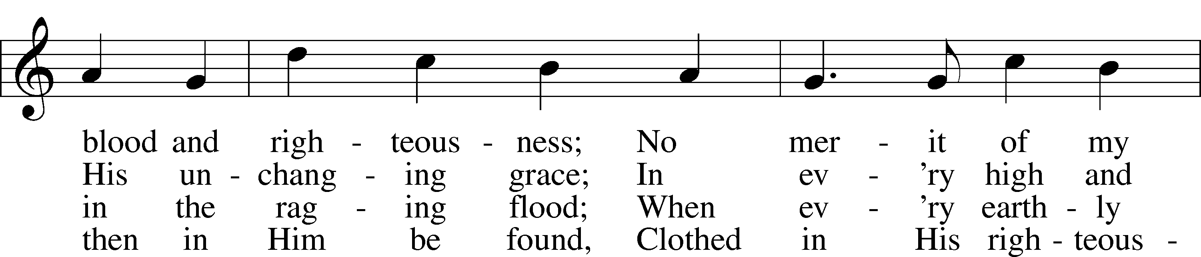

Text and tune: Public domain

**SERMON "Ripped from the Headlines" *Mark 13:3-13***

**OFFERING** *(Please fill out and pass the red Friendship Book at this time; and fill out the blue card in the pew rack for prayers.)*

*Please Stand*

**OFFERTORY** *Psalm 116:12-13, 17-19*

*Kneel or Be Seated*

**PRAYER OF THE CHURCH** *[1 Timothy 2:1-4]*

*Be Seated*

**Service of the Sacrament**

*The Sacrament, or Lord's Supper, is a special gift from God that brings us into personal communion with Jesus Christ. "In, with and under" the bread and wine we receive His body and blood for forgiveness and renewal. If you are a repentant sinner, come to the table expecting to receive God's wonderful gifts for you!*

*Communicants will take their own wine cups as they are passed. Those requiring non-alcoholic grape juice will take the cups with white grape juice from the middle of the tray.*

*Remain Seated*

**OUR EXAMINATION**

P In preparation for Holy Communion, St. Paul tells us in 1 Corinthians 11:27-29, “Whoever, therefore, eats the bread or drinks the cup of the Lord in an unworthy manner will be guilty concerning the body and blood of the Lord. 28Let a person examine himself, then, and so eat of the bread and drink of the cup. 29For anyone who eats and drinks without discerning the body eats and drinks judgment on himself.” So that we may properly examine ourselves prior to receiving the Lord’s Supper, I ask you to reflect on these questions:

* Do you repent of all your sins of thought, word, and deed?
* Do you believe that Jesus Christ is your only Savior from all sin, Satan, and death?
* Do you believe that the Risen Christ is really present in the Sacrament and that in, with, and under the bread and wine you receive His true Body and Blood?

If you answer in faith "Yes!" to these questions, and are properly instructed, you are invited to come forward and partake of the Lord's Supper during Distribution. If you are unable to answer yes to any of these questions, you are invited to come forward, cross your arms as I approach you and receive a blessing. By your coming forward, "You proclaim the Lord's death until He comes."

*Please Stand*

**PREFACE**

P The Lord be with you. *2 Timothy 4:22*

P Lift up your hearts. *[Colossians 3:1]*

P Let us give thanks to the Lord, our God. *[Psalm 136]*

P It is truly good, right, and salutary that we should at all times and in all places give thanks to You, holy Lord, almighty Father, everlasting God, through Jesus Christ, our Lord, who on this day overcame death and the grave and by His glorious resurrection opened to us the way of everlasting life. Therefore with angels and archangels and with all the company of heaven we laud and magnify Your glorious name, evermore praising you and singing:

**SANCTUS ~ *Holy, Holy, Holy*** *Isaiah 6:3; Matthew 21:9*

**PRAYER OF THANKSGIVING**

P Blessed are You, Lord of heaven and earth, for You have had mercy on those whom You created and sent Your only begotten Son into our flesh to bear our sin and be our Savior. With repentant joy we receive the salvation accomplished for us by the all-availing sacrifice of His body and His blood on the cross.

Gathered in the name and the remembrance of Jesus, we beg You, O Lord, to forgive, renew, and strengthen us with Your Word and Spirit. Grant us faithfully to eat His body and drink His blood as He bids us do in His own testament. Gather us together, we pray, from the ends of the earth to celebrate with all the faithful the marriage feast of the Lamb in His kingdom, which has no end. Graciously receive our prayers; deliver and preserve us. To You alone, O Father, be all glory, honor, and worship, with the Son and the Holy Spirit, one God, now and forever.

**C Amen.**

**LORD'S PRAYER** *Matthew 6:9-13*

**Our Father who art in heaven, hallowed be Thy name, Thy kingdom come, Thy will be done on earth as it is in heaven. Give us this day our daily bread; and forgive us our trespasses as we forgive those who trespass against us; and lead us not into temptation, but deliver us from evil. For Thine is the kingdom and the power and the glory forever and ever. Amen**.

**THE WORDS OF OUR LORD** *Matthew 26:26-28; Mark 14:22-24;*

*Luke 22:19-20; 1 Corinthians 11:23-25*

P Our Lord Jesus Christ, on the night when He was betrayed, took bread, and when He had given thanks, He broke it and gave it to the disciples and said: “Take, eat; this is My body, which is given for you. This do in remembrance of Me.” In the same way also He took the cup after supper, and when He had given thanks, He gave it to them, saying: "Drink of it, all of you; this is my blood of the new covenant, which is poured out for you for the remission of sins. This do as often as you drink it, in remembrance of Me."

**PAX DOMINI ~ *The Peace of the Lord*** *John 20:19*

PThe peace of the Lord be with you always.

C **And also with you.**

**AGNUS DEI ~ *Lamb of God*** *John 1:29*

*Be Seated*

**DISTRIBUTION HYMN**

**HYMN 620 "Jesus Comes Today with Healing"**

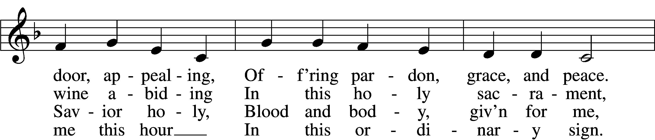

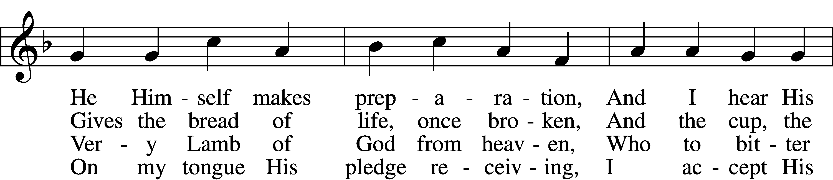

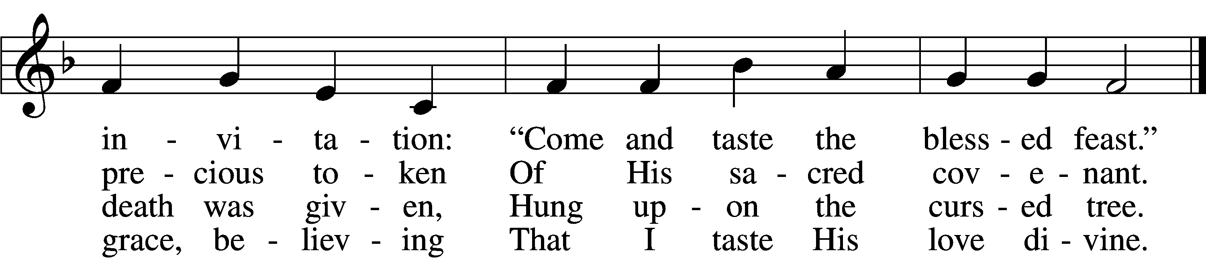

5 Let me praise God’s boundless favor,  
Whose own feast of love I savor,  
    Bidden by His gracious call.  
Wedding garments He provides me,  
With a robe of white He hides me,  
    Fits me for the royal hall.

6 Now have I found consolation,  
Comfort in my tribulation,  
    Balm to heal the troubled soul.  
God, my shield from ev’ry terror,  
Cleanses me from sin and error,  
    Makes my wounded spirit whole.

Text: © David W. Rogner. Used by permission: LSB Hymn License no. 110000966  
Tune: Public domain

*Please Stand*

**POST-COMMUNION CANTICLE "Thank the Lord"**

**POST-COMMUNION COLLECT**

P Let us pray.

We give thanks to You, almighty God, that You have refreshed us through this salutary gift, and we implore You that of Your mercy You would strengthen us through the same in faith toward You and in fervent love toward one another; through Jesus Christ, Your Son, our Lord, who lives and reigns with You and the Holy Spirit, one God, now and forever.

C **Amen.**

**BENEDICTION** *Numbers 6:24-26*

P The Lord bless you and keep you. The Lord make His face shine on you and be gracious to you. The Lord look upon you with favor and (†) give you peace.

**CLOSING HYMN 645 vv. 1-2, 5** **"Built on the Rock"**

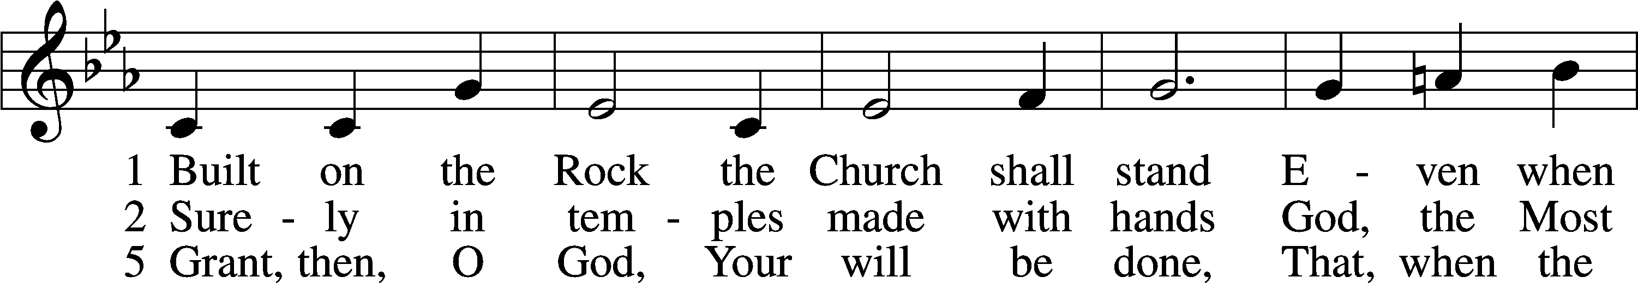

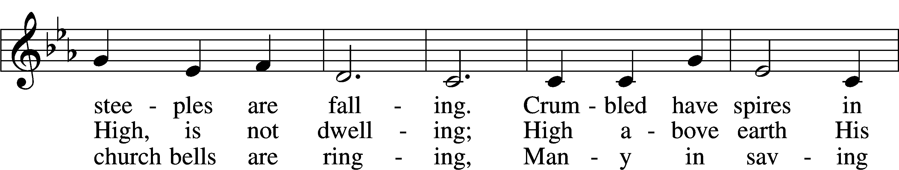

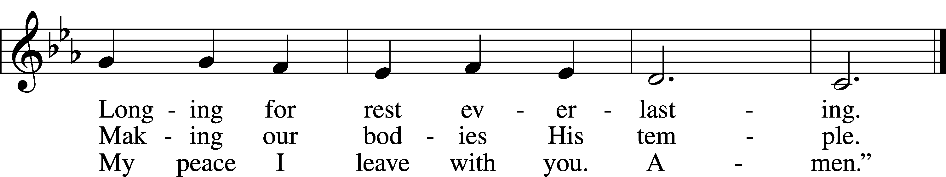

Text and tune: Public domain

*Be Seated*

**ANNOUNCEMENTS and RECOGNITION OF OUR GUESTS**

**ORGAN**

**TO THE GLORY OF GOD**

The Altar flowers are given to the glory of God

by Bill & Sharon Johnson in celebration of their anniversary.

***Do not be anxious about anything, but in everything by prayer and supplication***

***with thanksgiving let your requests be made known to God.***

***Philippians 4:6***

**COFFEE & CONVERSATION**

Join us in the Social Hall after the 8:30 service for coffee and breakfast goodies.

**BIBLE STUDY OPPORTUNITIES**

**ADULT SUNDAY BIBLE STUDY**

Pastor Webb leads a Bible study titled “Are You a Disciple or a Christian?” in the Social Hall after the 8:30 service.

**CHURCH YEAR CONNECTIONS**

**(Ages 3 through High School)**

Join us for Sunday School classes for ages three through young adult. Teachers: Megan Haverland (3 years-1st Grade), Judy Bringman (2nd-5th Grade), Bob Hanovich (Middle School), and Karl Schumacher (High School).

**PARENTS & TWOS CLASS**

In this class for parents and two-year-olds, Karen Hanovich helps parents encourage their little ones as they learn about Jesus together.

**YOUNG ADULT SINGLES CLASS**

For ages 18-26, this class led by Kevin Riedl is studying “Lessons from the Underground Church.”

**21ST CENTURY PARENTING CLASS**

Parents of school-aged kids gain insight into the issues facing Gen Z and learn how to engage them in meaningful conversations. Eric and Megan Thompson lead this class in the Education Building.

**YOUNG AT HEART CLASS**

Mature members study how we can demonstrate love and compassion to people in need. Bob Reynolds and Mark Waltz lead this class on the ground floor of the Education Building.

**WEDNESDAY MORNING BIBLE STUDY**

Join us at 10:00 a.m. on Wednesday mornings in the Education Building to study the Word.

**WOMEN’S BIBLE STUDY**

The Women’s Bible Study that meets on Mondays at 10:00am in the Education Building is currently taking a break and will resume in January. See Linda Tomko for more details.

**HAPPENING AT TRINITY**

**HOLIDAY WORSHIP SERVICES**

**Thanksgiving Eve:** November 27 at 7:00pm

**Wednesday Advent Worship:** December 4, 11, & 18 at 1:00 & 7:00

**Christmas Eve:** 5:00pm & 7:00pm (Communion)

**Christmas Day:** 10:00am (Communion)

**THANK YOU**

Thank you to Barbara Lunick for playing the organ for us.

**OFFERINGS**

Please remain faithful in bringing your offerings to the Lord by mail or online if you are unable to attend worship in person.

**TODAY IS "BUILDING REPAIR FUND SUNDAY"**

Please consider making an extra donation designated for our Building Repair Fund to help cover the cost of our needed repairs.

**PLEDGE FORMS**

Completed pledge forms can be placed in the offering plate as it is passed.

**SINGLE SERVICE & VOTERS MEETING**

**Today at 10:00 (Sunday School at 9:00, Voters Meeting after Worship)**

This morning, we have Sunday School at 9:00, a Single Worship Service at 10:00, and our fall Voters Meeting after worship. The meeting will include presentations by our various Boards and voting on the budget for the new year.

**THANKSGIVING EVE WORSHIP**

**Wednesday, November 27 at 7:00**

Join us for a reflective service of thanking our Lord for His abundant goodness.

**THANKSGIVING DAY DINNER**

**Thursday, November 28 at 12:00**

You are cordially invited to Thanksgiving Day Dinner on November 28. Fellowship starts at 12:00, with dinner at 1:00. If you can, please bring a covered dish to share. Sign-up sheet is on the table in the Narthex.

**POINSETTIAS**

**Order by Sunday, December 1**

Poinsettia order forms are now available. It was necessary for the Altar Guild to pre-order poinsettias to assure we would have them for Christmas Eve. We have ordered 10 – 6” red, 10 – 6” white, and 10 – 8” red. Please order by December 1. Thank you!

**CHRISTMAS PROGRAM**

**Sunday, December 15 at 9:45am**

The Sunday School Christmas program will be December 15th at 9:45am, during the Sunday School hour. We look forward to seeing each of you there to support the kids.

**HURRICANES HELENE & MILTON RELIEF**

If you would like to help the people affected by the recent hurricanes, you can donate to the LCMS Disaster Response efforts. Online: lcms.org/givenow/disaster; Text LCMSDISASTERS to 41444; Call 888-930-4438; Mail check payable to LCMS with memo “Disaster Response – Strategic Use (TR9206)” to LCMS, PO Box 66861, St Louis, MO 63166-6861. See the flyers on the table in the Narthex for more details.

**CHECK THE CALENDAR**

Curious what’s going on? Planning an event? Check the Trinity calendar on our website anytime ([www.trinitylutheransavannah.com](http://www.trinitylutheransavannah.com)/connect/calendar.cfm). If you need to schedule an event, please contact Traci in the office ([trinityoffice@bellsouth.net](mailto:trinityoffice@bellsouth.net), 912-925-4839). Thanks!

**CONNECT WITH US**

Connect with TLC and keep up with what’s going on.

\***Website** - [www.trinitylutheransavannah.com](http://www.trinitylutheransavannah.com)  
\***Facebook** - Friends of Trinity Lutheran Church; Trinity Lutheran Church of Savannah Media; Lizzie Comfort Dog  
\***Instagram** - #lcck9lizzie (Lizzie Comfort Dog)

\***YouTube** – Trinity Lutheran Savannah

**DEADLINE for BULLETIN ANNOUNCEMENTS**

**Every Wednesday by 9:00am**

Email bulletin announcements to [trinityoffice@bellsouth.net](mailto:trinityoffice@bellsouth.net) prior to 9:00am on Wednesdays.

**MINISTRY NEEDS**

**CANDY FOR MARITIME BETHEL**

Lindt Chocolates are a favorite of seafarers. During the Christmas season, captains will purchase a bag for each crew member. I would ask our Trinity family to purchase bags of Lindt chocolates for us to give them at Christmas. I will place a Christmas box in the Narthex to collect your gift. Any questions, ask me. “The Lord loves a cheerful giver.” Thank you in advance.

**ANGEL TREE HELP**

We need help to contact the 18 Angel Tree families. For more information, see Lonna McEwen.

**BLANKETS & JACKETS**

Hearts of Compassion is collecting new and gently used blankets and jackets to prepare for the cold months. Please place items in the basket in the Narthex. If you have any questions, please see Jennifer Wolfe.

**TODAY'S WORSHIP SERVICE**

Traditional 10:00 a.m.

**IN RESPONSE TO THE GOSPEL LAST SUNDAY**

8:30 a.m. – 64 11:00 a.m. – 55 Facebook – 75 YouTube – 11

Giving $5,077.52

Hearts of Compassion 100.00

Homeless Meals 100.00

Ladies’ Retreat 105.00

Lutheran Women’s Missionary League Mites 266.08

Memorial – Hafemann 50.00

Pastor's Discretionary Fund 200.00

Pastor's Discretionary Fund – W. Holland 350.00

Poinsettias 14.50

Youth 320.00

**SERVING IN THE LORD'S HOUSE TODAY**

**10:00 a.m.**

Betty Morrell, Greeter Kip & Delane Wiltse, Greeters

Cathy Crotwell & JB Strange, Ushers Bob Sautter, Usher

**SERVING NEXT SUNDAY**

**8:30 a.m. 11:00 a.m.**

Jackie Deemer, Greeter Cindy Baldwin & Cathy Dotson, Greeters

Chris Cesaroni & Barbara Duch, Ushers John Anander, Usher

**THIS WEEK AT A GLANCE**

TODAY Single Traditional Worship Service 10:00 a.m.

Sunday School 9:00 a.m.

Voters Meeting after the Service

Confirmation Class 12:30 p.m.

Building Repair Fund Sunday

MONDAY 11/18 Cub Scouts (Social Hall) 6:00-8:00 p.m.

TUESDAY 11/19 Windsor Forest Garden Club (Social Hall) 8:30 a.m.-12:30 p.m.

Clothes Closet 4:00-6:00 p.m.

Cub Scouts (Social Hall) 6:00-8:00 p.m.

WEDNESDAY 11/20 Bible Study (Education Building) 10:00 a.m.

THURSDAY 11/21 Clothes Closet 10:00 a.m.-1:00 p.m.

Crafters (Education Building) 10:00 a.m.-2:00 p.m.

NAMI (Social Hall) 6:00-7:00 p.m.

FRIDAY 11/22 Meals for Homeless (Education Building Kitchen) 4:00 p.m.

SATURDAY 11/23

**REMEMBER IN PRAYER**

*(Please help us keep the prayer list updated)*

HEALTH

Melissa Hall

CANCER

Wendy Holland; Harold LaMarr; Samuel Martin (19)

SPECIAL REQUEST

Family & friends of Pat Coleman; Family & friends of Gin Hafemann

STRENGTH, GUIDANCE, & PROVISION

Earlene Smith; everyone impacted by the hurricanes & natural disasters

PEACE

Israel, Ukraine, & all who suffer from war and violence

OUR WITNESS

Let us proclaim Jesus Christ is risen to all!

OUR CONCERNS

Raise up those, Lord, who would serve Your Church.

**TRINITY LUTHERAN CHURCH**

12391 Mercy Blvd

Savannah, GA 31419

phone 912-925-4839 [trinityoffice@bellsouth.net](mailto:trinityoffice@bellsouth.net)

fax 912-925-4056 www.trinitylutheransavannah.com

Contact Pastor: 717-333-6263; pastorjeffwebb@yahoo.com

**STAFF**

Jeff Webb, Pastor

Traci Schumacher, Administrative Assistant

Helen Williams, Church Custodian

**BOARD OF ELDERS**

Mark Waltz, Head Elder (C – E)

Mike Fajen (K – Mc)

Todd Freesemann (F – J)

Jacob Johnson (Various)

Sonny Massey (A – B)

Bob Reynolds (Me – Sa)

Tom Wayman (Sc – Z)

**CHURCH COUNCIL**

Kip Wiltse, President

Eric Thompson, Vice President

Cathy Crotwell, Secretary

Karl Schumacher, Treasurer

Megan Haverland, Board of Education

Mark Waltz, Board of Elders

Chris Garretson, Board of Evangelism

Charles Rogers, Board of Property Management

Jennifer Wolfe, Board of Social Ministry

Lonna McEwen, Board of Stewardship

Cindy Reynolds, Financial Secretary

Bob Hanovich, Board of Youth

**ORGANIZATIONAL LEADERS**

Cindy Baldwin, Comfort Dog Top Dog

Jackie Deemer, Director of TLC Singers & LWML President

Megan Thompson, Sunday School Superintendent

Rosemary Gerdes, Quilters

Karen Hanovich, TLC Marketing

Lonna McEwen, Altar Guild

Rose Pitt, Prayer Team