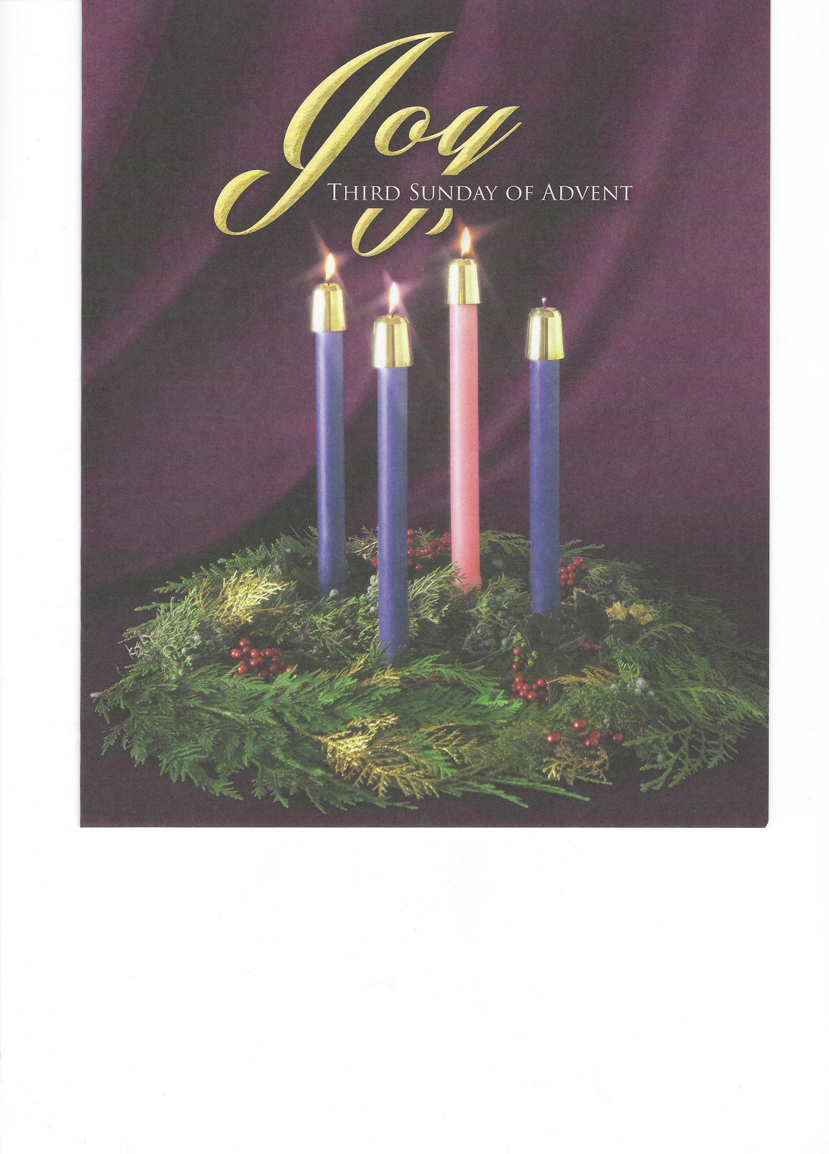

**Trinity Lutheran Church**

**Advent Midweek 3**

**December 18, 2024, 1:00 & 7:00 p.m.**

**WELCOME TO TRINITY!**

Thank you for worshipingwith us today. We want to know who you are, so please provide your contact information in the Friendship Book as it is passed during the Offertory. If you are visiting, honor us by signing the Guest Register in the Narthex.

There are times in our worship service where we stand or kneel. Feel free to participate in either as you are able or feel comfortable to remain seated.

Please ask an usher should you require a hearing assistance device.

(†) ~ Those who wish may make the sign of the Cross in remembrance of their Baptism.

**REQUESTS FOR PRAYER**

If you have a prayer request, please fill out a Blue Card from the pew rack and place it in the offering plate. Prayer requests may also be emailed to [trinityoffice@bellsouth.net](mailto:trinityoffice@bellsouth.net) or to pastorjeffwebb@yahoo.com.

**FOR PARENTS WITH YOUNG CHILDREN**

We are delighted that you have brought your child to worship! We invite you to use the Cry Room as a courtesy to others if your little one gets a little rambunctious. Our Cry Room, complete with seating and children's activities, is located at the back of the Sanctuary. The service can be heard through the sound system. We hope your children feel glad they were here and that they are a part of the Trinity family!

***Our Vision:***

***Growing in God’s Word to Share Christ’s Love***

***Our Mission:***

***Led by God, equipped as disciples through Word and Sacrament,***

***we are empowered by the Holy Spirit to reach out with the Gospel of Jesus Christ to all.***



**AS WE GATHER TODAY**

The weeks of Advent are a time for faithful listening. For centuries before the coming of Jesus, specially chosen messengers of God brought hope to God’s people with words of encouragement. An often-heard prophetic voice is that of Isaiah, who told of the fulfillment of God’s promises to His faithful people. In chapter 12 of Isaiah, we hear the prophet exclaim: “Behold, God is my salvation; I will trust, and will not be afraid; for the Lord God is my strength and my song, and He has become my salvation” (12:2). As the season of Advent progresses, we hear more and more voices announcing that God’s plan of salvation is being fulfilled. John the Baptist calls out in the wilderness, telling us to repent of our sins as we prepare for the coming of the Savior. With Mary, we hear the message of the angel Gabriel, announcing that God is coming in person and that His coming will be a great blessing to all people. With joyful anticipation, we listen for the message of the coming salvation and respond with songs of praise.

**Advent Midweek 3**

**The Song of Mary**

*Please Stand*

**INVOCATION**

Pastor: In the name of the Father and of the ✠ Son and of the Holy Spirit.

**People: Amen.**

**CONFESSION AND ABSOLUTION** *Psalm 124:8*

Pastor: Our help is in the name of the Lord,

**People: who made heaven and earth.**

Pastor: In this season of penitence and reflection, let us think of our unworthiness; confess before God that we have sinned in thought, word, and deed; and ask for His merciful forgiveness.

**People: Almighty God, have mercy on us, forgive us our sins, and bring us to life everlasting. Amen.**

Pastor: Almighty God, our heavenly Father, has had mercy upon us and has given His only Son to die for us and for His sake forgives us all our sins. As a called and ordained servant of Christ, and by His authority, I therefore forgive you all your sins in the name of the Father and of the ✠ Son and of the Holy Spirit. May the God of peace Himself sanctify you wholly; and may your spirit and soul and body be kept sound and blameless at the coming of our Lord Jesus Christ.

**People: Amen.**

**HYMN 334** “O Lord, How Shall I Meet You”

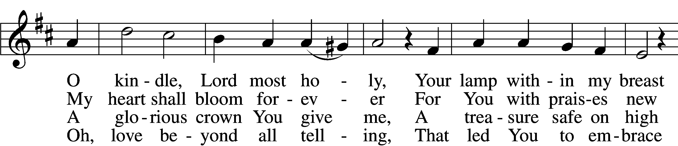

5 Sin’s debt, that fearful burden,  
    Cannot His love erase;  
Your guilt the Lord will pardon  
    And cover by His grace.  
He comes, for you procuring  
    The peace of sin forgiv’n,  
His children thus securing  
    Eternal life in heav’n.

6 He comes to judge the nations,  
    A terror to His foes,  
A light of consolations  
    And blessèd hope to those  
Who love the Lord’s appearing.  
    O glorious Sun, now come,  
Send forth Your beams so cheering,  
    And guide us safely home.

Text and tune: Public domain

**OPENING SENTENCES** *Psalm 27:1, 4, 7–8, 13–14*

Pastor: The Lord is my light and my salvation; whom shall I fear? The Lord is the stronghold of my life; of whom shall I be afraid?

**People: One thing have I asked of the Lord, that will I seek after: that I may dwell in the house of the Lord all the days of my life, to gaze upon the beauty of the Lord and to inquire in His temple.**

Pastor: Hear, O Lord, when I cry aloud; be gracious to me and answer me!

**People: You have said, “Seek My face.” My heart says to You, “Your face, Lord, do I seek.”**

Pastor: I believe that I shall look upon the goodness of the Lord in the land of the living!

**People: Wait for the Lord; be strong, and let your heart take courage; wait for the Lord!**

**SALUTATION**

Pastor: The Lord be with you.

**People: And also with you.**

**PRAYER OF THE DAY**

Pastor: Let us pray.  
Almighty Father, by the advent of whose Son into the world the kingdom of heaven is open to all who believe in Him: grant us Your Holy Spirit so that we may believe in Him with our whole heart and so serve Him in our daily lives, that when He comes again we may, together with Mary, our Lord’s mother; the prophets of old; and all of the faithful, by Your mercy be gathered together into the Kingdom that abides eternal in the heavens; through Your mercy, O God, who lives and reigns forever, world without end.

**People: Amen.**

**HYMN OF PRAISE 546** “O Jesus So Sweet, O Jesus So Mild”

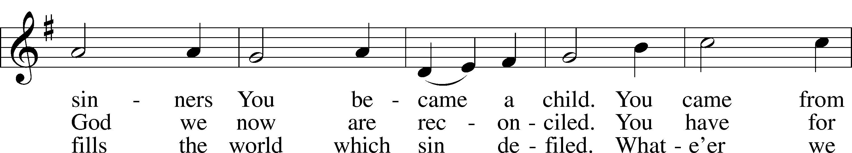

Text and tune: Public domain

*Be Seated*

**OLD TESTAMENT READING** *Daniel 7:13–14* (The rule of the Son of Man)

I saw in the night visions,

and behold, with the clouds of heaven  
 there came one like a son of man,  
and he came to the Ancient of Days  
 and was presented before him.  
And to him was given dominion  
 and glory and a kingdom,  
that all peoples, nations, and languages  
 should serve him;  
his dominion is an everlasting dominion,  
 which shall not pass away,  
and his kingdom one  
 that shall not be destroyed.

Lector: This is the Word of the Lord.

**People: Thanks be to God.**

**PSALM** *Psalm 26*

Pastor: Vindicate me, O Lord, for I have walked in my integrity, and I have trusted in the Lord without wavering.

**People: Prove me, O Lord, and try me; test my heart and my mind.**

Pastor: For Your steadfast love is before my eyes, and I walk in Your faithfulness.

*Men: I do not sit with men of falsehood, nor do I consort with hypocrites. I hate the assembly of evildoers, and I will not sit with the wicked.*

*Women: I wash my hands in innocence and go around Your altar, O Lord, proclaiming thanksgiving aloud, and telling all Your wondrous deeds.*

Pastor: O Lord, I love the habitation of Your house and the place where Your glory dwells.

**People: Do not sweep my soul away with sinners, nor my life with bloodthirsty men, in whose hands are evil devices, and whose right hands are full of bribes.**

Pastor: But as for me, I shall walk in my integrity; redeem me, and be gracious to me.

**People: My foot stands on level ground; in the great assembly I will bless the Lord.  
  
Glory be to the Father and to the Son and to the Holy Spirit;  
as it was in the beginning, is now, and will be forever. Amen.**

**EPISTLE** *Colossians 3:12–17* (The Word of Christ dwells in His thankful people.)

Put on then, as God’s chosen ones, holy and beloved, compassion, kindness, humility, meekness, and patience, bearing with one another and, if one has a complaint against another, forgiving each other; as the Lord has forgiven you, so you also must forgive. And above all these put on love, which binds everything together in perfect harmony. And let the peace of Christ rule in your hearts, to which indeed you were called in one body. And be thankful. Let the word of Christ dwell in you richly, teaching and admonishing one another in all wisdom, singing psalms and hymns and spiritual songs, with thankfulness in your hearts to God. And whatever you do, in word or deed, do everything in the name of the Lord Jesus, giving thanks to God the Father through him.

Lector: This is the Word of the Lord.

**People: Thanks be to God.**

*Please Stand*

**HOLY GOSPEL** *Luke 1:46–56* (The Magnificat)

Pastor: The Holy Gospel according to St. Luke, the first chapter

**People: Glory to You, O Lord.**

And Mary said,

“My soul magnifies the Lord,  
 and my spirit rejoices in God my Savior,  
for he has looked on the humble estate of his servant.  
 For behold, from now on all generations will call me blessed;  
for he who is mighty has done great things for me,  
 and holy is his name.  
And his mercy is for those who fear him  
 from generation to generation.  
He has shown strength with his arm;  
 he has scattered the proud in the thoughts of their hearts;  
he has brought down the mighty from their thrones  
 and exalted those of humble estate;  
he has filled the hungry with good things,  
 and the rich he has sent empty away.  
He has helped his servant Israel,  
 in remembrance of his mercy,  
as he spoke to our fathers,  
 to Abraham and to his offspring forever.”

And Mary remained with her about three months and returned to her home.

Pastor: This is the Gospel of the Lord.

**People: Praise to You, O Christ.**

*Be Seated*

**HYMN OF THE DAY 345** “Hark! A Thrilling Voice is Sounding”

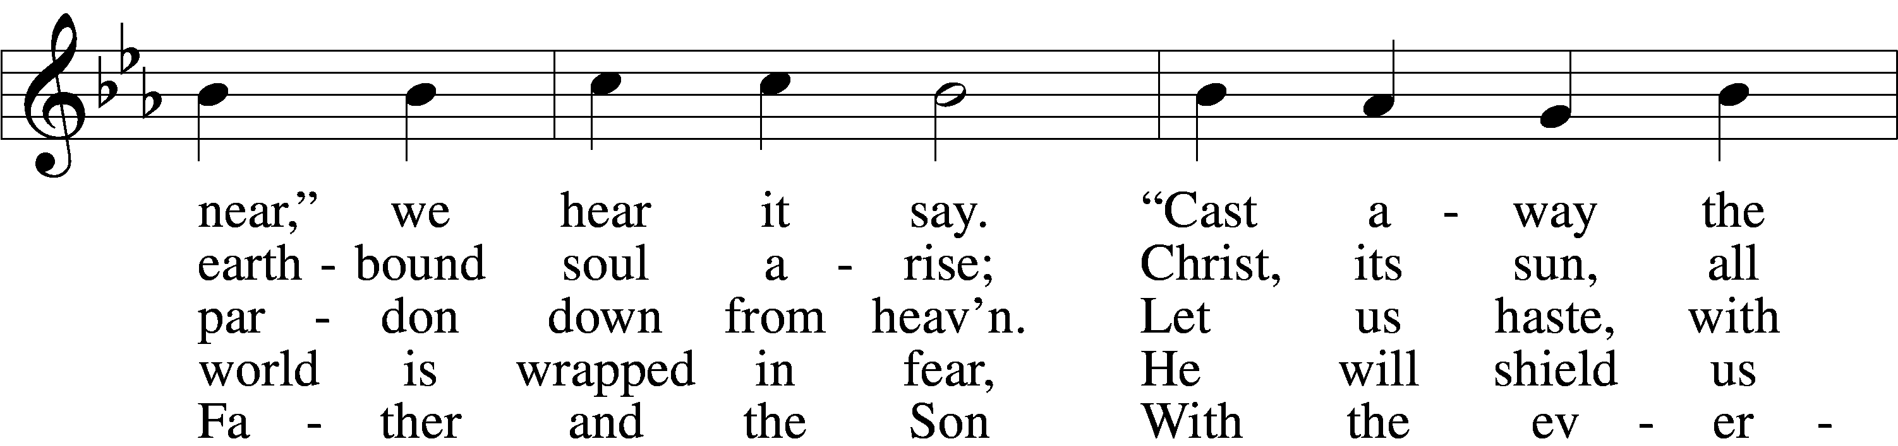

Text and tune: Public domain

**SERMON**

**OFFERING**

*Please Stand*

**OFFERTORY**

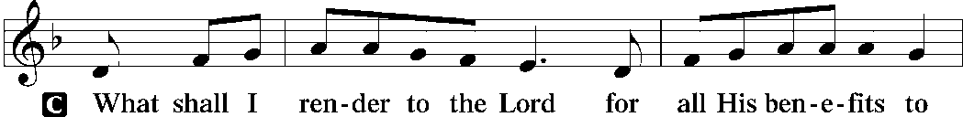

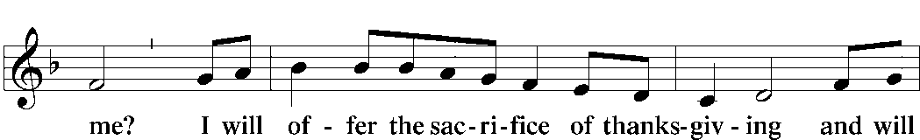

*Kneel or Be Seated*

**THE LITANY**

Pastor: O Lord,

**People: have mercy.**

Pastor: O Christ,

**People: have mercy.**

Pastor: O Lord,

**People: have mercy.**

Pastor: O Christ,

**People: hear us.**

Pastor: God the Father in heaven,

**People: have mercy.**

Pastor: God the Son, Redeemer of the world,

**People: have mercy.**

Pastor: God the Holy Spirit,

**People: have mercy.**

Pastor: Be gracious to us.

**People: Spare us, good Lord.**

Pastor: Be gracious to us.

**People: Help us, good Lord.**

Pastor: From all sin, from all error, from all evil;  
From the crafts and assaults of the devil; from sudden and evil death;  
From pestilence and famine; from war and bloodshed; from sedition and from  
rebellion;  
From lightning and tempest; from all calamity by fire and water; and from everlasting death:

**People: Good Lord, deliver us.**

Pastor: By the mystery of Your holy incarnation; by Your holy nativity;  
By Your Baptism, fasting, and temptation; by Your agony and bloody sweat; by Your cross and passion; by Your precious death and burial;  
By Your glorious resurrection and ascension; and by the coming of the Holy Spirit, the Comforter:

**People: Help us, good Lord.**

Pastor: In all time of our tribulation; in all time of our prosperity; in the hour of death; and in the day of judgment:

**People: Help us, good Lord.**

Pastor: We poor sinners implore You

**People: to hear us, O Lord.**

Pastor: To rule and govern Your holy Christian Church; to preserve all pastors and ministers of Your church in the true knowledge and understanding of Your wholesome Word and to sustain them in holy living;  
To put an end to all schisms and causes of offense; to bring into the way of truth all who have erred and are deceived;  
To beat down Satan under our feet; to send faithful laborers into Your harvest; and to accompany Your Word with Your grace and Spirit:

**People: We implore You to hear us, good Lord.**

Pastor: To raise those who fall and to strengthen those who stand; and to comfort and help the weakhearted and the distressed:

**People: We implore You to hear us, good Lord.**

Pastor: To give to all peoples concord and peace; to preserve our land from discord and strife; to give our country Your protection in every time of need;  
To direct and defend our president and all in authority; to bless and protect our magistrates and all our people;  
To watch over and help all who are in danger, necessity, and tribulation; to protect and guide all who travel;  
To grant all women with child, and all mothers with infant children, increasing happiness in their blessings; to defend all orphans and widows and provide for them;  
To strengthen and keep all sick persons and young children; to free those in bondage; and to have mercy on us all:

**People: We implore You to hear us, good Lord.**

Pastor: To forgive our enemies, persecutors, and slanderers and to turn their hearts; to give and preserve for our use the kindly fruits of the earth; and graciously to hear our prayers:

**People: We implore You to hear us, good Lord.**

Pastor: Lord Jesus Christ, Son of God,

**People: we implore You to hear us.**

Pastor: Christ, the Lamb of God, who takes away the sin of the world,

**People: have mercy.**

Pastor: Christ, the Lamb of God, who takes away the sin of the world,

**People: have mercy.**

Pastor: Christ, the Lamb of God, who takes away the sin of the world,

**People: grant us Your peace.**

Pastor: O Christ,

**People: hear us.**

Pastor: O Lord,

**People: have mercy.**

Pastor: O Christ,

**People: have mercy.**

Pastor: O Lord,

**People: have mercy. Amen.**

**LORD’S PRAYER** *Matthew 6:9–13*

**People:** **Our Father who art in heaven,  
 hallowed be Thy name,  
 Thy kingdom come,  
 Thy will be done on earth  
 as it is in heaven;  
 give us this day our daily bread;  
 and forgive us our trespasses  
 as we forgive those   
 who trespass against us;  
 and lead us not into temptation,  
 but deliver us from evil.  
For Thine is the kingdom  
 and the power and the glory  
 forever and ever. Amen.**

**CLOSING COLLECT**

Pastor: Let us pray.  
O Lord, grant us Your grace in this present age to live with kindness, faithfulness, and righteousness as we look for the fullness of Your coming among us in all Your glory and power at the end of the age. In Your mercy, may we come to that eternal inheritance that You have prepared for those who love You. By the indwelling of the Holy Spirit, lead us and guide us through our days until at last we join with saints and angels in endless praise around Your heavenly throne. This we ask through Jesus Christ, Your Son, our Lord.

**People: Amen.**

*Please Stand*

**BENEDICTION**

Pastor: The almighty and merciful Lord—the Father, the X Son, and the Holy Spirit—bless and preserve you.

**People: Amen.**

**HYMN 358 vv. 1-3, 15** “From Heaven Above to Earth I Come”

Text and tune: Public domain

*Be Seated*

**TO THE GLORY OF GOD**

The Altar flowers are given to the glory of God.

Creative Worship for the Lutheran Parish, Series C, Quarter 1.

Copyright © 2024 Concordia Publishing House. All rights reserved. Used by permission.

First closing collect from *Prayers for Worship: Alternate Collects*, Gregory J. Wismar, ed., © 1993 Concordia Publishing House. All rights reserved. Used by permission.

**HOLIDAY WORSHIP SCHEDULE**

**MIDWEEK ADVENT WORSHIP**

Wednesday Worship Service – December 18 at 1:00 & 7:00 p.m.

**CHRISTMAS WORSHIP**

Christmas Eve Candlelight Worship Service – 5:00 p.m.

Christmas Eve Candlelight Worship with Holy Communion – 7:00 p.m.

Christmas Day Worship with Holy Communion – 10:00 a.m.

**THE GENEALOGY OF JESUS**  *Matthew 1:1–16*

The book of the genealogy of Jesus Christ, the son of **David**, the son of **Abraham**.

Abraham was the father of Isaac, and Isaac the father of Jacob, and Jacob the father of Judah and his brothers, and Judah the father of Perez and Zerah by **Tamar**, and Perez the father of Hezron, and Hezron the father of Ram, and Ram the father of Amminadab, and Amminadab the father of Nahshon, and Nahshon the father of Salmon, and Salmon the father of Boaz by **Rahab**, and Boaz the father of Obed by **Ruth**, and Obed the father of Jesse, and Jesse the father of David the king.

And David was the father of Solomon by the **wife of Uriah**, and Solomon the father of Rehoboam, and Rehoboam the father of Abijah, and Abijah the father of Asaph, and Asaph the father of Jehoshaphat, and Jehoshaphat the father of Joram, and Joram the father of Uzziah, and Uzziah the father of Jotham, and Jotham the father of Ahaz, and Ahaz the father of Hezekiah, and Hezekiah the father of Manasseh, and Manasseh the father of Amos, and Amos the father of Josiah, and Josiah the father of Jechoniah and his brothers, at the time of the deportation to Babylon.

And after the deportation to Babylon: Jechoniah was the father of Shealtiel, and Shealtiel the father of Zerubbabel, and Zerubbabel the father of Abiud, and Abiud the father of Eliakim, and Eliakim the father of Azor, and Azor the father of Zadok, and Zadok the father of Achim, and Achim the father of Eliud, and Eliud the father of Eleazar, and Eleazar the father of Matthan, and Matthan the father of Jacob, and Jacob the father of **Joseph** the husband of **Mary**, of whom Jesus was born, who is called Christ.

**SEASON OF THE CHURCH YEAR**

We begin the church year with an ending and a beginning. Advent is the season before Christmas during which we anticipate the Second Coming of our Lord and Savior Jesus Christ. It is in this Second Coming that He will judge the earth and raise all the dead. Those who have faith will be given their reward in heaven and live with Him eternally. Advent is a beginning as well. For we look forward to the time we celebrate Christ’s first advent, His birth on this earth, which we celebrate on Christmas day. The color for Advent is blue, which suggests hope for us while we wait.

**THE SYMBOLS OF THE ADVENT WREATH**

The evergreen wreath symbolizes eternal life in Christ. The candles are symbolic of Jesus Christ, the Light of the World. The act of lighting more candles each week anticipates the imminent coming of Christ.

Each candle has a specific meaning:

1. **Prophecy Candle** announces a period of waiting for our Lord. – **Hope**
2. **Bethlehem Candle** symbolizes preparing to receive the Christ Child. – **Love**
3. **Shepherd’s Candle** symbolizes sharing of the news of Christ’s birth. The pink color is representative of their joy and witness to so great an event! – **Joy**
4. **Angels’ Candle** symbolizes Christ’s final coming on Judgment Day when He will appear in glory with all His angels. – **Peace**
5. **Christ Candle** is lit on Christmas Eve. This central candle signifies that the Light of the World, **Jesus, has come**.



**TRINITY LUTHERAN CHURCH**

12391 Mercy Blvd

Savannah, GA 31419

phone 912-925-4839 [trinityoffice@bellsouth.net](mailto:trinityoffice@bellsouth.net)

fax 912-925-4056 www.trinitylutheransavannah.com

Contact Pastor: 717-333-6263; pastorjeffwebb@yahoo.com

**STAFF**

Jeff Webb, Pastor

Traci Schumacher, Administrative Assistant

Helen Williams, Church Custodian

**BOARD OF ELDERS**

Mark Waltz, Head Elder (C – E)

Mike Fajen (K – Mc)

Todd Freesemann (F – J)

Jacob Johnson (Various)

Sonny Massey (A – B)

Bob Reynolds (Me – Sa)

Tom Wayman (Sc – Z)

**CHURCH COUNCIL**

Kip Wiltse, President

Eric Thompson, Vice President

Cathy Crotwell, Secretary

Karl Schumacher, Treasurer

Megan Haverland, Board of Education

Mark Waltz, Board of Elders

Chris Garretson, Board of Evangelism

Charles Rogers, Board of Property Management

Jennifer Wolfe, Board of Social Ministry

Lonna McEwen, Board of Stewardship

Cindy Reynolds, Financial Secretary

Bob Hanovich, Board of Youth

**ORGANIZATIONAL LEADERS**

Cindy Baldwin, Comfort Dog Top Dog

Jackie Deemer, Director of TLC Singers & LWML President

Megan Thompson, Sunday School Superintendent

Rosemary Gerdes, Quilters

Karen Hanovich, TLC Marketing

Lonna McEwen, Altar Guild

Rose Pitt, Prayer Team