**Trinity Lutheran Church**

**The Resurrection of Our Lord – Easter Day**

**March 31, 2024 8:30 & 11:00 a.m. Communion Service**

**WELCOME TO TRINITY!**

Thank you for worshipingwith us today. We want to know who you are, so please provide your contact information in the Friendship Book as it is passed during the Offertory. If you are visiting, honor us by signing the Guest Register in the Narthex.

There are times in our worship service where we stand or kneel. Feel free to participate in either as you are able or feel comfortable to remain seated.

Gluten-free wafers are available upon request during communion services. Please speak to the pastor before service if you wish to receive the host in this form.

Please ask an usher should you require a hearing assistance device.

(†) ~ Those who wish may make the sign of the Cross in remembrance of their Baptism.

**RECEPTION OF HOLY COMMUNION**

If you are not a member of Trinity Lutheran Church, we ask that you speak with the pastor prior to the service before receiving the Lord’s Supper.

**REQUESTS FOR PRAYER**

If you have a prayer request, please fill out a Blue Card from the pew rack and place it in the offering plate. Prayer requests may also be emailed to [trinityoffice@bellsouth.net](mailto:trinityoffice@bellsouth.net) or to pastorjeffwebb@yahoo.com.

**FOR PARENTS WITH YOUNG CHILDREN**

We are delighted that you have brought your child to worship! We invite you to use the Cry Room as a courtesy to others if your little one gets a little rambunctious. Our Cry Room, complete with seating and children's activities, is located at the back of the Sanctuary. The service can be heard through the sound system. We hope your children feel glad they were here and that they are a part of the Trinity family!

***Our Vision:***

***Growing in God’s Word to Share Christ’s Love***

***Our Mission:***

***Led by God, equipped as disciples through Word and Sacrament,***

***we are empowered by the Holy Spirit to reach out with the Gospel of Jesus Christ to all.***



**AS WE GATHER TODAY**

Those who followed Jesus from Galilee to Jerusalem had hopes and fears, but their experience was within what they expected. So, Isaiah’s prophecy, which we shall hear again today, was one of those things that didn’t seem to apply, for it was too much of a change to take seriously. And the news from the angel at the tomb went far beyond that! Life after death challenged every understanding so directly that the women were startled into fear-driven silence—at least for a time. That very day others would hear the news and soon many would see Jesus Himself, as Paul tells us in the Epistle. Today is a day to embark on a life based on the startling new reality that death is not the final word for anyone with faith in Christ. How then shall we live before we see Him ourselves?

**Divine Service**

***Setting One***

**PRELUDE** “This Joyful Eastertide”*John A. Behnke*

“The Day of Resurrection” *Benjamin Culli*

**WELCOME**

**CHIMING OF THE HOUR**

**✠ PREPARATION ✠**

*Please Stand*

**OPENING SENTENCES** *Psalm 118:24*

Pastor: The light of Christ!

**People: Thanks be to God!**

Pastor: All of you choirs of angels and saints in heaven before us:

**People: Rejoice at Christ’s victory over death.**

Pastor: Now, heaven and earth, even all of creation:

**People: Rejoice, for the eternal darkness has been defeated.**

Pastor: Rejoice, brothers and sisters in Christ both here and around the world!

**People: Our Lord has kept all God’s promises!**

Pastor: Alleluia! Christ is risen!

**People: He is risen indeed! Alleluia!**

Pastor: This is the day that the Lord has made;

**People: let us rejoice and be glad in it. Alleluia!**

**HYMN 464** “The Strife is O’er, the Battle Done”

4 He broke the age-bound chains of hell;  
The bars from heav’n’s high portals fell.  
Let hymns of praise His triumph tell.  
    Alleluia!

5 Lord, by the stripes which wounded Thee,  
From death’s dread sting Thy servants free  
That we may live and sing to Thee.  
    Alleluia! Refrain

Text and tune: Public domain

**INVOCATION**

Pastor: In the name of the Father and of the ✠ Son and of the Holy Spirit.

**People: Amen.**

*Kneel or Be Seated*

**CONFESSION AND ABSOLUTION**

Pastor: We cannot enter God’s presence as we are. Our sinful condition falls short of the glory of God. Let us therefore give voice to those sins, confessing our faults and failures to one another and to God Himself.

**People: Most merciful God, we confess that we are by nature sinful and unclean. We have sinned against You in thought, word, and deed, by what we have done and by what we have left undone. We have not loved You with our whole heart; we have not loved our neighbors as ourselves. We justly deserve Your present and eternal punishment. For the sake of Your Son, Jesus Christ, have mercy on us. Forgive us, renew us, and lead us, so that we may delight in Your will and walk in Your ways to the glory of Your holy name. Amen.**

Pastor: Rejoice and be glad! God has not merely overlooked your faults; He has not missed your failures; and He knows the frailty of the human condition. Rather, He became one of us as Jesus, who died to pay for every sin or yours and your sinfulness itself. Jesus not only paid the penalty; on this day our heavenly Father proclaimed to all the world that He accepted the payment. Your sins are forgiven indeed!  
  
In the stead and by the command of our risen Lord Jesus Christ, I therefore forgive you all your sins in the name of the Father and of the ✠ Son and of the Holy Spirit.

**People: Amen.**

Pastor: Alleluia! Christ is risen!

**People: He is risen indeed! Alleluia!**

**✠ WORD ✠**

*Please Stand*

**HYMN OF PRAISE 457** “Jesus Christ Is Risen Today”

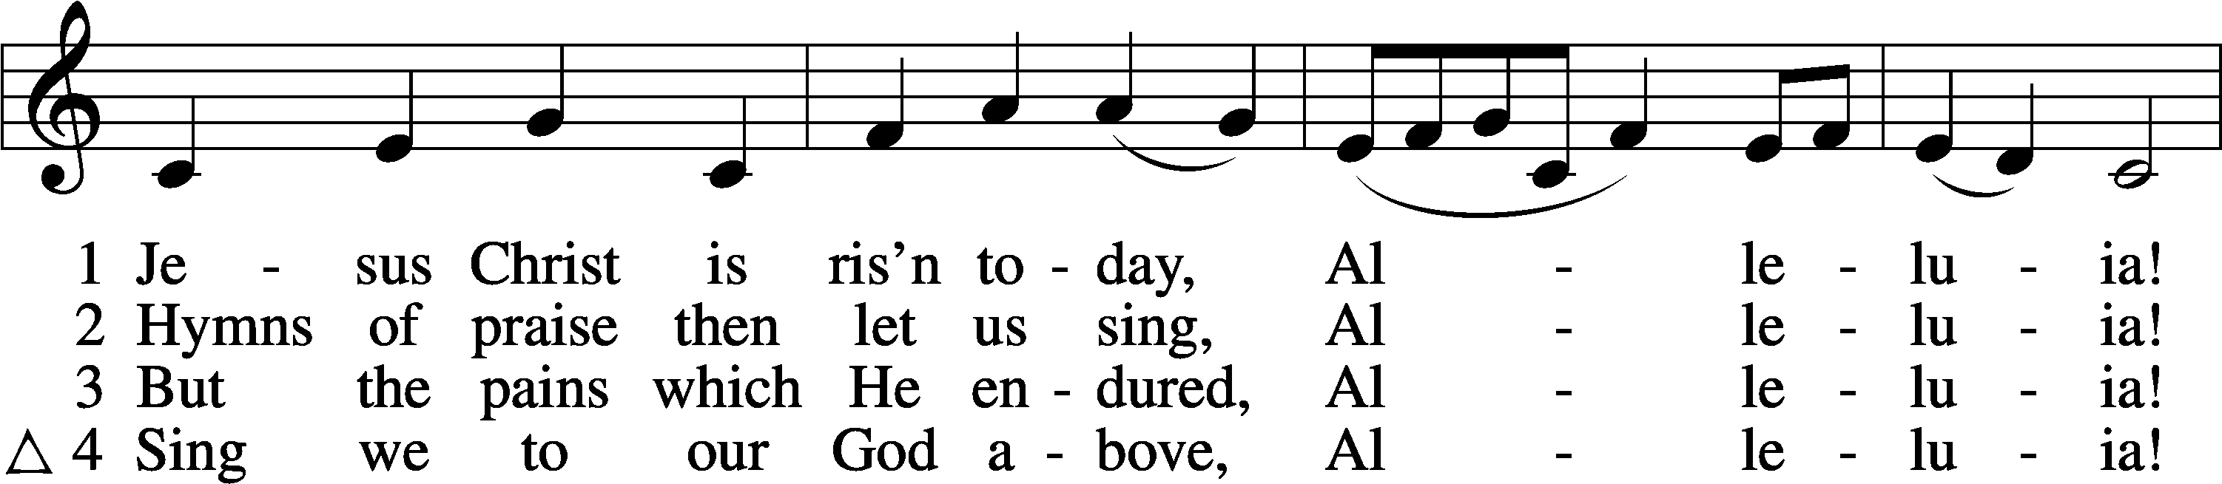

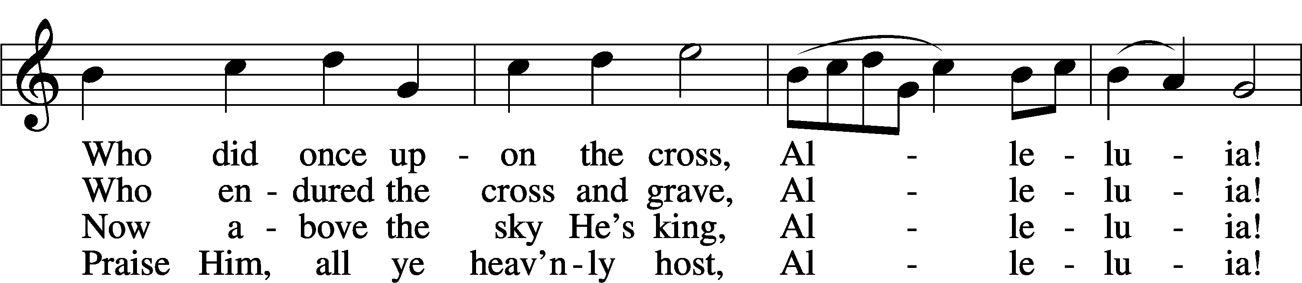

Text and tune: Public domain

**SALUTATION**

Pastor: The Lord be with you.

**People: And also with you.**

**PRAYER OF THE DAY**

Pastor: Let us pray.  
Almighty God the Father, through Your only-begotten Son, Jesus Christ, You have overcome death and opened the gate of everlasting life to us.

**People: Grant that we, who celebrate with joy the day of our Lord’s resurrection, may be raised from the death of sin by Your life-giving Spirit;**

Pastor: through Jesus Christ, our Lord, who lives and reigns with You and the Holy Spirit, one God, now and forever.

**People: Amen.**

*Be Seated*

**OLD TESTAMENT READING** *Isaiah 25:6–9*

(When the Lord swallows up death, it will be like having the best feast ever prepared.)

On this mountain the Lord of hosts will make for all peoples  
 a feast of rich food, a feast of well-aged wine,  
 of rich food full of marrow, of aged wine well refined.  
And he will swallow up on this mountain  
 the covering that is cast over all peoples,  
 the veil that is spread over all nations.  
 He will swallow up death forever;  
and the Lord God will wipe away tears from all faces,  
 and the reproach of his people he will take away from all the earth,  
 for the Lord has spoken.  
It will be said on that day,  
 “Behold, this is our God; we have waited for him, that he might save us.  
 This is the Lord; we have waited for him;  
 let us be glad and rejoice in his salvation.”

Lector: This is the Word of the Lord.

**People: Thanks be to God.**

**GRADUAL** *adapt. from Matthew 28:7; Hebrews 2:7; Psalm 8:6*

Pastor: Christ has risen from the dead.

**People: God the Father has crowned Him with glory and honor.**

Pastor: He has given Him dominion over the works of His hands;

**People: He has put all things under His feet.**

**EPISTLE** *1 Corinthians 15:1–11*

(Paul, persecutor of Christians, is one of many people who saw Jesus alive after death.

The news is of primary importance for people of faith.)

Now I would remind you, brothers, of the gospel I preached to you, which you received, in which you stand, and by which you are being saved, if you hold fast to the word I preached to you—unless you believed in vain.

For I delivered to you as of first importance what I also received: that Christ died for our sins in accordance with the Scriptures, that he was buried, that he was raised on the third day in accordance with the Scriptures, and that he appeared to Cephas, then to the twelve. Then he appeared to more than five hundred brothers at one time, most of whom are still alive, though some have fallen asleep. Then he appeared to James, then to all the apostles. Last of all, as to one untimely born, he appeared also to me. For I am the least of the apostles, unworthy to be called an apostle, because I persecuted the church of God. But by the grace of God I am what I am, and his grace toward me was not in vain. On the contrary, I worked harder than any of them, though it was not I, but the grace of God that is with me. Whether then it was I or they, so we preach and so you believed.

Lector: This is the Word of the Lord.

**People: Thanks be to God.**

*Please Stand*

**HOLY GOSPEL** *Mark 16:1–8*

(The women are so shocked by the news of the resurrection that they initially tell no one.)

Pastor: The Holy Gospel according to St. Mark, the sixteenth chapter.

**People: Glory to You, O Lord.**

When the Sabbath was past, Mary Magdalene and Mary the mother of James and Salome bought spices, so that they might go and anoint him. And very early on the first day of the week, when the sun had risen, they went to the tomb. And they were saying to one another, “Who will roll away the stone for us from the entrance of the tomb?” And looking up, they saw that the stone had been rolled back—it was very large. And entering the tomb, they saw a young man sitting on the right side, dressed in a white robe, and they were alarmed. And he said to them, “Do not be alarmed. You seek Jesus of Nazareth, who was crucified. He has risen; he is not here. See the place where they laid him. But go, tell his disciples and Peter that he is going before you to Galilee. There you will see him, just as he told you.” And they went out and fled from the tomb, for trembling and astonishment had seized them, and they said nothing to anyone, for they were afraid.

Pastor: This is the Gospel of the Lord.

**People: Praise to You, O Christ.**

*Be Seated*

**HYMN OF THE DAY 465** “Now All the Vault of Heaven Resounds”

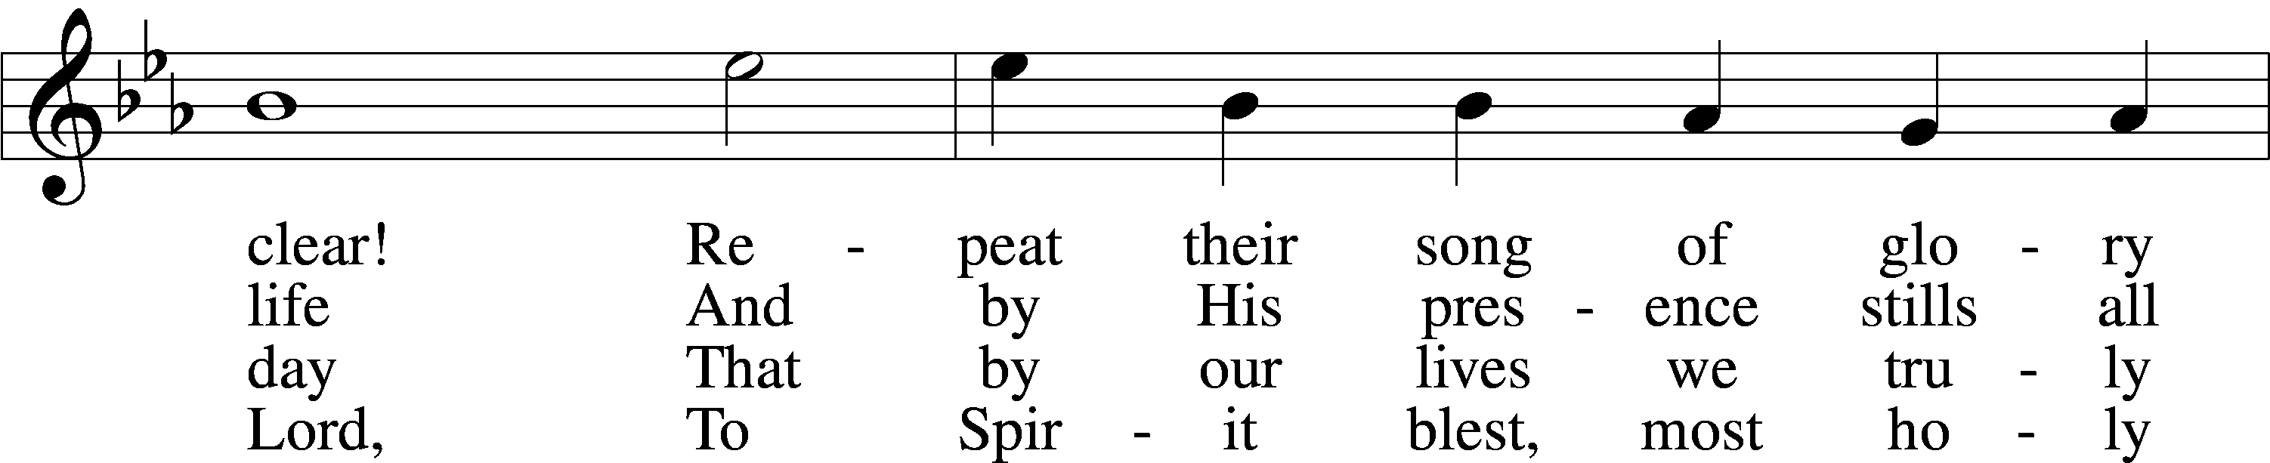

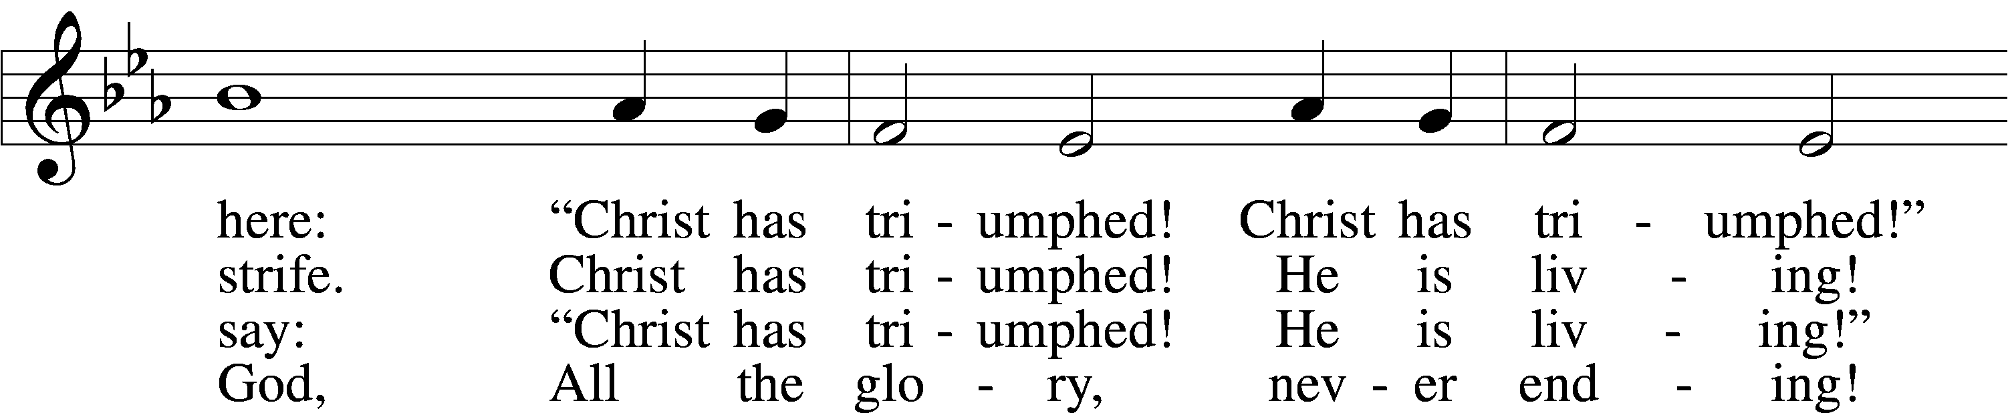

Text: © 1958 Augsburg Publishing House. Used by permission: LSB Hymn License no. 110000966  
Tune: Public domain

**SERMON**

*Please Stand*

**CATECHISM** *The Second Article*

**People: I believe in Jesus Christ, His only Son, our Lord, who was conceived by the Holy Spirit, born of the virgin Mary, suffered under Pontius Pilate, was crucified, died and was buried. He descended into hell. The third day He rose again from the dead. He ascended into heaven and sits at the right hand of God the Father Almighty. From thence He will come to judge the living and the dead.**

Pastor: What does this mean?

**People: I believe that Jesus Christ,**

*Women: true God, begotten of the Father from eternity,*

*Men: and also true man, born of the virgin Mary,*

**People: is my Lord,**

*Women: who has redeemed me, a lost and condemned person, purchased and won me from all sins, from death, and from the power of the devil;*

*Men: not with gold or silver, but with His holy, precious blood and with His innocent suffering and death,*

**People: that I may be His own and live under Him in His kingdom and serve Him in everlasting righteousness, innocence, and blessedness, just as He is risen from the dead, lives and reigns to all eternity. This is most certainly true.**

*Be Seated*

**OFFERING MUSIC** “Awake My Heart with Gladness” *M. Burkhardt*

*Please Stand*

**OFFERTORY**

*Kneel or Be Seated*

**PRAYER OF THE CHURCH**

Pastor: Christ has been raised from the dead, the firstfruits of those who have fallen asleep. He lives to intercede for us before the Father. With confidence, let us present to God our petitions for the whole people of God in Christ Jesus.  
  
For the holy Christian Church throughout the world, that it may be found without fault at the day of our Lord Jesus Christ, let us pray to the Lord.

**People: Lord, have mercy.**

Pastor: For all believers in the Lord Jesus that their lives may testify to His resurrection, let us pray to the Lord.

**People: Lord, have mercy.**

Pastor: For the peace of the whole world, that a spirit of respect may grow among nations and peoples, let us pray to the Lord.

**People: Lord, have mercy.**

Pastor: For those in positions of public trust in all levels of government, that they may serve justice and promote the welfare and dignity of every person, let us pray to the Lord.

**People: Lord, have mercy.**

Pastor: For all who suffer because of poverty, persecution, or sickness, [*especially* . . .], and all others we name in our hearts [*silence*], that they may know the healing power of the risen Christ, let us pray to the Lord.

**People: Lord, have mercy.**

Pastor: For those who grieve because of the death of their loved ones, [*especially . . .*], that through the sure hope of the resurrection of Christ, God would wipe away the tears from their eyes and give them comfort, let us pray to the Lord.

**People: Lord, have mercy.**

Pastor: For this congregation, that we may be delivered from hardness of heart, and show forth God’s glory in all that we do, let us pray to the Lord.

**People: Lord, have mercy.**

Pastor: For all who come this day to the feast of our Lord’s body and blood, that their faith be strengthened, let us pray to the Lord.

**People: Lord, have mercy.**

Pastor: Into Your hands, O Lord, we commend all for whom we pray, trusting in Your mercy; through Your Son, Jesus Christ, our risen Lord.

**People: Amen.**

Pastor: Alleluia! Christ is risen!

**People: He is risen indeed! Alleluia!**

*Be Seated*

**✠ SACRAMENT ✠**

*The Sacrament, or Lord's Supper, is a special gift from God that brings us into personal communion with Jesus Christ. "In, with and under" the bread and wine we receive His body and blood for forgiveness and renewal. If you are a repentant sinner, come to the table expecting to receive God's wonderful gifts for you!*

*Communicants will take their own wine cups as they are passed. Those requiring non-alcoholic grape juice will take the cups with white grape juice from the middle of the tray.*

*Remain Seated*

**OUR EXAMINATION**

Pastor: In preparation for Holy Communion, St. Paul tells us in 1 Corinthians 11:27-29, “Whoever, therefore, eats the bread or drinks the cup of the Lord in an unworthy manner will be guilty concerning the body and blood of the Lord. 28Let a person examine himself, then, and so eat of the bread and drink of the cup. 29For anyone who eats and drinks without discerning the body eats and drinks judgment on himself.” So that we may properly examine ourselves prior to receiving the Lord’s Supper, I ask you to reflect on these questions:

* Do you repent of all your sins of thought, word, and deed?
* Do you believe that Jesus Christ is your only Savior from all sin, Satan, and death?
* Do you believe that the Risen Christ is really present in the Sacrament and that in, with, and under the bread and wine you receive His true Body and Blood?

If you answer in faith "Yes!" to these questions, and are properly instructed, you are invited to come forward and partake of the Lord's Supper during Distribution. If you are unable to answer yes to any of these questions, you are invited to come forward, cross your arms as I approach you and receive a blessing. By your coming forward, "You proclaim the Lord's death until He comes."

*Please Stand*

**PREFACE** *2 Timothy 4:22*

Pastor: The Lord be with you.

**People: And also with you.**

Pastor: Lift up your hearts.

**People: We lift them to the Lord.**

Pastor: Let us give thanks to the Lord our God.

**People: It is right to give Him thanks and praise.**

**PROPER PREFACE**

Pastor: It is truly good, right, and salutary that we should at all times and in all places give thanks to You, holy Lord, almighty Father, everlasting God. And most especially are we bound to praise You on this day for the glorious resurrection of Your Son, Jesus Christ, the very Paschal Lamb, who was sacrificed for us and bore the sins of the world. By His dying He has destroyed death, and by His rising again He has restored to us everlasting life. Therefore with Mary Magdalene, Peter and John, and with all the witnesses of the resurrection, with angels and archangels, and with all the company of heaven we laud and magnify Your glorious name, evermore praising You and saying:

**HYMN 940 vv. 1, 4** “Holy God, We Praise Thy Name”

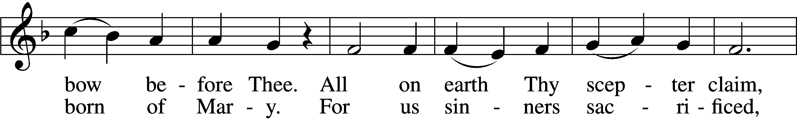

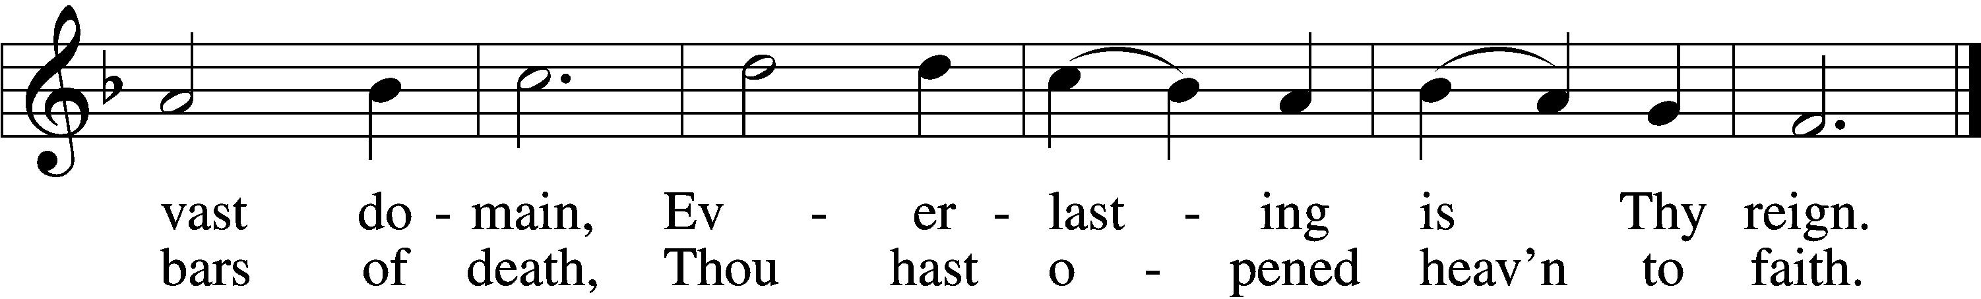

Text and tune: Public domain

**PRAYER OF THANKSGIVING**

Pastor: Blessed are You, Lord of heaven and earth, for You did not spare Your only Son, but gave Him into death that we might have life. Though we cannot understand Your love or comprehend eternity, we cannot keep the startling news to ourselves. Move us, we pray and strengthen us through this Sacrament to serve as Your witnesses.

**People: Give us opportunity, use our gifts, and move us by Your Holy Spirit to tell the starling news of Jesus’ victory over death until faith gives way to sight and we gather around the Lamb in His kingdom, which has no end.**

Pastor: Graciously receive our prayers; deliver and preserve us. To You alone, O Father, be all glory, honor, and worship, with the Son and the Holy Spirit, one God, now and forever.

**People: Amen.**

**THE WORDS OF OUR LORD** *Matthew 26:26–28; Mark 14:22–24; Luke 22:19–20;  
1 Corinthians 11:23–25*

Pastor: Our Lord Jesus Christ, on the night when He was betrayed, took bread, and when He had given thanks, He broke it and gave it to the disciples and said: “Take, eat; this is My ✠ body, which is given for you. This do in remembrance of Me.”  
  
In the same way also He took the cup after supper, and when He had given thanks, He gave it to them, saying: “Drink of it, all of you; this cup is the new testament in My ✠ blood, which is shed for you for the forgiveness of sins. This do, as often as you drink it, in remembrance of Me.”

**PROCLAMATION OF CHRIST** *1 Corinthians 11:26; Revelation 22:20*

Pastor: As often as we eat this bread and drink this cup, we proclaim the Lord’s death until He comes.

**People: Amen. Come, Lord Jesus.**

Pastor: O Lord Jesus Christ, only Son of the Father, in giving us Your body and blood to eat and to drink, You lead us to remember and confess Your holy cross and passion, Your blessed death, Your rest in the tomb, Your resurrection from the dead, Your ascension into heaven, and Your coming for the final judgment. So remember us in Your kingdom and teach us to pray:

**LORD’S PRAYER** *Matthew 6:9–13*

**People:** **Our Father who art in heaven,  
 hallowed be Thy name,  
 Thy kingdom come,  
 Thy will be done on earth  
 as it is in heaven;  
 give us this day our daily bread;  
 and forgive us our trespasses  
 as we forgive those   
 who trespass against us;  
 and lead us not into temptation,  
 but deliver us from evil.  
For Thine is the kingdom  
 and the power and the glory  
 forever and ever. Amen.**

**PAX DOMINI**

Pastor: The peace of the Lord be with you always.

**People: Amen.**

**HYMN 547 vv. 1, 5** “The Lamb”

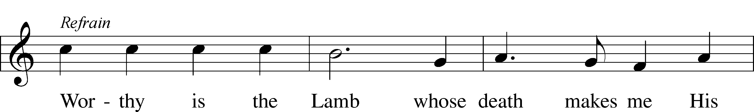

Text and tune: © 1987 and 1997 MorningStar Music Publishers. Used by permission: LSB Hymn License no. 110000966

*Be Seated*

**COMMUNION MEDITATION** “O Filii et Filiae” *M. Burkhardt*

**DISTRIBUTION HYMNS**

**HYMN 638** “Eat This Bread”

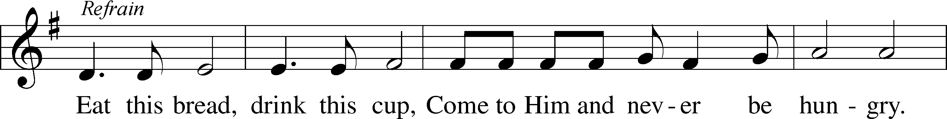

Text (sts. 1–2): © 1998 Concordia Publishing House. Used by permission: LSB Hymn License no. 110000966  
Text (sts. ref, 3–5) and tune: © 1984 Ateliers et Presses de Taizé, Taizé Community, France, admin. GIA Publications, Inc. Used by permission: LSB Hymn License no. 110000966

**HYMN 486** “If Christ Had Not Been Raised from Death”

Text: © 1985 The Jubilate Group, admin. Hope Publishing Co. Used by permission: LSB Hymn License no. 110000966  
Tune: © 2003 Phillip Magness. Used by permission: LSB Hymn License no. 110000966

*Please Stand*

**POST-COMMUNION CANTICLE**

**POST-COMMUNION THANKSGIVING**

Pastor: Let us pray.  
We give thanks, heavenly Father, through Jesus Christ, our Lord, that You have refreshed us through this gift of life, forgiveness, and salvation. Strengthen us by this Sacrament to announce this gracious Good News so that many may join us at the Lamb’s high feast; through Jesus Christ, Your Son, our Lord, who lives and reigns with You and the Holy Spirit, one God, now and forever.

**People: Amen.**

**BENEDICTION** *Numbers 6:24–26*

Pastor: The Lord bless you and keep you.  
The Lord make His face shine on you and be gracious to you.  
The Lord look upon you with favor and ✠ give you peace.

**People: Amen.**

**HYMN 461** “I Know That My Redeemer Lives”

5 He lives to silence all my fears;  
He lives to wipe away my tears;  
He lives to calm my troubled heart;  
He lives all blessings to impart.

6 He lives, my kind, wise, heav’nly friend;  
He lives and loves me to the end;  
He lives, and while He lives, I’ll sing;  
He lives, my Prophet, Priest, and King.

7 He lives and grants me daily breath;  
He lives, and I shall conquer death;  
He lives my mansion to prepare;  
He lives to bring me safely there.

8 He lives, all glory to His name!  
He lives, my Jesus, still the same;  
Oh, the sweet joy this sentence gives:  
I know that my Redeemer lives!

Text and tune: Public domain

**DISMISSAL**

Pastor: Alleluia! Christ is risen!

**People: He is risen indeed. Alleluia!**

Pastor: Go in peace as you serve our living Lord.

**People: Thanks be to God.**

*Be Seated*

**ANNOUNCEMENTS and RECOGNITION OF OUR GUESTS**

**POSTLUDE** “Christ the Lord Is Risen Today” *Richard Brown*

**TO THE GLORY OF GOD**

The Altar flowers are given to the glory of God

by the congregation.

***Jesus said to her, “I am the resurrection and the life.***

***Whoever believes in me, though he die, yet shall he live, and***

***everyone who lives and believes in me shall never die. Do you believe this?***

***John 11:25-26***

**A blessed Easter to you!!**

**+++**

**CONTRIBUTING EASTER LILIES THIS YEAR**

John & Mary Helen Anander Given in memory of Harry Anander

Cindy Baldwin Given in praise of our Risen Lord

Patricia & Gary Bradshaw Given in memory of Erma Lipari and Tony

Bradshaw & Chuck

Tracy Chance & Jackie Deemer Given in memory of Tom Deemer

Cathy Crotwell Given in praise of our Risen Lord

James & Carol Eckes Given in memory of Mark MacPhail

Elizabeth Geackel Given in memory of Kenneth R. Geackel, Jr.

and all my loved ones

Gin Hafemann Given in praise of our Risen Lord

Karen Hanovich Given in memory of Virginia & Richard

Shunk and Margaret & Michael Hanovich

Gretchen Holmes Given in praise of our Risen Lord

Bill & Sharon Johnson Given in memory of our parents

Sherry Kreger Given in praise of our Risen Lord

Gila & Ernest Martin Given in memory of Dolores Martin

Doug & Shirley Masini Given in memory of Eugene J. & Joyce A.

Masini

Marilyn McKee Given in memory of Bessie Stein

John Morrison Given in memory of Margot Morrison

Becky Reeve Given in memory of Bill & Janet Reeve

Bob & Pat Sautter Given in praise of our Risen Lord

Megan Thompson Given in praise of our Risen Lord

Creative Worship for the Lutheran Parish, Series B, Quarter 2.

Copyright © 2023 Concordia Publishing House. All rights reserved. Used by permission.

**EASTER POTLUCK BREAKFAST**

Join us in the Social Hall after the 8:30 service for a potluck breakfast provided by the congregation.

**BIBLE STUDY OPPORTUNITIES**

**ADULT SUNDAY BIBLE STUDY**

Pastor Webb leads a Bible study in the Social Hall after the 8:30 service.

**CHURCH YEAR CONNECTIONS**

**(Ages 3 through High School)**

Join us for Sunday School classes for ages three through young adult. Teachers: Megan Haverland (3 years-1st Grade), Judy Bringman (2nd-5th Grade), Bob Hanovich (Middle School), and Karl Schumacher (High School).

**PARENTS & TWOS CLASS**

In this class for parents and two-year-olds, Karen Hanovich helps parents encourage their little ones as they learn about Jesus together.

**YOUNG ADULT SINGLES CLASS**

For ages 18-26, this class led by Kevin Riedl is studying “Lessons from the Underground Church.”

**21ST CENTURY PARENTING CLASS**

Parents of school-aged kids gain insight into the issues facing Gen Z and learn how to engage them in meaningful conversations. Eric and Megan Thompson lead this class in the Education Building.

**YOUNG AT HEART CLASS**

Mature members study how we can demonstrate love and compassion to people in need. Bob Reynolds and Mark Waltz lead this class on the ground floor of the Education Building.

**WEDNESDAY MORNING BIBLE STUDY**

Join us at 10:00 a.m. on Wednesday mornings in the Education Building to study the Word.

**LADIES’ BIBLE STUDY**

The Ladies’ Bible Study meets on Mondays at 10:00am in the Education Building and now on Zoom also. Email Linda Tomko ([linda.tomko1946@gmail.com](mailto:linda.tomko1946@gmail.com).) for the Zoom link if you want to join that way. New members are welcome!

**HAPPENING AT TRINITY**

**THANK YOU**

Thank you to Barbara Lunick for playing the organ for us.

**OFFERINGS**

Please remain faithful in bringing your offerings to the Lord by mail or online if you are unable to attend worship in person.

**LUTHERAN WOMEN'S MISSIONARY LEAGUE MITES**

LWML MITES will be collected next Sunday.

**LUTHERAN WITNESS MAGAZINE SIGN-UP**

**Due by Sunday, April 14**

Lutheran Witness is an LCMS magazine published 11 times per year. You can subscribe now through April 14 on the sign-up sheet in the Narthex. Copies of the magazine are there so you can see what it’s like. It costs $21.50 per year; make the check out to Trinity, with a note designated for Lutheran Witness, and drop it in the offering plate or mail it to the church.

**WALK in the FOOTSTEPS of PAUL!**

A tour of many of the locations visited by the Apostle Paul is being offered this September 16-25, 2024.   A combination land and cruise tour, destinations include Thessalonica, Philippi, Athens, Corinth, Patmos, Crete, Santorini, and Delphi. Tour leaders are Pastor John Lehenbauer, and wife Renee, from Perry, Georgia. For further information, text or email Renee Lehenbauer at 478-397-5905 or [reneelehenbauer@gmail.com](mailto:reneelehenbauer@gmail.com).

**THANK YOU NOTE**

To the members of Trinity Lutheran Church: Four years ago Cathy and I made the decision to spend a portion of our year in Savannah. While we had been coming down here on vacation for years, buying a place was huge for two homebodies. The first thing we had to do was find a Lutheran Church, LCMS, to be specific and not only did He lead us to Trinity, you were the only choice and we hit a home run. Thank you for welcoming us from the moment we walked in. You are all absolutely amazing. The way the ladies embraced Cathy and brought her into the fold was beyond words. She loves you all. Pastor Webb, you talk right to me every Sunday. Your message, your approach and your heartfelt delivery are clearly divinely inspired. Again, we cannot thank you enough. We will be back. In Christ, Gary and Cathy Bear

**ONLINE GIVING**

Our ONLINE GIVING options have changed! We now have a TLC Venmo account for easy giving of your tithes and offerings. Contribute directly from your checking or savings account, check card, or credit card. Use the QR Code for easy access.

**CONNECT WITH US**

Connect with TLC and keep up with what’s going on.

\***Website** - [www.trinitylutheransavannah.com](http://www.trinitylutheransavannah.com)  
\***Facebook** - Friends of Trinity Lutheran Church; Trinity Lutheran Church – Community Info & Events (shareable page); Trinity Lutheran Church of Savannah Media; TLC Hearts of Compassion Helping Hands Ministry; Lizzie Comfort Dog  
\***Instagram** - #lcck9lizzie (Lizzie Comfort Dog)

\***YouTube** – Trinity Lutheran Savannah

**DEADLINE for BULLETIN ANNOUNCEMENTS**

**Every Wednesday by 9:00am**

Email bulletin announcements to [trinityoffice@bellsouth.net](mailto:trinityoffice@bellsouth.net) prior to 9:00am on Wednesdays.

**MINISTRY NEEDS**

**LOOKING FOR PHILIPS!**

Volunteers needed Sunday mornings to sit with visitors and guide them through our Divine Service. Please contact Chris Garretson or Bob Hanovich for additional information. *Acts 8:29 The Spirit told Philip, “Go to that chariot and stay near it.” 30 Then Philip ran up to the chariot and heard the man reading Isaiah the prophet. “Do you understand what you are reading?” Philip asked. 31 “How can I,” he said, “unless someone explains it to me?” So he invited Philip to come up and sit with him.*

**TODAY'S WORSHIP SERVICES**

Traditional 8:30 a.m. and 11:00 a.m.

**IN RESPONSE TO THE GOSPEL LAST SUNDAY**

8:30 a.m. – 67 11:00 a.m. – 61 Facebook – 89 YouTube – 0

Giving $4,681.38

Building Repair Fund 300.00

Easter Egg Hunt 50.00

Food Pantry 70.00

Lent 90.00

Pastor's Discretionary Fund 60.00

Seminary Student Willoughby 75.00

The Living Vine 75.00

Youth 81.00

**SERVING IN THE LORD'S HOUSE TODAY**

**8:30 a.m. 11:00 a.m.**

JB Strange, Greeter Vicki Lunick & Barbara Prieto, Greeters

Doug & Shirley Masini, Ushers Mark & Ann Waltz, Ushers

**SERVING NEXT SUNDAY**

**8:30 a.m. 11:00 a.m.**

Sherry Kreger, Reader

Bob & Cindy Reynolds, Greeters Shirley Lewis, Greeter

Larry Futch & Karl Schumacher, Ushers Rosemary Gerdes & Gretchen Holmes, Ushers

**THIS WEEK AT A GLANCE**

TODAY Traditional Worship Services 8:30 & 11:00 a.m.

Sunday School 9:45 a.m.

MONDAY 4/1 Board of Elders 6:30 p.m.

TUESDAY 4/2 Clothes Closet 4:00-6:00 p.m.

WEDNESDAY 4/3 Bible Study 10:00 a.m.

LWML Lunch & Meeting (Education Building) 11:30 a.m.

THURSDAY 4/4 Clothes Closet 10:00 a.m.-1:00 p.m.

Crafters (Education Building) 10:00 a.m.-2:00 p.m.

NAMI (Education Building) 6:00-7:00 p.m.

FRIDAY 4/5 Meals for Homeless (Education Building Kitchen) 4:00 p.m.

SATURDAY 4/6 Young Adult Singles Zoom 7:30 p.m.

**REMEMBER IN PRAYER**

*(Please help us keep the prayer list updated)*

HEALTH

Pastor Hopkins

CANCER

Alisha Goldbach; Harold LaMarr; Samuel Martin (19)

PEACE

Israel, Ukraine, & all who suffer from war and violence

OUR WITNESS

Let us proclaim Jesus Christ is risen to all!

OUR CONCERNS

Raise up those, Lord, who would serve Your Church.



**TRINITY LUTHERAN CHURCH**

12391 Mercy Blvd

Savannah, GA 31419

phone 912-925-4839 [trinityoffice@bellsouth.net](mailto:trinityoffice@bellsouth.net)

fax 912-925-4056 www.trinitylutheransavannah.com

Contact Pastor: 717-333-6263; pastorjeffwebb@yahoo.com

**STAFF**

Jeff Webb, Pastor

Traci Schumacher, Administrative Assistant

Helen Williams, Church Custodian

**BOARD OF ELDERS**

Mark Waltz, Head Elder (C – E)

Mike Fajen (K – Mc)

Todd Freesemann (F – J)

Sonny Massey (A – B)

Bob Reynolds (Me – Sa)

Tom Wayman (Sc – Z)

**CHURCH COUNCIL**

Kip Wiltse, President

Eric Thompson, Vice President

Cathy Crotwell, Secretary

Karl Schumacher, Treasurer

Jennifer Wolfe, Board of Education

Mark Waltz, Board of Elders

Chris Garretson, Board of Evangelism

Chris Cesaroni, Board of Property Management

Karen Hanovich, Board of Social Ministry

Lonna McEwen, Board of Stewardship

Cindy Reynolds, Financial Secretary

Bob Hanovich, Board of Youth

**ORGANIZATIONAL LEADERS**

Cindy Baldwin, Comfort Dog Top Dog

Jackie Deemer, Director of TLC Singers & LWML President

Katie Fester, Sunday School Superintendent

Rosemary Gerdes, Quilters

Karen Hanovich, TLC Marketing

Lonna McEwen, Altar Guild

Rose Pitt, Prayer Team