**Trinity Lutheran Church**

**Maundy Thursday**

**March 28, 2024 1:00 & 7:00 p.m. Communion Service**

**WELCOME TO TRINITY!**

Thank you for worshipingwith us today, whether at home or in person. If you are visiting, please honor us by signing the Guest Register in the Narthex.

There are times in our worship service where we stand or kneel. Feel free to participate in either as you are able or feel comfortable to remain seated.

Gluten-free wafers are available upon request during communion services. Please speak to the pastor before service if you wish to receive the host in this form.

Please ask an usher should you require a hearing assistance device.

(†) ~ Those who wish may make the sign of the Cross in remembrance of their Baptism.

**RECEPTION OF HOLY COMMUNION**

If you are not a member of Trinity Lutheran Church, we ask that you speak with the pastor prior to the service before receiving the Lord’s Supper.

**REQUESTS FOR PRAYER**

Prayer requests may be emailed to [trinityoffice@bellsouth.net](mailto:trinityoffice@bellsouth.net) or to pastorjeffwebb@yahoo.com.

**FOR PARENTS WITH YOUNG CHILDREN**

We are delighted that you have brought your child to worship! We invite you to use the Cry Room as a courtesy to others if your little one gets a little rambunctious. Our Cry Room, complete with seating and children's activities, is located at the back of the Sanctuary. The service can be heard through the sound system. We hope your children feel glad they were here and that they are a part of the Trinity family!

***Our Vision:***

***Growing in God’s Word to Share Christ’s Love***

***Our Mission:***

***Led by God, equipped as disciples through Word and Sacrament,***

***we are empowered by the Holy Spirit to reach out with the Gospel of Jesus Christ to all.***



**AS WE GATHER TODAY**

In about 1498, Leonardo da Vinci completed his masterpiece “The Last Supper.” This famous painting shows Jesus seated at the table on Holy Thursday, surrounded by His twelve disciples. Although Judas the betrayer is positioned lower than the rest and darkened in features, Christ is full of light. Both the set of three windows that appear behind Jesus and the triangular shape of His body show how the triune God is made flesh in our Redeemer. All the gestures and expressions of the disciples are painted in such a way to capture the mixed moods of the night when our Lord was betrayed and handed over to death for us. Looking closely at the painting, every line is positioned in such a way to guide your eyes toward the center: Jesus, the Host of the feast, the centerpiece of da Vinci’s masterpiece! The Meal we gather to receive today is all about Jesus. The One who is the center of it all longs to gather His guests together to feast in His presence, both now and forevermore.

**HOLY THURSDAY**

It’s All about Jesus

**✠ PREPARATION ✠**

*Please Stand*

**HYMN 435** “Come to Calvary’s Holy Mountain”

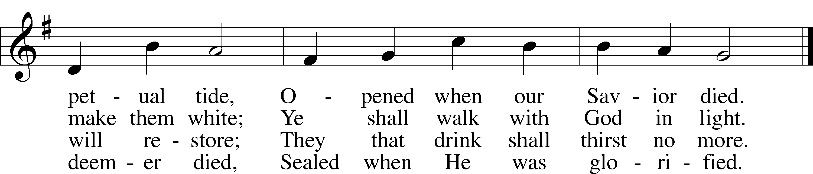

Text and tune: Public domain

**INVOCATION**

Pastor: In the name of the Father and of the ✠ Son and of the Holy Spirit.

**People: Amen.**

*Kneel or Be Seated*

**CONFESSION AND ABSOLUTION** *Luke 18:13*

Pastor: By means of His Word and Supper, we gather together this day to receive our Savior’s mercy and respond to Him in thanksgiving and praise. Because of our sins of thought, word, and deed, we are spiritually bankrupt and unworthy of the grace we receive. Yet at the invitation of our loving Redeemer, we come to His Table and take our place with Him. Acknowledging our sin, let us find refuge in our God of grace and say, “God be merciful to me, a sinner.”

*In silent prayer, we reflect on God’s Word and confess our sins to the Lord.*

Pastor: Together, let us pray:

**People: Almighty God, have mercy upon us, forgive us our sins, and lead us to everlasting life, that we may enjoy the fullness of Your presence at the feast You have prepared for all who trust in You. Amen.**

Pastor: Almighty God in His mercy has given His Son to die and rise again for you so that you may be redeemed and restored. You have been invited to the eternal banquet, the heavenly feast, where our Savior and Host delights us with the richest of fare, the forgiveness of sins. Upon this your confession, I, as a servant of Christ and your pastor, forgive you all your sins in the name of the Father and of the ✠ Son and of the Holy Spirit.

**People: Amen.**

*Please Stand*

**✠ WORD ✠**

**INTROIT** *Psalm 116:1–4; antiphon: v. 5*

Pastor: Gracious is the Lord, and righteous;

**People: our God is merciful.**

Pastor: I love the Lord, because He has heard

**People: my voice and my pleas for mercy.**

Pastor: Because He inclined His ear to me,

**People: therefore I will call on Him as long as I live.**

Pastor: The snares of death encompassed me; the pangs of Sheol laid hold on me;

**People: I suffered distress and anguish.**

Pastor: Then I called on the name of the Lord:

**People: “O Lord, I pray, deliver my soul!”**

Pastor: Gracious is the Lord, and righteous;

**People: our God is merciful.**

**KYRIE**

Pastor: In peace let us pray to the Lord.

Pastor: For the peace from above and for our salvation, let us pray to the Lord**.**

Pastor: For the peace of the whole world, for the well-being of the Church of God,

and for the unity of all, let us pray to the Lord.

Pastor: For this holy house and for all who offer here their worship and praise, let us pray to the Lord.

Pastor: Help, save, comfort, and defend us, gracious Lord.

**SALUTATION**

Pastor: The Lord be with you.

**People: And also with you.**

**PRAYER OF THE DAY**

Pastor: Let us pray.  
Lord Jesus, in this sacred Meal You have left us a remembrance of Your suffering and death for our salvation.

**People: As we eat with You in the kingdom of God, grant that our hearts and minds may be turned to You alone;**

Pastor: for You live and reign with the Father and the Holy Spirit, one God, now and forever.

**People: Amen.**

*Be Seated*

**OLD TESTAMENT READING** *Exodus 24:3–11*

(The blood of the covenant was offered for God’s people.)

Moses came and told the people all the words of the Lord and all the just decrees. And all the people answered with one voice and said, “All the words that the Lord has spoken we will do.” And Moses wrote down all the words of the Lord. He rose early in the morning and built an altar at the foot of the mountain, and twelve pillars, according to the twelve tribes of Israel. And he sent young men of the people of Israel, who offered burnt offerings and sacrificed peace offerings of oxen to the Lord. And Moses took half of the blood and put it in basins, and half of the blood he threw against the altar. Then he took the Book of the Covenant and read it in the hearing of the people. And they said, “All that the Lord has spoken we will do, and we will be obedient.” And Moses took the blood and threw it on the people and said, “Behold the blood of the covenant that the Lord has made with you in accordance with all these words.”

Then Moses and Aaron, Nadab, and Abihu, and seventy of the elders of Israel went up, and they saw the God of Israel. There was under his feet as it were a pavement of sapphire stone, like the very heaven for clearness. And he did not lay his hand on the chief men of the people of Israel; they beheld God, and ate and drank.

Lector: This is the Word of the Lord.

**People: Thanks be to God.**

**GRADUAL** *Hebrews 9:12a, c, 15a; Psalm 111:9a*

Pastor: [Christ] entered once for all into the holy places, by means of His own blood, thus securing an eternal redemption.

**People: Therefore He is the mediator of a new covenant, so that those who are called may receive the promised eternal inheritance.**

Pastor: He sent redemption to His people;

**People: He has commanded His covenant forever.**

**EPISTLE** *1 Corinthians 10:16–17* (A participation in the body and blood of Christ)

The cup of blessing that we bless, is it not a participation in the blood of Christ? The bread that we break, is it not a participation in the body of Christ? Because there is one bread, we who are many are one body, for we all partake of the one bread.

Lector: This is the Word of the Lord.

**People: Thanks be to God.**

**VERSE** *John 13:1b*

Pastor: Having loved His own who were in the world,

**People: He loved them to the end.**

*Please Stand*

**HOLY GOSPEL** *Mark 14:12–26* (Jesus institutes the Lord’s Supper.)

Pastor: The Holy Gospel according to St. Mark, the fourteenth chapter.

**People: Glory to You, O Lord.**

On the first day of Unleavened Bread, when they sacrificed the Passover lamb, [Jesus’] disciples said to him, “Where will you have us go and prepare for you to eat the Passover?” And he sent two of his disciples and said to them, “Go into the city, and a man carrying a jar of water will meet you. Follow him, and wherever he enters, say to the master of the house, ‘The Teacher says, Where is my guest room, where I may eat the Passover with my disciples?’ And he will show you a large upper room furnished and ready; there prepare for us.” And the disciples set out and went to the city and found it just as he had told them, and they prepared the Passover.

And when it was evening, he came with the twelve. And as they were reclining at table and eating, Jesus said, “Truly, I say to you, one of you will betray me, one who is eating with me.” They began to be sorrowful and to say to him one after another, “Is it I?” He said to them, “It is one of the twelve, one who is dipping bread into the dish with me. For the Son of Man goes as it is written of him, but woe to that man by whom the Son of Man is betrayed! It would have been better for that man if he had not been born.”

And as they were eating, he took bread, and after blessing it broke it and gave it to them, and said, “Take; this is my body.” And he took a cup, and when he had given thanks he gave it to them, and they all drank of it. And he said to them, “This is my blood of the covenant, which is poured out for many. Truly, I say to you, I will not drink again of the fruit of the vine until that day when I drink it new in the kingdom of God.”

And when they had sung a hymn, they went out to the Mount of Olives.

Pastor: This is the Gospel of the Lord.

**People: Praise to You, O Christ.**

**CREED** *Nicene Creed*

**People: I believe in one God,  
 the Father Almighty,  
 maker of heaven and earth  
 and of all things visible and invisible.  
  
And in one Lord Jesus Christ,  
 the only-begotten Son of God,  
 begotten of His Father before all worlds,  
 God of God, Light of Light,  
 very God of very God,  
 begotten, not made,  
 being of one substance with the Father,  
 by whom all things were made;  
 who for us men and for our salvation came down from heaven  
 and was incarnate by the Holy Spirit of the virgin Mary  
 and was made man;  
 and was crucified also for us under Pontius Pilate.  
 He suffered and was buried.  
 And the third day He rose again according to the Scriptures  
 and ascended into heaven  
 and sits at the right hand of the Father.  
 And He will come again with glory to judge both the living and the dead,  
 whose kingdom will have no end.  
  
And I believe in the Holy Spirit,  
 the Lord and giver of life,  
 who proceeds from the Father and the Son,  
 who with the Father and the Son together is worshiped and glorified,  
 who spoke by the prophets.  
 And I believe in one holy Christian and apostolic Church,  
 I acknowledge one Baptism for the remission of sins,  
 and I look for the resurrection of the dead  
 and the life ✠ of the world to come. Amen.**

*Be Seated*

**HYMN OF THE DAY 617** “O Lord, We Praise Thee”

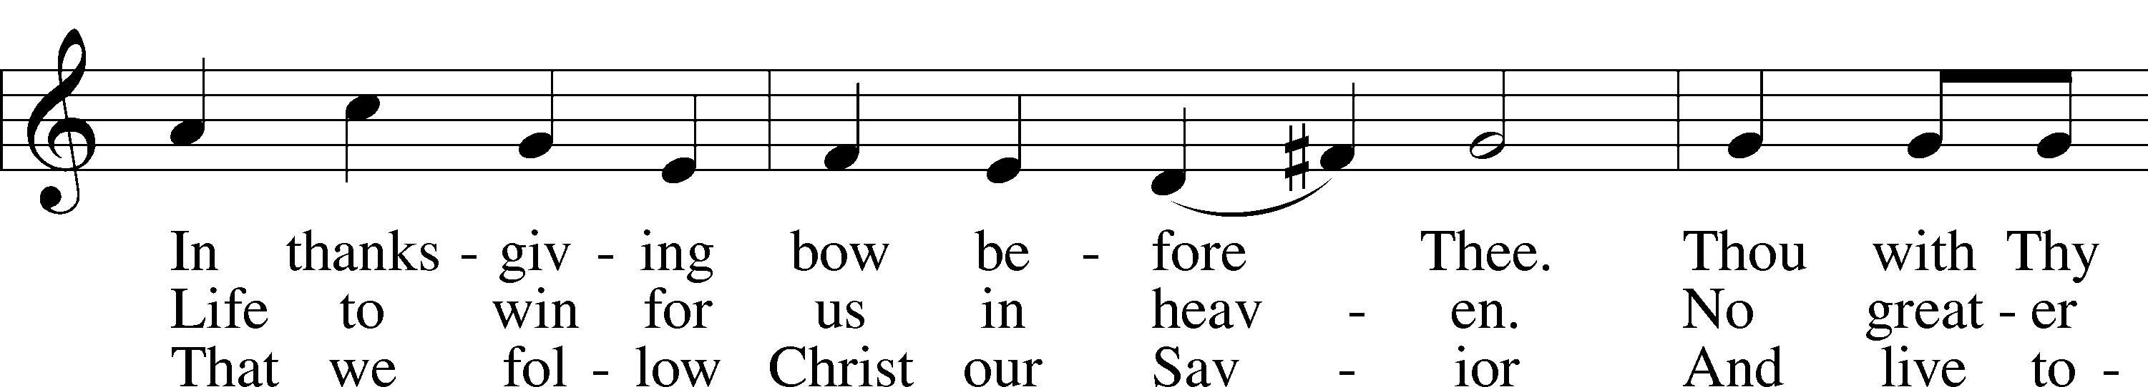

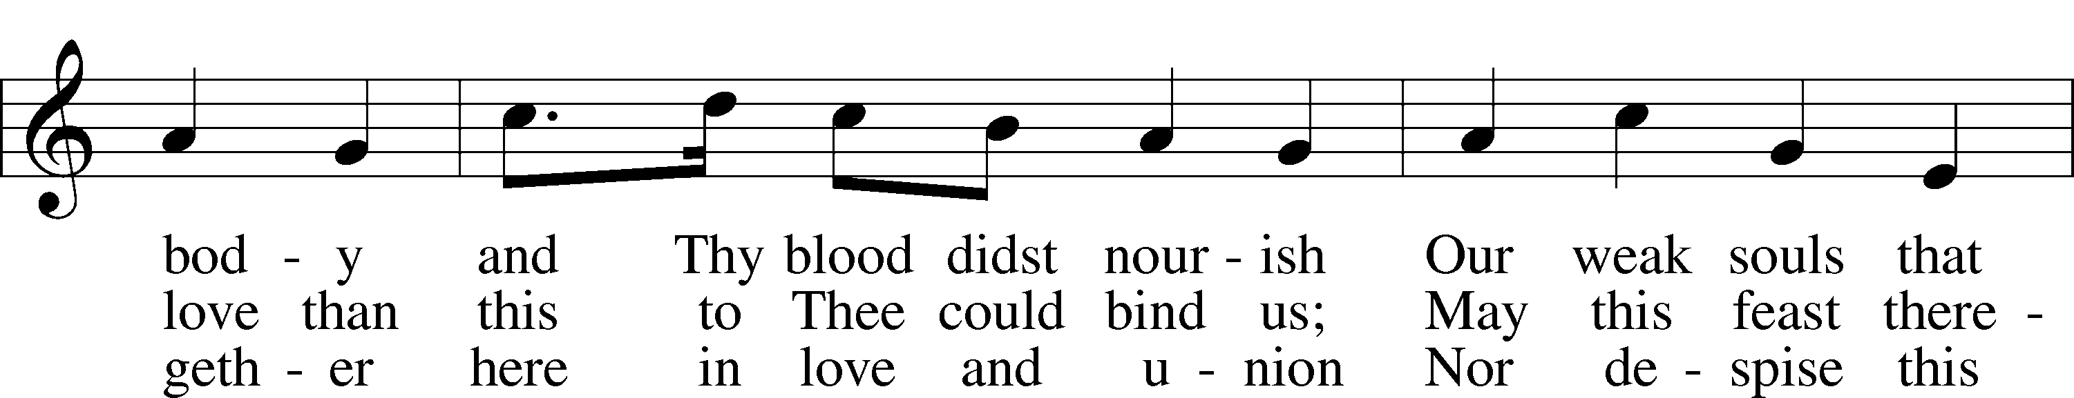

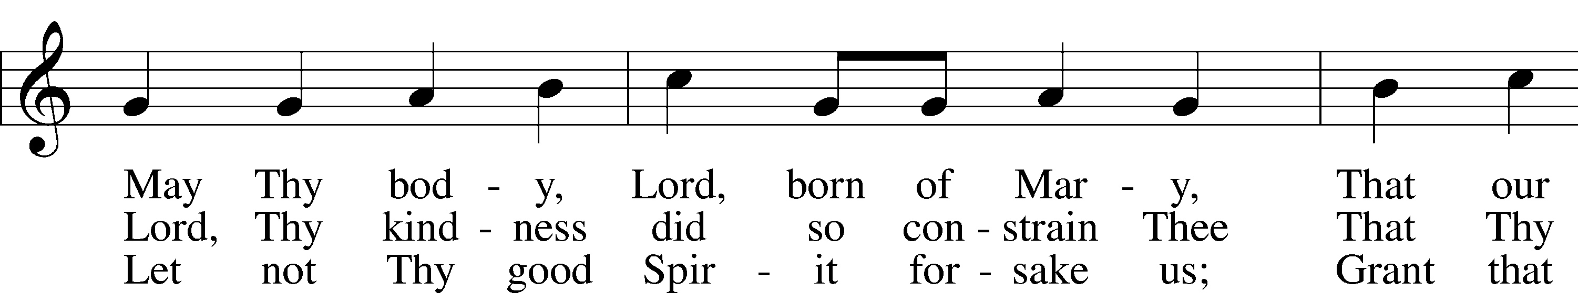

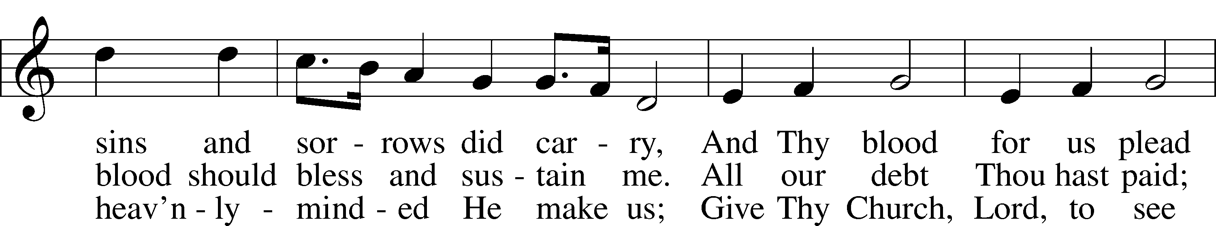

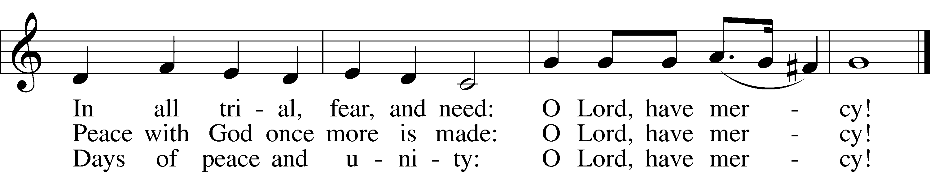

Text: © 1941 Concordia Publishing House. Used by permission: LSB Hymn License no. 110000966  
Tune: Public domain

**SERMON**

**OFFERING**

*Please Stand*

**OFFERTORY**

*Kneel or Be Seated*

**PRAYER OF THE CHURCH**

Pastor: Brothers and sisters in Christ, let us lift up our hearts and voices to the God of all mercy as He has invited us to pray to Him in the name of our Savior and in the way in which He has taught us. Lord, in Your mercy,

**People: hear our prayer.**

Pastor: Our Father in heaven, look with mercy upon us, for without Your aid we are spiritually poor, crippled, blind, and lame. Grant us grace that Your holy name is kept sacred among us and that, in all the world, Your Son may be known through the preaching of Your Word to the ends of the earth. Lord, in Your mercy,

**People: hear our prayer.**

Pastor: King of kings, may Your rule and reign come to us and expand throughout the world. Bring all who are blinded by sin and bound by death to know Jesus Christ, the Lamb of God who takes away the sin of the world. Work through our earthly leaders and public servants so that Your hand of blessing may be known to all. Lord, in Your mercy,

**People: hear our prayer.**

Pastor: Strengthen us by Your Spirit according to Your will, both in life and in death, in the midst of both good and evil things, that by faith we cling to the One who was betrayed and handed over to death for us. Into Your care we commend those who have needs in both soul and body, [*especially . . .*]. For these, and for all those we name before You in the silence of our hearts, we ask that Your will may be done among us [*silence*]. Lord, in Your mercy,

**People: hear our prayer.**

Pastor: How blessed we are to eat bread in Your kingdom, O God! Lord Jesus, You alone are the Bread of Life, and You alone satisfy our hungry hearts. Grant to us our daily bread and help us to realize that You daily and richly provide for all that we need according to Your own riches and grace. Lord, in Your mercy,

**People: hear our prayer.**

Pastor: Forgive us our sins as we also forgive those who sin against us. Center our hearts and minds on You alone. As we recognize that we are spiritually bankrupt without Your mercy, grant that the spirit of unforgiveness be removed from us so that we live in peace with You and with one another. Lord, in Your mercy,

**People: hear our prayer.**

Pastor: Lead us not into temptation, O Lord, but help us to take refuge in Your grace. On this very night, You were betrayed by one of Your own and handed over to death. Direct us to follow You to the cross of Calvary, where You laid down Your life to deliver us from the evil one and all his works and all his ways. Lord, in Your mercy,

**People: hear our prayer.**

Pastor: We belong to You, O Lord. Renew us, guide us, and lead us so that we may bless Your holy name and celebrate the feast You have prepared for us,

**People: for Yours is the kingdom, the power, and the glory, now and forever. Amen.**

*Be Seated*

**✠ SACRAMENT ✠**

*The Sacrament, or Lord's Supper, is a special gift from God that brings us into personal communion with Jesus Christ. "In, with and under" the bread and wine we receive His body and blood for forgiveness and renewal. If you are a repentant sinner, come to the table expecting to receive God's wonderful gifts for you!*

*Communicants will take their own wine cups as they are passed. Those requiring non-alcoholic grape juice will take the cups with white grape juice from the middle of the tray.*

*Remain Seated*

**OUR EXAMINATION**

Pastor: In preparation for Holy Communion, St. Paul tells us in 1 Corinthians 11:27-29, “Whoever, therefore, eats the bread or drinks the cup of the Lord in an unworthy manner will be guilty concerning the body and blood of the Lord. 28Let a person examine himself, then, and so eat of the bread and drink of the cup. 29For anyone who eats and drinks without discerning the body eats and drinks judgment on himself.” So that we may properly examine ourselves prior to receiving the Lord’s Supper, I ask you to reflect on these questions:

* Do you repent of all your sins of thought, word, and deed?
* Do you believe that Jesus Christ is your only Savior from all sin, Satan, and death?
* Do you believe that the Risen Christ is really present in the Sacrament and that in, with, and under the bread and wine you receive His true Body and Blood?

If you answer in faith "Yes!" to these questions, and are properly instructed, you are invited to come forward and partake of the Lord's Supper during Distribution. If you are unable to answer yes to any of these questions, you are invited to come forward, cross your arms as Pastor approaches you and receive a blessing. By your coming forward, "You proclaim the Lord's death until He comes."

*Please Stand*

**PREFACE** *2 Timothy 4:22*

Pastor: The Lord be with you.

**People: And also with you.**

Pastor: Lift up your hearts.

**People: We lift them to the Lord.**

Pastor: Let us give thanks to the Lord our God.

**People: It is right to give Him thanks and praise.**

**PROPER PREFACE**

Pastor: It is truly good, right, and salutary that we should at all times and in all places give thanks to You, holy Lord, almighty Father, everlasting God, through Jesus Christ, our Lord, who invites us to His eternal banquet Table and feeds us with the Bread of Life, which alone satisfies our hungry hearts and enables us to joyfully experience His presence forever. Therefore with angels and archangels and with all the company of heaven we laud and magnify Your glorious name, evermore praising You and saying:

**SANCTUS**

**PRAYER OF THANKSGIVING**

Pastor: Blessed are You, O Lord our God, King of all creation, for You have had mercy on us and given Your only-begotten Son that whoever believes in Him should not perish but have eternal life.

**People: Jesus prepares His Table before us and invites us to feast with Him in His eternal kingdom.**

Pastor: Grant us Your Holy Spirit that we may faithfully eat and drink of the fruits of Christ’s cross and receive the blessings of forgiveness, life, and salvation that come to us in His body and blood.  
  
Hear us as we pray in His name and as He has taught us:

**LORD’S PRAYER** *Matthew 6:9–13*

**People:** **Our Father who art in heaven,  
 hallowed be Thy name,  
 Thy kingdom come,  
 Thy will be done on earth  
 as it is in heaven;  
 give us this day our daily bread;  
 and forgive us our trespasses  
 as we forgive those   
 who trespass against us;  
 and lead us not into temptation,  
 but deliver us from evil.  
For Thine is the kingdom  
 and the power and the glory  
 forever and ever. Amen.**

**THE WORDS OF OUR LORD** *Matthew 26:26–28; Mark 14:22–24; Luke 22:19–20;  
1 Corinthians 11:23–25*

Pastor: Our Lord Jesus Christ, on the night when He was betrayed, took bread, and when He had given thanks, He broke it and gave it to the disciples and said: “Take, eat; this is My ✠ body, which is given for you. This do in remembrance of Me.”  
  
In the same way also He took the cup after supper, and when He had given thanks, He gave it to them, saying: “Drink of it, all of you; this cup is the new testament in My ✠ blood, which is shed for you for the forgiveness of sins. This do, as often as you drink it, in remembrance of Me.”

**PAX DOMINI**

Pastor: The peace of the Lord be with you always.

**People: Amen.**

**HYMN 434** “Lamb of God, Pure and Holy”

Text and tune: Public domain

*Be Seated*

**DISTRIBUTION HYMNS**

**HYMN 618** “I Come, O Savior, to Thy Table”

Text: © 1941 Concordia Publishing House. Used by permission: LSB Hymn License no. 110000966  
Tune: Public domain

**HYMN 627** “Jesus Christ, Our Blessed Savior”

Text (sts. 3, 6, 8, 10): © 1980 and 2006 Concordia Publishing House. Used by permission: LSB Hymn License no. 110000966  
Text (sts. 1–2, 4–5, 7, 9) and tune: Public domain

*Please Stand*

**POST-COMMUNION CANTICLE**

**POST-COMMUNION THANKSGIVING**

Pastor: Let us pray.   
O Jesus, Lamb of God, we thank You for refreshing us through the gift of Your body and blood in this sacred Meal.

**People: Enable us with renewed minds and hearts to always love and trust in You alone;**

Pastor: for You live and reign with the Father and the Holy Spirit, one God, now and forever.

**People: Amen.**

**BENEDICTION** *Numbers 6:24–26*

Pastor: The Lord bless you and keep you.  
The Lord make His face shine on you and be gracious to you.  
The Lord look upon you with favor and ✠ give you peace.

**People: Amen.**

**HYMN 436** “Go to Dark Gethsemane”

Text and tune: Public domain

*Be Seated*

**STRIPPING OF THE ALTAR**

*According to local custom, the chancel items and communion vessels are removed.*

*The congregation departs from the sanctuary in silent reflection.*

**LENT & EASTER SCHEDULE**

Maundy Thursday (March 28): 1:00 & 7:00pm

Good Friday (March 29): 3:00 & 7:00pm

Easter Sunday (March 31): 8:30 & 11:00am

Creative Worship for the Lutheran Parish, Series B, Quarter 2.

Copyright © 2023 Concordia Publishing House. All rights reserved. Used by permission.

**TRINITY LUTHERAN CHURCH**

12391 Mercy Blvd

Savannah, GA 31419

phone 912-925-4839 [trinityoffice@bellsouth.net](mailto:trinityoffice@bellsouth.net)

fax 912-925-4056 www.trinitylutheransavannah.com

Contact Pastor: 717-333-6263; pastorjeffwebb@yahoo.com

**STAFF**

Jeff Webb, Pastor

Traci Schumacher, Administrative Assistant

Helen Williams, Church Custodian

**BOARD OF ELDERS**

Mark Waltz, Head Elder (C – E)

Mike Fajen (K – Mc)

Todd Freesemann (F – J)

Sonny Massey (A – B)

Bob Reynolds (Me – Sa)

Tom Wayman (Sc – Z)

**CHURCH COUNCIL**

Kip Wiltse, President

Eric Thompson, Vice President

Cathy Crotwell, Secretary

Karl Schumacher, Treasurer

Jennifer Wolfe, Board of Education

Mark Waltz, Board of Elders

Chris Garretson, Board of Evangelism

Chris Cesaroni, Board of Property Management

Karen Hanovich, Board of Social Ministry

Lonna McEwen, Board of Stewardship

Cindy Reynolds, Financial Secretary

Bob Hanovich, Board of Youth

**ORGANIZATIONAL LEADERS**

Cindy Baldwin, Comfort Dog Top Dog

Jackie Deemer, Director of TLC Singers & LWML President

Katie Fester, Sunday School Superintendent

Rosemary Gerdes, Quilters

Karen Hanovich, TLC Marketing

Lonna McEwen, Altar Guild

Rose Pitt, Prayer Team