Trinity Lutheran Church

**The Lutheran Church-Missouri Synod**

**Trinity Lutheran Church**

**Trinity Lutheran Church**

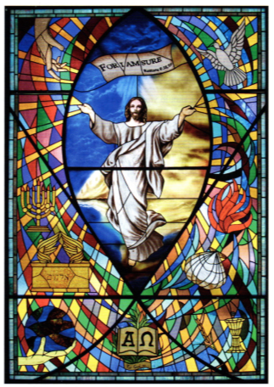

**12391 Mercy Blvd. · Savannah, GA 31419 · (912) 925-4839**

**www.trinitylutheransavannah.com**

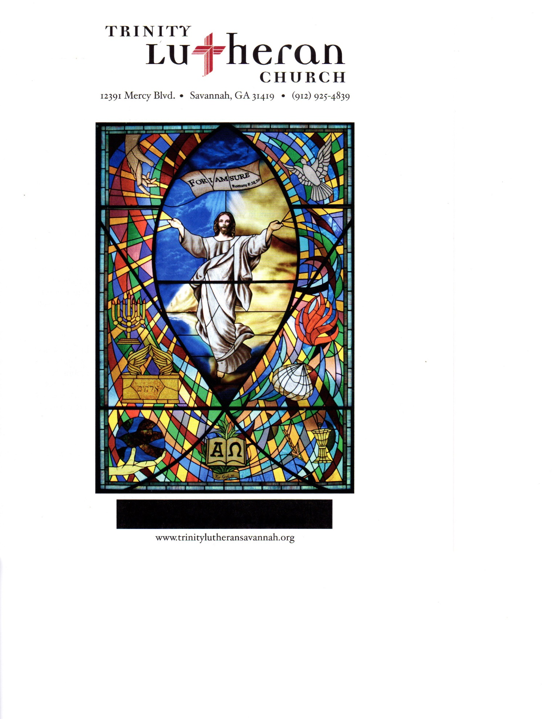

8:30 & 11:00 a.m. Divine Service

**Trinity Lutheran Church**

**The Third Sunday after the Epiphany**

**January 21, 2024 8:30 Communion & 11:00 a.m. Non-Communion Service**

**WELCOME TO TRINITY!**

Thank you for worshipingwith us today. We want to know who you are, so please provide your contact information in the Friendship Book as it is passed during the Offertory. If you are visiting, honor us by signing the Guest Register in the Narthex.

There are times in our worship service where we stand or kneel. Feel free to participate in either as you are able or feel comfortable to remain seated.

Gluten-free wafers are available upon request during communion services. Please speak to the pastor before service if you wish to receive the host in this form.

Please ask an usher should you require a hearing assistance device.

(†) ~ Those who wish may make the sign of the Cross in remembrance of their Baptism.

**RECEPTION OF HOLY COMMUNION**

If you are not a member of Trinity Lutheran Church, we ask that you speak with the pastor prior to the service before receiving the Lord’s Supper.

**REQUESTS FOR PRAYER**

If you have a prayer request, please fill out a Blue Card from the pew rack and place it in the offering plate. Prayer requests may also be emailed to [trinityoffice@bellsouth.net](mailto:trinityoffice@bellsouth.net) or to pastorjeffwebb@yahoo.com.

**FOR PARENTS WITH YOUNG CHILDREN**

We are delighted that you have brought your child to worship! We invite you to use the Cry Room as a courtesy to others if your little one gets a little rambunctious. Our Cry Room, complete with seating and children's activities, is located at the back of the Sanctuary. The service can be heard through the sound system. We hope your children feel glad they were here and that they are a part of the Trinity family!

***Our Vision:***

***Growing in God’s Word to Share Christ’s Love***

***Our Mission:***

***Led by God, equipped as disciples through Word and Sacrament,***

***we are empowered by the Holy Spirit to reach out with the Gospel of Jesus Christ to all.***



**AS WE GATHER TODAY**

Ever had those days that felt like weeks or those weeks that felt like days? Those minutes that felt like hours, or the hours that felt like minutes? Time is a fickle thing on this earth, as we are bound by it yet our perspective of it is ever changing. Our Scripture Readings today all deal with time. As God deemed it time for Nineveh to have the opportunity to repent and know His grace, He came to Jonah a second time. In the Epistle, Paul reminds us time is short, and the physical world is passing away.In the Gospel, Jesus would begin His earthly ministry and call His disciples, echoing the words of John the Baptist, “The time is fulfilled, and the kingdom of God is at hand” (Mark 1:15).Though to the Lord a day is like a thousand years and a thousand years are like a day, we live each day knowing that all time is in His hands. Until He calls His people to glory, we rejoice for the time to gather where His Spirit is, be blessed by His Word of Law and Gospel, rejoice in mercy and forgiveness, and make use of the time given to be witnesses to others.

**Divine Service**

***Setting One***

**ORGAN**

**WELCOME**

**CHIMING OF THE HOUR**

*Please Stand*

**PROCESSIONAL HYMN 688 vv. 1-2, 4-5 "’Come, Follow Me,’ the Savior Spake"**

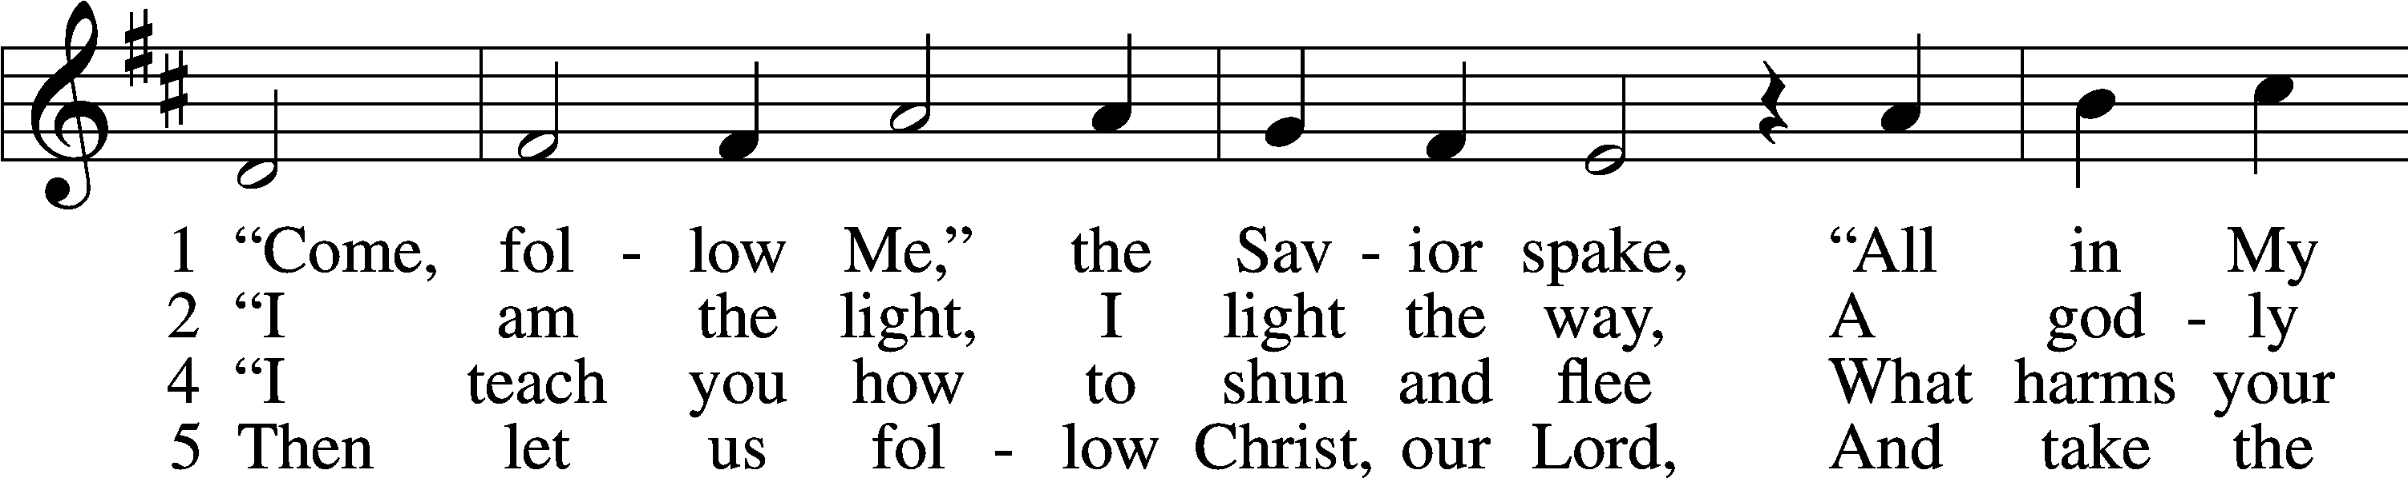

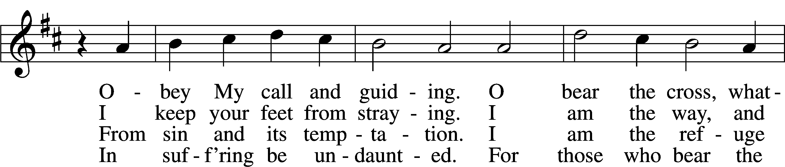

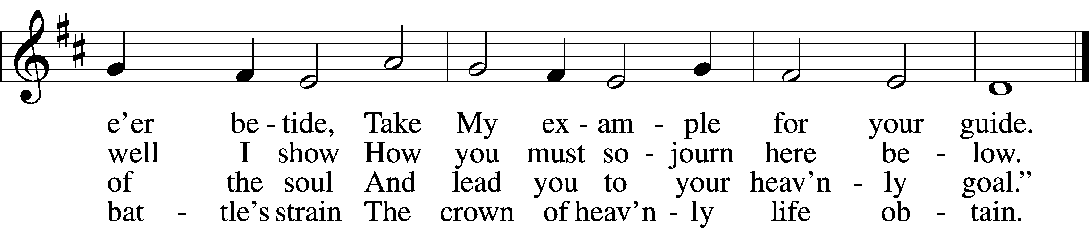

Text and tune: Public domain

**INVOCATION**

*(The sign of the cross may be made by all in remembrance of their Baptism.)*

P In the name of the Father and of the (†) Son and of the Holy Spirit.

C **Amen.** *Matthew 28:19b*

P If we say we have no sin, we deceive ourselves and the truth is not in us.

C **But if we confess our sins, God, who is faithful and just, will forgive our sins and cleanse us from all unrighteousness.** *1 John 1:8-9*

*Kneel or Be Seated*

**CONFESSION AND ABSOLUTION**

P Let us then confess our sins to God our Father.

*(Silence for reflection on God's Word and for self-examination.)*

P Most merciful God,

C **we confess that we are by nature sinful and unclean. We have sinned against You in thought, word, and deed, by what we have done and by what we have left undone. We have not loved You with our whole heart; we have not loved our neighbors as ourselves. We justly deserve Your present and eternal punishment. For the sake of Your Son, Jesus Christ, have mercy on us. Forgive us, renew us, and lead us, so that we may delight in Your will and walk in Your ways to the glory of Your holy name. Amen.**

P Almighty God in His mercy has given His Son to die for you and for His sake forgives you all your sins. As a called and ordained servant of Christ, and by His authority, I therefore forgive you all your sins in the name of the Father and of the (†) Son and of the Holy Spirit. *[John 20:19-23]*

C **Amen.**

**Service of the Word**

*Please Stand*

**PSALM *Psalm 62***

P 1For God alone my soul waits in silence;  
C  **from him comes my salvation.**

P 2He only is my rock and my salvation, my fortress;  
C  **I shall not be greatly shaken.**

P 3How long will all of you attack a man to batter him,  
C **like a leaning wall, a tottering fence?**

P 4They only plan to thrust him down from his high position.  
 They take pleasure in falsehood.  
C  **They bless with their mouths, but inwardly they curse.**

P 5For God alone, O my soul, wait in silence,  
C  **for my hope is from him.**

P 6He only is my rock and my salvation, my fortress;  
C  **I shall not be shaken.**

P 7On God rests my salvation and my glory;  
C **my mighty rock, my refuge is God.**

P 8Trust in him at all times, O people; pour out your heart before him;  
C  **God is a refuge for us.**

P 9Those of low estate are but a breath; those of high estate are a delusion;  
C  **in the balances they go up; they are together lighter than a breath.**

P 10Put no trust in extortion; set no vain hopes on robbery;  
C **if riches increase, set not your heart on them.**

P 11Once God has spoken; twice have I heard this:  
C **that power belongs to God,   
 12and that to you, O Lord, belongs steadfast love.**

P For you will render to a man  
C **according to his work.**

**All Glory be to the Father and to the Son and to the Holy Spirit;**

**as it was in the beginning, is now, and will be forever. Amen.**

**KYRIE ~ *Lord, Have Mercy*** *Mark 10:47*

P In peace let us pray to the Lord.

P For the peace from above and for our salvation, let us pray to the Lord**.**

P For the peace of the whole world, for the well-being of the Church of God,

and for the unity of all, let us pray to the Lord.

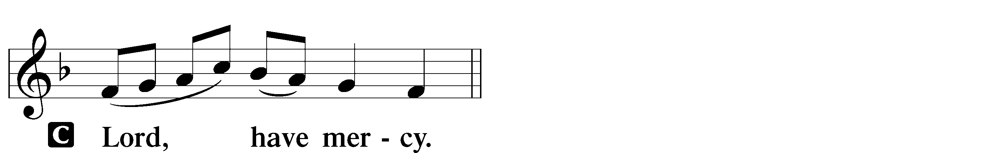

P For this holy house and for all who offer here their worship and praise, let us pray to the Lord.

P Help, save, comfort, and defend us, gracious Lord.

**HYMN OF PRAISE "This Is the Feast"** *Revelation 5:12-13; 19:5-9*

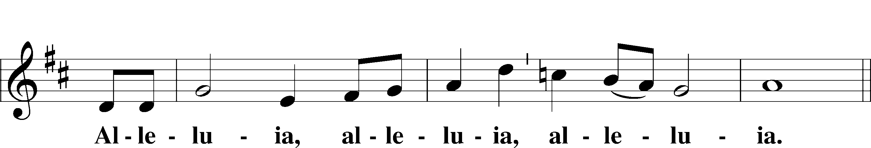

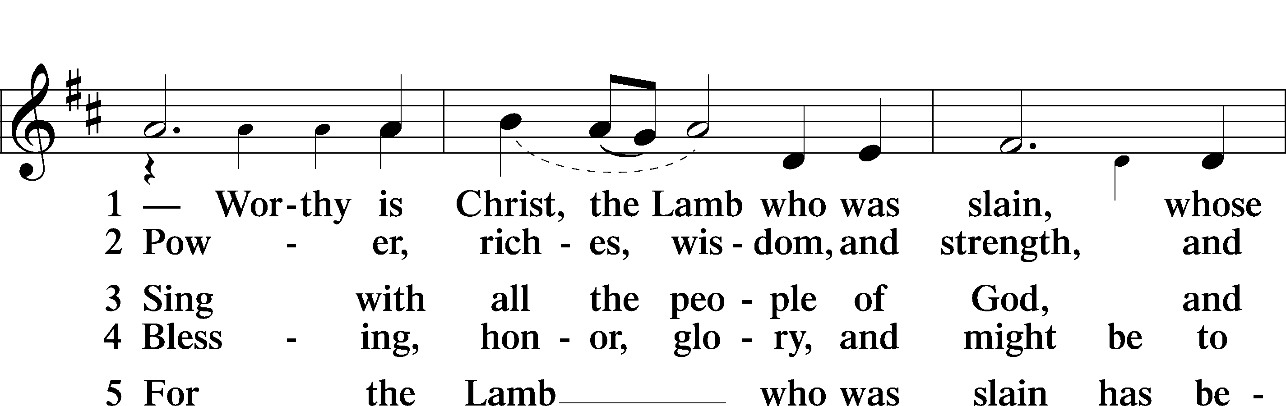

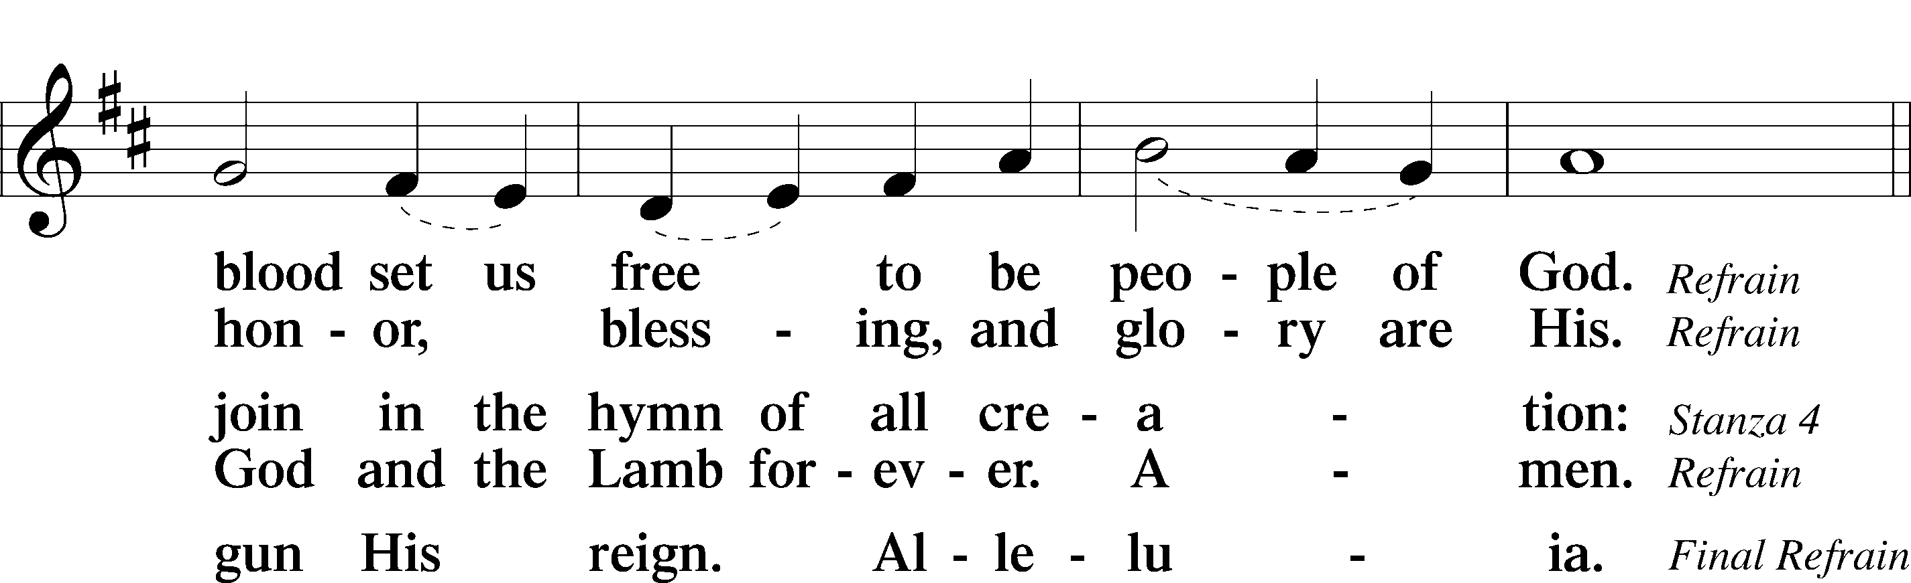

**SALUTATION and COLLECT OF THE DAY**

P The Lord be with you. *2 Timothy 4:22*

**C** **And also with you.**

P Let us pray.

Almighty and everlasting God, mercifully look upon our infirmities and stretch forth the hand of Your majesty to heal and defend us; through Jesus Christ, Your Son, our Lord, who lives and reigns with You and the Holy Spirit, one God, now and forever.

**C Amen.**

*Be Seated*

**OLD TESTAMENT LESSON *Jonah 3:1–5, 10***

1Then the word of the Lord came to Jonah the second time, saying, 2“Arise, go to Nineveh, that great city, and call out against it the message that I tell you.” 3So Jonah arose and went to Nineveh, according to the word of the Lord. Now Nineveh was an exceedingly great city, three days’ journey in breadth. 4Jonah began to go into the city, going a day’s journey. And he called out, “Yet forty days, and Nineveh shall be overthrown!” 5And the people of Nineveh believed God. They called for a fast and put on sackcloth, from the greatest of them to the least of them. . . .

10When God saw what they did, how they turned from their evil way, God relented of the disaster that he had said he would do to them, and he did not do it.

A This is the Word of the Lord.

**C** **Thanks be to God.**

**EPISTLE LESSON*****1 Corinthians 7:29–35***

29This is what I mean, brothers: the appointed time has grown very short. From now on, let those who have wives live as though they had none, 30and those who mourn as though they were not mourning, and those who rejoice as though they were not rejoicing, and those who buy as though they had no goods, 31and those who deal with the world as though they had no dealings with it. For the present form of this world is passing away.

32I want you to be free from anxieties. The unmarried man is anxious about the things of the Lord, how to please the Lord. 33But the married man is anxious about worldly things, how to please his wife, 34and his interests are divided. And the unmarried or betrothed woman is anxious about the things of the Lord, how to be holy in body and spirit. But the married woman is anxious about worldly things, how to please her husband. 35I say this for your own benefit, not to lay any restraint upon you, but to promote good order and to secure your undivided devotion to the Lord.

A This is the Word of the Lord.

**C** **Thanks be to God.**

*Please Stand*

**ALLELUIA and VERSE** *John 6:68*

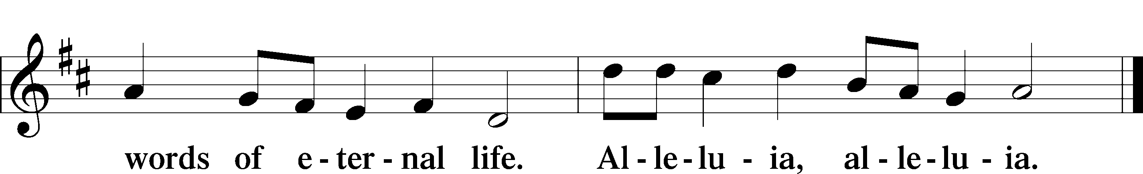

**HOLY GOSPEL *Mark 1:14–20***

P The Holy Gospel according to St. Mark, the first chapter.

14After John was arrested, Jesus came into Galilee, proclaiming the gospel of God, 15and saying, “The time is fulfilled, and the kingdom of God is at hand; repent and believe in the gospel.”

16Passing alongside the Sea of Galilee, he saw Simon and Andrew the brother of Simon casting a net into the sea, for they were fishermen. 17And Jesus said to them, “Follow me, and I will make you become fishers of men.” 18And immediately they left their nets and followed him. 19And going on a little farther, he saw James the son of Zebedee and John his brother, who were in their boat mending the nets. 20And immediately he called them, and they left their father Zebedee in the boat with the hired servants and followed him.

P This is the Gospel of the Lord.

**APOSTLES' CREED**

**I believe in God, the Father Almighty, maker of heaven and earth.**

**And in Jesus Christ, His only Son, our Lord, who was conceived by the Holy Spirit, born of the virgin Mary, suffered under Pontius Pilate, was crucified, died and was buried. He descended into hell. The third day He rose again from the dead. He ascended into Heaven and sits at the right hand of God the Father Almighty. From thence He will come to judge the living and the dead.**

**I believe in the Holy Spirit, the holy Christian Church, the communion of saints, the forgiveness of sins, the resurrection of the body, and the life everlasting. Amen.**

*Be Seated*

**CHILDREN'S MESSAGE *11:00 Service***

**HYMN OF THE DAY 685 "Let Us Ever Walk with Jesus"**

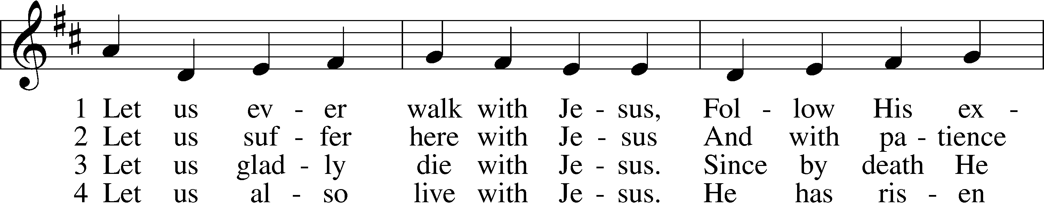

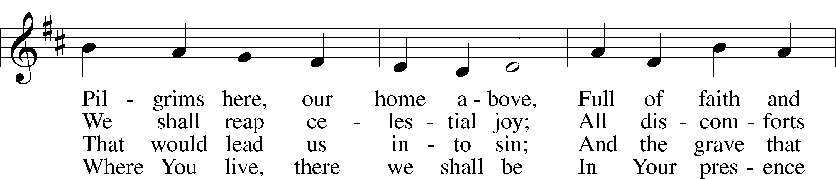

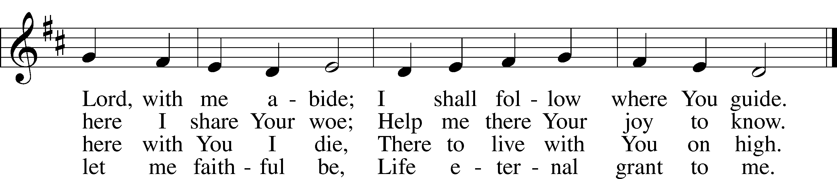

Text: © 1978 Lutheran Book of Worship. Used by permission: LSB Hymn License no. 110000966  
Tune: Public domain

**SERMON "Becoming a Follower of Jesus" *Mark 1:14-20***

**OFFERING** *(Please fill out and pass the red Friendship Book at this time; and fill out the blue card in the pew rack for prayers.)*

*Please Stand*

**OFFERTORY** *Psalm 116:12-13, 17-19*

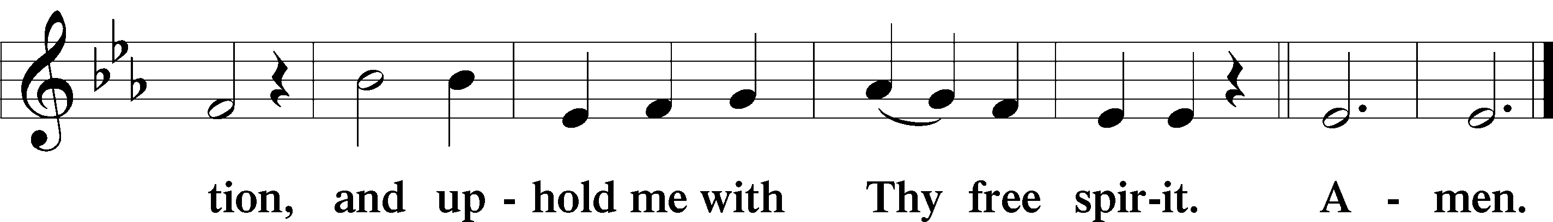

*Kneel or Be Seated*

**PRAYER OF THE CHURCH** *[1 Timothy 2:1-4]*

**Non-Communion Service (11:00)**

**LORD'S PRAYER** *Matthew 6:9-13*

**Our Father who art in heaven, hallowed be Thy name, Thy kingdom come, Thy will be done on earth as it is in heaven. Give us this day our daily bread; and forgive us our trespasses as we forgive those who trespass against us; and lead us not into temptation, but deliver us from evil. For Thine is the kingdom and the power and the glory forever and ever. Amen.**

*Please Stand*

**CLOSING PRAYER**

P Grant, we implore you, almighty God, to your Church your Holy Spirit and the wisdom which comes down from above that your Word may not be bound but have free course and be preached to the joy and edifying of Christ's holy people, so that in steadfast faith we may serve you and in the confession of your name abide to the end; through Jesus Christ, your Son, our Lord, who lives and reigns with you and the Holy Spirit, one God, now and forever.

**C Amen.**

**BENEDICTION** *Numbers 6:24-26*

P The Lord bless you and keep you. The Lord make His face shine on you and be gracious to you. The Lord look upon you with favor and (†) give you peace.

**CLOSING HYMN 839 vv. 1, 3, 5** **"O Christ, Our True and Only Light"**

Text and tune: Public domain

*Be Seated*

**Service of the Sacrament (8:30)**

*The Sacrament, or Lord's Supper, is a special gift from God that brings us into personal communion with Jesus Christ. "In, with and under" the bread and wine we receive His body and blood for forgiveness and renewal. If you are a repentant sinner, come to the table expecting to receive God's wonderful gifts for you!*

*Communicants will take their own wine cups as they are passed. Those requiring non-alcoholic grape juice will take the cups with white grape juice from the middle of the tray.*

*Be Seated*

**OUR EXAMINATION**

P In preparation for Holy Communion, St. Paul tells us in 1 Corinthians 11:27-29, “Whoever, therefore, eats the bread or drinks the cup of the Lord in an unworthy manner will be guilty concerning the body and blood of the Lord. 28Let a person examine himself, then, and so eat of the bread and drink of the cup. 29For anyone who eats and drinks without discerning the body eats and drinks judgment on himself.” So that we may properly examine ourselves prior to receiving the Lord’s Supper, I ask you to reflect on these questions:

* Do you repent of all your sins of thought, word, and deed?
* Do you believe that Jesus Christ is your only Savior from all sin, Satan, and death?
* Do you believe that the Risen Christ is really present in the Sacrament and that in, with, and under the bread and wine you receive His true Body and Blood?

If you answer in faith "Yes!" to these questions, and are properly instructed, you are invited to come forward and partake of the Lord's Supper during Distribution. If you are unable to answer yes to any of these questions, you are invited to come forward, cross your arms as Pastor approaches you and receive a blessing. By your coming forward, "You proclaim the Lord's death until He comes."

*Please Stand*

**PREFACE**

P The Lord be with you. *2 Timothy 4:22*

P Lift up your hearts. *[Colossians 3:1]*



P Let us give thanks to the Lord, our God. *[Psalm 136]*

P It is truly good, right, and salutary that we should at all times and in all places give thanks to You, holy Lord, almighty Father, everlasting God, through Jesus Christ, our Lord; for what had been hidden from before the foundation of the world You have made known to the nations in Your Son. In Him, being found in the substance of our mortal nature, You have manifested the fullness of Your glory. Therefore with angels and archangels and with all the company of heaven we laud and magnify Your glorious name, evermore praising You and singing:

**SANCTUS ~ *Holy, Holy, Holy*** *Isaiah 6:3; Matthew 21:9*

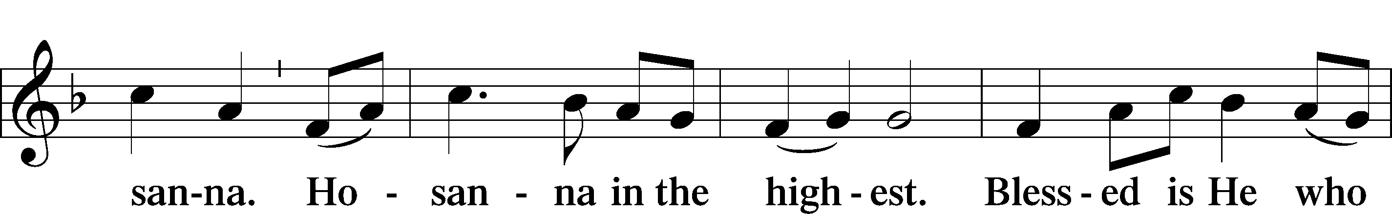

**PRAYER OF THANKSGIVING**

P Blessed are You, Lord of heaven and earth, for You have had mercy on those whom You created and sent Your only begotten Son into our flesh to bear our sin and be our Savior. With repentant joy we receive the salvation accomplished for us by the all-availing sacrifice of His body and His blood on the cross.

Gathered in the name and the remembrance of Jesus, we beg You, O Lord, to forgive, renew, and strengthen us with Your Word and Spirit. Grant us faithfully to eat His body and drink His blood as He bids us do in His own testament. Gather us together, we pray, from the ends of the earth to celebrate with all the faithful the marriage feast of the Lamb in His kingdom, which has no end. Graciously receive our prayers; deliver and preserve us. To You alone, O Father, be all glory, honor, and worship, with the Son and the Holy Spirit, one God, now and forever.

**C Amen.**

**LORD'S PRAYER** *Matthew 6:9-13*

**Our Father who art in heaven, hallowed be Thy name, Thy kingdom come, Thy will be done on earth as it is in heaven. Give us this day our daily bread; and forgive us our trespasses as we forgive those who trespass against us; and lead us not into temptation, but deliver us from evil. For Thine is the kingdom and the power and the glory forever and ever. Amen**.

**THE WORDS OF OUR LORD** *Matthew 26:26-28; Mark 14:22-24;*

*Luke 22:19-20; 1 Corinthians 11:23-25*

P Our Lord Jesus Christ, on the night when He was betrayed, took bread, and when He had given thanks, He broke it and gave it to the disciples and said: “Take, eat; this is My body, which is given for you. This do in remembrance of Me.” In the same way also He took the cup after supper, and when He had given thanks, He gave it to them, saying: "Drink of it, all of you; this is my blood of the new covenant, which is poured out for you for the remission of sins. This do as often as you drink it, in remembrance of Me."

**PAX DOMINI ~ *The Peace of the Lord*** *John 20:19*

PThe peace of the Lord be with you always.

C **And also with you.**

**AGNUS DEI ~ *Lamb of God*** *John 1:29*

*Be Seated*

**DISTRIBUTION HYMN**

**HYMN 856 "O Christ, Who Called the Twelve"**

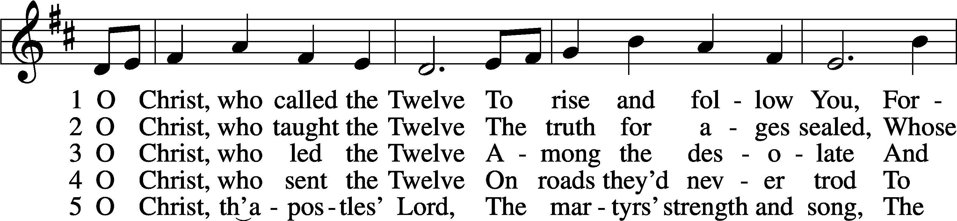

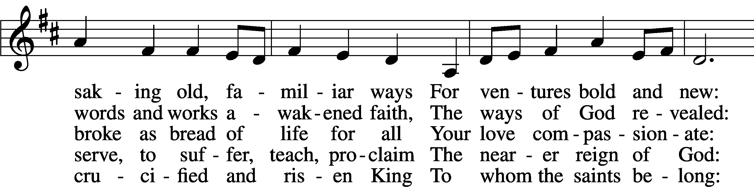

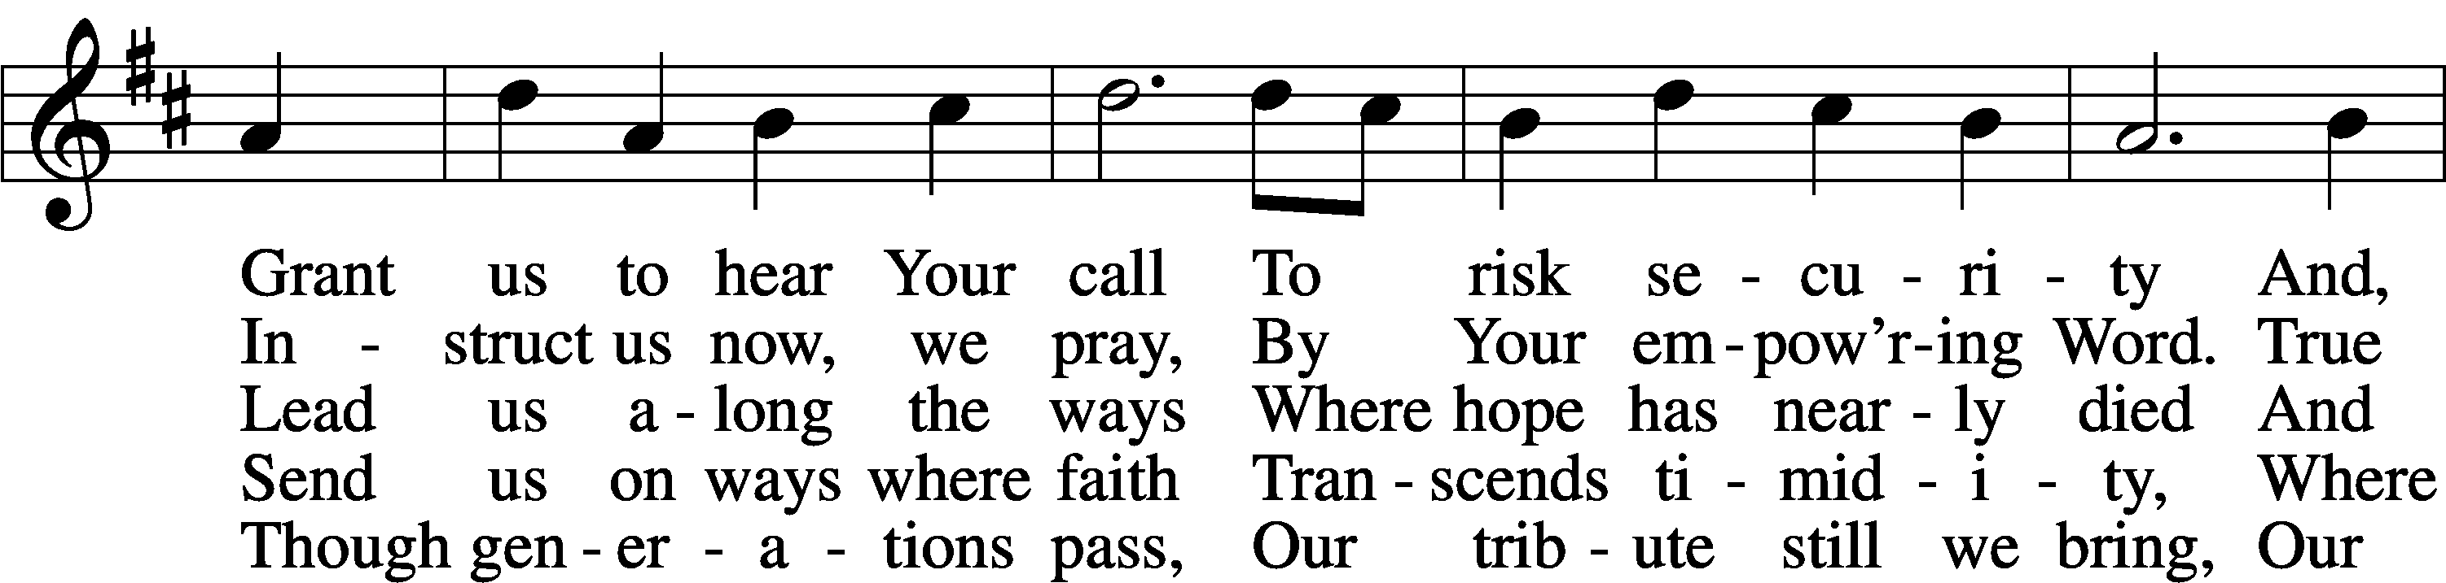

Text: © 1993 GIA Publications, Inc. Used by permission: LSB Hymn License no. 110000966  
Tune: Public domain

*Please Stand*

**POST-COMMUNION CANTICLE "Thank the Lord"**

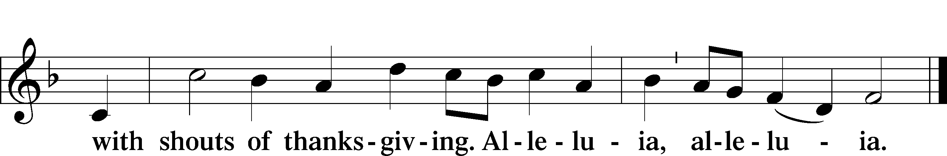

**POST-COMMUNION COLLECT**

P Let us pray.

Gracious God, our heavenly Father, You have given us a foretaste of the feast to come in the Holy Supper of Your Son's body and blood. Keep us firm in the true faith throughout our days of pilgrimage that, on the day of His coming, we may, together with all Your saints, celebrate the marriage feast of the Lamb in His kingdom which has no end; through Jesus Christ, Your Son, our Lord, who lives and reigns with You and the Holy Spirit, one God, now and forever.

C **Amen.**

**BENEDICTION** *Numbers 6:24-26*

P The Lord bless you and keep you. The Lord make His face shine on you and be gracious to you. The Lord look upon you with favor and (†) give you peace.

**CLOSING HYMN 839 vv. 1, 3, 5** **"O Christ, Our True and Only Light"**

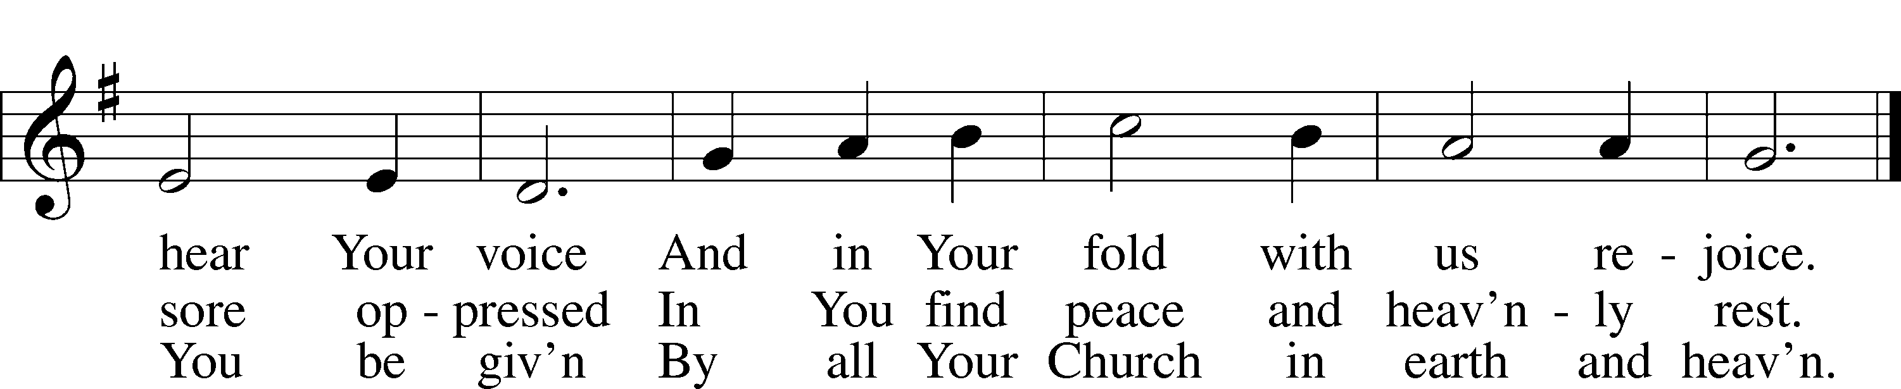

Text and tune: Public domain

*Be Seated*

**ANNOUNCEMENTS and RECOGNITION OF OUR GUESTS**

**ORGAN**

**TO THE GLORY OF GOD**

The Altar flowers are given to the glory of God

by Rick and Renee Tindall in celebration of their 50th wedding anniversary.

***For we are his workmanship, created in Christ Jesus for good works,***

***which God prepared beforehand, that we should walk in them.***

***Ephesians 2:10***

**COFFEE & CONVERSATION**

Join us in the Social Hall after the service for coffee and breakfast goodies

provided by the Lutheran Women’s Missionary League.

**BIBLE STUDY OPPORTUNITIES**

**ADULT SUNDAY BIBLE STUDY**

Pastor Webb leads a Bible study in the Social Hall after the 8:30 service.

**CHURCH YEAR CONNECTIONS**

**(Ages 3 through High School)**

Join us for Sunday School classes for ages three through young adult. Teachers: Megan Haverland (3 years-1st Grade), Judy Bringman (2nd-5th Grade), Bob Hanovich (Middle School), and Karl Schumacher (High School).

**PARENTS & TWOS CLASS**

In this class for parents and two-year-olds, Karen Hanovich helps parents encourage their little ones as they learn about Jesus together.

**YOUNG ADULT SINGLES CLASS**

For ages 18-26, this class led by Kevin Riedl is studying “Lessons from the Underground Church.”

**21ST CENTURY PARENTING CLASS**

Parents of school-aged kids gain insight into the issues facing Gen Z and learn how to engage them in meaningful conversations. Eric and Megan Thompson lead this class in the Education Building.

**YOUNG AT HEART CLASS**

Mature members study how we can demonstrate love and compassion to people in need. Bob Reynolds and Mark Waltz lead this class on the ground floor of the Education Building.

**WEDNESDAY MORNING BIBLE STUDY**

Join us at 10:00 a.m. on Wednesday mornings in the Education Building to study the Word.

**LADIES’ BIBLE STUDY**

The Ladies’ Bible Study meets on Mondays at 10:00am in the Education Building. New members are welcome! Bring a friend if you wish, and enjoy fellowship with other women!

**HAPPENING AT TRINITY**

**GUIDANCE FOR CHOOSING YOUR WORSHIP LOCATION**

**Gathering in the Sanctuary**

√ You are healthy and have not shown any of the symptoms associated with Covid-19.

(fever, persistent cough, difficulty breathing, chills, new loss of taste/smell, sore throat, chest pain)

√ You have not recently been in contact with someone with Covid-19

**Worshiping from Home via Live-Stream or YouTube**

√ Your age or health conditions make you more at-risk for contagion

√ You may have been exposed to Covid-19 at your workplace or through a relative

√ You are concerned about carrying Coronavirus home to at-risk family members.

**OFFERINGS**

Please remain faithful in bringing your offerings to the Lord by mail or online if you are unable to attend worship in person.

**THANK YOU**

Thank you to Barbara Lunick for playing the organ for us.

**LENT & EASTER SCHEDULE**

Ash Wednesday (February 14): 1:00 & 7:00pm

Wednesdays in Lent (February 21, 28, March 6, 13, 20):

1:00 & 7:00pm

Palm Sunday (March 24): 8:30 & 11:00am

Maundy Thursday (March 28): 1:00 & 7:00pm

Good Friday (March 29): 3:00 & 7:00pm

Easter Sunday (March 31): 8:30 & 11:00am

**TODAY IS "BUILDING REPAIR FUND SUNDAY"**

Please consider making an extra donation designated for our Building Repair Fund to help cover the cost of our needed repairs.

**VALENTINE’S DINNER & DANCE**

**Saturday, February 10 at 6:00-8:00**

The Board of Social Ministry invites you to our Valentine’s Dinner and Dance on Saturday, February 10th starting at 6 p.m. until 8 p.m. Dinner will be chicken alfredo, salad, rolls, tea and coffee, and an ice cream bar for dessert. Free will offering for dinner. There will be adult-only games, a kid’s treasure hunt, special dances, and a photo booth. Bring your whole family and have some fun. There is a sign-up sheet on the table in the Narthex. If you have any questions, please see Karen or Jennifer.

**BOARD & BRUSH WORKSHOP**

**Saturday, March 23**

The Board of Social Ministry has set up a sign and decor making workshop for the ladies of Trinity! We set the date for Saturday, March 23. There is a signup sheet on the table in the Narthex. Please be sure to include your email on the signup sheet as I will send you a link for you to pick out what you want to make. Cost will be between $35 and $38, depending on what you pick. You will be responsible to pay your fee at the workshop. You will be responsible for your own transportation to and from the workshop. If you have any questions, please see Karen.

**ATTENTION: ARTISTS**

Concordia Seminary invites you to submit artwork based on specific hymns for their Fifth Biennial Exhibition of Sacred Visual Art. See the flyer on the Narthex table for details.

**WHAT IS ALTAR GUILD?**

Trinity highlights the Altar Guild this month. Please see the display board in the Social Hall as to all they do in serving the Lord and Trinity and some of the correct terminology—Narthex, Nave, Sanctuary, cruet, paten, etc. Gretchen, Sandra, Becky, and Lonna are the ladies that serve faithfully. If you feel this is an area for you to serve the Lord, we are here to help you learn all the proper procedures in this awesome privilege of serving.

**2024 OFFERING ENVELOPES**

The 2024 Contribution Envelopes are now on a table in the Social Hall. Please look for your box and take it home with you. The address on the box will be used to send your end of year statement so if it’s not a current address, please update on the sheet next to the envelopes.

Thank you and looking forward to an exciting new year at Trinity. Cindy Reynolds, Trinity Financial Secretary [Cinreynold@icloud.com](mailto:Cinreynold@icloud.com)

**ONLINE GIVING**

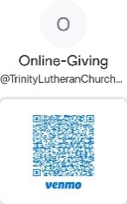Our ONLINE GIVING options have changed! We now have a TLC Venmo account for easy giving of your tithes and offerings. Contribute directly from your checking or savings account, check card, or credit card. Use the QR Code for easy access.

**CONNECT WITH US**

Connect with TLC and keep up with what’s going on.

\***Website** - [www.trinitylutheransavannah.com](http://www.trinitylutheransavannah.com)  
\***Facebook** - Friends of Trinity Lutheran Church; Trinity Lutheran Church – Community Info & Events (shareable page); Trinity Lutheran Church of Savannah Media; TLC Hearts of Compassion Helping Hands Ministry; Lizzie Comfort Dog  
\***Instagram** - #lcck9lizzie (Lizzie Comfort Dog)

\***YouTube** – Trinity Lutheran Savannah

**DEADLINE for BULLETIN ANNOUNCEMENTS**

**Every Wednesday by 9:00am**

Email bulletin announcements to [trinityoffice@bellsouth.net](mailto:trinityoffice@bellsouth.net) prior to 9:00am on Wednesdays.

**MINISTRY NEEDS**

**CLOTHES CLOSET DONATIONS**

Our clothes closet is in need of men’s and women’s winter coats, men’s small and medium shirts, men’s pants sizes 28-34, hats, and gloves. Please place your donations in the shopping cart in the Narthex or the bin in the Social Hall. Thank you.

**TODAY'S WORSHIP SERVICES**

Traditional 8:30 a.m. and 11:00 a.m.

**IN RESPONSE TO THE GOSPEL LAST SUNDAY**

8:30 a.m. – 56 11:00 a.m. – 64 Facebook – 186 YouTube – 3

Giving $3,865.01

Comfort Dog 20.00

Food Pantry 35.00

Homeless Ministry 300.00

Pastor's Discretionary Fund 165.00

Youth Breakfast 170.00

**SERVING IN THE LORD'S HOUSE TODAY**

**8:30 a.m. 11:00 a.m.**

Rosemary Gerdes, Reader

Betty Morrell, Greeter Marilyn McKee & Wayne White, Greeters

Cathy Crotwell & JB Strange, Ushers Bob Sautter, Usher

**SERVING NEXT SUNDAY**

**8:30 a.m. 11:00 a.m.**

Jackie Deemer, Reader

Jackie Deemer, Greeter Rosemary Gerdes & Ryan Smith, Greeters

Chris Cesaroni & Ryan Smith, Ushers John Anander, Usher

**THIS WEEK AT A GLANCE**

TODAY Traditional Worship Services 8:30 & 11:00 a.m.

Sunday School 9:45 a.m.

High School Youth Group 11:00 a.m.-1:00 p.m.

Building Fund Sunday

MONDAY 1/22 Ladies’ Bible Study (Education Building) 10:00 a.m.

Cub Scouts (Social Hall) 6:00-8:00 p.m.

TUESDAY 1/23 Windsor Forest Garden Club (Social Hall) 9:30 a.m.-12:00 p.m.

TLC Quilters (Education Building) 10:00 a.m.-1:00 p.m.

Clothes Closet 4:00-6:00 p.m.

Cub Scouts (Social Hall) 6:00-8:00 p.m.

WEDNESDAY 1/24 Bible Study 10:00 a.m.

THURSDAY 1/25 Clothes Closet 10:00 a.m.-1:00 p.m.

NAMI (Education Building) 6:00-7:00 p.m.

Cub Scout Leaders (Social Hall) 6:30-7:30 p.m.

FRIDAY 1/26 Meals for Homeless (Education Building Kitchen) 4:00 p.m.

SATURDAY 1/27 Young Adult Singles Zoom 7:30 p.m.

**REMEMBER IN PRAYER**

*(Please help us keep the prayer list updated)*

HEALTH

Carolyne Graham’s neighbors; Pastor Hopkins; Beth McCawley

CANCER

Harold LaMarr; Samuel Martin (19)

PEACE

Israel, Ukraine, & all who suffer from war

OUR WITNESS

Let us proclaim Jesus Christ is risen to all!

OUR CONCERNS

Raise up those, Lord, who would serve Your Church.

**TRINITY LUTHERAN CHURCH**

12391 Mercy Blvd

Savannah, GA 31419

phone 912-925-4839 [trinityoffice@bellsouth.net](mailto:trinityoffice@bellsouth.net)

fax 912-925-4056 www.trinitylutheransavannah.com

Contact Pastor: 717-333-6263; pastorjeffwebb@yahoo.com

**STAFF**

Jeff Webb, Pastor

Traci Schumacher, Administrative Assistant

Helen Williams, Church Custodian

**BOARD OF ELDERS**

Mark Waltz, Head Elder (C – E)

Mike Fajen (K – Mc)

Todd Freesemann (F – J)

Sonny Massey (A – B)

Bob Reynolds (Me – Sa)

Tom Wayman (Sc – Z)

**CHURCH COUNCIL**

Kip Wiltse, President

Eric Thompson, Vice President

Cathy Crotwell, Secretary

Karl Schumacher, Treasurer

Jennifer Wolfe, Board of Education

Mark Waltz, Board of Elders

Chris Garretson, Board of Evangelism

Chris Cesaroni, Board of Property Management

Karen Hanovich, Board of Social Ministry

Lonna McEwen, Board of Stewardship

Cindy Reynolds, Financial Secretary

Bob Hanovich, Board of Youth

**ORGANIZATIONAL LEADERS**

Cindy Baldwin, Comfort Dog Top Dog

Jackie Deemer, Director of TLC Singers & LWML President

Katie Fester, Sunday School Superintendent

Rosemary Gerdes, Quilters

Karen Hanovich, TLC Marketing

Lonna McEwen, Altar Guild

Rose Pitt, Prayer Team