8:30 & 11:00 a.m. Divine Service of Holy Communion

**Trinity Lutheran Church**

**The Transfiguration of Our Lord**

**LWML Sunday**

**Scout Sunday 11:00 a.m.**

**February 11, 2024 8:30 and 11:00 a.m. Communion Service**

**WELCOME TO TRINITY!**

Thank you for worshipingwith us today. We want to know who you are, so please provide your contact information in the Friendship Book as it is passed during the Offertory. If you are visiting, honor us by signing the Guest Register in the Narthex.

There are times in our worship service where we stand or kneel. Feel free to participate in either as you are able or feel comfortable to remain seated.

Gluten-free wafers are available upon request during communion services. Please speak to the pastor before service if you wish to receive the host in this form.

Please ask an usher should you require a hearing assistance device.

(†) ~ Those who wish may make the sign of the Cross in remembrance of their Baptism.

**RECEPTION OF HOLY COMMUNION**

If you are not a member of Trinity Lutheran Church, we ask that you speak with the pastor prior to the service before receiving the Lord’s Supper.

**REQUESTS FOR PRAYER**

If you have a prayer request, please fill out a Blue Card from the pew rack and place it in the offering plate. Prayer requests may also be emailed to [trinityoffice@bellsouth.net](mailto:trinityoffice@bellsouth.net) or to pastorjeffwebb@yahoo.com.

**FOR PARENTS WITH YOUNG CHILDREN**

We are delighted that you have brought your child to worship! We invite you to use the Cry Room as a courtesy to others if your little one gets a little rambunctious. Our Cry Room, complete with seating and children's activities, is located at the back of the Sanctuary. The service can be heard through the sound system. We hope your children feel glad they were here and that they are a part of the Trinity family!

***Our Vision:***

***Growing in God’s Word to Share Christ’s Love***

***Our Mission:***

***Led by God, equipped as disciples through Word and Sacrament,***

***we are empowered by the Holy Spirit to reach out with the Gospel of Jesus Christ to all.***



**AS WE GATHER TODAY**

The light of Christ is no mere metaphor. Christ is our light and He shines with the brightness of the one true light. Where the world lives in the darkness of doubt, Christ brings confidence to approach the throne of grace. Where the world lives in the faded glory of our aspirations and dreams, Christ’s light of forgiveness and hope never fades. Where the world imagines a future, Christ’s light shines on a new and everlasting tomorrow. As Christ shone with His light, so do we shine with the borrowed light of our Savior that those living in darkness and in the shadow of death might be shown the way.

**Divine Service**

***The King Is Coming***

**ORGAN**

**WELCOME**

**CHIMING OF THE HOUR**

**RECOGNITION OF NATIONAL SCOUT SUNDAY *11:00 Service***

*Please Stand*

**POSTING OF THE COLORS *11:00 Service***

**PLEDGE OF ALLEGIANCE *11:00 Service***

**I pledge allegiance to the Flag of the United States of America, and to the Republic for which it stands, one Nation under God, indivisible, with liberty and justice for all.**

*Be Seated*

**PRESENTATION OF RELIGIOUS AWARDS *11:00 Service***

**Confession and Absolution**

*Please Stand*

**HYMN OF INVOCATION 644 "The Church’s One Foundation"**

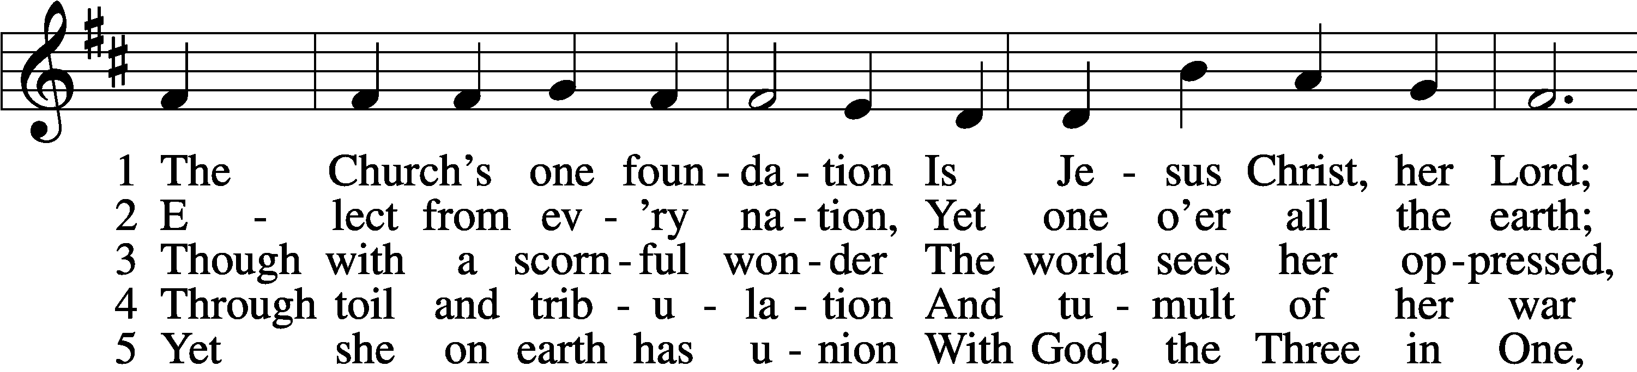

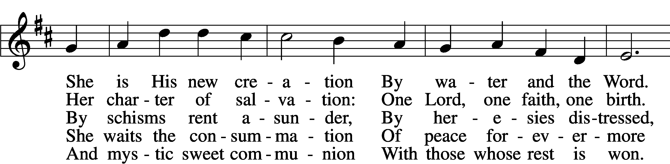

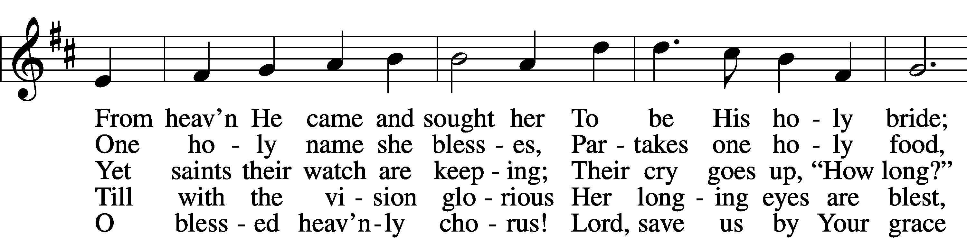

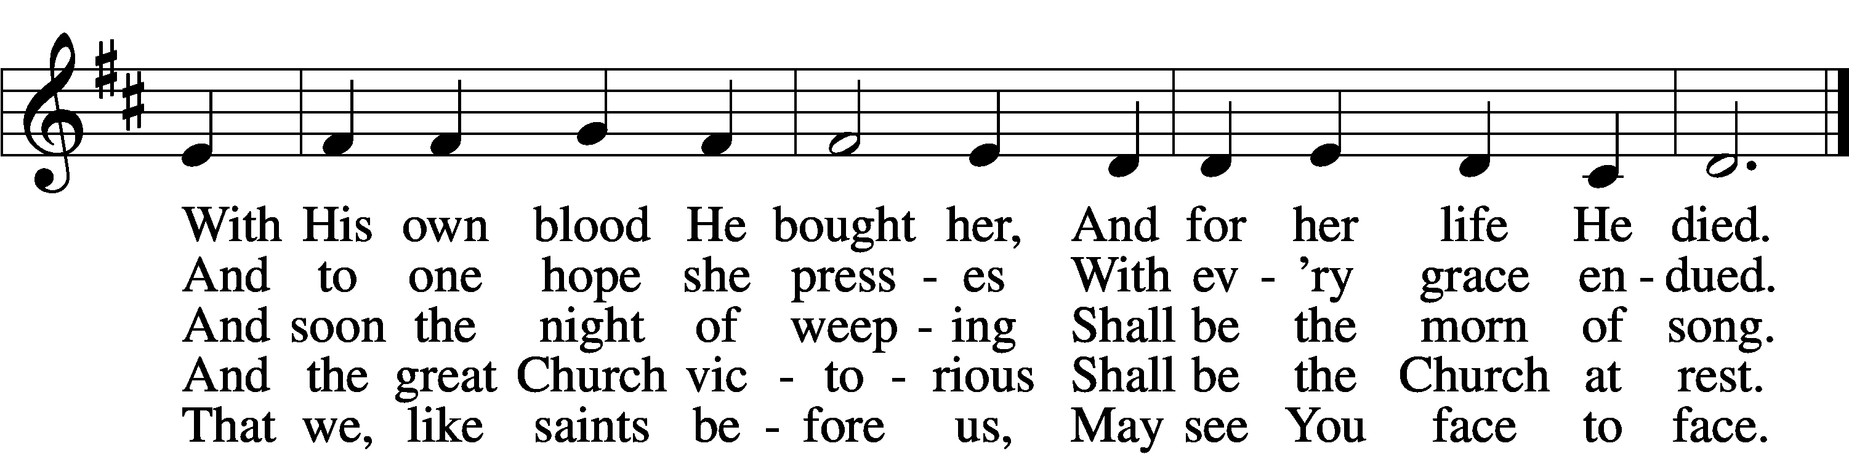

Text and tune: Public domain

*The sign of the cross may be made by all in remembrance of their baptism.*

P In the name of the Father and of the (†) Son and of the Holy Spirit.

C **Amen.**

P Our help is in the name of the Lord,

C **who made heaven and earth.**

P If You, O Lord, kept a record of sins, O Lord, who could stand?

C **But with You there is forgiveness; therefore You are feared.**

P Since we are gathered to hear God’s Word, call upon Him in prayer and praise, and receive the body and blood of our Lord Jesus Christ in the fellowship of this altar, let us first consider our unworthiness and confess before God and one another that we have sinned in thought, word, and deed, and that we cannot free ourselves from our sinful condition. Together as His people let us take refuge in the infinite mercy of God, our heavenly Father, seeking His grace for the sake of Christ, and saying: God, be merciful to me, a sinner. *[Luke 18:13]*

*Kneel or Stand*

C **Almighty God, have mercy upon us, forgive us our sins, and lead us to everlasting life. Amen.**

P Almighty God in His mercy has given His Son to die for you and for His sake forgives you all your sins. As a called and ordained servant of Christ, and by His authority, I therefore forgive you all your sins in the name of the Father and of the (†) Son and of the Holy Spirit.

C **Amen.** *[John 20:19-23]*

**Service of the Word**

**KYRIE ~ *Lord, Have Mercy*** *Mark 10:47*

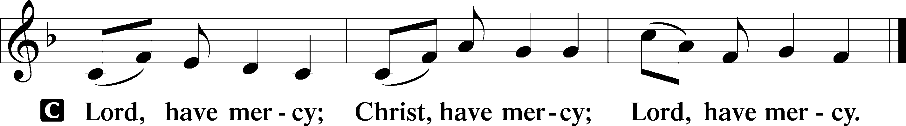

**HYMN OF PRAISE 527 "O Savior, Precious Savior"**

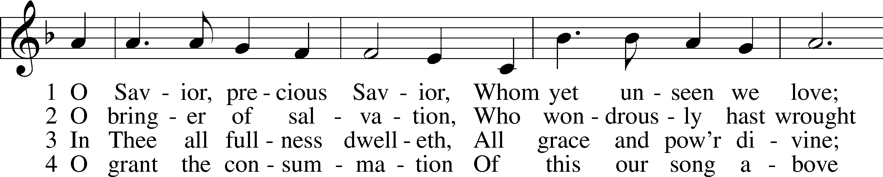

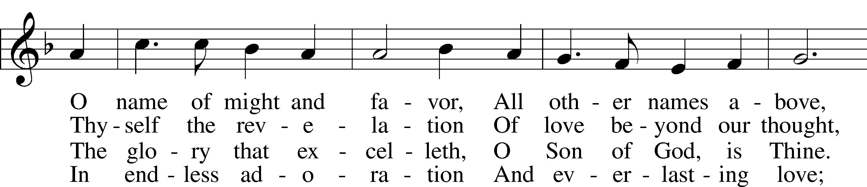

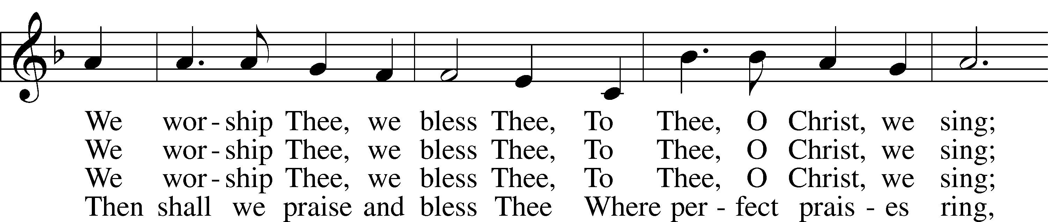

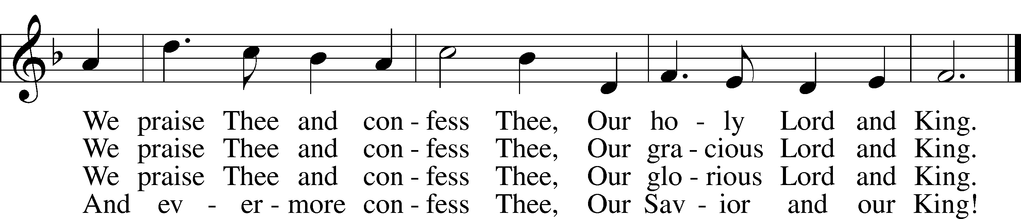

Text and tune: Public domain

**SALUTATION and COLLECT OF THE DAY**

P The Lord be with you. *2 Timothy 4:22*

C **And also with you.**

P Let us pray.

O God, You did not spare Your own Son but gave Him up for us all. Grant that by faith we may trust in Your promises and live according to Your will, through Jesus Christ, Your Son, our Lord, who lives and reigns with You and the Holy Spirit, one God, now and forever.

C **Amen.**

*Be Seated*

**OLD TESTAMENT READING “The Mountain of the Lord” *Isaiah 2:1-5***

The word that Isaiah the son of Amoz saw concerning Judah and Jerusalem.

It shall come to pass in the latter days  
 that the mountain of the house of the Lord  
shall be established as the highest of the mountains,  
 and shall be lifted up above the hills;  
and all the nations shall flow to it,  
 and many peoples shall come, and say:  
“Come, let us go up to the mountain of the Lord,  
 to the house of the God of Jacob,  
that he may teach us his ways  
 and that we may walk in his paths.”  
For out of Zion shall go the law,  
 and the word of the Lord from Jerusalem.  
He shall judge between the nations,  
 and shall decide disputes for many peoples;  
and they shall beat their swords into plowshares,  
 and their spears into pruning hooks;  
nation shall not lift up sword against nation,  
 neither shall they learn war anymore.  
O house of Jacob,  
 come, let us walk  
 in the light of the Lord.

A This is the Word of the Lord.

C **Thanks be to God.**

**PSALM *Psalm 24:7-10***

P Lift up your heads, O gates!  
 And be lifted up, O ancient doors,  
 that the King of glory may come in.

C **Who is this King of glory?  
 The Lord, strong and mighty,  
 the Lord, mighty in battle!**

P Lift up your heads, O gates!  
 And lift them up, O ancient doors,  
 that the King of glory may come in.

C **Who is this King of glory?  
 The Lord of hosts,  
 he is the King of glory!**

**All Glory be to the Father and to the Son and to the Holy Spirit;**

**as it was in the beginning, is now, and will be forever. Amen.**

**EPISTLE “The Living Stone and a Chosen People”*****1 Peter 2:4-10***

As you come to him, a living stone rejected by men but in the sight of God chosen and precious, you yourselves like living stones are being built up as a spiritual house, to be a holy priesthood, to offer spiritual sacrifices acceptable to God through Jesus Christ. For it stands in Scripture:

“Behold, I am laying in Zion a stone,  
 a cornerstone chosen and precious,  
and whoever believes in him will not be put to shame.”

So the honor is for you who believe, but for those who do not believe,

“The stone that the builders rejected  
 has become the cornerstone,”

and

“A stone of stumbling,  
 and a rock of offense.”

They stumble because they disobey the word, as they were destined to do.

But you are a chosen race, a royal priesthood, a holy nation, a people for his own possession, that you may proclaim the excellencies of him who called you out of darkness into his marvelous light. Once you were not a people, but now you are God’s people; once you had not received mercy, but now you have received mercy.

A This is the Word of the Lord.

C **Thanks be to God.**

*Please Stand*

**ALLELUIA and VERSE** *John 20:31*

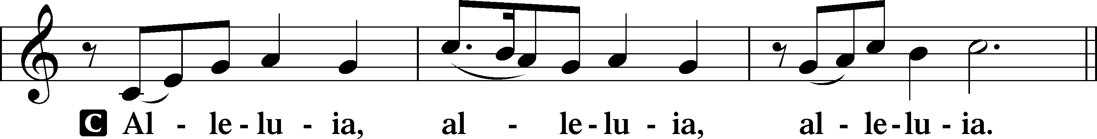

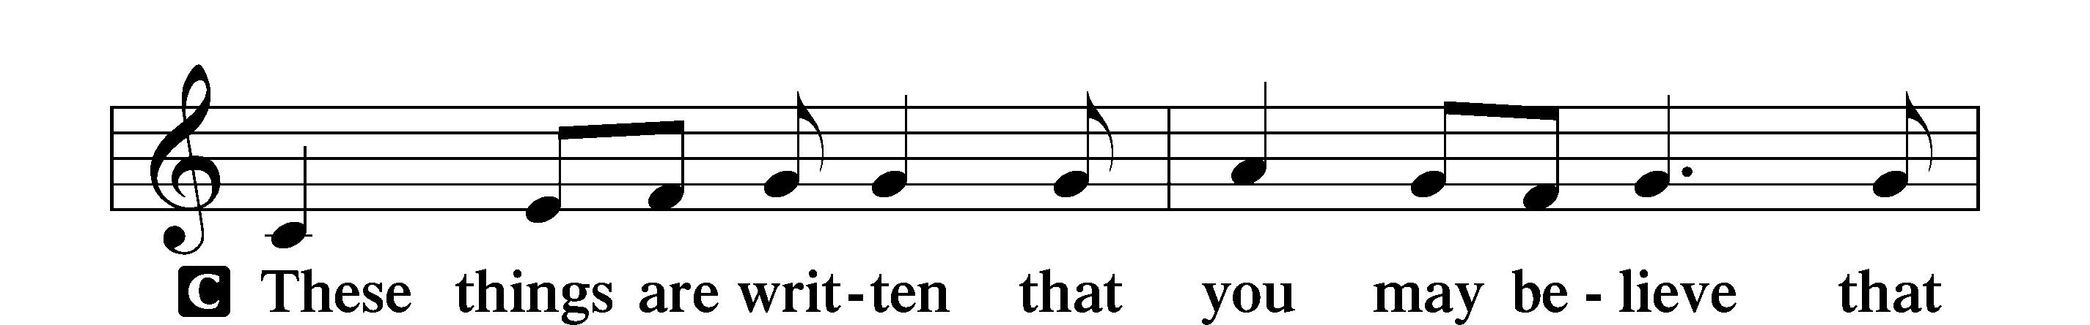

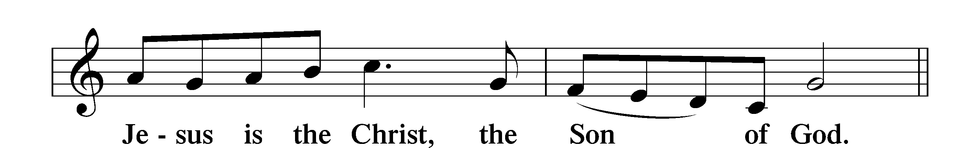

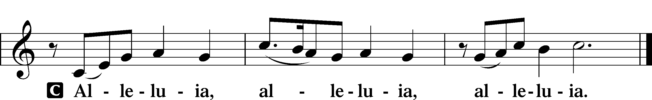

**HOLY GOSPEL “Rest for the Weary” *Matthew 11:25-30***

P The Holy Gospel according to St. Matthew, the eleventh chapter.

**C Glory to You, O Lord.**

At that time Jesus declared, “I thank you, Father, Lord of heaven and earth, that you have hidden these things from the wise and understanding and revealed them to little children; yes, Father, for such was your gracious will. All things have been handed over to me by my Father, and no one knows the Son except the Father, and no one knows the Father except the Son and anyone to whom the Son chooses to reveal him. Come to me, all who labor and are heavy laden, and I will give you rest. Take my yoke upon you, and learn from me, for I am gentle and lowly in heart, and you will find rest for your souls. For my yoke is easy, and my burden is light.”

P This is the Gospel of the Lord.

**C Praise to You, O Christ.**

**NICENE CREED**

**I believe in one God, the Father Almighty, maker of heaven and earth and of all things visible and invisible.**

**And in one Lord Jesus Christ, the only-begotten Son of God, begotten of His Father before all worlds, God of God, Light of Light, very God of very God, begotten, not made, being of one substance with the Father, by whom all things were made; who for us men and for our salvation came down from heaven and was incarnate by the Holy Spirit of the virgin Mary and was made man; and was crucified also for us under Pontius Pilate. He suffered and was buried. And the third day He rose again according to the Scriptures and ascended into heaven and sits at the right hand of the Father. And He will come again with glory to judge both the living and the dead, whose kingdom will have no end.**

**And I believe in the Holy Spirit, the Lord and Giver of life, who proceeds from the Father and the Son, who with the Father and the Son together is worshiped and glorified, who spoke by the prophets. And I believe in one holy Christian and apostolic Church, I acknowledge one Baptism for the remission of sins, and I look for the resurrection of the dead and the life of the world to come. Amen.**

*Be Seated*

**HYMN OF THE DAY 575 "My Hope Is Built on Nothing Less"**

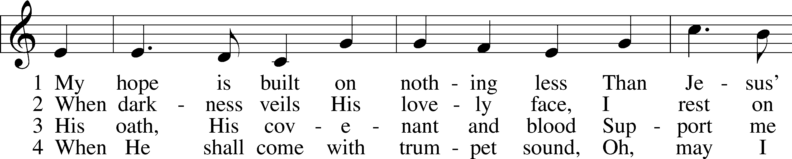

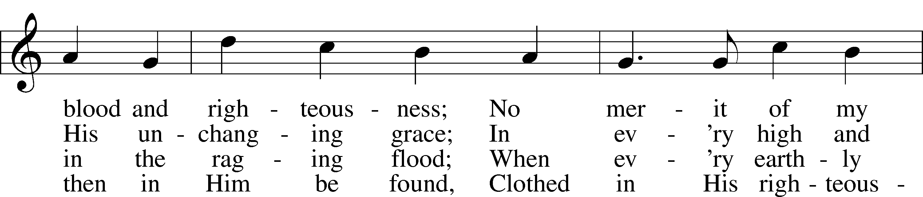

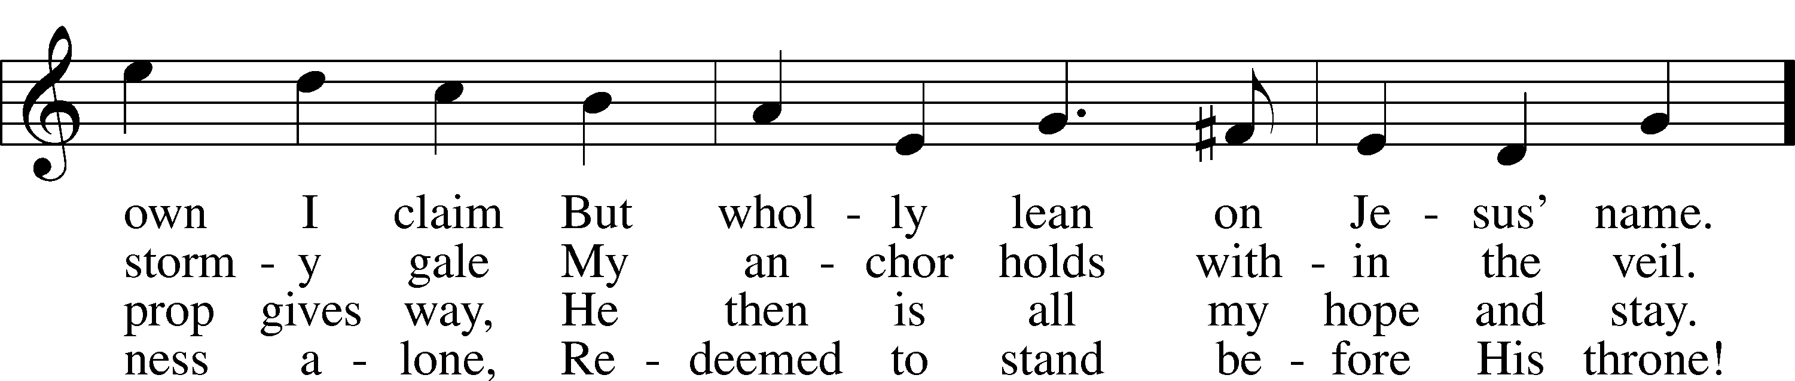

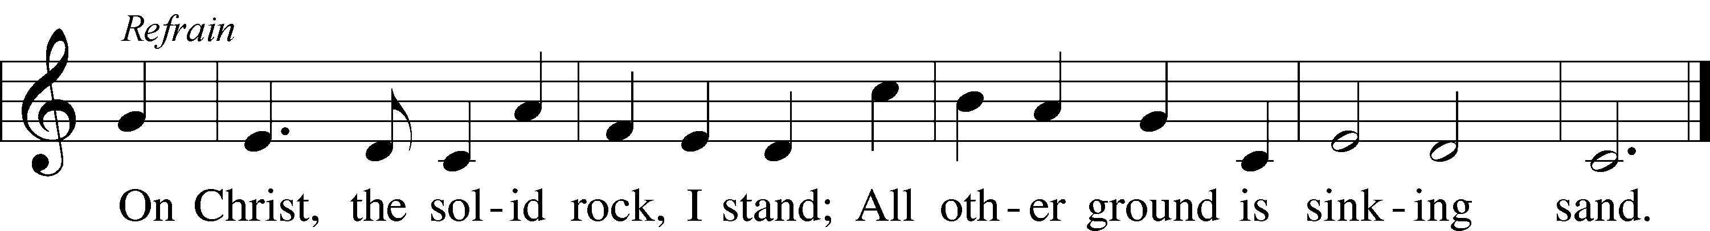

Text and tune: Public domain

**SERMON "Listen to Jesus" *Mark 9:2-9***

**OFFERING** *(Please fill out and pass the red Friendship Book at this time; and fill out the blue card in the pew rack for prayers.)*

*Kneel or Remain Seated*

**PRAYER OF THE CHURCH**

*After the prayers, the people may greet one another in the name of the Lord, saying, “Peace be with you,” as a sign of reconciliation and of the unity of the Spirit in the bond of peace (Matthew 5:22-24, Ephesians 4:1-3).*

*Be Seated*

**Service of the Sacrament**

*The Sacrament, or Lord's Supper, is a special gift from God that brings us into personal communion with Jesus Christ. "In, with and under" the bread and wine we receive His body and blood for forgiveness and renewal. If you are a repentant sinner, come to the table expecting to receive God's wonderful gifts for you!*

*Communicants will take their own wine cups as they are passed. Those requiring non-alcoholic grape juice will take the cups with white grape juice from the middle of the tray.*

*Remain Seated*

**OUR EXAMINATION**

P In preparation for Holy Communion, St. Paul tells us in 1 Corinthians 11:27-29, “Whoever, therefore, eats the bread or drinks the cup of the Lord in an unworthy manner will be guilty concerning the body and blood of the Lord. 28Let a person examine himself, then, and so eat of the bread and drink of the cup. 29For anyone who eats and drinks without discerning the body eats and drinks judgment on himself.” So that we may properly examine ourselves prior to receiving the Lord’s Supper, I ask you to reflect on these questions:

* Do you repent of all your sins of thought, word, and deed?
* Do you believe that Jesus Christ is your only Savior from all sin, Satan, and death?
* Do you believe that the Risen Christ is really present in the Sacrament and that in, with, and under the bread and wine you receive His true Body and Blood?

If you answer in faith "Yes!" to these questions, and are properly instructed, you are invited to come forward and partake of the Lord's Supper during Distribution. If you are unable to answer yes to any of these questions, you are invited to come forward, cross your arms as Pastor approaches you and receive a blessing. By your coming forward, "You proclaim the Lord's death until He comes."

*Please Stand*

**PREFACE**

P The Lord be with you. *2 Timothy 4:22*

**C And also with you.**

P Lift up your hearts. *[Colossians 3:1]*

**C We lift them to the Lord.**

P Let us give thanks to the Lord, our God. *[Psalm 136]*

**C It is right to give Him thanks and praise.**

P It is truly good, right, and salutary that we should at all times and in all places give thanks to You, O Lord, holy Father, almighty and everlasting God, for the countless blessings You so freely bestow on us and all creation. Above all, we give thanks for Your boundless love shown to us when You sent Your only-begotten Son, Jesus Christ, into our flesh and laid on Him our sin, giving Him unto death that we might not die eternally. Because He is now risen from the dead and lives and reigns for all eternity, all who believe in Him will overcome death and will rise again to new life. Therefore with angels and archangels and with all the company of heaven we laud and magnify Your glorious name, evermore praising You and singing:

**SANCTUS ~ *Holy, Holy, Holy*** *Isaiah 6:3; Matthew 21:9*

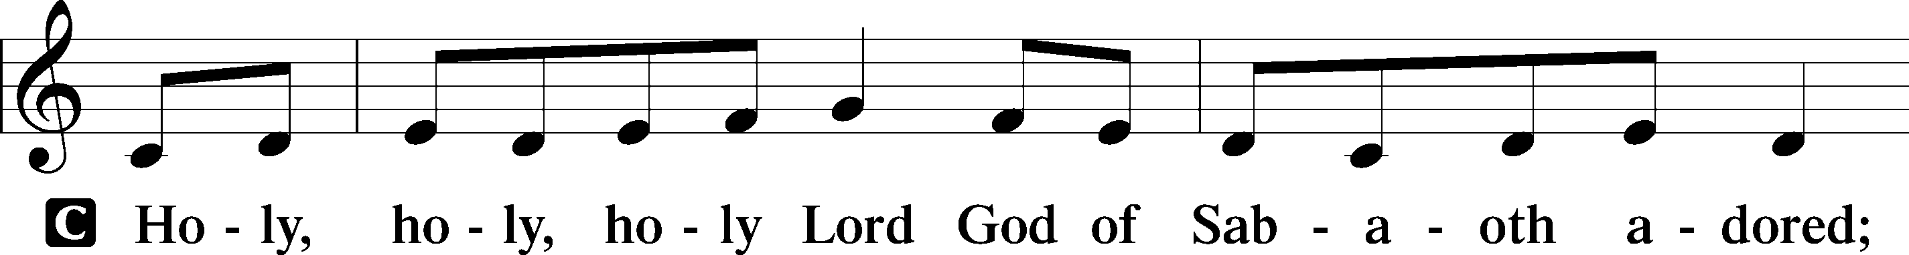

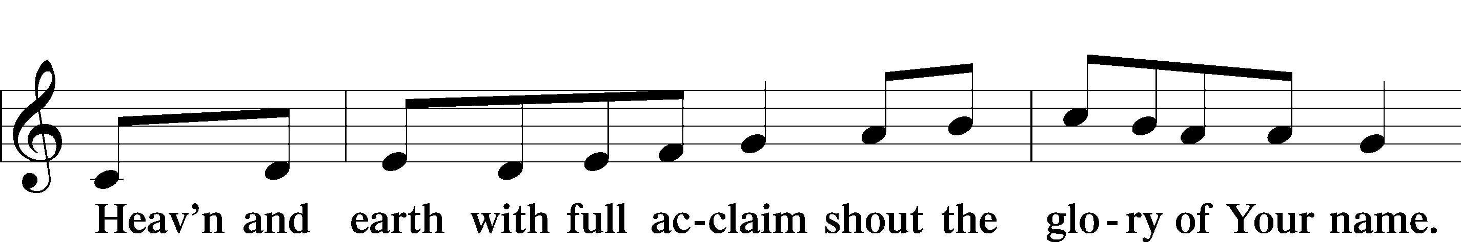

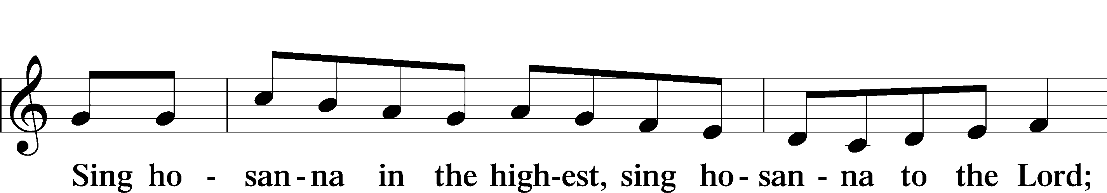

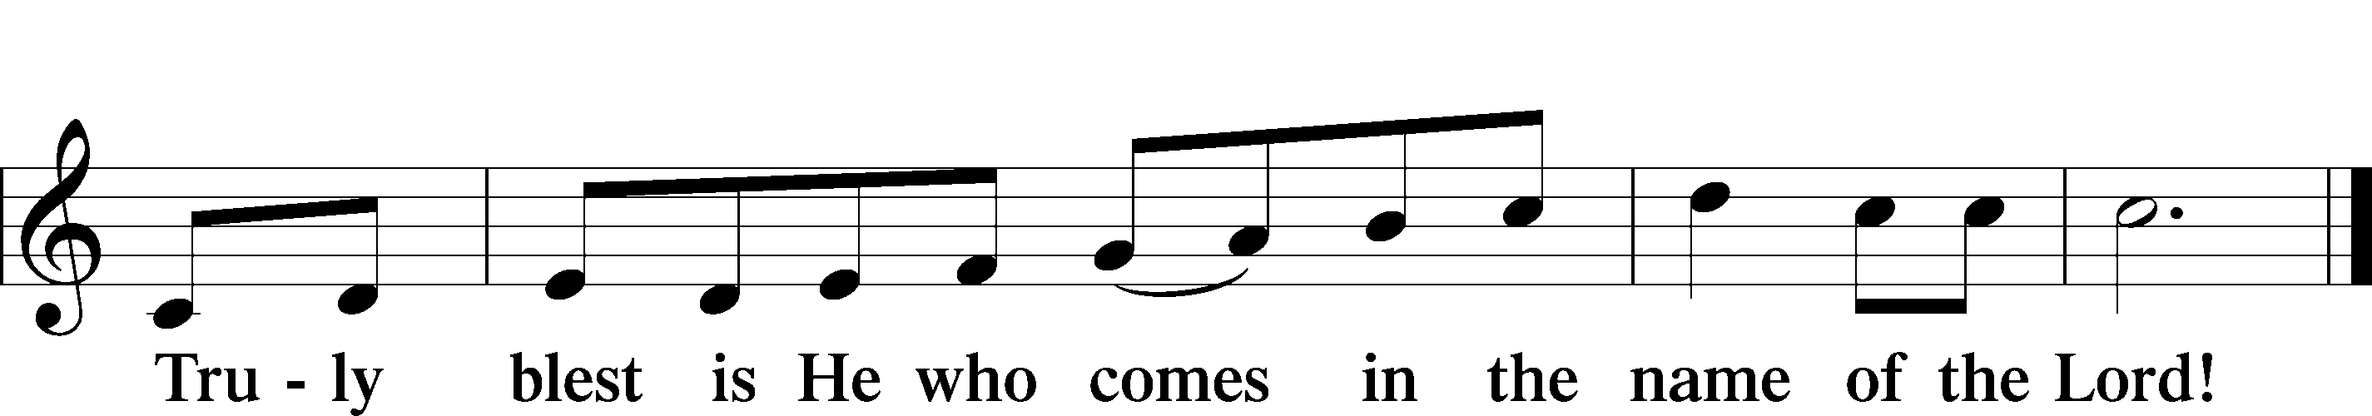

**PRAYER OF THANKSGIVING**

P Blessed are You, O Lord our God, king of all creation, for You have had mercy on us and given Your only-begotten Son that whoever believes in Him should not perish but have eternal life.

In Your righteous judgment You condemned the sin of Adam and Eve, who ate the forbidden fruit, and You justly barred them and all their children from the tree of life. Yet, in Your great mercy, You promised salvation by a second Adam, Your Son, Jesus Christ, our Lord, and made His cross a life-

giving tree for all who trust in Him.

We give You thanks for the redemption You have prepared for us through Jesus Christ. Grant us Your Holy Spirit that we may faithfully eat and drink of the fruits of His cross and receive the blessings of forgiveness, life, and salvation that come to us in His body and blood.

Hear us as we pray in His name and as He has taught us:

**LORD'S PRAYER** *Matthew 6:9-13*

**Our Father who art in heaven, hallowed be Thy name, Thy kingdom come, Thy will be done on earth as it is in heaven. Give us this day our daily bread; and forgive us our trespasses as we forgive those who trespass against us; and lead us not into temptation, but deliver us from evil. For Thine is the kingdom and the power and the glory forever and ever. Amen**.

**THE WORDS OF OUR LORD** *Matthew 26:26-28; Mark 14:22-24;*

*Luke 22:19-20; 1 Corinthians 11:23-25*

P Our Lord Jesus Christ, on the night when He was betrayed, took bread, and when He had given thanks, He broke it and gave it to the disciples and said: “Take, eat; this is My body, which is given for you. This do in remembrance of Me.” In the same way also He took the cup after supper, and when He had given thanks, He gave it to them, saying: "Drink of it, all of you; this is my blood of the new covenant, which is poured out for you for the remission of sins. This do as often as you drink it, in remembrance of Me."

**PAX DOMINI ~ *The Peace of the Lord*** *John 20:19*

PThe peace of the Lord be with you always.

C **Amen.**

**AGNUS DEI ~ *Lamb of God*** *John 1:29*

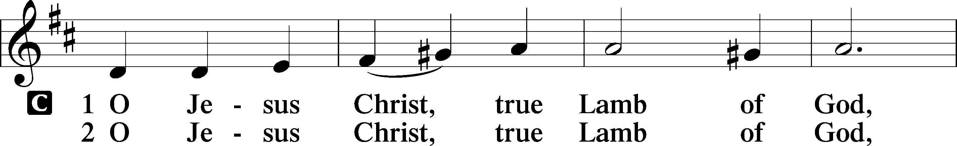

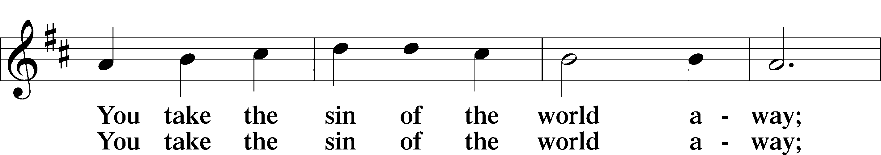

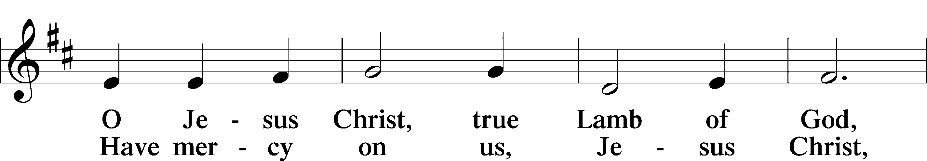

*Be Seated*

**DISTRIBUTION HYMN**

**HYMN 633 "At the Lamb’s High Feast We Sing"**

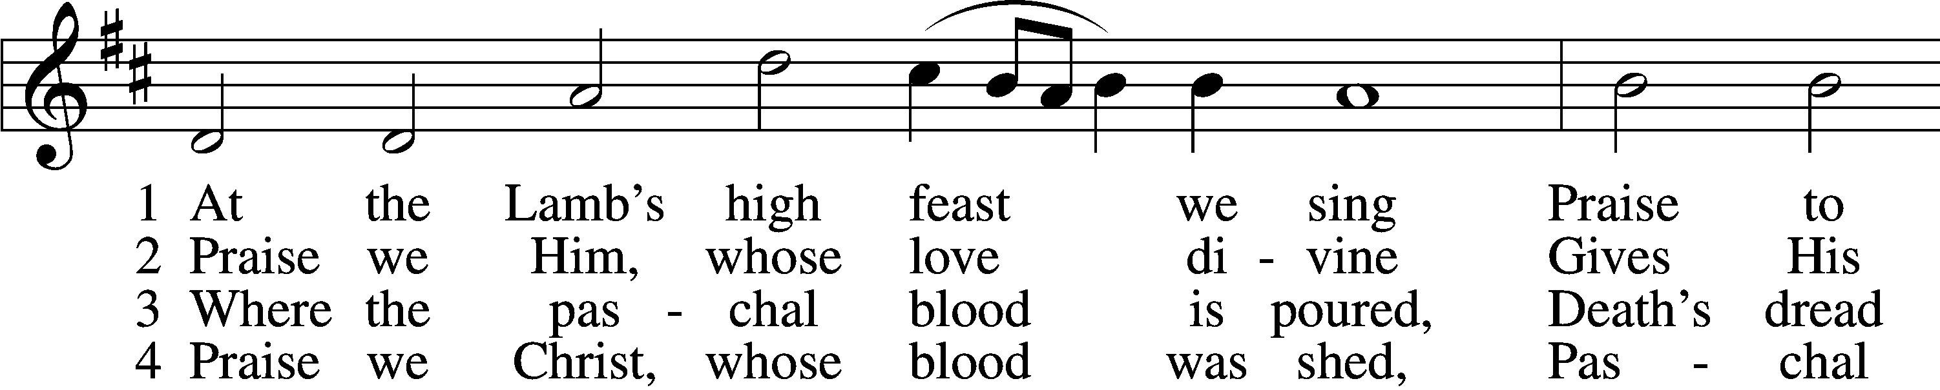

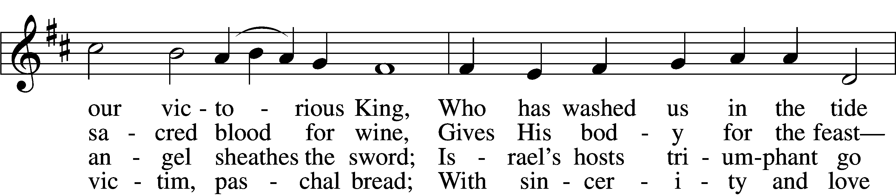

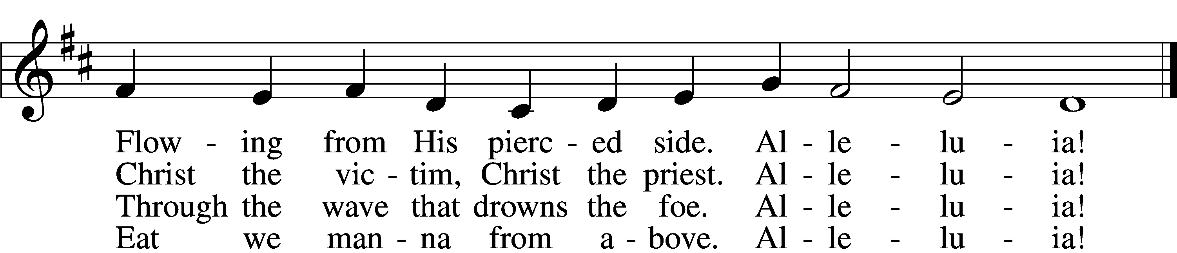

5 Mighty Victim from the sky,  
Hell’s fierce pow’rs beneath You lie;  
You have conquered in the fight,  
You have brought us life and light.  
    Alleluia!

6 Now no more can death appall,  
Now no more the grave enthrall;  
You have opened paradise,  
And Your saints in You shall rise.  
    Alleluia!

7 Easter triumph, Easter joy!  
This alone can sin destroy;  
From sin’s pow’r, Lord, set us free,  
Newborn souls in You to be.  
    Alleluia!

8 Father, who the crown shall give,  
Savior, by whose death we live,  
Spirit, guide through all our days:  
Three in One, Your name we praise.  
    Alleluia!

Text and tune: Public domain

*Please Stand*

**NUNC DIMITTIS ~ *Song of Simeon*** *Luke 2:29-32*

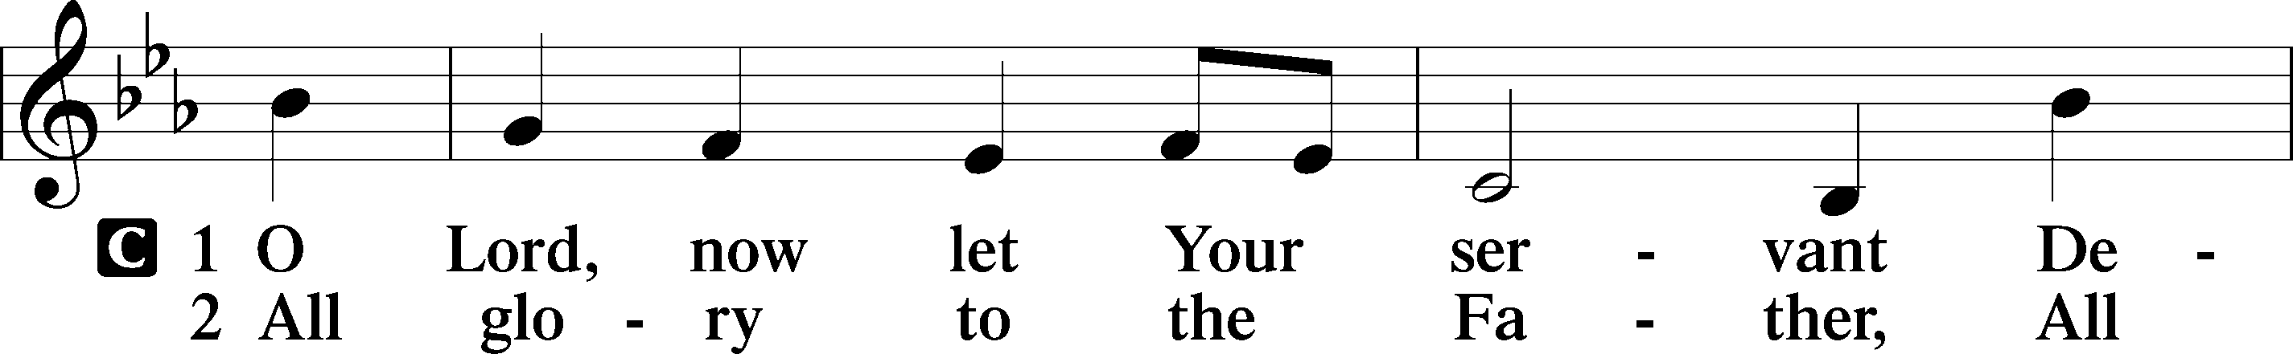

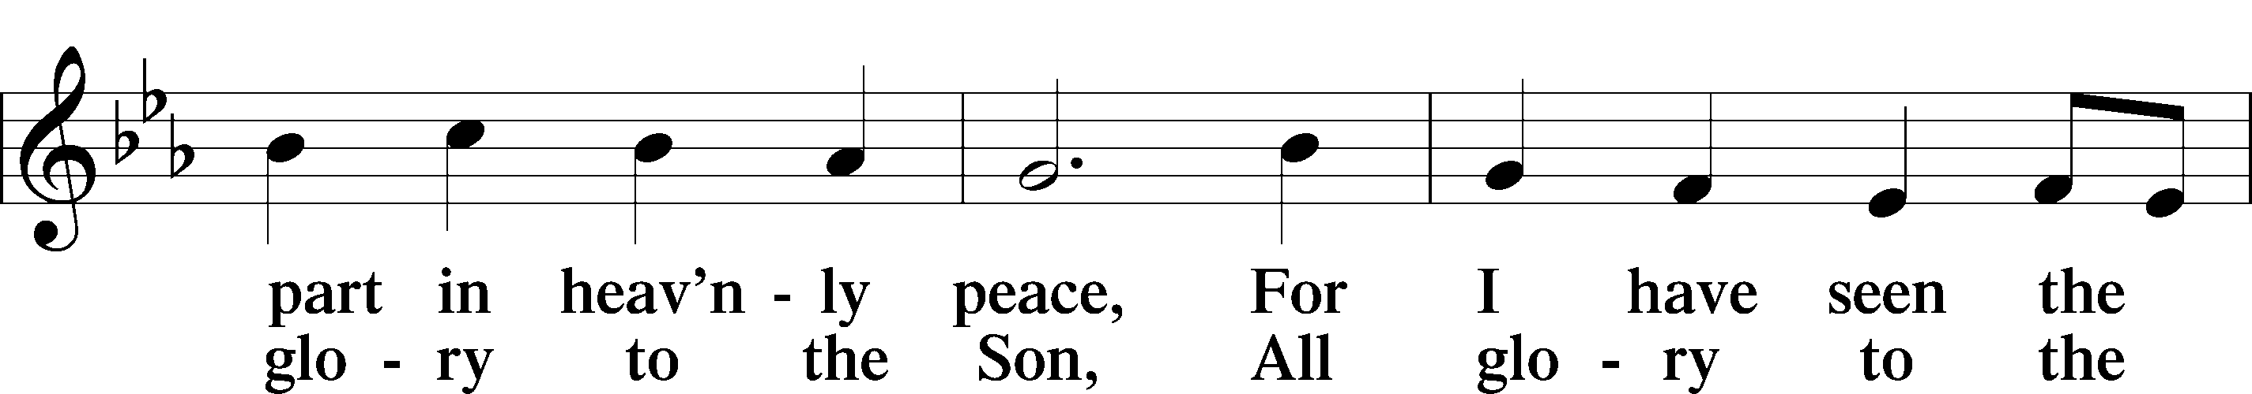

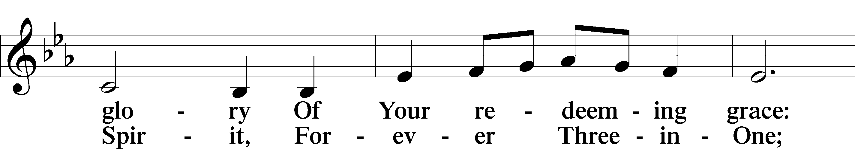

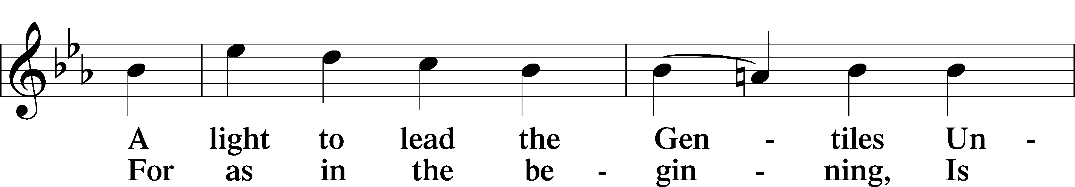

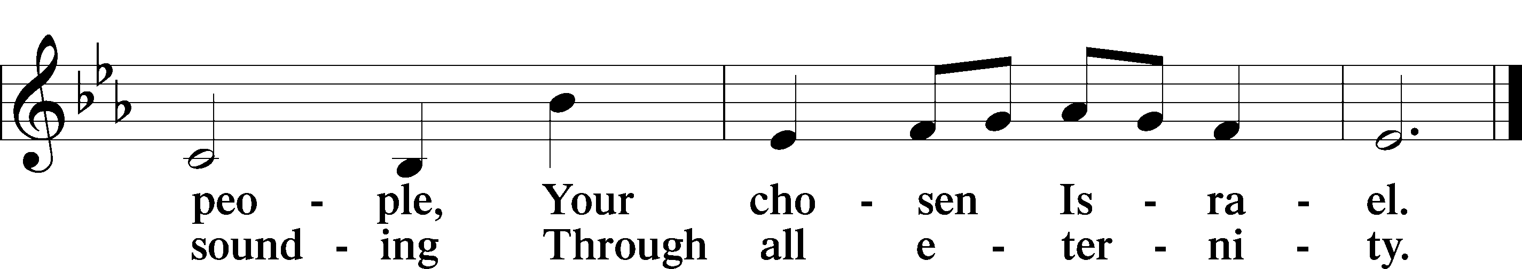

**POST-COMMUNION COLLECT**

P Let us pray.

We give thanks to You, almighty God, that You have refreshed us through this salutary gift, and we implore You that of Your mercy You would strengthen us through the same in faith toward You and fervent love toward one another; through Jesus Christ, Your Son, our Lord, who lives and reigns with You and the Holy Spirit, one God, now and forever.

C **Amen.**

**BENEDICAMUS and BENEDICTION**

P Let us bless the Lord. *[Psalm 103:1]*

C **Thanks be to God.**

P The Lord bless you and keep you. The Lord make His face shine on you and be gracious to you. The Lord look upon you with favor and (†) give you peace. *Numbers 6:24-26*

C **Amen.**

**CLOSING HYMN 653**  **"In Christ There Is No East or West"**

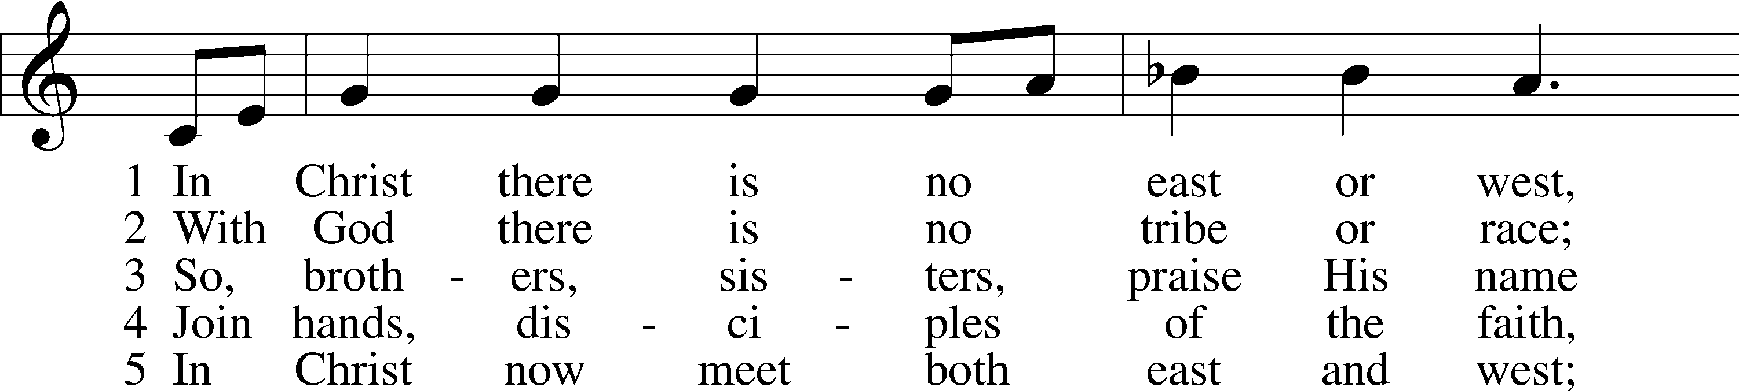

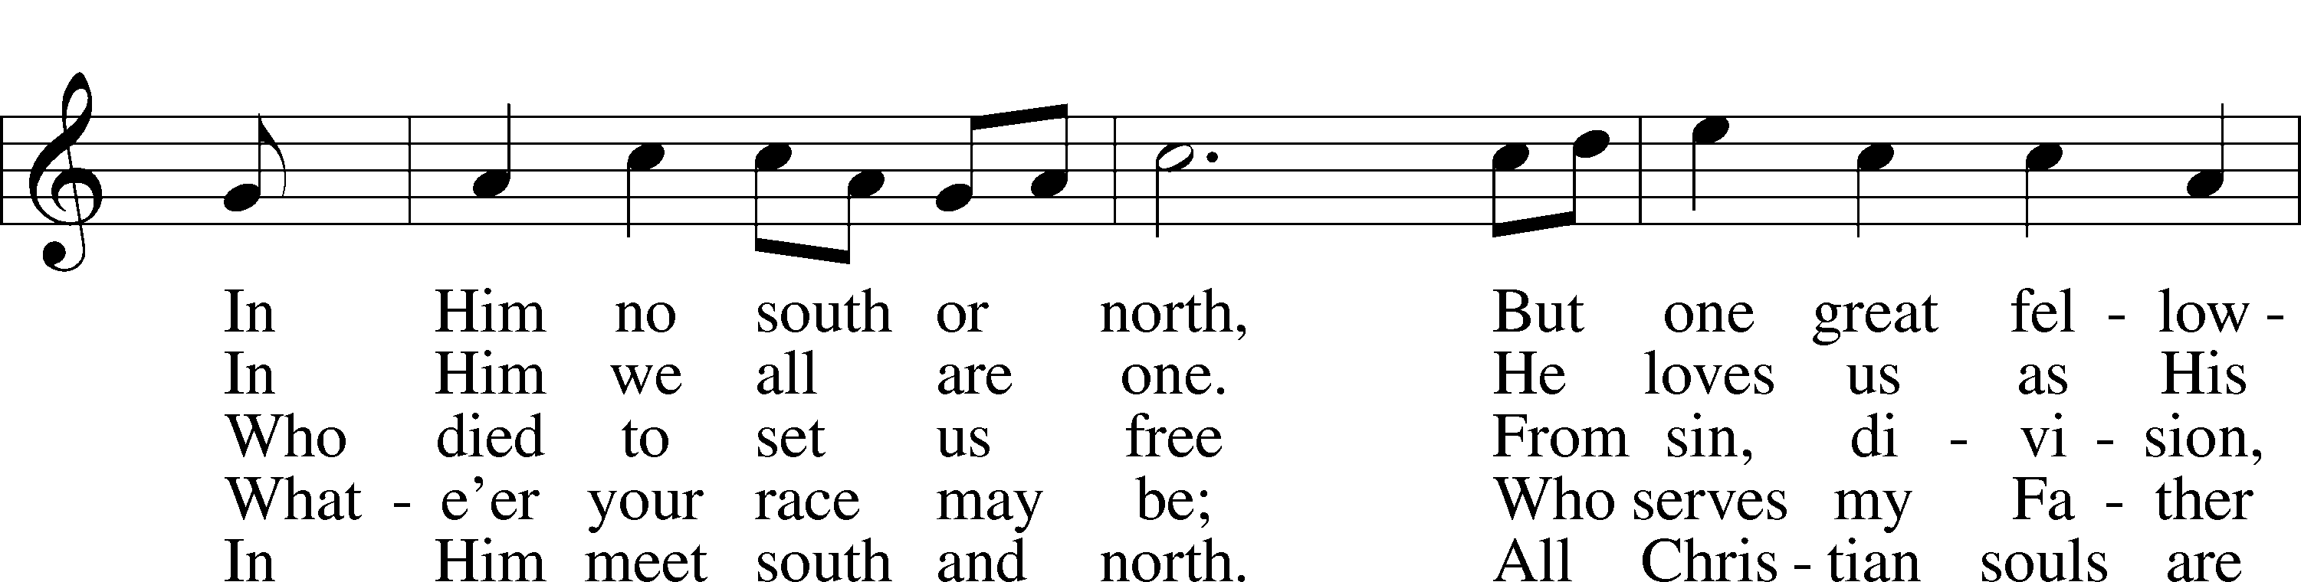

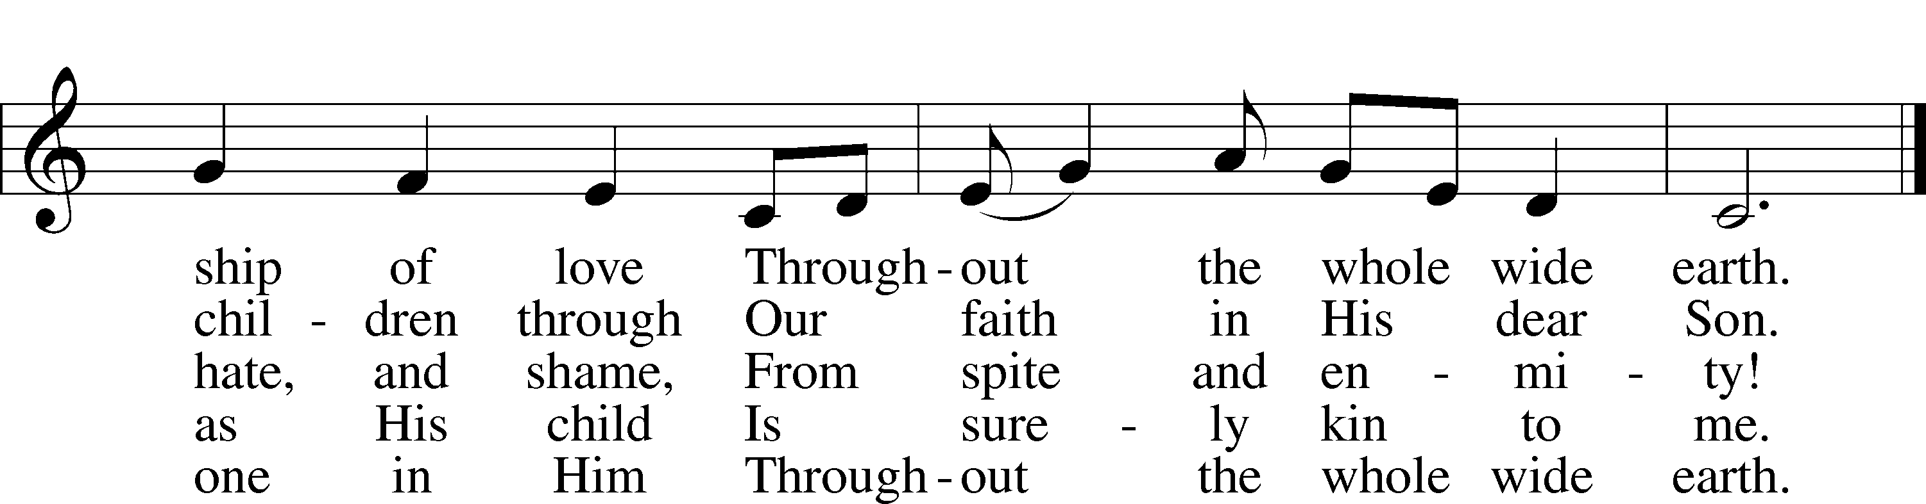

Text (st. 2): © 1993 Mark A. Jeske; (st. 3): © 1982 The Jubilate Group, admin. Hope Publishing Co. Used by permission: LSB Hymn License no. 110000966  
Text (sts. 1, 4–5) and tune: Public domain

*Be Seated*

**ANNOUNCEMENTS and RECOGNITION OF OUR GUESTS**

**ORGAN**

**TO THE GLORY OF GOD**

The Altar flowers are given to the glory of God.

***For God so loved the world, that he gave his only Son,***

***that whoever believes in him should not perish but have eternal life.***

***John 3:16***

**COFFEE & CONVERSATION**

Join us in the Social Hall after the 8:30 service for coffee and breakfast

provided by the Lutheran Women’s Missionary League.

**BIBLE STUDY OPPORTUNITIES**

**ADULT SUNDAY BIBLE STUDY**

Pastor Webb leads a Bible study in the Social Hall after the 8:30 service.

**CHURCH YEAR CONNECTIONS**

**(Ages 3 through High School)**

Join us for Sunday School classes for ages three through young adult. Teachers: Megan Haverland (3 years-1st Grade), Judy Bringman (2nd-5th Grade), Bob Hanovich (Middle School), and Karl Schumacher (High School).

**PARENTS & TWOS CLASS**

In this class for parents and two-year-olds, Karen Hanovich helps parents encourage their little ones as they learn about Jesus together.

**YOUNG ADULT SINGLES CLASS**

For ages 18-26, this class led by Kevin Riedl is studying “Lessons from the Underground Church.”

**21ST CENTURY PARENTING CLASS**

Parents of school-aged kids gain insight into the issues facing Gen Z and learn how to engage them in meaningful conversations. Eric and Megan Thompson lead this class in the Education Building.

**YOUNG AT HEART CLASS**

Mature members study how we can demonstrate love and compassion to people in need. Bob Reynolds and Mark Waltz lead this class on the ground floor of the Education Building.

**WEDNESDAY MORNING BIBLE STUDY**

Join us at 10:00 a.m. on Wednesday mornings in the Education Building to study the Word.

**LADIES’ BIBLE STUDY**

The Ladies’ Bible Study meets on Mondays at 10:00am in the Education Building and now on Zoom also. Email Linda Tomko ([linda.tomko1946@gmail.com](mailto:linda.tomko1946@gmail.com).) for the Zoom link if you want to join that way. New members are welcome!

**HAPPENING AT TRINITY**

**GUIDANCE FOR CHOOSING YOUR WORSHIP LOCATION**

**Gathering in the Sanctuary**

√ You are healthy and have not shown any of the symptoms associated with Covid-19.

(fever, persistent cough, difficulty breathing, chills, new loss of taste/smell, sore throat, chest pain)

√ You have not recently been in contact with someone with Covid-19

**Worshiping from Home via Live-Stream or YouTube**

√ Your age or health conditions make you more at-risk for contagion

√ You may have been exposed to Covid-19 at your workplace or through a relative

√ You are concerned about carrying Coronavirus home to at-risk family members.

**OFFERINGS**

Please remain faithful in bringing your offerings to the Lord by mail or online if you are unable to attend worship in person.

**THANK YOU**

Thank you to Barbara Lunick for playing the organ for us.

**LENT & EASTER SCHEDULE**

Ash Wednesday (February 14): 1:00 & 7:00pm

Wednesdays in Lent (February 21, 28, March 6, 13, 20):

1:00 & 7:00pm

Palm Sunday (March 24): 8:30 & 11:00am

Maundy Thursday (March 28): 1:00 & 7:00pm

Good Friday (March 29): 3:00 & 7:00pm

Easter Sunday (March 31): 8:30 & 11:00am

**TODAY IS "CAN DO SUNDAY"**

Please place your food items in the grocery cart in the Social Hall to help provide a meal for those in need who visit our Food Pantry. As always, thank you for your participation.

**VALENTINE BAKE SALE**

**Today in the Social Hall**

Get some tasty treats for yourself or your Valentine and help support our Ladies’ Guild.

**EASTER LILY ORDERS**

**Due by February 25**

Easter Lily order forms are available in the Narthex, and the deadline to order is February 25. Fill out the form, place it with your payment in the envelope, and place it in the offering plate.

**BOARD & BRUSH WORKSHOP**

**Saturday, March 23**

The Board of Social Ministry has set up a sign and decor making workshop for the ladies of Trinity! We set the date for Saturday, March 23. There is a signup sheet on the table in the Narthex. Please be sure to include your email on the signup sheet as I will send you a link for you to pick out what you want to make. Cost will be between $35 and $38, depending on what you pick. You will be responsible to pay your fee at the workshop. You will be responsible for your own transportation to and from the workshop. If you have questions, please see Karen.

**WOMEN’S BIBLE STUDY ZOOM**

**Mondays at 10:00**

Women’s Bible Study on Mondays at 10:00 can now be seen on Zoom. If you would like to join the group, please send your email address to me ([linda.tomko1946@gmail.com](mailto:linda.tomko1946@gmail.com).) and I will send you the link so you can join us! We would love to have you join our group, so please prayerfully consider this option!

**NO OVER 50 GROUP LUNCH**

**During Lent**

The Over 50 Group will not meet in February and March to avoid conflicting with the 1:00 Wednesday Lent services. Feel free to get together for meals at other times as desired.

**MEMBER PHOTO BOARD**

Check out our Member Photo Board in the Narthex with photos of our members. If you need your photo taken or updated, please see Lonna McEwen, Karen Hanovich, or Betty Morrell.

**ONLINE GIVING**

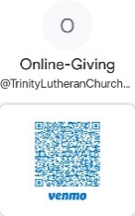Our ONLINE GIVING options have changed! We now have a TLC Venmo account for easy giving of your tithes and offerings. Contribute directly from your checking or savings account, check card, or credit card. Use the QR Code for easy access.

**CONNECT WITH US**

Connect with TLC and keep up with what’s going on.

\***Website** - [www.trinitylutheransavannah.com](http://www.trinitylutheransavannah.com)  
\***Facebook** - Friends of Trinity Lutheran Church; Trinity Lutheran Church – Community Info & Events (shareable page); Trinity Lutheran Church of Savannah Media; TLC Hearts of Compassion Helping Hands Ministry; Lizzie Comfort Dog  
\***Instagram** - #lcck9lizzie (Lizzie Comfort Dog)

\***YouTube** – Trinity Lutheran Savannah

**DEADLINE for BULLETIN ANNOUNCEMENTS**

**Every Wednesday by 9:00am**

Email bulletin announcements to [trinityoffice@bellsouth.net](mailto:trinityoffice@bellsouth.net) prior to 9:00am on Wednesdays.

**TODAY'S WORSHIP SERVICES**

Traditional 8:30 a.m. and 11:00 a.m.

**IN RESPONSE TO THE GOSPEL LAST SUNDAY**

8:30 a.m. – 74 11:00 a.m. – 43 Facebook – 110 YouTube – 0

Giving $6,269.42

Building Repair Fund 5.00

Easter Flowers 20.00

Lutheran Women’s Missionary League Mites 213.30

NAMI 5.00

Old Savannah City Mission 15.00

Pastor's Discretionary Fund 100.00

Seminary Student Willoughby 200.00

**SERVING IN THE LORD'S HOUSE TODAY**

**8:30 a.m. 11:00 a.m.**

Linda Tomko, Reader Sherry Kreger, Reader

Gin Hafemann & Sandra Jarrell, Greeters Shirley Lewis & Marilyn McKee, Greeters

Cathy Crotwell & Ellen Lutes, Ushers Rosemary Gerdes & Lonna McEwen, Ushers

**SERVING NEXT SUNDAY**

**8:30 a.m. 11:00 a.m.**

Mary Helen Anander, Reader

Betty Morrel, Greeter Vicki Lunick & Barbara Prieto, Greeters

Cathy Crotwell & JB Strange, Ushers Bob Sautter, Usher

**THIS WEEK AT A GLANCE**

TODAY Traditional Worship Services 8:30 & 11:00 a.m.

Sunday School 9:45 a.m.

Evangelism Meeting (Cry Room) 9:45-10:45 a.m.

LWML Sunday 8:30 & 11:00 a.m.

Scout Sunday 11:00 a.m.

LWML Breakfast 9:45 a.m.

Valentine Bake Sale

Can Do Sunday

MONDAY 2/12 Ladies’ Bible Study (Education Building) 10:00 a.m.

Cub Scouts (Social Hall) 6:00-8:00 p.m.

TUESDAY 2/13 TLC Quilters (Education Building) 10:00 a.m.-1:00 p.m.

Clothes Closet 4:00-6:00 p.m.

Cub Scouts (Social Hall) 6:00-8:00 p.m.

WEDNESDAY 2/14 Bible Study 10:00 a.m.

Ash Wednesday Worship 1:00 & 7:00 p.m.

THURSDAY 2/15 Clothes Closet 10:00 a.m.-1:00 p.m.

NAMI (Social Hall) 6:00-7:00 p.m.

Cub Scout Leaders (Social Hall) 6:30-8:00 p.m.

FRIDAY 2/16 Meals for Homeless (Education Building Kitchen) 4:00 p.m.

SATURDAY 2/17 Altar Guild 10:00 a.m.

Young Adult Singles Zoom 7:30 p.m.

**REMEMBER IN PRAYER**

*(Please help us keep the prayer list updated)*

HEALTH

Pastor Hopkins

CANCER

Harold LaMarr; Samuel Martin (19)

PEACE

Israel, Ukraine, & all who suffer from war

OUR WITNESS

Let us proclaim Jesus Christ is risen to all!

OUR CONCERNS

Raise up those, Lord, who would serve Your Church.

**TRINITY LUTHERAN CHURCH**

12391 Mercy Blvd

Savannah, GA 31419

phone 912-925-4839 [trinityoffice@bellsouth.net](mailto:trinityoffice@bellsouth.net)

fax 912-925-4056 www.trinitylutheransavannah.com

Contact Pastor: 717-333-6263; pastorjeffwebb@yahoo.com

**STAFF**

Jeff Webb, Pastor

Traci Schumacher, Administrative Assistant

Helen Williams, Church Custodian

**BOARD OF ELDERS**

Mark Waltz, Head Elder (C – E)

Mike Fajen (K – Mc)

Todd Freesemann (F – J)

Sonny Massey (A – B)

Bob Reynolds (Me – Sa)

Tom Wayman (Sc – Z)

**CHURCH COUNCIL**

Kip Wiltse, President

Eric Thompson, Vice President

Cathy Crotwell, Secretary

Karl Schumacher, Treasurer

Jennifer Wolfe, Board of Education

Mark Waltz, Board of Elders

Chris Garretson, Board of Evangelism

Chris Cesaroni, Board of Property Management

Karen Hanovich, Board of Social Ministry

Lonna McEwen, Board of Stewardship

Cindy Reynolds, Financial Secretary

Bob Hanovich, Board of Youth

**ORGANIZATIONAL LEADERS**

Cindy Baldwin, Comfort Dog Top Dog

Jackie Deemer, Director of TLC Singers & LWML President

Katie Fester, Sunday School Superintendent

Rosemary Gerdes, Quilters

Karen Hanovich, TLC Marketing

Lonna McEwen, Altar Guild

Rose Pitt, Prayer Team