**Trinity Lutheran Church**

**Ash Wednesday**

**February 14, 2024 1:00 & 7:00 p.m. Imposition of Ashes**

**WELCOME TO TRINITY!**

Thank you for worshipingwith us today, whether at home or in person. If you are visiting, please honor us by signing the Guest Register in the Narthex.

There are times in our worship service where we stand or kneel. Feel free to participate in either as you are able or feel comfortable to remain seated.

Gluten-free wafers are available upon request during communion services. Please speak to the pastor before service if you wish to receive the host in this form.

Please ask an usher should you require a hearing assistance device.

(†) ~ Those who wish may make the sign of the Cross in remembrance of their Baptism.

**RECEPTION OF HOLY COMMUNION**

If you are not a member of Trinity Lutheran Church, we ask that you speak with the pastor prior to the service before receiving the Lord’s Supper.

**REQUESTS FOR PRAYER**

Prayer requests may be emailed to [trinityoffice@bellsouth.net](mailto:trinityoffice@bellsouth.net) or to pastorjeffwebb@yahoo.com.

**FOR PARENTS WITH YOUNG CHILDREN**

We are delighted that you have brought your child to worship! We invite you to use the Cry Room as a courtesy to others if your little one gets a little rambunctious. Our Cry Room, complete with seating and children's activities, is located at the back of the Sanctuary. The service can be heard through the sound system. We hope your children feel glad they were here and that they are a part of the Trinity family!

***Our Vision:***

***Growing in God’s Word to Share Christ’s Love***

***Our Mission:***

***Led by God, equipped as disciples through Word and Sacrament,***

***we are empowered by the Holy Spirit to reach out with the Gospel of Jesus Christ to all.***



**AS WE GATHER TODAY**

Marked. During this special service for the beginning of our Lenten journey, we will be marked—marked with ashes. These ashes stand as a stark reminder of the dust of death, which is the wages of sin—Adam’s sin, the world’s sin, and our personal sin. But notice the shape in which the ashes are applied to our foreheads: the shape of the cross. “Remember that you are dust,” we hear. Powerful words, yes. But may we also have ears to hear the words even more powerful: “Your sins are forgiven!” The Gospel assures us that we have been marked and redeemed by Christ, the Crucified. The One who entered into our world to shape our dust and breathe new life into our death is the One who has named us and claimed us to be His own. He took on the ashes of our death. He became sin for us, “so that in Him we might become the righteousness of God” (2 Corinthians 5:21).

**Ash Wednesday**

**Marked and Redeemed by Christ, the Crucified**

*Please Stand*

**✠ PREPARATION ✠**

**HYMN 435** “Come to Calvary’s Holy Mountain”

Text and tune: Public domain

**INVOCATION**

Pastor: In the name of the Father and of the ✠ Son and of the Holy Spirit.

**People: Amen.**

**PSALM** *Psalm 51:1–3, 10–12; antiphon: v. 17*

Pastor: The sacrifices of God are a broken spirit;

**People: a broken and contrite heart, O God, You will not despise.**

Pastor: Have mercy on me, O God, according to Your steadfast love;

**People: according to Your abundant mercy blot out my transgressions.**

Pastor: Wash me thoroughly from my iniquity,

**People: and cleanse me from my sin!**

Pastor: For I know my transgressions,

**People: and my sin is ever before me.**

Pastor: Create in me a clean heart, O God,

**People: and renew a right spirit within me.**

Pastor: Cast me not away from Your presence,

**People: and take not Your Holy Spirit from me.**

Pastor: Restore to me the joy of Your salvation,

**People: and uphold me with a willing spirit.  
  
Glory be to the Father and to the Son and to the Holy Spirit;  
as it was in the beginning, is now, and will be forever. Amen.**

Pastor: The sacrifices of God are a broken spirit;

**People: a broken and contrite heart, O God, You will not despise.**

*Be Seated*

**IMPOSITION OF ASHES**

*The pastor may apply ashes to the forehead of each worshiper while speaking to them the words: “Remember that you are dust, and to dust you shall return.”*

**HYMN DURING THE IMPOSITION OF ASHES**

**HYMN 419** “Savior, When in Dust to Thee”

Text and tune: Public domain

*Please Stand*

**CONFESSION AND ABSOLUTION**

Pastor: If we say we have no sin, we deceive ourselves, and the truth is not in us.

**People: But if we confess our sins, God, who is faithful and just, will forgive our sins and cleanse us from all unrighteousness.**

*Silence for reflection on God’s Word and for self-examination.*

Pastor: Let us then confess our sins to God our Father.

**People: Most merciful God, we confess that we are by nature sinful and unclean. We have sinned against You in thought, word, and deed, by what we have done and by what we have left undone. We have not loved You with our whole heart; we have not loved our neighbors as ourselves.**

Pastor: The ashes of our sin remind us of the curse of death and our need for Your redemption.

**People: For the sake of Your Son, Jesus Christ, have mercy on us. Forgive us and renew us. Mark us with Your cross and take our sins from us. Help us to delight in Your will and walk in Your ways to the glory of Your holy name. Amen.**

Pastor: Almighty God in His mercy delivered His Son over to the death of the cross to bear the burden of our brokenness, becoming sin for us “so that in Him we might become the righteousness of God” (2 Corinthians 5:21). The ashes of your sin have been taken away and you have been marked and redeemed by Christ, the Crucified. As a called and ordained servant of Christ, I forgive you all your sins in the name of the Father and of the ✠ Son and of the Holy Spirit.

**People: Amen.**

**✠ WORD ✠**

**KYRIE**

Pastor: Lord, have mercy upon us.

**People: Christ, have mercy upon us.**

Pastor: Lord, have mercy upon us.

**SALUTATION**

Pastor: The Lord be with you.

**People: And also with you.**

**PRAYER OF THE DAY**

Pastor: Let us pray.  
Almighty and everlasting God, You despise nothing You have made and forgive the sins of all who come to You in repentance and faith.

**People: Cleanse us from the ashes of our sin that we may hold fast to the promise that we have been marked and redeemed by the Christ, the Crucified,**

Pastor: who lives and reigns with You and the Holy Spirit, one God, now and forever.

**People: Amen.**

*Be Seated*

**OLD TESTAMENT READING** *Joel 2:12–19* (“Return to the Lord, your God, for

He is gracious and merciful.”)

“Yet even now,” declares the Lord,  
 “return to me with all your heart,  
with fasting, with weeping, and with mourning;  
 and rend your hearts and not your garments.”  
Return to the Lord, your God,  
 for he is gracious and merciful,  
slow to anger, and abounding in steadfast love;  
 and he relents over disaster.  
Who knows whether he will not turn and relent,  
 and leave a blessing behind him,  
a grain offering and a drink offering  
 for the Lord your God?  
Blow the trumpet in Zion;  
 consecrate a fast;  
call a solemn assembly;  
 gather the people.  
Consecrate the congregation;  
 assemble the elders;  
gather the children,  
 even nursing infants.  
Let the bridegroom leave his room,  
 and the bride her chamber.  
Between the vestibule and the altar  
 let the priests, the ministers of the Lord, weep  
and say, “Spare your people, O Lord,  
 and make not your heritage a reproach,  
 a byword among the nations.  
Why should they say among the peoples,  
 ‘Where is their God?’”

Then the Lord became jealous for his land  
 and had pity on his people.  
The Lord answered and said to his people,  
“Behold, I am sending to you  
 grain, wine, and oil,  
 and you will be satisfied;  
and I will no more make you  
 a reproach among the nations.”

Lector: This is the Word of the Lord.

**People: Thanks be to God.**

**GRADUAL** *Hebrews 12:2*

Pastor: O come, let us fix our eyes on Jesus,

**People: the founder and perfecter of our faith,**

Pastor: who for the joy that was set before Him endured the cross, despising the shame,

**People: and is seated at the right hand of the throne of God.**

**EPISTLE** *2 Corinthians 5:20b–6:10* (God reconciles us through Christ, who became sin for us.)

We implore you on behalf of Christ, be reconciled to God. For our sake he made him to be sin who knew no sin, so that in him we might become the righteousness of God.

Working together with him, then, we appeal to you not to receive the grace of God in vain. For he says,

“In a favorable time I listened to you,  
 and in a day of salvation I have helped you.”

Behold, now is the favorable time; behold, now is the day of salvation. We put no obstacle in anyone’s way, so that no fault may be found with our ministry, but as servants of God we commend ourselves in every way: by great endurance, in afflictions, hardships, calamities, beatings, imprisonments, riots, labors, sleepless nights, hunger; by purity, knowledge, patience, kindness, the Holy Spirit, genuine love; by truthful speech, and the power of God; with the weapons of righteousness for the right hand and for the left; through honor and dishonor, through slander and praise. We are treated as impostors, and yet are true; as unknown, and yet well known; as dying, and behold, we live; as punished, and yet not killed; as sorrowful, yet always rejoicing; as poor, yet making many rich; as having nothing, yet possessing everything.

Lector: This is the Word of the Lord.

**People: Thanks be to God.**

**VERSE** *Joel 2:13b, alt.*

Pastor: Return to the Lord, your God,

**People: for He is gracious and merciful,**

Pastor: slow to anger, and abounding in steadfast love,

**People: and abounding in steadfast love.**

*Please Stand*

**HOLY GOSPEL** *Matthew 6:1–6, 16–21* (“Lay up for yourselves treasures in heaven.”)

Pastor: The Holy Gospel according to St. Matthew, the sixth chapter.

**People: Glory to You, O Lord.**

[Jesus said:] “Beware of practicing your righteousness before other people in order to be seen by them, for then you will have no reward from your Father who is in heaven.

“Thus, when you give to the needy, sound no trumpet before you, as the hypocrites do in the synagogues and in the streets, that they may be praised by others. Truly, I say to you, they have received their reward. But when you give to the needy, do not let your left hand know what your right hand is doing, so that your giving may be in secret. And your Father who sees in secret will reward you.

“And when you pray, you must not be like the hypocrites. For they love to stand and pray in the synagogues and at the street corners, that they may be seen by others. Truly, I say to you, they have received their reward. But when you pray, go into your room and shut the door and pray to your Father who is in secret. And your Father who sees in secret will reward you. . . .

“And when you fast, do not look gloomy like the hypocrites, for they disfigure their faces that their fasting may be seen by others. Truly, I say to you, they have received their reward. But when you fast, anoint your head and wash your face, that your fasting may not be seen by others but by your Father who is in secret. And your Father who sees in secret will reward you.

“Do not lay up for yourselves treasures on earth, where moth and rust destroy and where thieves break in and steal, but lay up for yourselves treasures in heaven, where neither moth nor rust destroys and where thieves do not break in and steal. For where your treasure is, there your heart will be also.”

Pastor: This is the Gospel of the Lord.

**People: Praise to You, O Christ.**

**CREED** *Nicene Creed*

**People: I believe in one God,  
 the Father Almighty,  
 maker of heaven and earth  
 and of all things visible and invisible.  
  
And in one Lord Jesus Christ,  
 the only-begotten Son of God,  
 begotten of His Father before all worlds,  
 God of God, Light of Light,  
 very God of very God,  
 begotten, not made,  
 being of one substance with the Father,  
 by whom all things were made;  
 who for us men and for our salvation came down from heaven  
 and was incarnate by the Holy Spirit of the virgin Mary  
 and was made man;  
 and was crucified also for us under Pontius Pilate.  
 He suffered and was buried.  
 And the third day He rose again according to the Scriptures  
 and ascended into heaven  
 and sits at the right hand of the Father.  
 And He will come again with glory to judge both the living and the dead,  
 whose kingdom will have no end.  
  
And I believe in the Holy Spirit,  
 the Lord and giver of life,  
 who proceeds from the Father and the Son,  
 who with the Father and the Son together is worshiped and glorified,  
 who spoke by the prophets.  
 And I believe in one holy Christian and apostolic Church,  
 I acknowledge one Baptism for the remission of sins,  
 and I look for the resurrection of the dead  
 and the life ✠ of the world to come. Amen.**

*Be Seated*

**HYMN OF THE DAY 607** “From Depths of Woe I Cry to Thee”

Text and tune: Public domain

**SERMON**

**OFFERING**

*Please Stand*

**OFFERTORY**

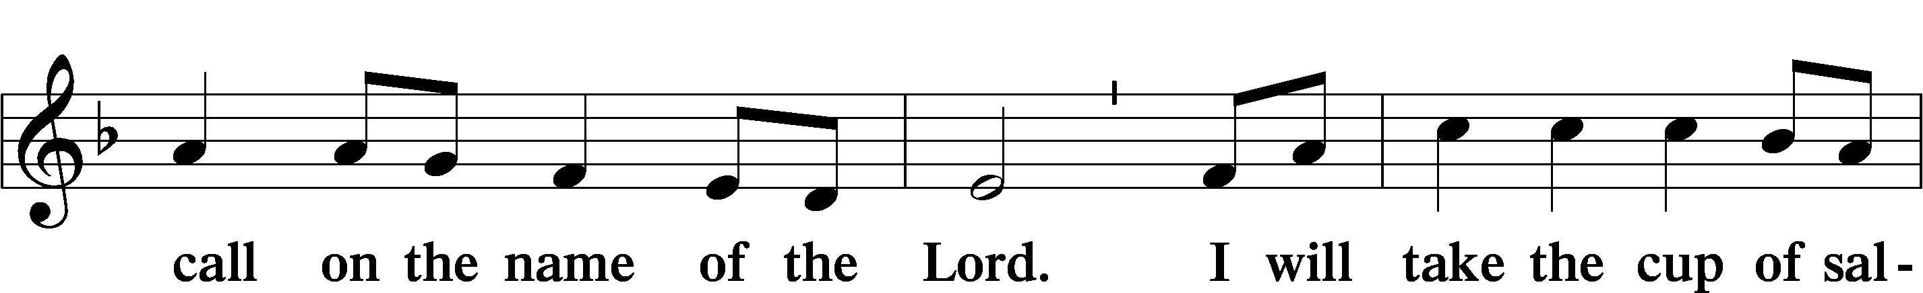

*Kneel or Be Seated*

**PRAYER OF THE CHURCH**

Pastor: Let us pray for the whole people of God in Christ Jesus and for all people according to their needs.   
  
For the name of the Lord our God to be held sacred in our congregation and throughout the world, that His Word be taught in its truth and purity and we, as the children of God, live holy lives according to it, as those who have been marked and redeemed by Christ, the crucified, let us pray to the Lord.

**People: Lamb of God, have mercy upon us.**

Pastor: For the blessing of all who have been named and claimed by Christ and who seek to carry out His Great Commission, that when we face a world that struggles under the curse of sin and in the ashes of death, we may rejoice in the assurance of our Savior’s never-failing grace, love, and deliverance, let us pray to the Lord.

**People: Lamb of God, have mercy upon us.**

Pastor: For the well-being of all the world, especially the community, the schools, the workplaces, and the families in our midst, that our creator and provider would supply all that we need and enable us to dwell in peace and security, let us pray to the Lord.

**People: Lamb of God, have mercy upon us.**

Pastor: For the restoration of all who are broken in heart, body, mind, spirit, and relationships, that times of difficulty would lead all who struggle to seek refuge in the support of others and, ultimately, to receive the eternal treasures of the sure mercies of our God, let us pray to the Lord.

**People: Lamb of God, have mercy upon us.**

Pastor: For the healing of those who are struggling with medical issues and battling various types of illnesses, [*especially . . .*], that Jesus, our healer of both body and soul, would hear our prayers and grant mercy to them all, let us pray to the Lord.

**People: Lamb of God, have mercy upon us.**

Pastor: For the answering of these and all other prayers that we boldly bring before the throne of grace, that we take confidence in God as our Father, who has marked us with the cross of His Son and redeemed us by His blood so that the ashes of our sin may be replaced by the beauty of His righteousness, let us pray to the Lord.

**People: Lamb of God, have mercy upon us. Answer our prayers in the way that best brings glory to Your holy name. Amen.**

*Be Seated*

**✠ SACRAMENT ✠**

*The Sacrament, or Lord's Supper, is a special gift from God that brings us into personal communion with Jesus Christ. "In, with and under" the bread and wine we receive His body and blood for forgiveness and renewal. If you are a repentant sinner, come to the table expecting to receive God's wonderful gifts for you!*

*Communicants will take their own wine cups as they are passed. Those requiring non-alcoholic grape juice will take the cups with white grape juice from the middle of the tray.*

*Remain Seated*

**OUR EXAMINATION**

Pastor: In preparation for Holy Communion, St. Paul tells us in 1 Corinthians 11:27-29, “Whoever, therefore, eats the bread or drinks the cup of the Lord in an unworthy manner will be guilty concerning the body and blood of the Lord. 28Let a person examine himself, then, and so eat of the bread and drink of the cup. 29For anyone who eats and drinks without discerning the body eats and drinks judgment on himself.” So that we may properly examine ourselves prior to receiving the Lord’s Supper, I ask you to reflect on these questions:

* Do you repent of all your sins of thought, word, and deed?
* Do you believe that Jesus Christ is your only Savior from all sin, Satan, and death?
* Do you believe that the Risen Christ is really present in the Sacrament and that in, with, and under the bread and wine you receive His true Body and Blood?

If you answer in faith "Yes!" to these questions, and are properly instructed, you are invited to come forward and partake of the Lord's Supper during Distribution. If you are unable to answer yes to any of these questions, you are invited to come forward, cross your arms as Pastor approaches you and receive a blessing. By your coming forward, "You proclaim the Lord's death until He comes."

*Please Stand*

**PREFACE** *2 Timothy 4:22*

Pastor: The Lord be with you.

**People: And also with you.**

Pastor: Lift up your hearts.

**People: We lift them to the Lord.**

Pastor: Let us give thanks to the Lord our God.

**People: It is right to give Him thanks and praise.**

**PROPER PREFACE**

Pastor: It is truly good, right, and salutary that we should at all times and in all places give thanks to You, holy Lord, almighty Father, everlasting God, through Jesus Christ, our priceless treasure, whose blood cleanses us of our sin and enables us to celebrate His feast in sincerity and truth. Therefore with angels and archangels and with all the company of heaven we laud and magnify Your glorious name, evermore praising You and saying:

**SANCTUS**

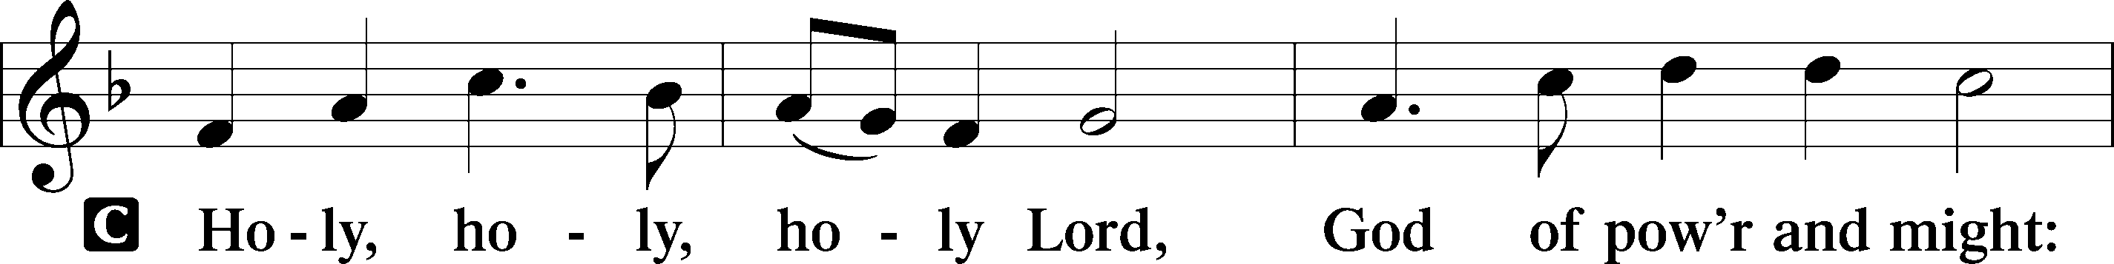

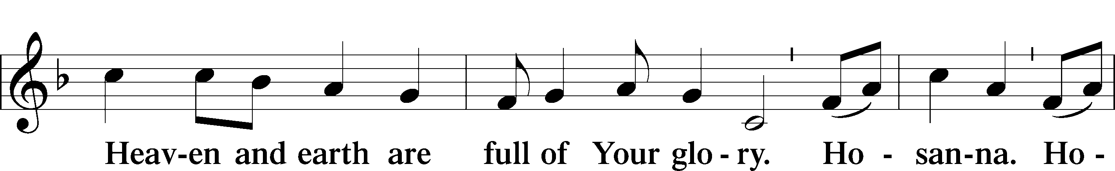

**PRAYER OF THANKSGIVING**

Pastor: Blessed are You, Lord of heaven and earth, for You have had mercy on those whom You created and sent Your only-begotten Son into our flesh to perfectly obey Your commands and fully redeem us from sin’s curse by becoming a curse for us. In repentance and faith, we trust in Your sure mercies, shown to us at the cross of Your Son.

**People: As we gather in Your name, O Lord, form and shape this dust of ours again, breathing new life into us by Your Word and Spirit.**

Pastor: Grant us faithfully to receive our Savior’s body and blood as He invites us to do in this sacred Meal.

**People: Hear our prayers; deliver and preserve us.**

Pastor: To You alone, O Father, be all glory, honor, and worship, with the Son and the Holy Spirit, one God, now and forever.

**People: Amen.**

**THE WORDS OF OUR LORD** *Matthew 26:26–28; Mark 14:22–24; Luke 22:19–20;  
1 Corinthians 11:23–25*

Pastor: Our Lord Jesus Christ, on the night when He was betrayed, took bread, and when He had given thanks, He broke it and gave it to the disciples and said: “Take, eat; this is My ✠ body, which is given for you. This do in remembrance of Me.”  
  
In the same way also He took the cup after supper, and when He had given thanks, He gave it to them, saying: “Drink of it, all of you; this cup is the new testament in My ✠ blood, which is shed for you for the forgiveness of sins. This do, as often as you drink it, in remembrance of Me.”

**PROCLAMATION OF CHRIST** *1 Corinthians 11:26; Revelation 22:20*

Pastor: As often as we eat this bread and drink this cup, we proclaim the Lord’s death until He comes.

**People: Amen. Come, Lord Jesus.**

Pastor: O Lord Jesus Christ, only Son of the Father, in giving us Your body and blood to eat and to drink, You lead us to remember and confess Your holy cross and passion, Your blessed death, Your rest in the tomb, Your resurrection from the dead, Your ascension into heaven, and Your coming for the final judgment. So remember us in Your kingdom and teach us to pray:

**LORD’S PRAYER** *Matthew 6:9–13*

**People:** **Our Father who art in heaven,  
 hallowed be Thy name,  
 Thy kingdom come,  
 Thy will be done on earth  
 as it is in heaven;  
 give us this day our daily bread;  
 and forgive us our trespasses  
 as we forgive those   
 who trespass against us;  
 and lead us not into temptation,  
 but deliver us from evil.  
For Thine is the kingdom  
 and the power and the glory  
 forever and ever. Amen.**

**PAX DOMINI**

Pastor: The peace of the Lord be with you always.

**People: Amen.**

**AGNUS DEI**

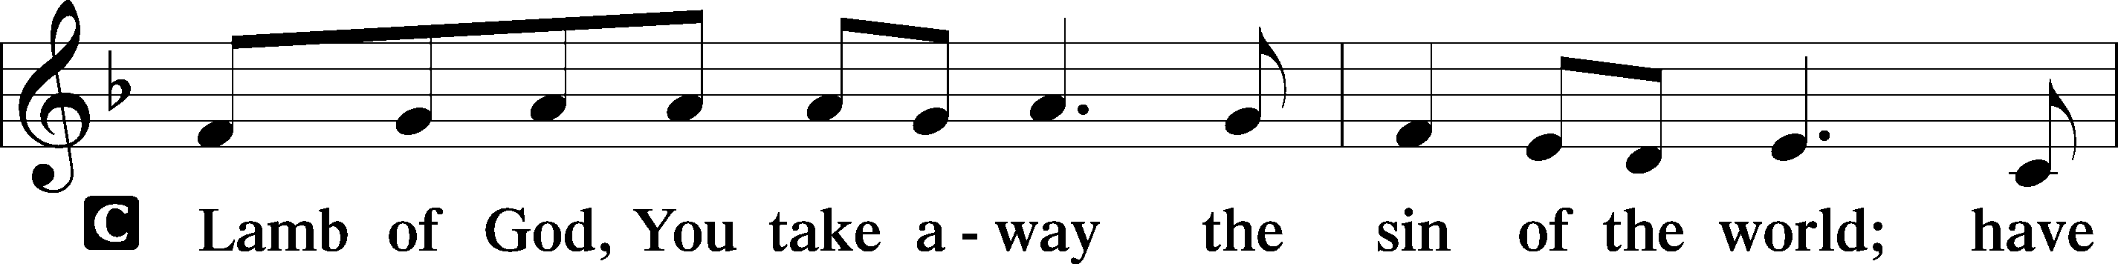

*Be Seated*

**DISTRIBUTION HYMNS**

**HYMN 563**  “Jesus, Thy Blood and Righteousness”

5 When from the dust of death I rise  
To claim my mansion in the skies,  
This then shall be my only plea:  
Jesus hath lived and died for me.

6 Jesus, be endless praise to Thee,  
Whose boundless mercy hath for me,  
For me, and all Thy hands have made,  
An everlasting ransom paid.

Text and tune: Public domain

**HYMN 550**  “Lamb of God”

Text and tune: © 1985 Straightway Music, admin. EMI. Used by permission: LSB Hymn License no. 110000966

*Please Stand*

**POST-COMMUNION CANTICLE**

**POST-COMMUNION THANKSGIVING**

Pastor: Let us pray.   
O Jesus, Lamb of God, we thank You for refreshing us yet again through Your Word and Sacrament.

**People: Assure us by Your Spirit that we have been marked and redeemed by You, the One who was crucified for us;**

Pastor: for You live and reign with the Father and the Holy Spirit, one God, now and forever.

**People: Amen.**

**CLOSING SENTENCES** *Psalm 51:10–12*

Pastor: Create in me a clean heart, O God,

**People: and renew a right spirit within me.**

Pastor: Cast me not away from Your presence,

**People: and take not Your Holy Spirit from me.**

Pastor: Restore to me the joy of Your salvation,

**People: and uphold me with a willing spirit.**

**BENEDICTION** *Numbers 6:24–26*

Pastor: The Lord bless you and keep you.  
The Lord make His face shine on you and be gracious to you.  
The Lord look upon you with favor and ✠ give you peace.

**People: Amen.**

**HYMN 418** “O Lord, throughout These Forty Days”

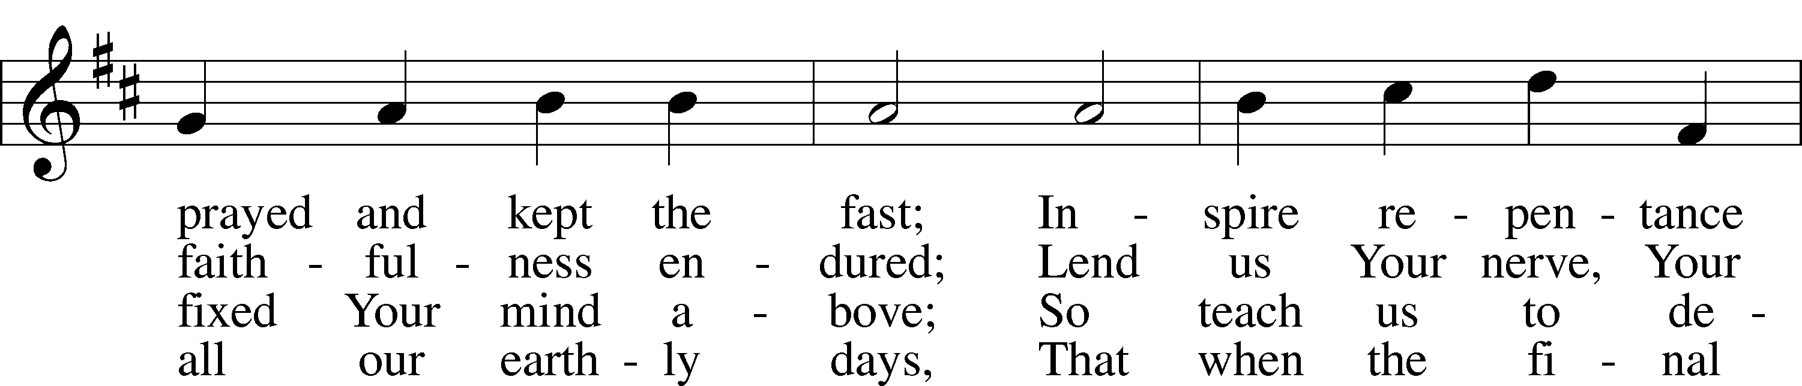

Text: © 1978 Lutheran Book of Worship. Used by permission: LSB Hymn License no. 110000966  
Tune: Public domain

*Be Seated*

***We implore you on behalf of Christ, be reconciled to God.***

***2 Corinthians 5:20***

Creative Worship for the Lutheran Parish, Series B, Quarter 2.

Copyright © 2023 Concordia Publishing House. All rights reserved. Used by permission.

**LENT & EASTER SCHEDULE**

Ash Wednesday (February 14): 1:00 & 7:00pm

Wednesdays in Lent (February 21, 28, March 6, 13, 20):

1:00 & 7:00pm

Palm Sunday (March 24): 8:30 & 11:00am

Maundy Thursday (March 28): 1:00 & 7:00pm

Good Friday (March 29): 3:00 & 7:00pm

Easter Sunday (March 31): 8:30 & 11:00am

**TRINITY LUTHERAN CHURCH**

12391 Mercy Blvd

Savannah, GA 31419

phone 912-925-4839 [trinityoffice@bellsouth.net](mailto:trinityoffice@bellsouth.net)

fax 912-925-4056 www.trinitylutheransavannah.com

Contact Pastor: 717-333-6263; pastorjeffwebb@yahoo.com

**STAFF**

Jeff Webb, Pastor

Traci Schumacher, Administrative Assistant

Helen Williams, Church Custodian

**BOARD OF ELDERS**

Mark Waltz, Head Elder (C – E)

Mike Fajen (K – Mc)

Todd Freesemann (F – J)

Sonny Massey (A – B)

Bob Reynolds (Me – Sa)

Tom Wayman (Sc – Z)

**CHURCH COUNCIL**

Kip Wiltse, President

Eric Thompson, Vice President

Cathy Crotwell, Secretary

Karl Schumacher, Treasurer

Jennifer Wolfe, Board of Education

Mark Waltz, Board of Elders

Chris Garretson, Board of Evangelism

Chris Cesaroni, Board of Property Management

Karen Hanovich, Board of Social Ministry

Lonna McEwen, Board of Stewardship

Cindy Reynolds, Financial Secretary

Bob Hanovich, Board of Youth

**ORGANIZATIONAL LEADERS**

Cindy Baldwin, Comfort Dog Top Dog

Jackie Deemer, Director of TLC Singers & LWML President

Katie Fester, Sunday School Superintendent

Rosemary Gerdes, Quilters

Karen Hanovich, TLC Marketing

Lonna McEwen, Altar Guild

Rose Pitt, Prayer Team